|  |  |
| --- | --- |
|  | **MINISTRY OF EDUCATION AND TRAINING** |

|  |
| --- |
| **FPT UNIVERSITY** |
| Capstone Project Document |
| **Student Counseling and Support System with Advanced Search at FPTU HCM Campus** |

|  |  |
| --- | --- |
| **GFA24SE27** | |
| **Group Members** | Trình Vĩnh Phát - Team leader - phattvse170042  Vũ Ngọc Hải Đăng - Team member - dangvnhse170225  Đoàn Tiến Phát- Team member - phatdtse170440  Phạm Trần Sơn Nguyên- Team member - nguyenptsse170048  Nguyễn An Khánh - Team member - khanhnase170431 |
| **Supervisor** | Mr. Huỳnh Công Việt Ngữ  Mrs. Lê Võ Minh Thư |
| **Capstone Project code** | FA24SE111 |

- Ho Chi Minh, November 2024 -

Definition and Acronyms 31

I. Project Introduction 32

1. Overview 32

1.1 Project Information 33

1.2 Project Team 33

2. Product Background 33

3. Existing Systems 33

4. Business Opportunity 33

5. Software Product Vision 33

6. Project Scope & Limitations 34

6.1 Major Features 34

6.2 Limitations & Exclusions 34

6.2.1 Limitations 34

6.2.2 Exclusions 34

II. Project Management Plan 35

1. Overview 35

1.1 Scope & Estimation 36

1.2 Project Objectives 36

1.3 Project Risks 37

2. Management Approach 37

2.1 Project Process 38

2.2 Quality Management 38

2.3 Training Plan 38

3. Project Deliverables 38

4. Responsibility Assignments 38

5. Project Communications 39

6. Configuration Management 39

6.1 Document Management 39

6.2 Source Code Management 39

6.3 Tools & Infrastructures 39

III. Software Requirement Specification 40

1. Product Overview 40

2. User Requirements 40

2.1. Actors 40

2.2. Use Cases 41

2.2.1. Diagram(s) 41

2.2.2. Descriptions 41

2.2.2.1. Administrator Use Case Description 42

2.2.2.2. Counselor Use Case Description 43

2.2.2.3. Manager Use Case Description 45

2.2.2.4. Support Staff Use Case Description 46

2.2.2.5. Student Use Case Description 47

3. Functional Requirements 48

3.1. System Functional Overview 48

3.1.1. Screens Flow 48

3.1.1.1. Administrator Screen Flow 49

3.1.1.2. Counselor Screenflow 50

3.1.1.3. Manager Screen Flow 51

3.1.1.4. Support Staff Screenflow 51

3.1.1.5. Student Screenflow 52

3.1.2. Screen Descriptions 52

3.1.2.1. Administrator Screen Description 52

3.1.2.2. Counselor Screen Description 54

3.1.2.3. Manager Screen Description 55

3.1.2.4. Support Staff Screen Description 56

3.1.2.5. Student Screen Description 57

3.1.3. Screen Authorization 58

3.1.3.1. Web Screen Authorization 58

3.1.3.2. Mobile Screen Authorization 60

3.1.4. Non-Screen Functions 60

3.1.5.1 Conceptual Model 61

3.1.5.2 Logical Model 61

3.2. Functional requirements 63

3.2.1. Accounts Feature 63

3.2.2. Authentications Feature 64

3.2.3. Booking Counseling Feature 64

3.2.4. Appointment Feature 66

3.2.5. Q&A Feature 67

3.2.6. Counseling Demand Feature 69

3.2.7. Dashboards Feature 70

3.2.8. Manage Student Feature 70

3.2.9. Manage Counselor Feature 71

4. Non-Functional Requirements 73

4.1. External Interfaces 74

4.1.1. User Interfaces 74

4.1.2. Communications Interfaces 74

4.2. Quality Attributes 74

4.2.1. Usability 74

4.2.2. Reliability 74

4.2.3. Performance 74

4.2.4. Security 74

5. Requirement Appendix 74

5.1. Business Rules 74

5.2. Application Messages List 75

5.2.1. Web application 75

5.2.2. Mobile application 77

IV. Software Design Description 78

1. System Design 79

1.1. System Architecture 79

1.1.1. Overall System Architecture 79

1.2. Package Diagram 80

1.2.1. Web Application Package Diagram 80

1.2.2. Mobile Application Package Diagram 81

1.2.3. Backend Application Package Diagram 83

2. Database Design 84

2.1. Database 84

2.2. Data Dictionary 84

2.2.1. Academic counselor table 84

2.2.2. Academic_transcript table 85

2.2.2. Account table 85

2.2.3. Appointment feedback Table 85

2.2.4. Appointment_for_demand table 86

2.2.5. Appointment_report  table 86

2.2.6. attendance_detail table 86

2.2.7. Available_date_range table 87

2.2.8. certifications table 87

2.2.9. Chat_session table 87

2.2.10. contributed_question_card_category table 87

2.2.11. contribution_question_card table 88

2.2.12. Counseling_appointment table 88

2.2.13. Counseling_appointment_request table 88

2.2.14. Counseling_demand Table 89

2.2.15. Counseling_slot table 90

2.2.12. Counselor table 90

2.2.16. Counselor_slot table 90

2.2.17. Demand_problem_tag table 90

2.2.18. Department table 91

2.2.19. Expertise table 91

2.2.20. Login_type table 91

2.2.21. Major table 91

2.2.22. Message table 91

2.2.23. Non_academic_counselor table 92

2.2.24. Notification table 92

2.2.25. Offline_appointment  table 92

2.2.26. Online_appointment table 92

2.2.27. Problem_category  table 92

2.2.28. Problem_tag  table 93

2.2.29. Profile  table 93

2.2.30. qualifications table 93

2.2.31. Question_ban table 94

2.2.32. Question_card  table 94

2.2.33. Question_flag  table 95

2.2.34. Semester table 95

2.2.35. slot_of_counselor table 95

2.2.36. Specialization table 95

2.2.37. Student table 96

2.2.38. Student_counseling_profile table 96

2.2.39. student_following table 96

2.2.40. student_study table 97

2.2.41. Support_staff  table 97

2.2.42. Topic table 97

2.2.43. Certifications table 98

2.2.44. Contributed_question_card_category table 98

2.2.45. contribution_question_card table 98

2.2.46. qualifications table 98

3. Detailed Design 99

3.1 Booking, handling, and tracking counseling appointments: 99

3.1.1. Class Diagram 99

3.1.1.1. Class Specification 99

3.1.1.1.1. CounselorController class 99

3.1.1.1.2. CounselorService class 100

3.1.1.1.3. CounselorServiceImpl class 100

3.1.1.1.4. NotificationServiceImpl class 101

3.1.1.1.5. CounselingAppointmentRequestServiceImpl class 101

3.1.1.1.6. BookingCounselingController class 101

3.1.1.1.7. CounselorRepository class 102

3.1.1.1.8. CounselingAppointmentRequestService class 102

3.1.1.1.9. OpenAIServiceImpl class 102

3.1.1.1.10. OpenAIServiceImpl class 103

3.1.1.1.11. NotificationService class 103

3.1.1.1.12. OpenAIService class 104

3.1.1.1.13. NotificationRepository class 104

3.1.1.1.14. Notification class 104

3.1.1.1.15 . CounselingAppointmentService class 105

3.1.1.1.16 . CounselingAppointmentServiceImpl class 105

3.1.1.1.17 . AppointmentFeedback class 106

3.1.1.1.18 . AppointmentFeedbackRepository class 106

3.1.1.1.19 . AppointmentReportRepository class 106

3.1.1.1.20 . AppointmentReport class 106

3.1.1.1.21 . CounselingAppointmentRequestRepository class 107

3.1.1.1.22. Counselor class 107

3.1.1.1.23. CounselingAppointmentRequest class 107

3.1.1.1.24 . CounselingAppointment class 108

3.1.1.1.25. AppointmentForDemand class 108

3.1.1.1.26 . StudentRepository class 108

3.1.1.1.27. CounselingDemandRepository class 108

3.1.1.1.28. CounselingAppointmentRepository class 109

3.1.1.1.29 . Student class 109

3.1.1.1.30 . CounselingDemand class 109

3.1.2. Sequence Diagram 110

3.1.2.1. Sequence Diagrarm 110

3.1.2.1.1. Student quick matching counselor 110

3.1.2.1.2. Student creates appointment request 110

3.1.2.1.3. Counselor approves appointment request 112

3.1.2.1.4. Take attendance 112

3.1.2.1.5. Student provide feedback 113

3.1.2.1.6. Counselor cancel appointment 113

3.1.2.1.7. Student cancel appointment 114

3.1.3. Activity Diagram 115

3.1.3.1. Create Booking request with quick booking 115

3.1.3.2. Create booking request with choosing a specific counselor 116

3.1.3.3. Take attendance 117

3.1.3.4. Provide Feedback 118

3.1.3.5. Cancel Appointment 119

3.1.4. State Machine Diagram 121

3.1.4.1. Booking Appointment State Machine Diagram 121

3.1.4.2. Taking Appointment State Machine Diagram 122

3.2. Student Questions and Counselor Support 123

3.2.1. Class Diagram 123

3.2.1.1. Class Specification 123

3.2.1.1.1. Counselor class 123

3.2.1.1.2 . StudentRepository class 124

3.2.1.1.3. CounselorRepository class 124

3.2.1.1.4. Student class 124

3.2.1.1.5. QuestionCard class 125

3.2.1.1.6. QuestionBan class 125

3.2.1.1.7. NotificationService class 125

3.2.1.1.8. NotificationServiceImpl class 125

3.2.1.1.9 . NotificationRepository class 126

3.2.1.1.10. Notification class 126

3.2.1.1.11. ChatSession class 126

3.2.1.1.12. Message class 126

3.2.1.1.13. MessageRepository class 127

3.2.1.1.14. MessageRepository class 127

3.2.1.1.15. QuestionFlag class 127

3.2.1.1.16. QuestionFlagRepository class 127

3.2.1.1.17. QuestionBanRepository class 127

3.2.1.1.18. QuestionCardServiceImpl class 127

3.2.1.1.19. QuestionCardController class 129

3.2.1.1.20. QuestionCardController class 129

3.2.1.1.21. OpenAIService class 130

3.2.1.1.22. QuestionCardRepository class 130

3.2.1.1.23. OpenAIService class 131

3.2.1.1.24. NonAcademicCounselor class 131

3.2.1.1.25. AcademicCounselor class 132

3.2.1.1.26. ExpertiseRepository class 132

3.2.1.1.27. AcademicCounselorRepository class 132

3.2.1.1.28. NonAcademicCounselorRepository class 132

3.2.1.1.29. Expertise class 132

3.2.2. Sequence Diagram 133

3.2.2.1. Student create question card 133

3.2.2.2. Counselor answer question sequence diagram 133

3.2.2.3. Counselor closes question sequence diagram 134

3.2.2.4. Student accepts question sequence diagram 134

3.2.2.5 Student initiate chat sequence diagram 135

3.2.3. Activity Diagram 136

3.2.3.1. Create question activity diagram 136

3.2.3.2. Answer question activity diagram 137

3.2.3.3. Flag question activity diagram 138

3.2.3.4. Close question activity diagram 139

3.2.3.5. Chat in session activity diagram 140

3.2.4. State Machine Diagram 140

3.2.4.1. Q&A State Machine Diagram 140

3.3. Staff-Driven Student Support and Counselor Matching for student’s demand 141

3.3.1. Class Diagram 141

3.3.1.1. Class Specification 141

3.3.1.1.1. CounselorController class 141

3.3.1.1.2. CounselorService class 142

3.3.1.1.3. CounselorServiceImpl class 142

3.3.1.1.4. CounselorRepository class 143

3.3.1.1.5. Counselor class 143

3.3.1.1.6. Student class 144

3.3.1.1.7. CounselingDemand class 144

3.3.1.1.8. StudentFollowing class 144

3.3.1.1.9. StudentRepository class 145

3.3.1.1.10. SupportStaffRepository class 145

3.3.1.1.11. CounselingDemandController class 145

3.3.1.1.12. CounselingDemandRepository class 145

3.3.1.1.13. SupportStaff class 145

3.3.1.1.14. CounselingDemandService class 146

3.3.1.1.15. CounselingDemandService class 146

3.3.1.1.16. CounselingDemandServiceImpl class 146

3.3.1.1.17. CounselingDemandService class 147

3.3.1.1.18. StudentServiceImpl class 147

3.3.2. Sequence Diagram 148

3.3.2.1. Support staff follows student sequence diagram 148

3.3.2.2. Support staff create demand card sequence diagram 149

3.3.2.3. Counselor creates appointment and attach to demand card sequence diagram 150

3.3.2.4. Counselor solves demand card sequence diagram 151

3.3.3. Activity Diagram 152

3.3.3.1. Staff Create demand card for mapping counselor with student activity diagram 152

3.3.3.1. Counselor Create appointment for demand if student need activity diagram 153

3.3.3.2. Staff Follow student activity diagram 154

3.3.3.3. Staff Unfollow student activity diagram 155

3.3.3.4. Solve demand activity diagram 156

3.3.4. State Machine Diagram 156

3.3.4.1. Demand Mapping State Machine Diagram 156

V. Software Testing Documentation 156

1. Overall Description 157

2. Test Strategy 157

2.1. Testing Types 157

2.2. Test Levels 157

3. Test Plan 157

3.1. Human Resources 157

4. Test Cases & Test Reports 158

VI. Release Package & User Guides 158

1. Deliverable Package 158

2. Installation Guides 158

2.1.1.2 Mobile application 159

*2.1.2* Software requirements 159

2.2. Installation Instruction 159

2.2.1. Environment Setup 159

2.2.1.1. Mobile Application Development 159

2.2.1.2. Web application 160

2.2.1.3. Back-end Server 160

2.2.1.3.1. Install Intellij 160

2.2.1.3.2. Install Environment 161

2.2.1.3.3 Simulation Student Data Server 161

2.2.1.3.4. SCSS Server 166

3. User Manual 174

3.1. Overview 174

3.2. Web Application 174

3.2.1. Authentication 174

3.2.1.1. Login 174

3.2.1.1.1. Description 174

3.2.1.1.2. Guide Steps 174

3.2.1.2. Reset Password 175

3.2.1.2.1. Description 175

3.2.1.2.2. Guide Steps 175

3.2.1.3. Edit Password 176

3.2.1.3.1. Description 176

3.2.1.3.2. Guide Steps 176

3.2.2.  Booking counseling appointment 178

3.2.2.1. Quick booking a counselor 178

3.2.2.1.1. Description 178

3.2..2.1.2. Guide steps 178

3.2.2.2. Booking a specific counselor 181

3.2.2.2.1. Description 181

3.2..2.1.2. Guide steps 181

3.2.2.3. Approve an appointment request 185

3.2.2.3.1. Description 185

3.2.2.3.2. Guide steps 185

3.2.2.4. Deny an appointment request 187

3.2.2.4.1. Description 187

3.2.2.4.2. Guide steps 187

3.2.2.5. Take Attendance for Appointment 190

3.2.2.5.1. Description 190

3.2.2.5.1. Guide Steps: 190

3.2.2.6. Give Feedback for Appointment 193

3.2.2.6.1. Description 193

3.2.2.6.2. Guide Steps 193

3.2.2.7. Create report for an appointment 196

3.2.2.7.1. Description 196

3.2.2.7.2. Guide Steps 196

3.2.2.8. Cancel an appointment 199

3.2.2.8.1. Description 199

3.2.2.8.2. Guide Steps: 199

3.2.2.9. View counseling schedule 202

3.2.2.9.1. Description 202

3.2.2.9.2. Guide Steps 202

3.2.3. Question and answer 206

3.2.3.1. Ask a question 206

3.2.3.1.1 Description 206

3.2.3.1.2. Guide Steps 206

3.2.3.2. Edit a question 209

3.2.3.1.1 Description 209

3.2.3.1.2. Guide Steps 209

3.2.3.3. Answer a question 212

3.2.3.3.1 Description 212

3.2.3.3.2. Guide Steps 212

3.2.3.4. Edit your answer 214

3.2.3.4.1 Description 214

3.2.3.4.2. Guide Steps 214

3.2.3.5. Chat about a question 217

3.2.3.5.1 Description 217

3.2.3.5.2. Guide Steps 217

3.2.3.6. Close a question 219

3.2.3.6.1 Description 219

3.2.3.6.2. Guide Steps 219

3.2.3.7. Contribute to FAQ 222

3.2.3.3.7 Description 222

3.2.3.3.7. Guide Steps 222

3.2.3.8. Edit contributed FAQ 225

3.2.3.3.8 Description 225

3.2.3.3.8. Guide Steps 225

3.2.3.9. Reject a question 228

3.2.3.9.1 Description 228

3.2.3.9.2. Guide Steps 228

3.2.3.10. Flag a question 231

3.2.3.10.1 Description 231

3.2.3.10.2. Guide Steps 231

3.2.4. Counseling demand 234

3.3.4.1. Create counseling demand 234

3.3.3.3.1 Description 234

3.3.3.3.2. Guide Steps 234

3.3.4.2. Create an appointment from demand 238

3.3.3.3.1 Description 238

3.3.3.3.2. Guide Steps 238

3.3.4.3. Solve a counseling demand 241

3.3.3.3.1 Description 241

3.3.3.3.2. Guide Steps 241

3.2.5. Counselor Management 244

3.3.5.1. Update counselor availability 244

3.3.5.1.1 Description 244

3.3.5.1.2 . Guide Steps 244

3.3.5.2. Update counselor weekly schedule 246

3.3.5.2.1 Description 246

3.3.5.2.2 . Guide Steps 246

3.3.5.3. Update counselor date range 249

3.3.5.1.1 Description 249

3.3.5.1.2 . Guide Steps 249

3.2.6. Account Management 251

3.2.6.1. Create non-academic/academic counselor  account 251

3.2.6.1.1. Description 251

3.2.6.1.2. Guide Steps 251

3.2.6.2. Create manager/support staff account 259

3.2.6.2.1. Description 259

3.2.6.2.2. Guide Steps 259

3.2.6.3. Update account 262

3.2.6.3.1. Description 262

3.2.6.3.2. Guide Steps 262

3.2.6.4. Block/Unblock accounts 265

3.2.6.4.1. Description 265

3.2.6.4.2. Guide Steps 265

3.2.7. Resource Management 269

3.2.7.1. Create problem tag 269

3.2.7.1.1. Description 269

3.2.7.1.2. Guide Steps 269

3.2.7.2. Create problem tag’s category 272

3.2.7.2.1. Description 272

3.2.7.2.2. Guide Steps 272

3.2.7.3. Create counseling time slot 276

3.2.7.3.1. Description 276

3.2.7.3.2. Guide Steps 276

3.2.7.4. Remove problem tag’s category 279

3.2.7.4.1. Description 279

3.2.7.4.2. Guide Steps 279

3.2.7.5. Remove problem tag 283

3.2.7.5.1. Description 283

3.2.7.5.2. Guide Steps 283

3.2.7.6. Remove counseling time slot 287

3.2.7.6.1. Description 287

3.2.7.6.2. Guide Steps 287

3.2.7.7. Update problem tag 290

3.2.7.7.1. Description 290

3.2.7.7.2. Guide Steps 290

3.2.7.8. Update problem tag’s category 294

3.2.7.8.1. Description 294

3.2.7.8.2. Guide Steps 294

3.2.7.9. Update counseling time slot 298

3.2.7.9.1. Description 298

3.2.7.9.2. Guide Steps 298

3.2.7.10. View academic information 302

3.2.7.10.1. Description 302

3.2.7.10.2. Guide Steps 302

3.2.8. Question Management 304

3.2.8.1. Update public question’s public status. 304

3.2.8.1.1. Description 304

3.2.8.1.2. Guide Steps 304

3.2.8.2. Update frequently asked question’s visibility status. 307

3.2.8.2.1. Description 307

3.2.8.2.2. Guide Steps 307

3.2.8.3. Create frequently asked question’s category. 311

3.2.8.3.1. Description 311

3.2.8.3.2. Guide Steps 311

3.2.8.4. Update frequently asked question’s category. 314

3.2.8.4.1. Description 314

3.2.8.4.2. Guide Steps 314

3.2.8.5. Remove frequently asked question’s category. 318

3.2.8.5.1. Description 318

3.2.8.5.2. Guide Steps 318

3.2.9. Analytics View 322

3.2.9.1. View analytics 322

3.2.9.1.1 Description 322

3.2.9.1.2 . Guide Steps 322

3.2.9.2. View overview 323

3.2.9.2.1 Description 323

3.2.9.2.2 . Guide Steps 323

3.3. Mobile Application 325

3.3.1. Authentication 325

3.3.1.1. Login 325

3.3.1.1.1. Description 325

3.3.1.1.2. Guide Steps 325

3.3.1.2. Reset Password 327

3.3.1.2.1. Description 327

3.3.1.2.2. Guide steps 328

3.3.1.3. Edit Password 330

3.3.1.3.1. Description 330

3.3.1.3.2. Guide Steps 330

3.3.2.  Booking counseling appointment 334

3.3.2.1. Quick booking a counselor 334

3.3.2.1.1. Description 334

3.3.2.1.2. Guide Steps 334

3.3.2.2. Booking a specific counselor 342

3.3.2.2.1. Description 342

3.3.2.2.2. Guide Steps 342

3.3.2.3. Approve Appointment Request 351

3.3.2.3.1. Description 351

3.3.2.4. Deny Appointment Request 360

3.3.2.4.1. Description 360

3.3.2.5. Take Attendance for Appointment 367

3.3.2.5.1. Description 367

3.3.2.6. Write Feedback for Appointment 374

3.3.2.6.1. Description 374

3.3.2.7. Write Report for Appointment 382

3.3.2.7.1. Description 382

3.3.2.7.2. Guide Steps 383

3.3.2.8. Cancel Appointment 392

3.3.2.8.1. Description 392

3.3.2.8.2. Guide Steps 393

3.3.3.  Question and Answer 409

3.3.3.1. Create a question 409

3.3.3.1.1. Description 409

3.3.3.1.2. Guide Steps 409

3.3.3.2. Edit a question 418

3.3.3.2.1. Description 418

3.3.3.2.2. Guide Steps: 419

3.3.3.3. Delete a question 422

3.3.3.3.1. Description 422

3.3.3.3.2. Guide Steps: 423

3.3.3.4. Answer a question 425

3.3.3.4.1. Description 425

3.3.3.4.2. Guide Steps 426

3.3.3.5. Edit Answer of a question 432

3.3.3.5.1. Description 432

3.3.3.5.2. Guide Steps: 433

3.3.3.6. Create a chat session 435

3.3.3.6.1. Description 435

3.3.3.6.2. Guide Steps 436

3.3.3.7. Accept a question’s answer 438

3.3.3.7.1. Description 438

3.3.3.7.2. Guide Steps 439

3.3.3.8. Close a question 441

3.3.3.8.1. Description 441

3.3.3.8.2. Guide Steps 442

3.3.3.9. Create a contribution question 451

3.3.3.9.1. Description 451

3.3.3.9.2. Guide Steps 452

3.3.3.10. Edit a contribution question 458

3.3.3.10.1. Description 458

3.3.3.10.2. Guide Steps: 459

3.3.3.11. Delete a contribution question 462

3.3.3.11.1. Description 462

3.3.3.11.2. Guide Steps 463

3.3.4. Counseling Demands 465

3.3.4.1. View Demands List 465

3.3.4.1.1. Description 465

3.3.4.1.2. Guide Steps 465

3.3.4.2. Create Appointment through Demand 470

3.3.4.2.1. Description 470

3.3.4.2.2. Guide Steps 471

3.3.4.3. Solve Demand 473

3.3.4.3.1. Description 473

3.3.4.3.2. Guide Steps: 474

**List of Tables**

Table 1- Acronym and Definition 31

Table 2 - Project team 32

Table 3 - Scope & Estimation 35

Table 4 - Project Objectives 35

Table 5 - Project Risks 36

Table 6 - Training Plan 37

Table 7 - Project Deliverables 37

Table 8 - Responsibility Assignments 37

Table 9 - Project Communications 38

Table 10 - Tools & Infrastructures 38

Table 11 - Actors 39

Table 12 - Administrator Use Case Description 41

Table 13 - Counselor Use Case Description 42

Table 14 - Manager Use Case Description 44

Table 15 - Support Staff Use Case Description 45

Table 16 - Student Use Case Description 46

Table 17 - Aministrator Screen Description 51

Table 18 - Counselor Screen Description 53

Table 19 - Manager Screen Description 54

Table 20 - Support Staff Screen Description 55

Table 21 - Student Screen Description 56

Table 22 - Web Screen Authorization 57

Table 23 - Mobile Screen Authorization 59

Table 24 - Non-Screen Functions 59

Table 25 - Entities Description 60

Table 26 - Authentications Feature 63

Table 27 - Booking Counseling Feature 63

Table 28 - Appointment Feature 65

Table 29 - Q&A Feature 66

Table 30 - Counseling Demand Feature 68

Table 31 - Dashboards Feature 69

Table 32 - Manage Student Feature 69

Table 33 - Manage Counselor Feature 70

Table 34 - Business Rules 73

Table 35 - Web application 74

Table 36 - Mobile application 76

Table 37 - Web Package Descriptions 79

Table 38 - Mobile Package Descriptions 81

Table 39 - Backend Package Descriptions 82

Table 40 - Academic counselor Table 83

Table 41 - Academic transcript table 84

Table 42 - Account table 84

Table 43 - Appointment feedback Table 84

Table 44 - Appointment_for_demand table 85

Table 45 - Appointment_report table 85

Table 46 - attendance_detail table 85

Table 47 - contributed_question_card_category table 86

Table 48 - contribution_question_card table 87

Table 49 - Counseling_appointment table 87

Table 50 - Counseling_appointment_request 87

Table 51 - Counseling_demand Table 88

Table 52 - Counseling_slot table 89

Table 53 - Counselor table 89

Table 54 - Counselor_slot table 89

Table 55 - Demand_problem_tag table 89

Table 56 - Department table 90

Table 57 - Expertise table 90

Table 58 - Login_type table 90

Table 59 - Major table 90

Table 60 - Message table 90

Table 61 - Non_academic_counselor table 91

Table 62 - Notification table 91

Table 63 - Offline_appointment table 91

Table 64 - Online_appointment table 91

Table 65 - Problem_category table 91

Table 66 - Problem_tag table 92

Table 67 - Profile table 92

Table 68 – qualifications table 92

Table 69 - Question_ban table 93

Table 70 - Question_card table 93

Table 71- Question_flag table 94

Table 72 - Semester table 94

Table 73 - slot_of_counselor table 94

Table 74 - Specialization table 94

Table 75 - Student table 95

Table 76 - Student_counseling_profile table 95

Table 77 - student_following table 95

Table 78 - student_study table 96

Table 79 - Support_staff table 96

Table 80 - Topic table 96

Table 81 - Certifications table 97

Table 82 - Contributed_question_card_category table 97

Table 83 - contribution_question_card table 97

Table 84 - qualifications table 97

Table 85 - CounselorController class 98

Table 86 - CounselorController method class 98

Table 87 - CounselorService method class 99

Table 88 - CounselorServiceImpl class 99

Table 89 - CounselorServiceImpl method class 99

Table 90 - NotificationServiceImpl class 100

Table 91 - NotificationServiceImp method class 100

Table 92 – CounselingAppointmentRequestServiceImpl class 100

Table 93- CounselingAppointmentRequestServiceImpl method class 100

Table 94 - BookingCounselingController class 100

Table 95 - BookingCounselingController method class 101

Table 96 - CounselorRepository class 101

Table 97 – CounselingAppointmentRequestService method class 101

Table 98 - OpenAIServiceImpl class 101

Table 99 - OpenAIServiceImpl method class 102

Table 100 – OpenAIServiceImpl method class 102

Table 101 - NotificationService class 102

Table 102 - OpenAIService class 103

Table 103 - OpenAIService method class 103

Table 104 - NotificationRepository class 103

Table 105 - Notification class 103

Table 106 - CounselingAppointmentService method class 104

Table 107 - CounselingAppointmentServiceImpl class 104

Table 108 - CounselingAppointmentServiceImpl method class 104

Table 109 - AppointmentFeedback class 105

Table 110 - AppointmentFeedbackRepository method class 105

Table 111 - AppointmentReportRepository method class 105

Table 112 - AppointmentReport class 105

Table 113 - CounselingAppointmentRequestRepository method class 106

Table 114 - Counselor class 106

Table 115 - CounselingAppointmentRequest class 106

Table 116 - CounselingAppointment class 107

Table 117 - AppointmentForDemand class 107

Table 118 - StudentRepository method class 107

Table 119 - CounselingDemandRepository method class 107

Table 120 - CounselingAppointmentRepository method class 108

Table 121 - Student class 108

Table 122 - CounselingDemand class 108

Table 123 - Counselor class 122

Table 124 – StudentRepository method class 123

Table 125 – CounselorRepository method class 123

Table 126 - Student class 123

Table 127 - QuestionCard class 124

Table 128 - QuestionBan class 124

Table 129 – NotificationService method class 124

Table 130 - NotificationServiceImpl class 124

Table 131 - NotificationServiceImpl method class 125

Table 132 - NotificationRepository method class 125

Table 133 - Notification class 125

Table 134 - ChatSession class 125

Table 135 - Message class 125

Table 136 - MessageRepository method class 126

Table 137 - MessageRepository method class 126

Table 138 - QuestionFlag class 126

Table 139 - QuestionFlagRepository class 126

Table 140 - QuestionBanRepository method class 126

Table 141 - QuestionCardServiceImpl class 126

Table 142 - QuestionCardServiceImpl method class 127

Table 143 - QuestionCardController class 128

Table 144 - QuestionCardController method class 128

Table 145 - QuestionCardController method class 128

Table 146 - OpenAIService method class 129

Table 147 - QuestionCardRepository method class 129

Table 148 - OpenAIService class 130

Table 149 - OpenAIService method class 130

Table 150 - NonAcademicCounselor class 130

Table 151 - AcademicCounselor class 131

Table 152 - ExpertiseRepository method class 131

Table 153 - AcademicCounselorRepository method class 131

Table 154 - NonAcademicCounselorRepository method class 131

Table 155 - Expertise class 131

Table 156 - CounselorController class 140

Table 157 - CounselorController method class 140

Table 158 – CounselorService method class 141

Table 159 - CounselorServiceImpl class 141

Table 160 - CounselorServiceImpl method class 141

Table 161 - CounselorRepository method class 142

Table 162 - Counselor class 142

Table 163 - Student class 143

Table 164 - CounselingDemand class 143

Table 165 - StudentFollowing class 143

Table 166 – StudentRepository method class 144

Table 167 - SupportStaffRepository method class 144

Table 168 - CounselingDemandController class 144

Table 169 - CounselingDemandController method class 144

Table 170 - CounselingDemandRepository method class 144

Table 171 - SupportStaff class 144

Table 172 - CounselingDemandService method class 145

Table 173 - CounselingDemandService method class 145

Table 174 - CounselingDemandServiceImpl class 145

Table 175 - CounselingDemandServiceImpl method class 145

Table 176 - CounselingDemandService method class 146

Table 177 - StudentServiceImpl class 146

Table 178 - StudentServiceImpl method class 146

Table 179 - Test Levels 156

Table 180 - Supporting Tools 156

Table 181 - Human Resources 156

Table 182 - Test Environment 157

Table 183 - Test Milestones 157

Table 184 - Deliverable Package 157

Table 185 - Website application 158

Table 186 - Mobile application 158

Table 187 - Software requirements 158

**List of Figures**

Figure 1 - The Scrum Framework Process 37

Figure 2 – Sysyem Context Diagram 40

Figure 3 - Use case diagram 41

Figure 4 - Administrator Screen Flow 49

Figure 5 - Counselor Screenflow 50

Figure 6 - Manager Screen Flow 51

Figure 7 - Support Staff Screenflow 51

Figure 8 - Student Screenflow 52

Figure 9 - Conceptual Model 61

Figure 10 - Logical diagram 61

Figure 11 - Overall System Architecture 79

Figure 12 - Web Application Package Diagram 80

Figure 13 - Mobile Application Package Diagram 82

Figure 14 - Backend Application Package Diagram 83

Figure 15 - Database Diagram 84

Figure 16 - Booking, handling, and tracking counseling appointments class diagram 99

Figure 17- Student quick matching counselor sequence diagram 110

Figure 18 - Student creates appointment request sequence diagram 111

Figure 19 - Counselor Approves appointment request sequence diagram 112

Figure 20 - Take attendance sequence diagram 113

Figure 21 - Student provide feedback sequence diagram 113

Figure 22 – Counselor cancel appointment sequence diagram 113

Figure 23 - Student cancel appointment sequence diagram 114

Figure 24 - Create Booking request with quick booking activity diagram 115

Figure 25 - Create booking request with choosing a specific counselor activity diagram 116

Figure 26 - Take attendance activity diagram 117

Figure 27 - Provide Feedback activity diagram 118

Figure 28 - Cancel Appointment activity diagram 119

Figure 29 - Approve appointment request activity diagram 120

Figure 30 - Create report activity diagram 121

Figure 31 - Booking Appointment State Machine Diagram 121

Figure 32 - Student Questions and Counselor Support class diagram 123

Figure 33 - Student create question card sequence diagram 133

Figure 34 – Counselor answer question sequence diagram 133

Figure 35 - Counselor closes question sequence diagram 134

Figure 36 - Student accepts question sequence diagram 134

Figure 37 - Student initiate chat sequence diagram 135

Figure 38 - Create question activity diagram 136

Figure 39 - Answer question activity diagram 137

Figure 40 - Flag question activity diagram 138

Figure 41 - Close question activity diagram 139

Figure 42 - Chat in session activity diagram 140

Figure 43 - Q&A State Machine Diagram 141

Figure 44 - Staff-Driven Student Support and Counselor Matching for student’s demand class diagram 141

Figure 45 - Support staff follows student sequence diagram 148

Figure 46 - Staff Create demand card for mapping counselor with student activity diagram 152

Figure 47 - Counselor Create appointment for demand if student need activity diagram 153

Figure 48 - Staff Follow student activity diagram 154

Figure 49 - Staff Unfollow student activity diagram 155

Figure 50 - Solve demand activity diagram 156

Figure 51 -Demand Mapping State Machine Diagram 156

Figure 52 - User Manual - Feature 1 - Step 1 176

Figure 53 - User Manual - Feature 1 - Step 2 176

Figure 54 - User Manual - Feature 2 - Step 1 177

Figure 55 - User Manual - Feature 2 - Step 2 177

Figure 56 - User Manual - Feature 3 - Step 1 178

Figure 57 - User Manual - Feature 3 - Step 2 178

Figure 58 - User Manual - Feature 3 - Step 3 179

Figure 59 - User Manual - Feature 4 - Step 1 179

Figure 60 - User Manual - Feature 4 - Step 2 180

Figure 61 - User Manual - Feature 4 - Step 3 180

Figure 62 - User Manual - Feature 4 - Step 4 181

Figure 63 - User Manual - Feature 4 - Step 5 181

Figure 64 - User Manual - Feature 4 - Step 6 182

Figure 65 - User Manual - Feature 5 - Step 1 182

Figure 66 - User Manual - Feature 5 - Step 2 183

Figure 67 - User Manual - Feature 5 - Step 3 183

Figure 68 - User Manual - Feature 5 - Step 4 184

Figure 69 - User Manual - Feature 5 - Step 5 184

Figure 70 - User Manual - Feature 5 - Step 6 185

Figure 71 - User Manual - Feature 5 - Step 7 185

Figure 72 - User Manual - Feature 5 - Step 8 186

Figure 73 - User Manual - Feature 6 - Step 1 186

Figure 74 - User Manual - Feature 6 - Step 2 187

Figure 75 - User Manual - Feature 6 - Step 3 187

Figure 76 - User Manual - Feature 6 - Step 3 188

Figure 77 - User Manual - Feature 6 - Step 4 188

Figure 78 - User Manual - Feature 7 - Step 1 189

Figure 79- User Manual - Feature 7 - Step 2 189

Figure 80- User Manual - Feature 8 - Step 2 190

Figure 81- User Manual - Feature 8 - Step 3 190

Figure 82 - User Manual - Feature 8 - Step 4 191

Figure 83 - User Manual - Feature 9 - Step 1 191

Figure 84 - User Manual - Feature 9 - Step 2 192

Figure 85 - User Manual - Feature 9 - Step 3 192

Figure 86 - User Manual - Feature 9 - Step 4 193

Figure 87 - User Manual - Feature 9 - Step 5 193

Figure 88 - User Manual - Feature 9 - Step 5 194

Figure 89 - User Manual - Feature 10 - Step 1 194

Figure 90 - User Manual - Feature 10 - Step 2 195

Figure 91 - User Manual - Feature 10 - Step 3 195

Figure 92 - User Manual - Feature 10 - Step 4 196

Figure 93 - User Manual - Feature 10 - Step 5 196

Figure 94 - User Manual - Feature 10 - Step 6 197

Figure 95 - User Manual - Feature 11 - Step 1 197

Figure 96 - User Manual - Feature 11 - Step 2 198

Figure 97 - User Manual - Feature 11 - Step 3 198

Figure 98 - User Manual - Feature 11 - Step 4 199

Figure 99 - User Manual - Feature 11 - Step 5 199

Figure 100 - User Manual - Feature 11 - Step 6 200

Figure 101 - User Manual - Feature 11 - Step 7 200

Figure 102 - User Manual - Feature 12 - Step 1 201

Figure 103 - User Manual - Feature 12 - Step 2 201

Figure 104 - User Manual - Feature 12 - Step 3 202

Figure 105 - User Manual - Feature 12 - Step 4 202

Figure 106 - User Manual - Feature 12 - Step 5 203

Figure 107 - User Manual - Feature 12 - Step 6 203

Figure 108 - User Manual - Feature 13 - Step 1 204

Figure 109 - User Manual - Feature 13 - Step 2 204

Figure 110 - User Manual - Feature 13 – Step 3 205

Figure 111 - User Manual - Feature 13 – Step 4.1 205

Figure 112 - User Manual - Feature 13 – Step 4.2 206

Figure 113 - User Manual - Feature 13 – Step 4.3 206

Figure 114 - User Manual - Feature 13 – Step 5 207

Figure 115 - User Manual - Feature 13 – Step 6 207

Figure 116 - User Manual - Feature 14 – Step 1 208

Figure 117 - User Manual - Feature 14 – Step 2 208

Figure 118 - User Manual - Feature 14 – Step 3 209

Figure 119 - User Manual - Feature 14 – Step 4 209

Figure 120 - User Manual - Feature 14 – Step 5 210

Figure 121 - User Manual - Feature 14 – Step 6 210

Figure 122 - User Manual - Feature 15 – Step 1 211

Figure 123 - User Manual - Feature 15 – Step 2 211

Figure 124 - User Manual - Feature 15 – Step 3 212

Figure 125 - User Manual - Feature 15 – Step 4 212

Figure 126 - User Manual - Feature 15 – Step 5 213

Figure 127 - User Manual - Feature 16 – Step 1 213

Figure 128 - User Manual - Feature 16 – Step 2 214

Figure 129 - User Manual - Feature 16 – Step 3 214

Figure 130 - User Manual - Feature 16 – Step 4 215

Figure 131 - User Manual - Feature 16 – Step 5 215

Figure 132 - User Manual - Feature 17 – Step 1 216

Figure 133 - User Manual - Feature 17 – Step 2 216

Figure 134 - User Manual - Feature 17 – Step 3 217

Figure 135 - User Manual - Feature 17 – Step 4 217

Figure 136 - User Manual - Feature 17 – Step 5 218

Figure 137 - User Manual - Feature 18 – Step 1 218

Figure 138 - User Manual - Feature 18 – Step 2 219

Figure 139 - User Manual - Feature 18 – Step 3 219

Figure 140 - User Manual - Feature 18 – Step 4 220

Figure 141 - User Manual - Feature 18 – Step 5 220

Figure 142 - User Manual - Feature 19 – Step 1 221

Figure 143 - User Manual - Feature 19 – Step 2 221

Figure 144 - User Manual - Feature 19 – Step 3 222

Figure 145 - User Manual - Feature 19 – Step 4 222

Figure 146 - User Manual - Feature 19 – Step 5 223

Figure 147 - User Manual - Feature 20 – Step 1 223

Figure 148 - User Manual - Feature 20 – Step 2 224

Figure 149 - User Manual - Feature 20 – Step 3 224

Figure 150 - User Manual - Feature 20 – Step 4 225

Figure 151 - User Manual - Feature 20 – Step 5 225

Figure 152 - User Manual - Feature 20 – Step 6 226

Figure 153 - User Manual - Feature 21 – Step 1 226

Figure 154 - User Manual - Feature 21 – Step 2 227

Figure 155 - User Manual - Feature 21 – Step 3 227

Figure 156 - User Manual - Feature 21 – Step 4 228

Figure 157 - User Manual - Feature 21 – Step 5 228

Figure 158 - User Manual - Feature 21 – Step 6 229

Figure 159 - User Manual - Feature 22 – Step 1 229

Figure 160 - User Manual - Feature 22 – Step 2 230

Figure 161 - User Manual - Feature 22 – Step 3 230

Figure 162 - User Manual - Feature 22 – Step 4 231

Figure 163 - User Manual - Feature 22 – Step 5 231

Figure 164 - User Manual - Feature 22 – Step 7 232

Figure 165 - User Manual - Feature 23 – Step 1 232

Figure 166 - User Manual - Feature 23 – Step 2 233

Figure 167 - User Manual - Feature 23 – Step 3 233

Figure 168 - User Manual - Feature 23 – Step 4 234

Figure 169 - User Manual - Feature 23 – Step 5 234

Figure 170 - User Manual - Feature 23 – Step 6 235

Figure 171 - User Manual - Feature 24 – Step 1 235

Figure 172 - User Manual - Feature 24 – Step 2 236

Figure 173 - User Manual - Feature 24 – Step 3 236

Figure 174 - User Manual - Feature 24 – Step 4 237

Figure 175 - User Manual - Feature 24 – Step 5 237

Figure 176 - User Manual - Feature 24 – Step 6 238

Figure 177 - User Manual - Feature 24 – Step 7 238

Figure 178 - User Manual - Feature 24 – Step 8 239

Figure 179 - User Manual - Feature 24 – Step 9 239

Figure 180 - User Manual - Feature 25 – Step 1 240

Figure 181 - User Manual - Feature 25 – Step 2 240

Figure 182 - User Manual - Feature 25 – Step 3 241

Figure 183 - User Manual - Feature 25 – Step 4 241

Figure 184 - User Manual - Feature 25 – Step 6 242

Figure 185 - User Manual - Feature 26 – Step 1 242

Figure 186 - User Manual - Feature 26 – Step 2 243

Figure 187 - User Manual - Feature 26 – Step 3 243

Figure 188 - User Manual - Feature 26 – Step 4 244

Figure 189 - User Manual - Feature 26 – Step 5 244

Figure 190 - User Manual - Feature 26 – Step 6 245

Figure 191 - User Manual - Feature 27 – Step 1 245

Figure 192 - User Manual - Feature 27 – Step 2 246

Figure 193 - User Manual - Feature 27 – Step 3 246

Figure 194 - User Manual - Feature 27 – Step 4 247

Figure 195 - User Manual - Feature 27 – Step 5 247

Figure 196 - User Manual - Feature 28 – Step 1 248

Figure 197 - User Manual - Feature 28 – Step 2 248

Figure 198 - User Manual - Feature 28 – Step 3 249

Figure 199 - User Manual - Feature 28 – Step 4 249

Figure 200 - User Manual - Feature 28 – Step 5 250

Figure 201 - User Manual - Feature 29 – Step 1 250

Figure 202 - User Manual - Feature 29 – Step 2 251

Figure 203 - User Manual - Feature 29 – Step 3 251

Figure 204 - User Manual - Feature 29 – Step 4 252

Figure 205 - User Manual - Feature 29 – Step 5 252

Figure 206 - User Manual - Feature 30 – Step 1 253

Figure 207 - User Manual - Feature 30 – Step 2 253

Figure 208 - User Manual - Feature 30 – Step 3 254

Figure 209 - User Manual - Feature 30 – Step 4 254

Figure 210 - User Manual - Feature 30 – Step 5 255

Figure 211 - User Manual - Feature 30 – Step 6 255

Figure 212 - User Manual - Feature 30 – Step 7.1 256

Figure 213 - User Manual - Feature 30 – Step 7.2 256

Figure 214 - User Manual - Feature 30 – Step 8 257

Figure 215 - User Manual - Feature 30 – Step 9 257

Figure 216 - User Manual - Feature 30 – Step 10.1 258

Figure 217 - User Manual - Feature 30 – Step 10.2 259

Figure 218 - User Manual - Feature 30 – Step 11 259

Figure 219 - User Manual - Feature 30 – Step 12 260

Figure 220 - User Manual - Feature 31 – Step 1 260

Figure 221 - User Manual - Feature 31 – Step 2 261

Figure 222 - User Manual - Feature 31 – Step 3 261

Figure 223 - User Manual - Feature 31 – Step 4 262

Figure 224 - User Manual - Feature 31 – Step 5 262

Figure 225 - User Manual - Feature 31 – Step 6 263

Figure 226 - User Manual - Feature 31 – Step 7 263

Figure 227 - User Manual - Feature 32 – Step 1 264

Figure 228 - User Manual - Feature 32 – Step 2 264

Figure 229 - User Manual - Feature 32 – Step 3 265

Figure 230 - User Manual - Feature 32 – Step 4 265

Figure 231 - User Manual - Feature 32 – Step 5 266

Figure 232 - User Manual - Feature 32 – Step 6 266

Figure 233 - User Manual - Feature 33 – Step 1 267

Figure 234 - User Manual - Feature 33 – Step 2 267

Figure 235 - User Manual - Feature 33 – Step 3 268

Figure 236 - User Manual - Feature 33 – Step 4 268

Figure 237 - User Manual - Feature 33 – Step 5 269

Figure 238 - User Manual - Feature 33 – Step 6 269

Figure 239 - User Manual - Feature 33 – Step 7 270

Figure 240 - User Manual - Feature 34 – Step 1 270

Figure 241 - User Manual - Feature 34 – Step 2 271

Figure 242 - User Manual - Feature 34 – Step 3 271

Figure 243 - User Manual - Feature 34 – Step 4 272

Figure 244 - User Manual - Feature 34 – Step 5 272

Figure 245 - User Manual - Feature 34 – Step 6 273

Figure 246 - User Manual - Feature 34 – Step 7 273

Figure 247 - User Manual - Feature 35 – Step 1 274

Figure 248 - User Manual - Feature 35 – Step 2 274

Figure 249 - User Manual - Feature 35 – Step 3 275

Figure 250 - User Manual - Feature 35 – Step 4 275

Figure 251 - User Manual - Feature 35 – Step 5 276

Figure 252 - User Manual - Feature 35 – Step 6 276

Figure 253 - User Manual - Feature 35 – Step 7 277

Figure 254 - User Manual - Feature 36 – Step 1 277

Figure 255 - User Manual - Feature 36 – Step 2 278

Figure 256 - User Manual - Feature 36 – Step 3 278

Figure 257 - User Manual - Feature 36 – Step 4 279

Figure 258 - User Manual - Feature 36 – Step 5 279

Figure 259 - User Manual - Feature 36 – Step 7 280

Figure 260 - User Manual - Feature 37 – Step 1 280

Figure 261 - User Manual - Feature 37 – Step 2 281

Figure 262 - User Manual - Feature 37 – Step 3 281

Figure 263 - User Manual - Feature 37 – Step 4 282

Figure 264 - User Manual - Feature 37 – Step 5 282

Figure 265 - User Manual - Feature 37 – Step 6 283

Figure 266 - User Manual - Feature 37 – Step 7 283

Figure 267 - User Manual - Feature 37 – Step 8 284

Figure 268 - User Manual - Feature 38 – Step 1 284

Figure 269 - User Manual - Feature 38 – Step 2 285

Figure 270 - User Manual - Feature 38 – Step 3 285

Figure 271 - User Manual - Feature 38 – Step 4 286

Figure 272 - User Manual - Feature 38 – Step 5 286

Figure 273 - User Manual - Feature 38 – Step 6 287

Figure 274 - User Manual - Feature 38 – Step 7 287

Figure 275 - User Manual - Feature 38 – Step 8 288

Figure 276 - User Manual - Feature 39 – Step 1 288

Figure 277 - User Manual - Feature 39 – Step 2 289

Figure 278 - User Manual - Feature 39 – Step 3 289

Figure 279 - User Manual - Feature 39 – Step 4 290

Figure 280 - User Manual - Feature 39 – Step 5 290

Figure 281 - User Manual - Feature 39 – Step 6 291

Figure 282 - User Manual - Feature 39 – Step 7 291

Figure 283 - User Manual - Feature 40 – Step 1 292

Figure 284 - User Manual - Feature 40 – Step 2 292

Figure 285 - User Manual - Feature 40 – Step 3 293

Figure 286 - User Manual - Feature 40 – Step 4 293

Figure 287 - User Manual - Feature 40 – Step 5 294

Figure 288 - User Manual - Feature 40 – Step 6 294

Figure 289 - User Manual - Feature 40 – Step 7 295

Figure 290 - User Manual - Feature 40 – Step 8 295

Figure 291 - User Manual - Feature 41 – Step 1 296

Figure 292 - User Manual - Feature 41 – Step 2 296

Figure 293 - User Manual - Feature 41 – Step 3 297

Figure 294 - User Manual - Feature 41 – Step 4 297

Figure 295 - User Manual - Feature 41 – Step 5 298

Figure 296 - User Manual - Feature 41 – Step 6 298

Figure 297 - User Manual - Feature 41 – Step 7 299

Figure 298 - User Manual - Feature 41 – Step 8 299

Figure 299 - User Manual - Feature 42 – Step 1 300

Figure 300 - User Manual - Feature 42 – Step 2 300

Figure 301 - User Manual - Feature 42 – Step 3 301

Figure 302 - User Manual - Feature 42 – Step 4 301

Figure 303 - User Manual - Feature 42 – Step 5 302

Figure 304 - User Manual - Feature 42 – Step 6 302

Figure 305 - User Manual - Feature 42 – Step 7 303

Figure 306 - User Manual - Feature 43 – Step 1 303

Figure 307 - User Manual - Feature 43 – Step 2 304

Figure 308 - User Manual - Feature 43 – Step 3 304

Figure 309 - User Manual - Feature 43 – Step 4 305

Figure 310 - User Manual - Feature 44 – Step 1 305

Figure 311 - User Manual - Feature 44 – Step 2 306

Figure 312 - User Manual - Feature 44 – Step 3 306

Figure 313 - User Manual - Feature 44 – Step 4 307

Figure 314 - User Manual - Feature 44 – Step 5 307

Figure 315 - User Manual - Feature 44 – Step 6 308

Figure 316 - User Manual - Feature 44 – Step 7 308

Figure 317 - User Manual - Feature 45 – Step 1 309

Figure 318 - User Manual - Feature 45 – Step 2 309

Figure 319 - User Manual - Feature 45 – Step 3 310

Figure 320 - User Manual - Feature 45 – Step 4 310

Figure 321 - User Manual - Feature 45 – Step 5 311

Figure 322 - User Manual - Feature 45 – Step 6 311

Figure 323 - User Manual - Feature 45 – Step 7 312

Figure 324 - User Manual - Feature 46 – Step 1 312

Figure 325 - User Manual - Feature 46 – Step 2 313

Figure 326 - User Manual - Feature 46 – Step 3 313

Figure 327 - User Manual - Feature 46 – Step 4 314

Figure 328 - User Manual - Feature 46 – Step 5 314

Figure 329 - User Manual - Feature 46 – Step 6 315

Figure 330 - User Manual - Feature 47 – Step 1 315

Figure 331 - User Manual - Feature 47 – Step 2 316

Figure 332 - User Manual - Feature 47 – Step 3 316

Figure 333 - User Manual - Feature 47 – Step 4 317

Figure 334 - User Manual - Feature 47 – Step 5 317

Figure 335 - User Manual - Feature 47 – Step 6 318

Figure 336 - User Manual - Feature 47 – Step 7 318

Figure 337 - User Manual - Feature 47 – Step 8 319

Figure 338 - User Manual - Feature 48 – Step 1 319

Figure 339 - User Manual - Feature 48 – Step 2 320

Figure 340 - User Manual - Feature 48 – Step 3 320

Figure 341 - User Manual - Feature 48 – Step 4 321

Figure 342 - User Manual - Feature 48 – Step 5 321

Figure 343 - User Manual - Feature 48 – Step 6 322

Figure 344 - User Manual - Feature 48 – Step 7 322

Figure 345 - User Manual - Feature 48 – Step 8 323

Figure 346 - User Manual - Feature 49 – Step 1 323

Figure 347 - User Manual - Feature 49 – Step 2 324

Figure 348 - User Manual - Feature 49 – Step 3 324

Figure 349 - User Manual - Feature 50 – Step 1 325

Figure 350 - User Manual - Feature 50 – Step 2 325

Figure 351 - User Manual - Feature 50 – Step 3 326

Figure 352 - User Manual - Mobile Feature 1 – Step 1 327

Figure 353 - User Manual - Mobile Feature 1 – Step 2 328

Figure 354 - User Manual - Mobile Feature 2 – Step 1 329

Figure 355 - User Manual - Mobile Feature 2 – Step 2 330

Figure 356 - User Manual - Mobile Feature 3 – Step 1 332

Figure 357 - User Manual - Mobile Feature 3 – Step 2 333

Figure 358 - User Manual - Mobile Feature 3 – Step 3 334

Figure 359 - User Manual - Mobile Feature 4 – Step 1 336

Figure 360 - User Manual - Mobile Feature 4 – Step 2 337

Figure 361 - User Manual - Mobile Feature 4 – Step 3 338

Figure 362 - User Manual - Mobile Feature 4 – Step 4 339

Figure 363 - User Manual - Mobile Feature 4 – Step 5 340

Figure 364 - User Manual - Mobile Feature 4 – Step 6 341

Figure 365 - User Manual - Mobile Feature 4 – Step 7 342

Figure 366 - User Manual - Mobile Feature 5 – Step 1 344

Figure 367 - User Manual - Mobile Feature 5 – Step 2 345

Figure 368 - User Manual - Mobile Feature 5 – Step 3 346

Figure 369 - User Manual - Mobile Feature 5 – Step 4 347

Figure 370 - User Manual - Mobile Feature 5 – Step 5 348

Figure 371 - User Manual - Mobile Feature 5 – Step 6.1 349

Figure 372 - User Manual - Mobile Feature 5 – Step 6.2 350

Figure 373 - User Manual - Mobile Feature 5 – Step 7 351

Figure 374 - User Manual - Mobile Feature 5 – Step 8 352

Figure 375 - User Manual - Mobile Feature 6 – Step 1 353

Figure 376 - User Manual - Mobile Feature 6 – Step 2 354

Figure 377 - User Manual - Mobile Feature 6 – Step 3 – Option 1 355

Figure 378 - User Manual - Mobile Feature 6 – Step 3 – Option 2 356

Figure 379 - User Manual - Mobile Feature 6 – Step 4 357

Figure 380 - User Manual - Mobile Feature 6 – Step 5 358

Figure 381 - User Manual - Mobile Feature 6 – Step 6.1 359

Figure 382 - User Manual - Mobile Feature 6 – Step 6.2 360

Figure 383 - User Manual - Mobile Feature 6 – Step 7 361

Figure 384 - User Manual - Mobile Feature 7 – Step 1 362

Figure 385 - User Manual - Mobile Feature 7 – Step 2 363

Figure 386 - User Manual - Mobile Feature 7– Step 3 – Option 1 364

Figure 387 - User Manual - Mobile Feature 7 – Step 3 – Option 2 365

Figure 388 - User Manual - Mobile Feature 7 – Step 4 366

Figure 389 - User Manual - Mobile Feature 7 – Step 5 367

Figure 390 - User Manual - Mobile Feature 7 – Step 6 368

Figure 391 - User Manual - Mobile Feature 8 – Step 1 369

Figure 392 - User Manual - Mobile Feature 8 – Step 2 370

Figure 393 - User Manual - Mobile Feature 8 – Step 3 – Option 1 371

Figure 394 - User Manual - Mobile Feature 8 – Step 3 – Option 2 372

Figure 395 - User Manual - Mobile Feature 8 – Step 4 373

Figure 396 - User Manual - Mobile Feature 8 – Step 5 374

Figure 397 - User Manual - Mobile Feature 8 – Step 6 375

Figure 398 - User Manual - Mobile Feature 9 – Step 1 376

Figure 399 - User Manual - Mobile Feature 9 – Step 2 377

Figure 400 - User Manual - Mobile Feature 9 – Step 3 – Option 1 378

Figure 401 - User Manual - Mobile Feature 9 – Step 3 – Option 2 379

Figure 402 - User Manual - Mobile Feature 9 – Step 4 380

Figure 403 - User Manual - Mobile Feature 9 – Step 6 381

Figure 404 - User Manual - Mobile Feature 9 – Step 7 382

Figure 405 - User Manual - Mobile Feature 9 – Step 8 383

Figure 406 - User Manual - Mobile Feature 10 – Step 1 384

Figure 407 - User Manual - Mobile Feature 10 – Step 2 385

Figure 408 - User Manual - Mobile Feature 10 – Step 3 – Option 1 386

Figure 409 - User Manual - Mobile Feature 10 – Step 3 – Option 2 387

Figure 410 - User Manual - Mobile Feature 10 – Step 4 388

Figure 411 - User Manual - Mobile Feature 10 – Step 5 389

Figure 412 - User Manual - Mobile Feature 10 – Step 6 390

Figure 413 - User Manual - Mobile Feature 10 – Step 7 391

Figure 414 - User Manual - Mobile Feature 10 – Step 8.1 392

Figure 415 - User Manual - Mobile Feature 10 – Step 8.2 393

Figure 416 - User Manual - Mobile Feature 10 – Case 1 – Step 1 394

Figure 417 - User Manual - Mobile Feature 10 – Case 1 – Step 2 395

Figure 418 - User Manual - Mobile Feature 10 – Case 1 – Step 3 – Option 1 396

Figure 419 - User Manual - Mobile Feature 10 – Case 1 – Step 3 – Option 2 397

Figure 420 - User Manual - Mobile Feature 10 – Case 1 – Step 4 398

Figure 421 - User Manual - Mobile Feature 10 – Case 1 – Step 5 399

Figure 422 - User Manual - Mobile Feature 10 – Case 1 – Step 6.1 400

Figure 423 - User Manual - Mobile Feature 10 – Case 1 – Step 6.2 401

Figure 424 - User Manual - Mobile Feature 10 – Case 2 – Step 1 402

Figure 425 - User Manual - Mobile Feature 10 – Case 2 – Step 2 403

Figure 426 - User Manual - Mobile Feature 10 – Case 2 – Step 3 – Option 1 404

Figure 427 - User Manual - Mobile Feature 10 – Case 2 – Step 3 – Option 2 405

Figure 428 - User Manual - Mobile Feature 10 – Case 2 – Step 4 406

Figure 429 - User Manual - Mobile Feature 10 – Case 2 – Step 5 407

Figure 430 - User Manual - Mobile Feature 10 – Case 2 – Step 6.1 408

Figure 431 - User Manual - Mobile Feature 10 – Case 2 – Step 6.2 409

Figure 432 - User Manual - Mobile Feature 11 – Step 1 411

Figure 433 - User Manual - Mobile Feature 11 – Step 2 412

Figure 434 - User Manual - Mobile Feature 11 – Step 3 413

Figure 435 - User Manual - Mobile Feature 11 – Step 4 414

Figure 436 - User Manual - Mobile Feature 11 – Step 5 415

Figure 437 - User Manual - Mobile Feature 11 – Step 6 416

Figure 438 - User Manual - Mobile Feature 11 – Step 7 417

Figure 439 - User Manual - Mobile Feature 11 – Step 8.1 418

Figure 440 - User Manual - Mobile Feature 11 – Step 8.2 419

Figure 441 - User Manual - Mobile Feature 12 – Step 1.1 420

Figure 442 - User Manual - Mobile Feature 12 – Step 1.1 421

Figure 443 - User Manual - Mobile Feature 12 – Step 2 422

Figure 444 - User Manual - Mobile Feature 12 – Step 3 423

Figure 445 - User Manual - Mobile Feature 13 – Step 1.1 424

Figure 446 - User Manual - Mobile Feature 13 – Step 1.1 425

Figure 447 - User Manual - Mobile Feature 13 – Step 2 426

Figure 448 - User Manual - Mobile Feature 14 – Step 1 427

Figure 449 - User Manual - Mobile Feature 14 – Step 2 428

Figure 450 - User Manual - Mobile Feature 14 – Step 3 429

Figure 451 - User Manual - Mobile Feature 14 – Step 4 430

Figure 452 - User Manual - Mobile Feature 14 – Step 5 431

Figure 453 - User Manual - Mobile Feature 14 – Step 6 432

Figure 454 - User Manual - Mobile Feature 14 – Step 7 433

Figure 455 - User Manual - Mobile Feature 15 – Step 1 434

Figure 456 - User Manual - Mobile Feature 15 – Step 2 435

Figure 457 - User Manual - Mobile Feature 15 – Step 3 436

Figure 458 - User Manual - Mobile Feature 16 – Step 1 437

Figure 459 - User Manual - Mobile Feature 16 – Step 2.1 438

Figure 460 - User Manual - Mobile Feature 16 – Step 2.2 439

Figure 461 - User Manual - Mobile Feature 17 – Step 1 440

Figure 462 - User Manual - Mobile Feature 17 – Step 2 441

Figure 463 - User Manual - Mobile Feature 17 – Step 3 442

Figure 464 - User Manual - Mobile Feature 18 – Case 1 - Step 1.1 444

Figure 465 - User Manual - Mobile Feature 18 – Case 1 - Step 1.2 445

Figure 466 - User Manual - Mobile Feature 18 – Case 1 - Step 2 446

Figure 467 - User Manual - Mobile Feature 18 – Case 1 - Step 3.1 447

Figure 468 - User Manual - Mobile Feature 18 – Case 1 - Step 3.1 448

Figure 469 - User Manual - Mobile Feature 18 – Case 2 - Step 1.1 449

Figure 470 - User Manual - Mobile Feature 18 – Case 2 - Step 1.1 450

Figure 471 - User Manual - Mobile Feature 18 – Case 2 - Step 2 451

Figure 472 - User Manual - Mobile Feature 18 – Case 2 - Step 3 452

Figure 473 - User Manual - Mobile Feature 19 - Step 1 453

Figure 474 - User Manual - Mobile Feature 19 - Step 2 454

Figure 475 - User Manual - Mobile Feature 19 - Step 3 455

Figure 476 - User Manual - Mobile Feature 19 - Step 4 456

Figure 477 - User Manual - Mobile Feature 19 - Step 5 457

Figure 478 - User Manual - Mobile Feature 19 - Step 6 458

Figure 479 - User Manual - Mobile Feature 19 - Step 7 459

Figure 480 - User Manual - Mobile Feature 20 - Step 1 460

Figure 481 - User Manual - Mobile Feature 20 - Step 2 461

Figure 482 - User Manual - Mobile Feature 20 - Step 3.1 462

Figure 483 - User Manual - Mobile Feature 20 - Step 3.2 463

Figure 484 - User Manual - Mobile Feature 21 - Step 1.1 464

Figure 485 - User Manual - Mobile Feature 20 - Step 1.1 465

Figure 486 - User Manual - Mobile Feature 21- Step 1 467

Figure 487 - User Manual - Mobile Feature 21 - Step 2 468

Figure 488 - User Manual - Mobile Feature 21 - Step 3 – Option1 469

Figure 489 - User Manual - Mobile Feature 21 - Step 3 – Option 2 470

Figure 490 - User Manual - Mobile Feature 21 - Step 4 471

Figure 491 - User Manual - Mobile Feature 22 - Step 1 472

Figure 492 - User Manual - Mobile Feature 22 - Step 2 473

Figure 493 - User Manual - Mobile Feature 22 - Step 3 474

Figure 494 - User Manual - Mobile Feature 23 - Step 1 475

Figure 495 - User Manual - Mobile Feature 23 - Step 2 476

Figure 496 - User Manual - Mobile Feature 23 - Step 3 477

**Acknowledgement**

We would like to extend our heartfelt gratitude to our supervisors, Mr. Huynh Cong Viet Ngu and Ms. Le Vo Minh Thu, for their invaluable mentorship throughout our project journey. Their continuous support and expert guidance over the past four months have played a crucial role in our development as developers. Their professional advice on both project execution and career development has been essential in keeping us on track and ensuring the successful completion of our project.

Additionally, we wish to express our sincere appreciation to Mr. Lam Huu Khanh Phuong, Mr. Le Nguyen Son Vu, Ms. Vo Thi Thanh Van and Mr. Nguyen Ngoc Lam for dedicating their time to reviewing our work and providing valuable feedback.

We are also deeply thankful to every member of our capstone project team. Each individual’s dedication, time, enthusiasm, and collaborative spirit have greatly contributed to our shared success. Special recognition goes to our leader, Mr. Trinh Vinh Phat, for his exceptional leadership and unwavering commitment. His comprehensive understanding of the project allowed him to assist team members in overcoming challenges effectively. We also extend our appreciation to Mr. Vu Ngoc Hai Dang, Mr. Doan Tien Phat, and Mr. Pham Tran Son Nguyen, Mr. Nguyen An Khanh for their outstanding teamwork and dedication.

Lastly, we owe a profound debt of gratitude to our families for their unconditional love and unwavering support throughout this journey. We also want to acknowledge our friends, who offered both emotional and practical support along the way. Finally, we are grateful to FPT University and all of its lecturers for equipping us with valuable knowledge and experiences that will guide us throughout our future careers.

# Definition and Acronyms

Table - Acronym and Definition

|  |  |
| --- | --- |
| **Acronym** | **Definition** |
| PWM | Psychology website |
| SCSS | Student Counseling and Support System |
| BA | Business Analysis |
| BR | Business Rule |
| ERD | Entity Relationship Diagram |
| GUI | Graphical User Interface |
| PM | Project Manager |
| SDD | Software Design Description |
| SPMP | Software Project Management Plan |
| SRS | Software Requirement Specification |
| UAT | User Acceptance Test |
| UC | Use Case |
| API | Application Program Interface |

# I. Project Introduction

## 1. Overview

### 1.1 Project Information

• Project name: Student Counseling and Support System with Advanced Search

• Project code: FA24SE111

• Group name: GFA24SE27

• Software type: Web application, Mobile application

### 1.2 Project Team

Table - Project team

|  |  |  |  |
| --- | --- | --- | --- |
| **Full Name** | **Role** | **Email** | **Mobile** |
| Huỳnh Công Việt Ngữ | Lecturer | nguhcv@fe.edu.vn | 0912.656.836 |
| Lê Võ Minh Thư | Lecturer | thulvm@fe.edu.vn | 0909.570.819 |
| Trình Vĩnh Phát | Leader | phattvse170042@fpt.edu.vn | 0941.428.082 |
| Vũ Ngọc Hải Đăng | Member | dangvnhse170225@fpt.edu.vn | 0868.305.462 |
| Đoàn Tiến Phát | Member | phatdtse170440@fpt.edu.vn | 0832.551.316 |
| Phạm Trần Sơn Nguyên | Member | nguyenptsse170048@fpt.edu.vn | 0913.783.124 |
| Nguyễn An Khánh | Member | khanhnase170431@fpt.edu.vn | 0947.047.331 |

## 2. Product Background

The Student Counseling and Support System (SCSS) is designed to offer comprehensive counseling and support services for students at FPT University HCM Campus. SCSS focuses on three key services: proactive appointment scheduling and a Q&A system; passive counseling features allow staff to filter students having problems with built-in advanced search. The system will enable students to book counseling sessions with counselors, submit questions for passive advice, and receive real-time answers from counselors.

Additionally, the system integrates role-based access for students, counselors, support staff, managers, and administrators. The goal of SCSS is to streamline the counseling process and improve the overall student support experience at the university.

## 3. Existing Systems

Currently, there is no dedicated system at FPT University HCM Campus that offers comprehensive support for student counseling. Students face challenges in finding the right help and scheduling appointments efficiently. SCSS addresses this gap by introducing an easy-to-use platform where students can book counseling sessions, ask questions, and receive guidance on their academic and personal matters.

## 4. Business Opportunity

The development of SCSS presents a significant business opportunity for FPT University. By creating this platform, the university can position itself as a leader in providing student-centered services. SCSS will enhance the student experience by offering seamless access to counseling services and personalized guidance.In addition, SCSS has the potential to expand to other universities, providing an opportunity for FPT University to license or collaborate on this platform with other institutions. This could result in a new revenue stream while also enhancing the university's reputation as a leader in educational innovation.

## 5. Software Product Vision

The goal of SCSS is to provide a user-friendly platform for students to access counseling services and personal development advice. With features like proactive appointment booking, an advanced search system for counselors, and a Q&A section for passive counseling, SCSS will simplify the process of receiving guidance.The system will also provide tools for counselors to manage appointments and respond to student queries effectively. By offering a seamless experience for both students and staff, SCSS aims to become the go-to platform for student support services at FPT University.

## 6. Project Scope & Limitations

### 6.1 Major Features

As a Student, I want to:

* Proactive Counseling Appointment Booking: Students can schedule counseling sessions with available counselors.
* Q&A System: Students can submit questions and receive answers from counselors.
* Appointment History: Students can track and review past counseling appointments.
* Counselor Search: Students can search for counselors based on availability, expertise, or ratings.

As a Counselor, I want to:

* Manage Appointments: Counselors can view and manage student appointments, approve or cancel sessions.
* Q&A Management: Counselors can respond to student-submitted questions.
* Profile Access: Counselors can view student profiles to understand their background and needs.
* FAQ Management: Counselors can contribute frequently asked questions to the FAQ page.

As a Manager, I want to:

* Access Activity Reports: Review reports on counselor and student activities.
* Manage Counselor: Manage the availability and schedule of counselors along with further information.
* Control Counseling Slots: Manage the availability and allocation of counseling slots.
* Evaluate Counselor Performance: Monitor and assess the effectiveness and performance of counselors.
* View Student Profiles: Access and review student profiles to understand their background and needs.
* Manage Support Staff: Oversee the roles and responsibilities of support staff, ensuring they perform tasks efficiently and accurately.

As an Administrator, I want to:

* Manage User Accounts: Create, update, block, or unblock user accounts for system access.
* Manage Counseling Slots: Oversee the list of available counseling slots for scheduling.
* Generate Reports & Analytics: Access and review system activity, generating reports and statistics for management.
* Oversee and manage each role in systems.

As a Support staff, I want to:

* Using built-in advanced search for browsing student having problem
* Provide passive counseling by matching suitable counselors for each student case.

### 6.2 Limitations & Exclusions

#### 6.2.1 Limitations

* Feature Restrictions: Some necessary features, like advanced analytics or custom reporting, may not be available in the current system version.
* Counseling Availability: Limited to designated hours; no booking outside these times.
* No Third-party Integration: Initial version excludes external systems (e.g., Google Calendar).
* Resource Limitations: Limited support and documentation may slow down troubleshooting

#### 6.2.2 Exclusions

* Offline Support: In-person or face-to-face counseling services must be managed outside the system.
* External User Access: Only FPT University students, counselors, and staff can use the system; external users (e.g., from other universities) are excluded.

# II. Project Management Plan

## 1. Overview

### 1.1 Scope & Estimation

Table - Scope & Estimation

|  |  |  |  |
| --- | --- | --- | --- |
| **#** | **WBS Item** | **Complexity** | **Est. Effort**  **(man-days)** |
| **1** | **Requirement analysis** |  | **9** |
| 1.1 | Define background and context of product | Complex | 3 |
| 1.2 | Find problems and solutions of project | Medium | 3 |
| 1.3 | Determine project scope | Medium | 2 |
| 1.4 | List requirements | Medium | 1 |
| **2** | **Project Planning** |  | **7** |
| 2.1 | Discussion project scope | Complex | 3 |
| 2.2 | Estimate time of scope | Complex | 2 |
| 2.3 | Assign roles to each member of the project | Complex | 2 |
| **3** | **Document writing** |  | **21** |
| 3.1 | Write project introduction | Medium | 2 |
| 3.2 | Write project management plan | Medium | 3 |
| 3.3 | Write software requirement specification | Complex | 4 |
| 3.4 | Write software design document | Complex | 6 |
| 3.5 | Write test document | Medium | 2 |
| 3.6 | Write user guide document | Medium | 2 |
| 3.7 | Write final document | Medium | 2 |
| **4** | **Workspace setup** |  | **7** |
| 4.1 | Setup resource storage workspace | Medium | 3 |
| 4.2 | Setup resource and version control | Medium | 4 |
| **6** | **Implementation** |  | **77** |
| 6.1 | Implement authentication/authorization features | Complex | 7 |
| 6.2 | Implement Admin features | Complex | 15 |
| 6.3 | Implement Student features | Complex | 20 |
| 6.4 | Implement Counselor features | Complex | 15 |
| 6.5 | Implement Manager features | Complex | 10 |
| 6.6 | Implement Support Staff features | Complex | 10 |
| **7** | **Testing** |  | **7** |
| 7.1 | Create test cases | Medium | 2 |
| 7.3 | System testing | Complex | 5 |
| **8** | **Closing** |  | **2** |
| 8.1 | Create Final Project Report | Complex | 2 |
| ***Total Estimated Effort (man-days)*** | | | ***130*** |

### 1.2 Project Objectives

Table - Project Objectives

|  |  |  |  |  |
| --- | --- | --- | --- | --- |
| **#** | **Testing Stage** | **No. of Defects** | **% of Defect** | **Notes** |
| 01 | Integration Test | <20 | 13,3% |  |
| 02 | System Test | <15 | 12,5% |  |

### 1.3 Project Risks

Table - Project Risks

|  |  |  |  |  |
| --- | --- | --- | --- | --- |
| **#** | **Risk Description** | **Impact** | **Possibility** | **Response Plans** |
| 01 | Team member is illness | Medium | Low | Give tasks for each member, not too big or too small. So that they can catch up when they recover. |
| 02 | The team member's computer is possible to be damaged | Medium | Low | The computer needs to be fixed, so the task should be assigned to another member until it is repaired. |
| 03 | Requirement changes: requirements unexpected changes | High | High | Choose an alternative solution to adapt to those changes. |
| 04 | Technology risk: cannot find the suitable solution for technique problems, the software cannot fulfill the expectation | High | Medium | Conduct more research using official resources and discuss it with mentors. |

## 2. Management Approach

Figure - The Scrum Framework Process

**SCRUM Methodology**: The SCSS project will follow a SCRUM development process with iterations for each major feature, ensuring continuous feedback and delivery.

### 2.1 Project Process

### 2.2 Quality Management

**Defect Prevention**: Continuous code reviews and adherence to coding standards.

**Unit Testing**: Ensure at least 95% test coverage.

**Integration Testing**: Test all integrated features before system testing.

**System Testing**: Validate the overall functionality with comprehensive test cases.

### 2.3 Training Plan

Table - Training Plan

|  |  |  |  |
| --- | --- | --- | --- |
| **Training Area** | **Participants** | **When, Duration** | **Waiver Criteria** |
| Java Spring Boot | Trình Vĩnh Phát | 7 days | Mandatory |
| Git, Github | All members | 3 days | Mandatory |
| React Native | Nguyễn An Khánh  Phạm Trần Sơn Nguyên | 7 days | Mandatory |
| React JS | Vũ Ngọc Hải Đăng  Đoàn Tiến Phát | 7 days | Mandatory |
| DevOps tools (Docker) | All members | 7 days | Mandatory |

## 3. Project Deliverables

Table - Project Deliverables

|  |  |  |  |
| --- | --- | --- | --- |
| **Sprint** | **Deliverable** | **Due Date** | **Notes** |
| 1 | Project Plan Document, SRS Document | 14 days | Project Planning, Software Requirement |
| 2 | Authentication module, Admin module | 14 days | Architecture Design, Basic Design, Detail Design and Database Design |
| 3 | Student module, | 14 days | Code & API test cases & System test cases |
| 4 | Counselor Module | 14 days | Code & API test cases & System test cases |
| 5 | Manager module | 14 days | Code & API test cases & System test cases |
| 6 | Support staff module | 14 days | Code & API test cases & System test cases |
| 7 | Test Reports, Guide Documents, Final Project Package | 14 days | User manual guides, Final code, documents. |

## 4. Responsibility Assignments

Table - Responsibility Assignments

|  |  |  |
| --- | --- | --- |
| **Fullname** | **Role** | **Responsibility** |
| Huỳnh Công Việt Ngữ  Lê Võ Minh Thư | Supervisor | * Instruct project team * Supervise project status * Review deliverables * Answer questions about the project |
| Trình Vĩnh Phát | Leader | * Managing process * Clarifying requirements * Prepare documents * Quality management * Support other team members * Arrange meeting |
| Vũ Ngọc Hải Đăng  Đoàn Tiến Phát  Phạm Trần Sơn Nguyên  Nguyễn An Khánh | Team members | * Designing database * Clarifying requirements * Prepare documents * Coding Create test plan * Testing GUI design * Support other team members |

## 5. Project Communications

Table - Project Communications

|  |  |  |  |  |
| --- | --- | --- | --- | --- |
| **Communication Item** | **Who/ Target** | **Purpose** | **When, Frequency** | **Type, Tool, Method(s)** |
| Daily Stand-up Meetings | All member | Check the progress of all members. Assign new task | Daily | Google Meet, Discord |
| Weekly Progress Report | All member | Provide status updates | Weekly | Google Meet, Discord |
| Sprint Planning & Review | All member | Plan and review sprint progress | Weekly | Jira |

## 6. Configuration Management

### 6.1 Document Management

All project documents will be managed using **Google Docs Online** for version control. Changes will be tracked using document version history table to ensure traceability.

### 6.2 Source Code Management

**GitHub** will be used for source code management. Branching strategies (feature branches, development, and release branches) will be enforced, and code reviews will be mandatory before merging into the main branch to ensure code quality and traceability.

### 6.3 Tools & Infrastructures

Table - Tools & Infrastructures

|  |  |
| --- | --- |
| **Category** | **Tools / Infrastructure** |
| **Technology** | ReactJS (FrontEnd), React-Native (App), Java/SpringBoot (BackEnd) |
| **Database** | MySQL |
| **IDEs/Editors** | Visual Studio Code, IntelliJ |
| **Diagramming** | StarUML, DrawIO |
| **Documentation** | Ms Office, Google Docs/Sheets/Slides |
| **Version Control** | Github(Source Codes), Google Drive (Documents) |
| **Deployment server** | Azure, Docker |
| **Project management** | Jira, Zalo(Task Management) |

# III. Software Requirement Specification

## 1. Product Overview

The Student Counseling and Support System (SCSS) is a comprehensive platform designed to provide essential support services to students at FPT University HCM Campus. This system includes a wide range of services such as academic counseling, career guidance, and mental health resources. To improve user experience, the platform features an advanced search functionality, enabling students and staff to efficiently locate the resources and services they need. The system also incorporates a Manager role, which is crucial for overseeing operations, managing resource allocation, and monitoring counselor performance. Overall, SCSS is designed to be a robust and effective tool that not only offers vital counseling and support services but also includes advanced management features to ensure smooth and efficient administration at the FPTU HCM Campus.

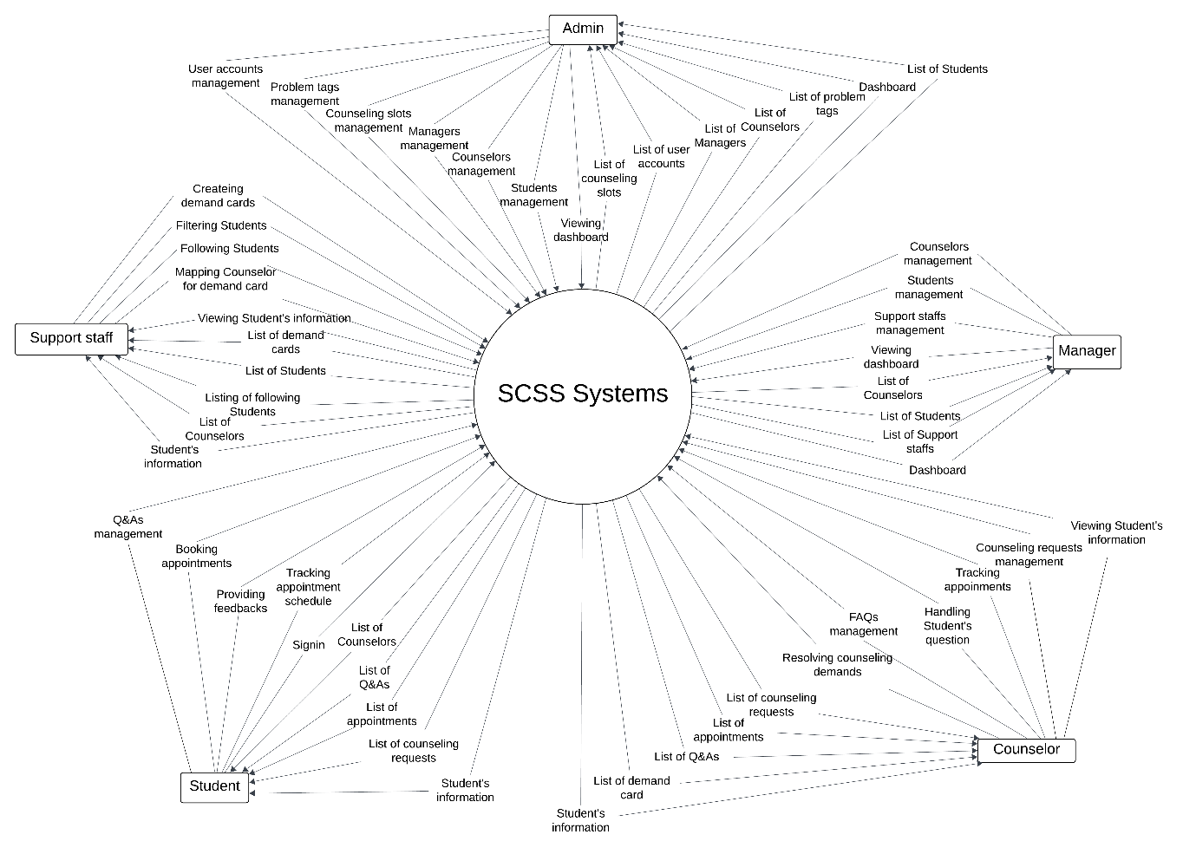

Figure – Sysyem Context Diagram

## 2. User Requirements

### 2.1. Actors

Table - Actors

|  |  |  |
| --- | --- | --- |
| **#** | **Actor** | **Description** |
| 1 | Student | A person who logs in, books appointments, creates questions. |
| 2 | Counselor | A person who manages counseling slots, Q&A and takes appointments with students. |
| 3 | Manager | A person who manages counselors, support staff. Assign a counseling slot to the counselor. |
| 4 | Support Staff | A person who assigns counselors to the student base on demand form system. |
| 5 | Administrator | A person who manages the SCSS system. |

### 2.2. Use Cases

#### 2.2.1. Diagram(s)

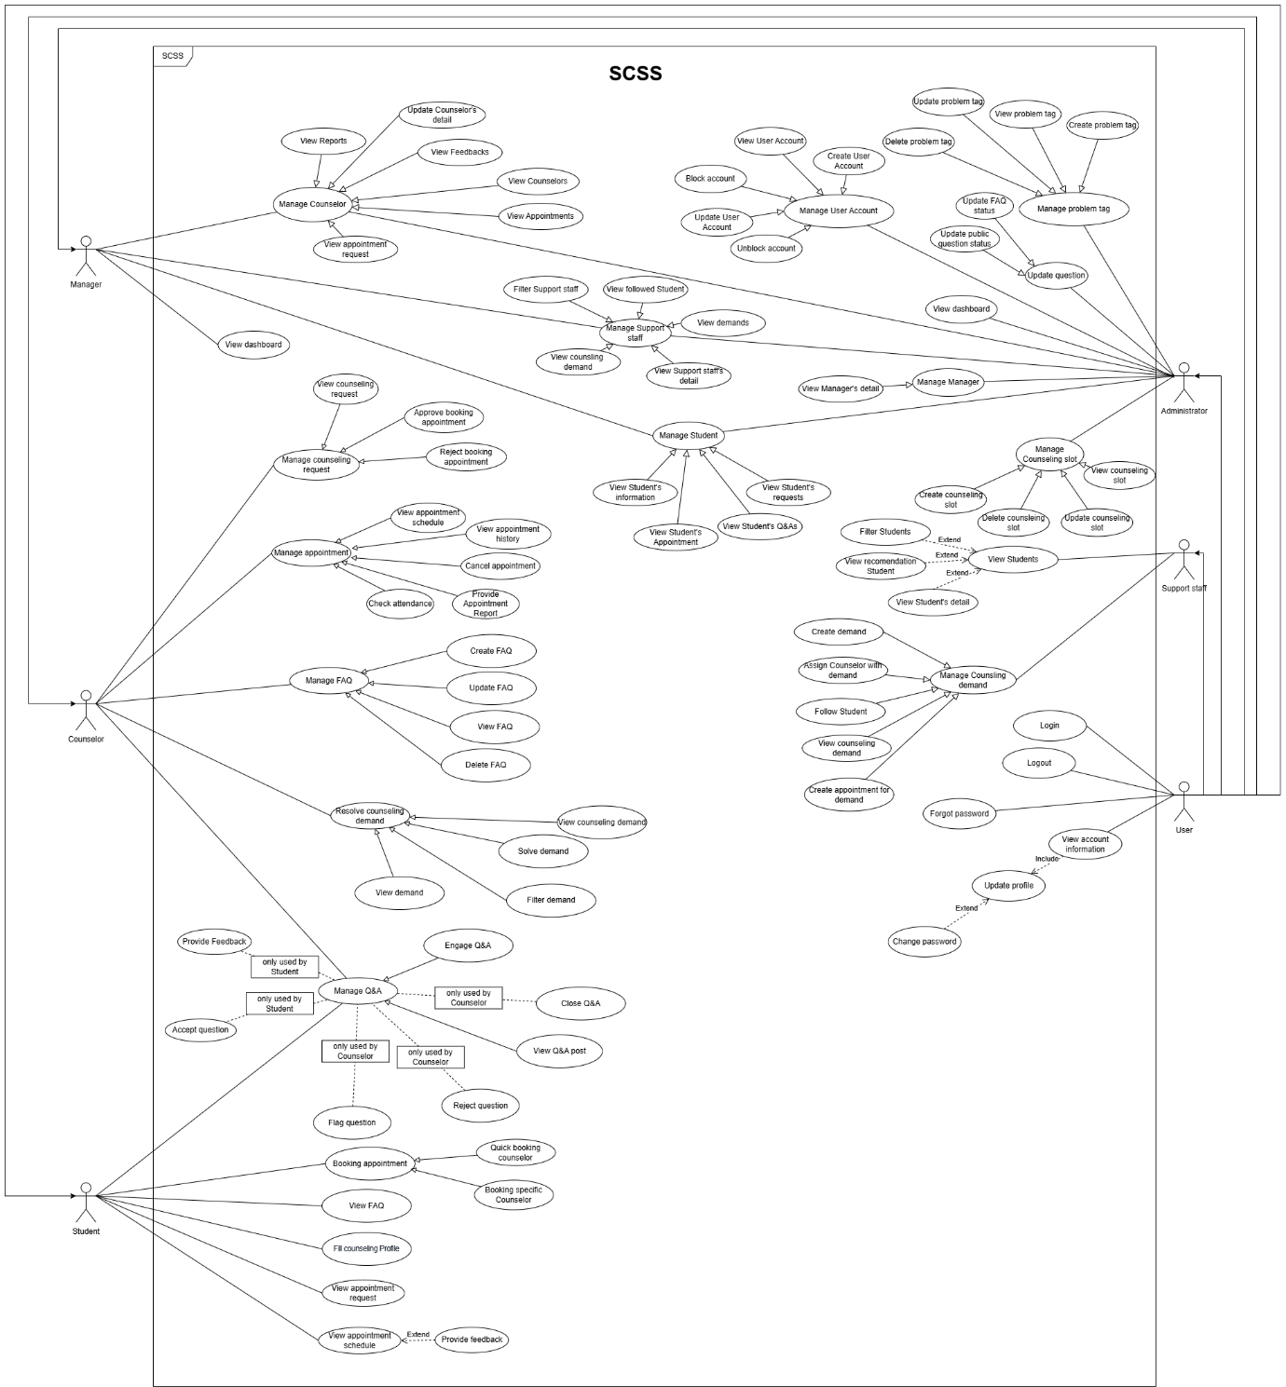

Figure - Use case diagram

#### 2.2.2. Descriptions

##### 2.2.2.1. Administrator Use Case Description

Table - Administrator Use Case Description

|  |  |  |  |
| --- | --- | --- | --- |
| **ID** | **Use Case** | **Actors** | **Use Case Description** |
| 01 | Login | Administrator | This use case allows “Admin” to login by gmail. |
| 02 | Logout | Administrator | This use case allows “Admin” to logout from SCSS Web applications. |
| 03 | View dashboard | Administrator | This use case allows “Admin” to view dashboard. |
| 04 | View Profile | Administrator | This use case allows “Admin” to view user’s profile. |
| 05 | View user accounts | Administrator | This use case allows “Admin” to view user accounts. |
| 06 | Filter account | Administrator | This use case allows “Admin” to filter account. |
| 07 | View user detail | Administrator | This use case allows “Admin” to view user details. |
| 08 | Update profile | Administrator | This use case allows “Admin” to search update profile. |
| 09 | Create user account | Administrator | This use case allows “Admin” to create a new user account and assign roles. |
| 10 | Delete user account | Administrator | This use case allows “Admin” to delete user accounts. |
| 11 | Update user account | Administrator | This use case allows “Admin” to update user account roles and information. |
| 12 | Ban user | Administrator | This use case allows “Admin” to block user account. |
| 13 | Unban user | Administrator | This use case allows “Admin” to unblock user accounts. |
| 14 | Create problem tag | Administrator | This use case allows “Admin” to create problem tag. |
| 15 | View problem tag | Administrator | This use case allows “Admin” to view problem tag. |
| 16 | Update problem tag | Administrator | This use case allows “Admin” to update problem tag. |
| 17 | Delete problem tag | Administrator | This use case allows “Admin” to delete problem tag. |
| 18 | Create counseling slot | Administrator | This use case allows “Admin” to create counseling slot. |
| 19 | View Counseling slots | Administrator | This use case allows “Admin” to view counseling slot list. |
| 20 | View Counseling slot | Administrator | This use case allows “Admin” to view counseling slot details. |
| 21 | Search counseling slot | Administrator | This use case allows “Admin” to search counseling slot. |
| 22 | Update counseling slot | Administrator | This use case allows “Admin” to update counseling slot. |
| 23 | Delete counseling slot | Administrator | This use case allows “Admin” to delete counseling slots. |
| 24 | Update counselor | Administrator | This use case allows “Admin” to delete update counselor. |
| 25 | View counselor detail | Administrator | This use case allows “Admin” to view counselor detail. |
| 26 | Update student | Administrator | This use case allows “Admin” to view update student. |
| 27 | View student detail | Administrator | This use case allows “Admin” to search view student detail. |
| 28 | Update manager | Administrator | This use case allows “Admin” to update update manager. |
| 29 | View manager detail | Administrator | This use case allows “Admin” to delete view manager details. |
| 30 | Update support staff | Administrator | This use case allows “Admin” to view update support staff. |
| 31 | View support staff | Administrator | This use case allows “Admin” to view support staff. |

##### 2.2.2.2. Counselor Use Case Description

Table - Counselor Use Case Description

|  |  |  |  |
| --- | --- | --- | --- |
| **ID** | **Use Case** | **Actors** | **Use Case Description** |
| 01 | Login | Counselor | This use case allows “Counselor” to Login. |
| 02 | Logout | Counselor | This use case allows “Counselor” to Logout. |
| 03 | Update password | Counselor | This use case allows “Counselor” to update password. |
| 04 | View Profile | Counselor | This use case allows “Counselor” to View Profile. |
| 05 | Filter student | Counselor | This use case allows “Counselor” to Filter students. |
| 06 | View student detail | Counselor | This use case allows “Counselor” to View student detail. |
| 07 | View request history | Counselor | This use case allows “Counselor” to View request History. |
| 08 | View request detail | Counselor | This use case allows “Counselor” to View request detail. |
| 09 | Filter request history | Counselor | This use case allows “Counselor” to Filter request history. |
| 10 | Approve booking appointment | Counselor | This use case allows “Counselor” to Approve booking appointments. |
| 11 | Approve Online Request | Counselor | This use case allows “Counselor” to Approve Online Request. |
| 12 | Approve Offline Request | Counselor | This use case allows “Counselor” to Approve Offline Requests. |
| 13 | Reject booking appointment | Counselor | This use case allows “Counselor” to Reject booking appointments. |
| 14 | View appointment schedule | Counselor | This use case allows “Counselor” to View appointment schedules. |
| 15 | View Appointment History | Counselor | This use case allows “Counselor” to View Appointment History. |
| 16 | View Appointment detail | Counselor | This use case allows “Counselor” to View Appointment detail. |
| 17 | Filter appointment history | Counselor | This use case allows “Counselor” to Filter appointment history. |
| 18 | Update Attendance | Counselor | This use case allows “Counselor” to Update Attendance. |
| 19 | Provide Appointment Report | Counselor | This use case allows “Counselor” to Provide Appointment Report. |
| 20 | View report | Counselor | This use case allows “Counselor” to View report. |
| 21 | Check Attendance | Counselor | This use case allows “Counselor” to Check Attendance. |
| 22 | Create report | Counselor | This use case allows “Counselor” to Create report. |
| 23 | Engage Q&A | Counselor | This use case allows “Counselor” to Engage Q&A. |
| 24 | Chat Student | Counselor | This use case allows “Counselor” to Chat Student. |
| 25 | Answer Question | Counselor | This use case allows “Counselor” to Answer Question. |
| 26 | Close Q&A | Counselor | This use case allows “Counselor” to Close Q&A. |
| 27 | View Q&A post | Counselor | This use case allows “Counselor” to View Q&A post. |
| 28 | Reject question | Counselor | This use case allows “Counselor” to reject questions. |
| 29 | Flag question | Counselor | This use case allows “Counselor” to flag questions. |
| 30 | Filter Q&A | Counselor | This use case allows “Counselor” to Filter Q&A. |
| 31 | View Q&A detail | Counselor | This use case allows “Counselor” to View Q&A detail. |
| 32 | View counseling demand | Counselor | This use case allows “Counselor” to VIew counseling demand. |
| 33 | Filter demand | Counselor | This use case allows “Counselor” to Filter demand. |
| 34 | View demand | Counselor | This use case allows “Counselor” to View demand. |
| 35 | Create appointment for demand | Counselor | This use case allows “Counselor” to Create appointments for demand. |
| 36 | Create FAQ | Counselor | This use case allows “Counselor” to create FAQs. |
| 37 | Update FAQ | Counselor | This use case allows “Counselor” to update FAQs. |
| 38 | View FAQ | Counselor | This use case allows “Counselor” to view FAQs. |
| 39 | Delete FAQ | Counselor | This use case allows “Counselor” to delete FAQs. |

##### 2.2.2.3. Manager Use Case Description

Table - Manager Use Case Description

|  |  |  |  |
| --- | --- | --- | --- |
| **ID** | **Use Case** | **Actors** | **Use Case Description** |
| 01 | Login | Manager | This use case allows “Manager” to login. |
| 02 | Logout | Manager | This use case allows “Manager” to Logout. |
| 03 | View Profile | Manager | This use case allows “Manager” to View Profile. |
| 04 | Update profile | Manager | This use case allows “Manager” to Update profile. |
| 05 | View Counselors | Manager | This use case allows “Manager” to View Counselors. |
| 06 | View Counselor Profile | Manager | This use case allows “Manager” to View Counselor Profile. |
| 07 | Search Counselor | Manager | This use case allows “Manager” to Search Counselor. |
| 08 | Change Status | Manager | This use case allows “Manager” to Change Status. |
| 09 | Assign Slot | Manager | This use case allows “Manager” to Assign Slot. |
| 10 | Update date range | Manager | This use case allows “Manager” to Update date range. |
| 11 | View Appointment request | Manager | This use case allows “Manager” to View Appointment requests. |
| 12 | View Appointments | Manager | This use case allows “Manager” to View Appointments. |
| 13 | View Feedbacks | Manager | This use case allows “Manager” to View Feedbacks. |
| 14 | View Reports | Manager | This use case allows “Manager” to View Reports. |
| 15 | View Students | Manager | This use case allows “Manager” to View Students. |
| 16 | View Student Profile | Manager | This use case allows “Manager” to View Student Profile. |
| 17 | Search student | Manager | This use case allows “Manager” to Search students. |

##### 2.2.2.4. Support Staff Use Case Description

Table - Support Staff Use Case Description

|  |  |  |  |
| --- | --- | --- | --- |
| **ID** | **Use Case** | **Actors** | **Use Case Description** |
| 01 | Login | Support Staff | This use case allows “Support Staff” to login. |
| 02 | Logout | Support Staff | This use case allows “Support Staff” to Logout. |
| 03 | Reset password | Support Staff | This use case allows “Support Staff” to reset password. |
| 04 | Create demand | Support Staff | This use case allows “Support Staff” to create demand. |
| 05 | View counseling demand | Support Staff | This use case allows “Support Staff” to view counseling demand. |
| 06 | Filter counseling demand | Support Staff | This use case allows “Support Staff” to filter counseling demand. |
| 07 | View counseling detail | Support Staff | This use case allows “Support Staff” to view counseling details. |
| 08 | Assign counselor with demand | Support Staff | This use case allows “Support Staff” to assign counselor with demand. |
| 09 | Find counselor | Support Staff | This use case allows “Support Staff” to find counselor. |
| 10 | Fill student contact note | Support Staff | This use case allows “Support Staff” to fill student contact note. |
| 11 | Search student detail | Support Staff | This use case allows “Support Staff” to Fill student contact notes. |
| 12 | View Students | Support Staff | This use case allows “Support Staff” to View Students . |
| 13 | View student detail | Support Staff | This use case allows “Support Staff” to View student detail. |
| 14 | Filter student | Support Staff | This use case allows “Support Staff” to Filter students. |

##### 2.2.2.5. Student Use Case Description

Table - Student Use Case Description

|  |  |  |  |
| --- | --- | --- | --- |
| **ID** | **Use Case** | **Actors** | **Use Case Description** |
| 01 | Login | Student | This use case allows the “Student” to log in to the platform using their university credentials. |
| 02 | View profile | Student | This use case allows “Student” to view their profile. |
| 03 | Update password | Student | This use case allows “Student” to update their password. |
| 04 | Logout | Student | This use case allows “Student” to logout. |
| 05 | View dashboard | Student | This use case allows “Student” to view dashboard. |
| 06 | View appointment schedule | Student | This use case allows “Student” to view the appointment schedule . |
| 07 | View counseling booking request | Student | This use case allows “Student” to view counseling booking requests. |
| 08 | View appointment details | Student | This use case allows the “Student” to view appointment details. |
| 09 | Filter appointment request | Student | This use case allows the “Student” to view filter appointment requests. |
| 10 | View detail request | Student | This use case allows the “Student” to view detail requests. |
| 11 | Booking Appointment | Student | This use case allows the “Student” to book appointments. |
| 12 | Quick booking counselor | Student | This use case allows the “Student” to quickly book a counselor. |
| 13 | Booking Specific Counselor | Student | This use case allows the “Student” to book a Specific Counselor. |
| 14 | Booking academic counselor | Student | This use case allows the “Student” to book an academic counselor. |
| 15 | Booking non-academic counselor | Student | This use case allows the “Student” to book a non-academic counselor. |
| 16 | Provide counseling feedback | Student | This use case allows the “Student” to provide feedback. |
| 17 | View Q&A post | Student | This use case allows the “Student” to view Q&A posts. |
| 18 | Create Question | Student | This use case allows the “Student” to create question |
| 19 | Filter Question | Student | This use case allows the “Student” to filter question posts. |
| 20 | Engage Q&A | Student | This use case allows the “Student” to engage Q&A. |
| 21 | Chat counselor | Student | This use case allows the “Student” to chat with a counselor. |
| 22 | Update Question | Student | This use case allows the “Student” to update Q&A. |
| 23 | Delete Question | Student | This use case allows the “Student” to delete questions. |
| 24 | Edit Question | Student | This use case allows the “Student” to edit question |
| 25 | Close question | Student | This use case allows the “Student” to close question |
| 26 | View Appointment History | Student | This use case allows the “Student” to view Appointment History list |
| 27 | Filter appointment history | Student | This use case allows the “Student” to filter appointment history |
| 28 | View Appointment detail | Student | This use case allows the “Student” to view appointment details. |
| 29 | Fill counseling profile | Student | This use case allows the “Student” to fill counseling profile |

## 3. Functional Requirements

### 3.1. System Functional Overview

#### 3.1.1. Screens Flow

##### 3.1.1.1. Administrator Screen Flow

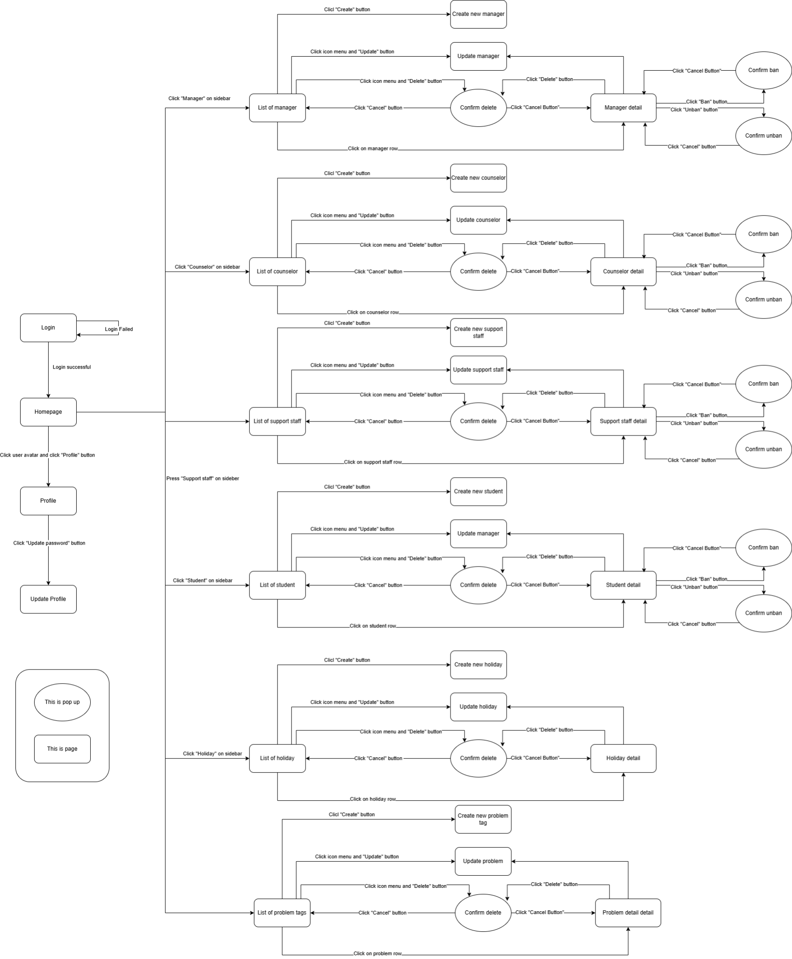

Figure - Administrator Screen Flow

##### 3.1.1.2. Counselor Screenflow

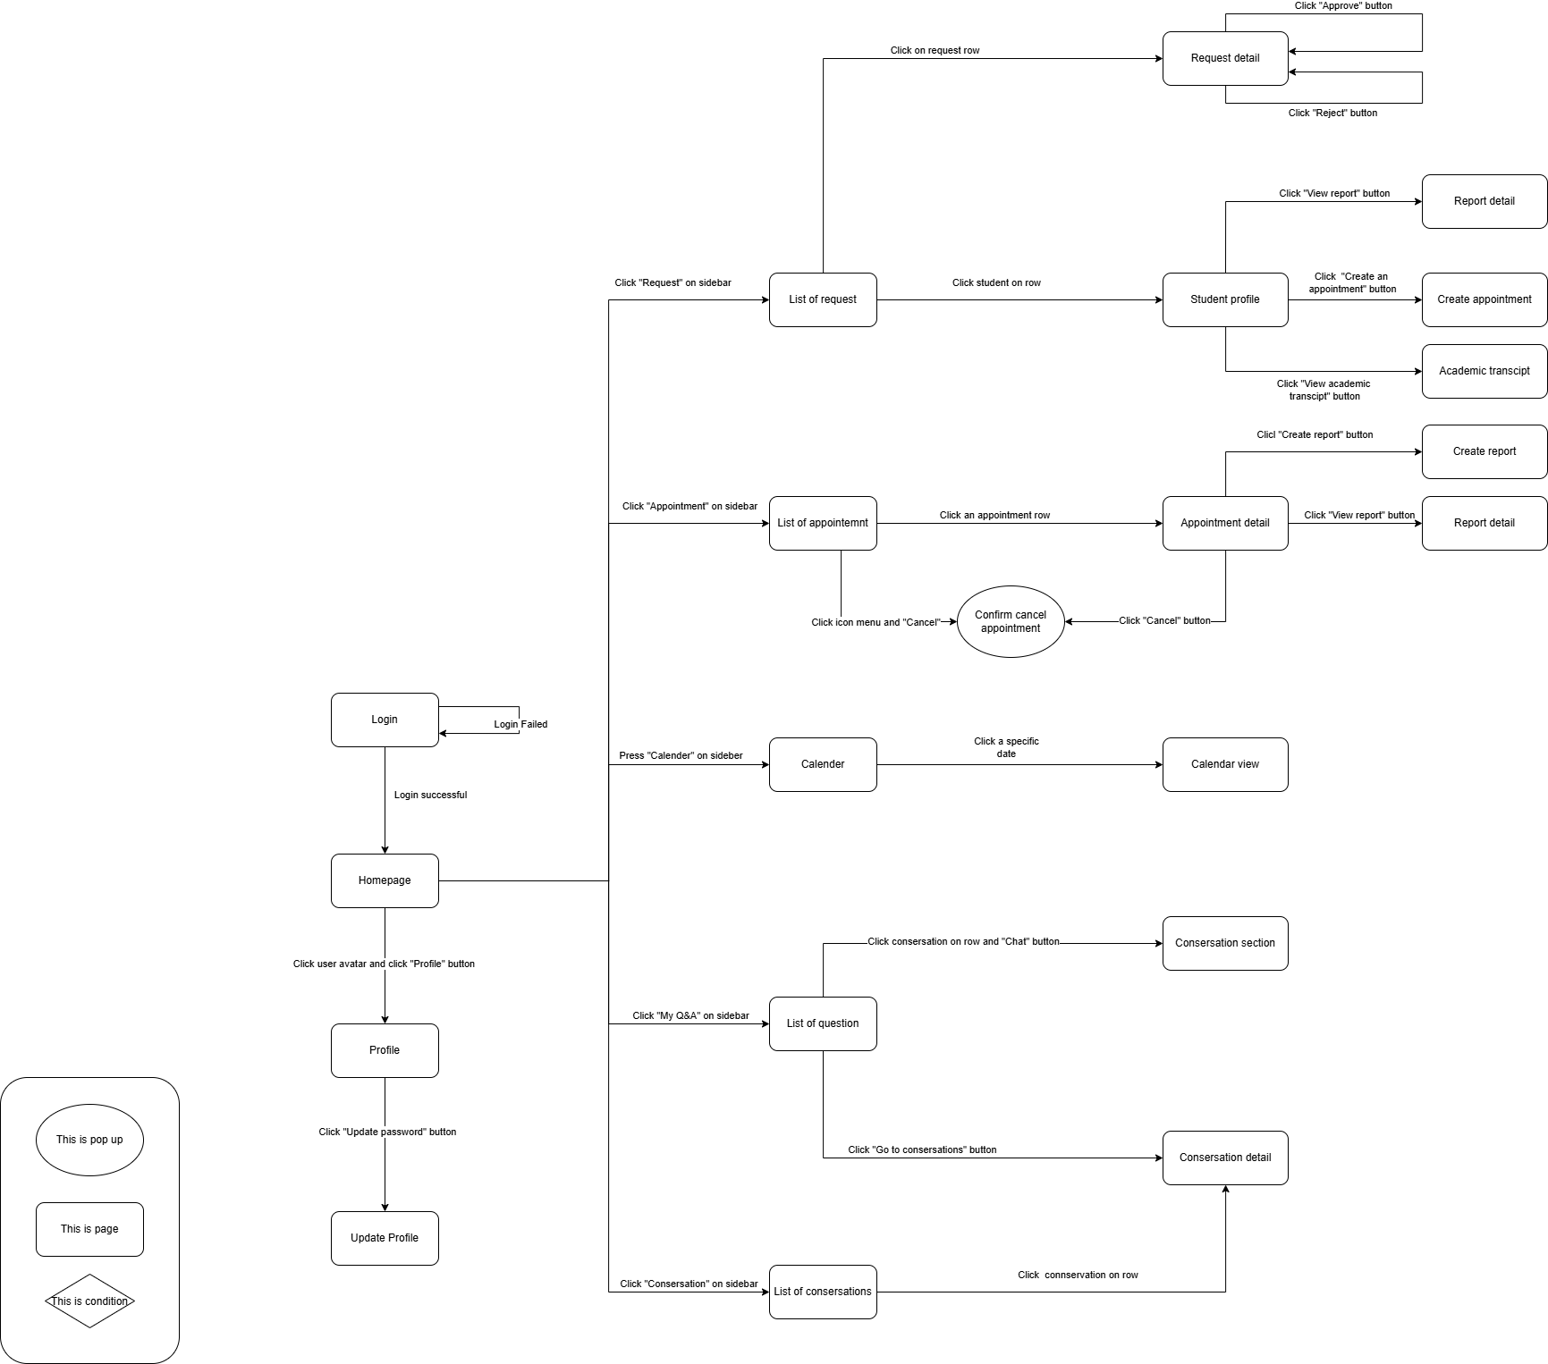

Figure - Counselor Screenflow

##### 3.1.1.3. Manager Screen Flow

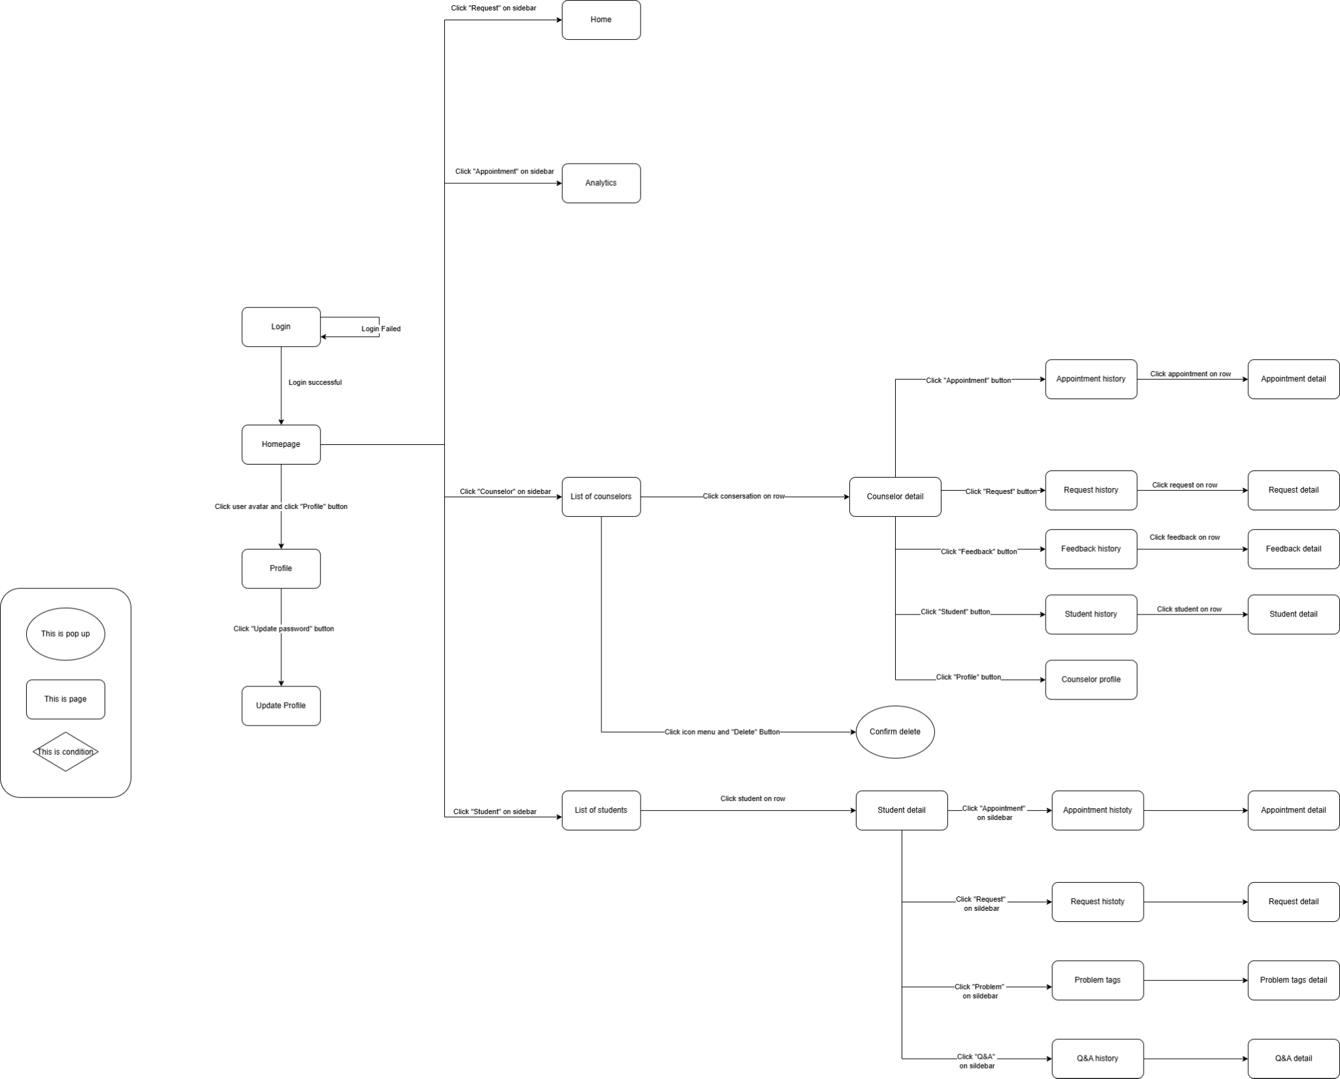

Figure - Manager Screen Flow

##### 3.1.1.4. Support Staff Screenflow

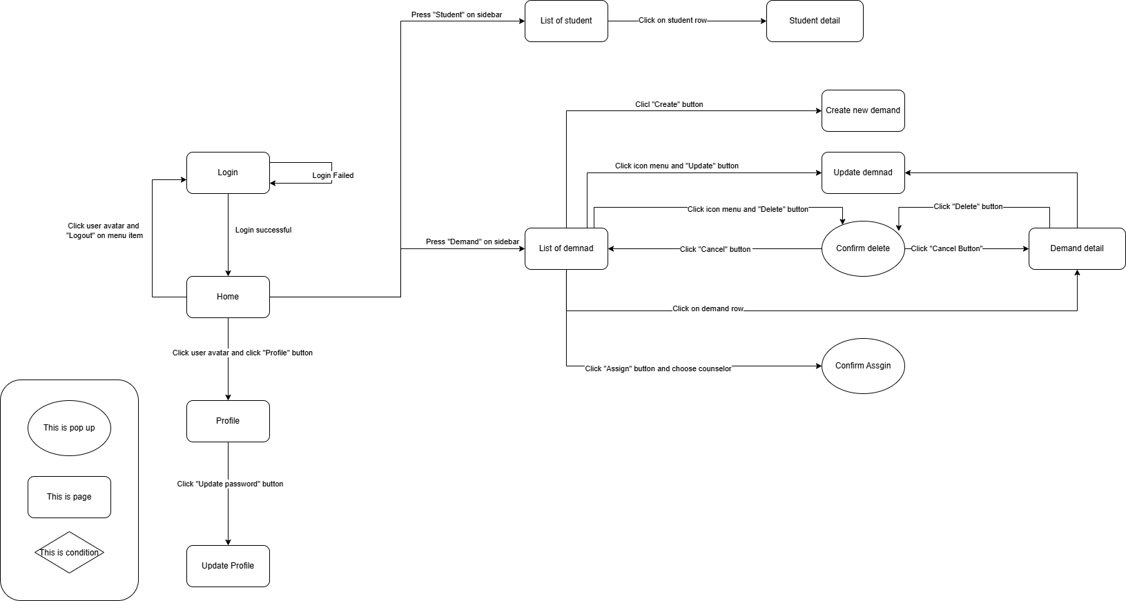

Figure - Support Staff Screenflow

##### 3.1.1.5. Student Screenflow

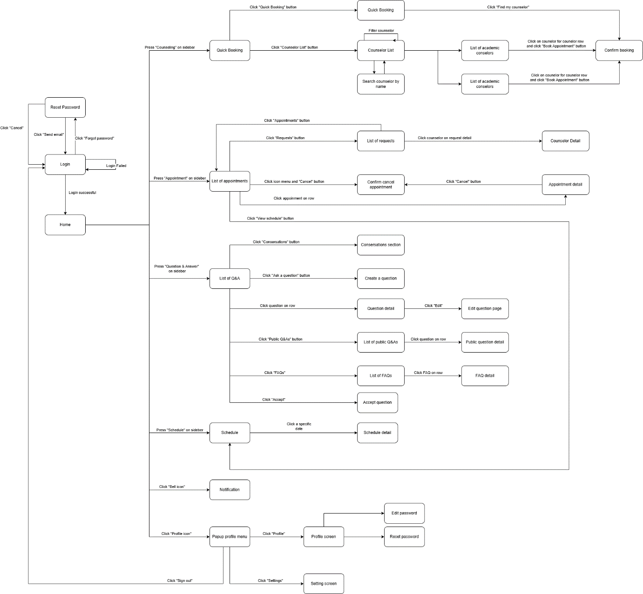

Figure - Student Screenflow

#### 3.1.2. Screen Descriptions

##### 3.1.2.1. Administrator Screen Description

Table - Aministrator Screen Description

|  |  |  |  |
| --- | --- | --- | --- |
| # | Feature | Screen | Description |
| 1 | Login | Login | Admin can login into the system by gâmil |
| 2 | View homepage | Homepage | Admin can view a few information: accounts, notifications, … |
| 3 | View list of manager | List of manager | Admin can view list of managers in the system. Include all information of manager |
| 4 | View list of counselor | List of counselor | Admin can view list of counselor sin the system. Include all information of manager |
| 5 | View list of counselor | List of support staff | Admin can view list of support staff in the system. Include all information of manager |
| 6 | View list of student | List of student | Admin can view list of student in the system. Include all information of manager |
| 7 | Create new manager | Create new manager | Admin can create a new manager for the system with input manager information. |
| 3 | Update manager | Update manager | Admin can update manager information with input manager information |
| 4 | View manager detail | Manager detail | Admin can view all information of manager. |
| 5 | Delete manager | List of manager, Manager detail | Admin can delete manager’s account. |
| 6 | Ban manager | Manager detail | Admin can ban manager. |
| 7 | Unban manager | Manager detail | Admin can unban manager |
| 8 | Create new counselor | Create new counselor | Admin can create a new counselor for the system with input manager information. |
| 9 | Update counselor | Update counselor | Admin can update counselor information with input counselor information |
| 10 | View counselor detail | Counselor detail | Admin can view all information of counselor. |
| 11 | Ban manager | Manager detail | Admin can ban counselor. |
| 12 | Unban manager | Manager detail | Admin can unban counselor |
| 12 | Create new support staff | Create new support staff | Admin can create a new support staff for the system with input manager information. |
| 13 | Update support staff | Update support staff | Admin can update support staff information with input manager information. |
| 14 | View support staff detail | Support staff detail | Admin can view all information of support staff. |
| 15 | Ban manager | Manager detail | Admin can ban support staff.. |
| 16 | Unban manager | Manager detail | Admin can unban support staff. |
| 17 | Create new student | Create new student | Admin can create a new student for the system with input manager information. |
| 18 | Update student | Update student | Admin can update student information with input manager information. |
| 19 | View student detail | Student detail | Admin can view all information of student. |
| 20 | Ban manager | Manager detail | Admin can ban student. |
| 21 | Unban manager | Manager detail | Admin can unban student. |
| 20 | View Account  Info | Account  Info | View Account  Info |
| 21 | View Specialization | View Specialization | Admin View Specialization |
| 22 | View Work Experience | View Work Experience | Admin View Work Experience |
| 23 | View Qualifications | View Qualifications | View Qualifications |
| 24 | View Certifications | View Certifications | View Certifications |
| 25 | View list of problem tags | List of problem tags | Admin can view list of problem tags |
| 26 | Create new problem tag | Create new problem tag | Admin can create a new problem tag for the system with input holiday information. |
| 27 | Update problem tag | Update problem tag | Admin can update holiday information with input manager information. |
| 29 | Problem tag detail | Problem tag detail | Admin can view all information of support staff. |

##### 3.1.2.2. Counselor Screen Description

Table - Counselor Screen Description

|  |  |  |  |
| --- | --- | --- | --- |
| **#** | **Feature** | **Screen** | **Description** |
| 1 | Loign | Login | Counselor can login into the system by gmail. |
| 2 | View homepage | Homepage | Counselor can view a few information: upcoming appointments, … |
| 3 | View profile | Profile | Counselor can view profile. |
| 4 | Update profile | Update profile | Counselor can update their profile. |
| 5 | View list of requests | List of request | Counselor can view list of requests. |
| 6 | View request detail | Request detail | Counselor can view request detail. Include all details of request. |
| 7 | Approve request | Request detail | Counselor can approve request |
| 8 | Reject request | Request detail | Counselor can reject request |
| 9 | View student profile | Student profile | Counselor can view student profile. Include all information of student. |
| 10 | View report detail | Report detail | Counselor can view report detail. Include all information of report. |
| 1 | Create an appointment | Create appointment | Counselor can create an appointment for student with select date, slot, time, meeting type (online/offline). |
| 12 | View academic transcript | Academic transcript | Counselor can view academic transcript of student, each row of table list has no, term, semester, subject code, prerequisite, replaced subject,subject name, credit, grade, status. |
| 13 | View list of appointment | List of appointment | Counselor can view list of appointment, each row has date, time, meeting type, student profile.attendance status |
| 14 | Cancel appointment | List of appointment, Appointment detail | Counselor can cancel appointment |
| 15 | View appointment detail | Appointment detail | Counselor can view appointment detail. Include all information of appointment |
| 16 | Create report | Create report | Counselor can create report with input consultation goal, consultation content, consultation conclusion, intervention. |
| 17 | View report | Report detail | Counselor can view all information of report. |
| 18 | View calendar | Calendar | Counselor can view calendar by day, week, month |
| 19 | View calendar detail | Calendar view | Counselor can view all appointment in that day. |
| 20 | View list of question, Answer the question | List of question | Counselor can view list of question, each row has student name, question and counselor can answer the question. |
| 21 | Chat with student | Conversation detail, conversation section | Counselor can chat with the student to clarify the answer for them. |

##### 3.1.2.3. Manager Screen Description

Table - Manager Screen Description

|  |  |  |  |
| --- | --- | --- | --- |
| **#** | **Feature** | **Screen** | **Description** |
| 1 | Loign | Login | Manager can login into the system by gmail. |
| 2 | View homepage | Homepage, Home | Manager can view a few information: upcoming appointments, … |
| 3 | View analytics | Analytics | Manager can view analytics of the system. |
| 4 | Update profile | Update profile | Manager can update their profile. |
| 5 | View list of counselor | List of counselor | Manager can view list of counselors. |
| 6 | View counselor detail | Counselor detail | Manager can view request details. Include all details of counselor. |
| 7 | View appointment history | Appointment history | Manager can view appointment history. |
| 8 | View appointment detail | Appointment detail | Manager can view appointment detail |
| 9 | View request history | Request history | Manager can view request history. |
| 10 | View request detail | Request detail | Manager can view request detail |
| 11 | View feedback history | Feedback history | Manager can view feedback history. |
| 12 | View feedback detail | Feedback detail | Manager can view feedback detail |
| 13 | View student counseling history | Appointment history | Manager can view student counseling history. |
| 14 | View student counseling detail | Appointment detail | Manager can view student counseling detail |
| 15 | View counselor detail | Counselor profile | Manager can view counselor’s profile. |
| 16 | View list of student | List of student | Manager can view list of students. Include all details of student. |
| 17 | View problem tag history | Problem tag | Manager can view all the student's problem tags. |
| 18 | View problem tag detail detail | Problem tag detail | Manager can view student’s problem tag detail |
| 19 | View student appointment history | Appointment history | Manager can view student appointment history. |
| 20 | View student appointment detail | Appointment detail | Manager can view student appointment history. detail |
| 21 | View student request history | Request history | Manager can view student request history. |
| 22 | View student appointment detail | Request Detail | Manager can view student request history detail |
| 23 | View student Q&A | Q&A history | Manager can view student Q&A history |
| 24 | View student Q&A detail | Q&A detail | Manager can view student Q&A detail |

##### 3.1.2.4. Support Staff Screen Description

Table - Support Staff Screen Description

|  |  |  |  |
| --- | --- | --- | --- |
| **#** | **Feature** | **Screen** | **Description** |
| 1 | View list of student | List of student | Support staff can view list of student. |
| 2 | View student’ detail | Student detail | Support staff can view the student with full information. |
| 3 | View list of demand | List of demand | Support staff can view list of demand |
| 4 | Create new demand | Create new demand | Support staff can create a new demand to a specific student. |
| 5 | Update demand | Update demand | Support staff can update demand. |
| 6 | View demand detail | Demand detail | Support staff can view demand detail with full information of that detail. |
| 7 | Delete demand | List of demand | Support staff can delete demand |
| 8 | Assign counselor with demand | List of demand | Support staff can assign a specific counselor with demand. |

##### 3.1.2.5. Student Screen Description

Table - Student Screen Description

|  |  |  |  |
| --- | --- | --- | --- |
| **#** | **Feature** | **Screen** | **Description** |
| 1 | Login | Login | Student can login into the system by gmail or FeID. |
| 2 | View homepage | Home | Student can view a few information: upcoming appointments, … |
| 3 | Counselling | Counselling | Students can book an appointment using Quick Booking or by selecting a counselor from the Counselor List. |
| 4 | View Profile | Profile | Student can view profile. |
| 5 | Quick Booking | Quick Booking | Students can book an appointment using Quick Booking by selecting the counseling type, date, time, counselor's specialization (optional), and counselor's gender (optional). |
| 6 | View counselor list | Counselor List | Students can book an appointment by selecting a specific counselor, counseling type, date, time. |
| 7 | Manage appointment | Appointment Management | Student can view list of appointment, list of request and other activity |
| 8 | View list of request | List of request | Student can view a list of requests, each row of table list has date, time, meeting type, status, counselor profile |
| 9 | View list of management | List of appointment | Student can view a list of appointment, each row of table list has date, time, meeting type,meet URL, status, counselor profile. |
| 10 | View appointment detail | Appointment detail | Student can view appointment detail and provide feedback |
| 11 | Cancer Appointment | Appointment detail, List of appointment | Student can cancel appointment and enter reason. |
| 12 | View other activity | Other Activity | Student can view other activity |
| 13 | View counselor profile | Counselor profile | Student can view counselor profile such as name, major, phone, bio, |
| 14 | View list of Q&A | List of Q&A | Student can view list of Q&Ai in the system, each row of table list has id, type, status, topic, question title, and answer. |
| 15 | Conversation | Conversations | Student can view list of conversations and chat section |
| 16 | Ask a question | Ask a question | Student can submit a question by select question, counseling topic and input content |
| 17 | View calendar | Calendar | Student can view calendar by day, week, month |
| 18 | View calendar detail | Calendar view | Student can view all appointment in a specific day |

#### 3.1.3. Screen Authorization

##### 3.1.3.1. Web Screen Authorization

Table - Web Screen Authorization

|  |  |  |  |  |  |
| --- | --- | --- | --- | --- | --- |
| **Screen** | **Admin** | **Counselor** | **Manager** | **Support Staff** | **Student** |
| Login | X | X | X | X | X |
| Homepage | X | X | X | X | X |
| List of manager | X |  |  |  |  |
| List of counselor | X |  | X |  | X |
| List of support staff | X |  |  |  |  |
| List of student | X | X | X | X |  |
| Create new manager | X |  |  |  |  |
| Update manager | X |  |  |  |  |
| Manager detail | X |  |  |  |  |
| Create new counselor | X |  |  |  |  |
| Update counselor | X |  |  |  |  |
| Counselor detail | X |  |  |  |  |
| Create new support staff | X |  |  |  |  |
| Update support staff | X |  |  |  |  |
| Support staff detail | X |  |  |  |  |
| Create new student | X |  |  |  |  |
| Update student | X |  |  |  |  |
| Student detail | X | X | X | X | X |
| List of holiday | X |  |  |  |  |
| Create new holiday | X |  |  |  |  |
| Update holiday | X |  |  |  |  |
| Holiday detail | X |  |  |  |  |
| List of problem tags | X |  |  |  |  |
| Create new problem tag | X |  |  |  |  |
| Update problem tag | X |  |  |  |  |
| Problem tag detail | X |  |  |  |  |
| Counselor detail | X | X | X | X | X |
| Appointment history | X | X | X |  | X |
| Appointment detail | X | X | X |  | X |
| Request history | X | X | X |  | X |
| Request detail | X | X | X |  | X |
| Feedback history | X | X | X |  | X |
| Feedback detail | X | X | X |  | X |
| Student detail |  |  | X |  |  |
| Analytics |  |  | X |  |  |
| Create appointment |  | X |  |  |  |
| Student’s academic transcript | X | X | X | X | X |
| Create report |  | X |  |  |  |
| Report detail |  | X |  |  |  |
| Schedule |  | X |  |  | X |
| Schedule detail |  | X |  |  | X |
| List of question |  | X |  |  |  |
| Conversation detail |  | X |  |  | X |
| Conversation section |  | X |  |  |  |
| List of demand |  |  |  | X |  |
| Create new demand |  |  |  | X |  |
| Update demand |  |  |  | X |  |
| Demand detail |  |  |  | X |  |
| Counselling |  |  |  |  | X |
| Profile |  |  |  |  | X |
| Counselor List |  |  |  |  | X |
| Appointment Management |  |  |  |  | X |
| Other Activity |  |  |  |  | X |
| Counselor profile |  |  |  |  | X |
| List of Q&A |  |  |  |  | X |
| Ask a question |  |  |  |  | X |
| Schedule |  |  | X |  | X |
| Schedule view |  |  | X |  | X |

##### 3.1.3.2. Mobile Screen Authorization

Table - Mobile Screen Authorization

|  |  |  |
| --- | --- | --- |
| **Screen** | **Student** | **Counselor** |
| Login | X | X |
| Home | X | X |
| Profile | X | X |
| Schedule | X | X |
| Q&A | X | X |
| Personal | X | X |
| Quick booking | X |  |
| Academic booking | X |  |
| Non academic booking | X |  |
| Chat section | X | X |
| Notification | X | X |
| Appointment detail | X | X |
| Feedback detail | X | X |

#### 3.1.4. Non-Screen Functions

Table - Non-Screen Functions

|  |  |  |  |
| --- | --- | --- | --- |
| **#** | **Feature** | **System Function** | **Description** |
| 01 | Send notification | Send notification | The system will send notifications in the following cases:   * Booking appointment * Question Notification |
| 02 | Send mail | Send mail | The system will send mail in the following cases:   * Forget password |

**3.1.5. Entity Relationship Diagram**

##### 3.1.5.1 Conceptual Model

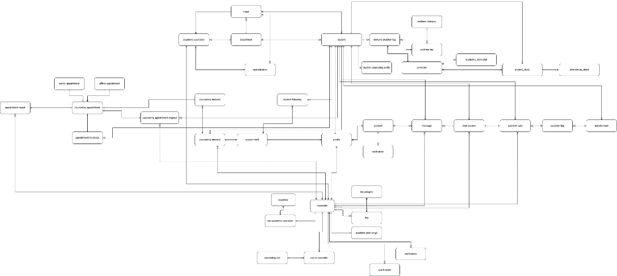

[Figure 9 - Conceptual Model](https://drive.google.com/file/d/1il-CwkHQKMA8ms3CqWuazFZSypsp8jwF/view?usp=drive_link)

##### 3.1.5.2 Logical Model

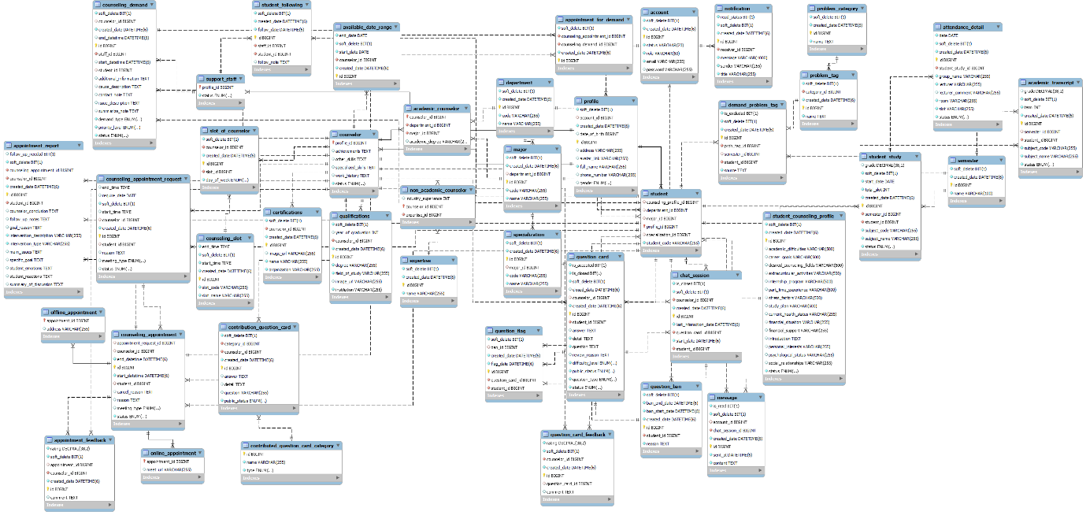

[Figure 10 - Logical diagram](https://drive.google.com/file/d/1DTEND7hRm6PIXhBfHS6boN0s74kuxycM/view?usp=sharing)

**Entities Description**

Table - Entities Description

|  |  |  |
| --- | --- | --- |
| **#** | **Entity** | **Description** |
| 01 | account | Store account in system |
| 02 | academic counselor | Store academic counselor in system |
| 03 | academic_transcript | Store academic transcript in system |
| 04 | available date range | Store available date range |
| 05 | appointment feedback | Store appointment feedback |
| 06 | appointment for demand | Store appointment for demand in system |
| 07 | appointment report | Store appointment report in system |
| 08 | Attendance detail | Store attendance detail in system |
| 09 | counselor | Store certification |
| 10 | certification | Store certification |
| 11 | chat session | Store counseling demand |
| 12 | counseling demand | Store counseling demand |
| 13 | Contributed question card category | Store contributed question card category category in system |
| 14 | Contribution question card | Store contribution question card |
| 15 | counseling appointment | Store counseling appointment |
| 16 | counseling appointment request | Store counseling appointment request |
| 17 | counseling slot | Store counseling slot |
| 18 | demand problem tag | Store demand problem tag |
| 19 | department | Store department |
| 20 | expertise | Store expertise |
| 21 | faq | Store faq |
| 22 | faq category | Store faq category |
| 23 | message | Store message |
| 24 | major | Store major major |
| 25 | notification | Store notification used through out the system |
| 26 | non academic counselor | Store non academic counselor |
| 27 | online appointment | Store online appointment |
| 28 | offline appointment | Store offline appointment |
| 29 | profile | Store profile of user |
| 30 | problem category | Store problem category |
| 31 | problem tag | Store problem tag |
| 32 | qualification | Store qualification |
| 33 | question card | Store question card |
| 34 | question flag | Store question flag |
| 35 | question ban | Store question ban |
| 36 | slot of counselor | Store slot of counselor |
| 37 | student | Store student |
| 38 | specialization | Store specialization of counselor |
| 39 | support staff | Store support staff |
| 40 | student following | Store student following by support staff |
| 41 | student counseling profile | Store student counseling profile |

### 3.2. Functional requirements

#### 3.2.1. Accounts Feature

|  |  |  |  |  |  |
| --- | --- | --- | --- | --- | --- |
| **No** | **Actor** | **Function Name** | **Purpose** | **Data requirements** | **Data validation** |
| 1 | Admin, manager, counselor, support staff, student | View account detail | View information of a specific account | Account id |  |
| 2 | Admin, manager, counselor, support staff, student | View account profile | View account profile | Account id |  |
| 3 | Admin | Ban account | Ban account | Account id |  |
| 4 | Admin | Unban account | Unban account | Account id |  |
| 5 | Admin | Create account | Create account | Email  Password  fullName  phoneNumber  dateOfBirth  avatar  Gender  role | Email:  Type: text field (string)   * Not empty * Max Length = 100 * Email address format   Password:  Type: text field (string)   * Not empty   Fullname:   * Type: text field (string) * Not empty   phoneNumber:   * Type: text field (string) * Not empty   dateOfBirth:   * Type: Datetime picker * Not empty   Avatar:   * Type: file (image) * Not empty * Max size < 5MB * Extension file: .png, .jpg, .webp, .jpeg   Gender:   * Type: Dropdown * Not empty   Role:   * Type: Dropdown * Not Empty |
| 6 | Admin | Delete account | Delete account | Account id |  |

#### 3.2.2. Authentications Feature

Table - Authentications Feature

|  |  |  |  |  |  |
| --- | --- | --- | --- | --- | --- |
| **No** | **Actor** | **Function Name** | **Purpose** | **Data requirements** | **Data validation** |
| 1 | Admin, manager, counselor, support staff, student | Login | Login to website and mobile app | Email  Password | Email:   * Type: text field (string) * Email address format * Not empty   Password:   * Type: text fields (string) |
| 2 | Admin, manager, counselor, support staff, student | Regeneration token | Re-generate pair token from the old pair token provided by the SCSS system before. | Access token Refresh token | AccessToken:   * Type: text field (string) * Not empty   RefreshToken:   * Type: text field (string) * Not empty |
| 3 | Admin, manager, counselor, support staff, student | Logout | Logout to website and mobile app |  |  |

#### 3.2.3. Booking Counseling Feature

Table - Booking Counseling Feature

|  |  |  |  |  |  |
| --- | --- | --- | --- | --- | --- |
| **No** | **Actor** | **Function Name** | **Purpose** | **Data requirements** | **Data validation** |
| 1 | Student | Quick booking counselor | Quick booking counselor | Counseling Type  Date  SlotCode  Counselor's specialization  Gender  Meeting type  Resson | Counseling type:   * Dropdown * Not empty   Date:   * Type:Datetime picker * Not empty   SlotCode:   * Type:Datetime picker * Not empty   Counselor’s specialization:   * Type: Dropdown   Gender:   * Type: Dropdown   Meeting type:   * Type: Dropdown * Not empty   Resson:   * Type; Text field (String) * Not empty |
| 2 | Counselor,  Student | View appointment schedule | View appointment schedule | Appointment id |  |
| 3 | Counselor,  Student | View appointment request | View appointment request | Request id  Start date  End date | Start date:   * Type: text field (string) * Format type dd/MM/yyyy * Must less than or equal End Date   End date:   * Type: text field (string) * Format type dd/MM/yyyy |
| 4 | Admin, manager | View Counselor’s appointment request | View Counselor’s appointment request | Counselor id  Request id |  |
| 5 | Student | Booking specific counselor | Booking specific counselor | Date  Slot  Meeting type  Resson | Date:  + Type:Datetime picker  + Not empty  Meeting type:   * Type: Dropdown * Not empty   Resson:   * Type; Text field (String) * Not empty |
| 6 | Counselor | View counseling request | View a list of request from the system | Student Id  Start date  End date  Meeting type  SortBy | Start date:   * Type: text field (string) * Format type dd/MM/yyyy * Must less than or equal End Date   End date:   * Type: text field (string) * Format type dd/MM/yyyy   Meeting type:   * Required: “Online” or “Offline”   Sort:   * Match with format “id_ASC” or “id_DESC” |
| 7 | Counselor | Approve online request | Approve online request | Request id  Meet url | Meet URL:   * Type: URL format * Not empty |
| 8 | Counselor | Approve offline request | Approve offline request | Request id  Address | Address:   * Type: text field(String) * Not empty |
| 9 | Counselor | Reject booking appointment | Reject booking appointment | Request id |  |

#### 3.2.4. Appointment Feature

Table - Appointment Feature

|  |  |  |  |  |  |
| --- | --- | --- | --- | --- | --- |
| **No** | **Actor** | **Function Name** | **Purpose** | **Data requirements** | **Data validation** |
| 1 | Counselor, student | View list of appointment | Get a list of counselor’s appointment from the system | Appointment id  Start date  Endate  Status | Start date:   * Type: text field (string) * Format type dd/MM/yyyy * Must less than or equal End Date   End date:   * Type: text field (string) * Format type dd/MM/yyyy   Status:   * Must equal “Cancel” or “Attend” or “Absent” or “Expired” |
| 3 | Counselor, student | Cancel appointment | Cancel appointment | Appointment id  Resson | Resson:   * Type: text field (string) * Not empty |
| 4 | Counselor | Check attendance | Check attendance for student by counselor | Appointment id |  |
| 5 | Counselor | Create appointment for specific student | Create an appointment to counseling with student | Student id  Date  SlotCode  Meeting type  Resson | Date:   * Type:Datetime picker * Not empty   SlotCode:   * Type:Datetime picker * Not empty   Meeting type:   * Required: “Online” and “URL” or “Offline” and “Address”   Resson:   * Type; Text field (String) * Not empty |
| 6 | Student | Provide feedback | Provide feedback | Appointment id  Ratting  Commnet | Ratting:   * Type: * Not empty   Comment:   * Type: text field (string) * Not empty |

#### 3.2.5. Q&A Feature

Table - Q&A Feature

|  |  |  |  |  |  |
| --- | --- | --- | --- | --- | --- |
| **No** | **Actor** | **Function Name** | **Purpose** | **Data requirements** | **Data validation** |
| 1 | Student | Create a question | Create a question | Question type  Topic  Content | Question type:   * Type: Dropdown * Not empty   Topic:   * Type: Dropdown * Not empty   Content:   * Text field: (string) * Not empty |
| 2 | Counselor, Admin,  Student | View Q&A posts | View Q&A posts | Question card id |  |
| 3 | Counselor | Close Q&A | Close Q&A | Question card id |  |
| 4 | Counselor | Answer question | Answer question | Question card id  Content | Content:   * Text field: (string) * Not empty |
| 5 | Counselor | Approve question | Approve question | Question card id |  |
| 6 | Counselor | Reject question | Reject question | Question card id |  |
| 7 | Counselor | Flag question | Flag question | Question card id |  |
| 8 | Student | Delete question | Delete question before answer by counselor | Question card id |  |
| 9 | Student | Update question | Update question before answer by counselor | Question card id  Content | Content:   * Type: text field (string) |
| 10 | Counselor | Update answer | Update answer | Question card id |  |
| 11 | Student, counselor | Engage chat session | Engage into chat session for specific question card | Chat session id |  |
| 12 | Student | Provide feedback for question | Student can provide feedback after close question | Question card id  Rating  Comment | Rating:   * Type: number * Must from 1 to 5   Comment:   * Type: text field (string) |
| 13 | Stundet | Accept question | Student accept a question to counselor | Question card id |  |

#### 3.2.6. Counseling Demand Feature

Table - Counseling Demand Feature

|  |  |  |  |  |  |
| --- | --- | --- | --- | --- | --- |
| **No** | **Actor** | **Function Name** | **Purpose** | **Data requirements** | **Data validation** |
| 1 | Admin, Counselor | View demand list | View demand list | Demand id  Start date  End date | Start date:   * Type: text field (string) * Format type dd/MM/yyyy * Must less than or equal End Date   End date:   * Type: text field (string) * Format type dd/MM/yyyy |
| 2 | Counselor | Create appointment for demand | Create appointment for demand | Demand id  Student id  Date  SlotCode  Meeting type  Resson | Date:   * Type:Datetime picker * Not empty   SlotCode:   * Type:Datetime picker * Not empty   Meeting type:   * Required: “Online” and “URL” or “Offline” and “Address”   Resson:   * Type; Text field (String) * Not empty |
| 3 | Counselor | Solve demand card | Solve demand card | Demand id  Summarize Note | Summarize Note:   * Type: text field(string) * Not empty |
| 4 | Support staff | Create demand card | Create demand card | Demand id |  |
| 5 | Support staff | Assign demand card to counselor | Assign demand to card to counselor by counselor to solve problem of student | Counselor id |  |
| 6 | Support staff | Follow student | Support staff follows student who have problems in recommendation | Student id |  |
| 7 | Support Staff | Unfollow student | Support staff unfollows student has been resolve problem | Student id |  |

#### 3.2.7. Dashboards Feature

Table - Dashboards Feature

|  |  |  |  |  |  |
| --- | --- | --- | --- | --- | --- |
| **No** | **Actor** | **Function Name** | **Purpose** | **Data requirements** | **Data validation** |
| 1 | Admin | View admin dashboard | View admin dashboard |  |  |
| 2 | Manager | View manager dashboard | View manager dashboard |  |  |
| 3 | Counselor | View counselor dashboard | View counselor dashboard |  |  |

#### 3.2.8. Manage Student Feature

Table - Manage Student Feature

|  |  |  |  |  |  |
| --- | --- | --- | --- | --- | --- |
| **No** | **Actor** | **Function Name** | **Purpose** | **Data requirements** | **Data validation** |
| 1 | Manager, counselor, admin, support staff | View student list | View student list | Student id  specializationId  sortBy  Keyword  sortDirection  page | sortBy:   * Type: text field (string) * Format type dd/MM/yyyy   Keyword:   * Type: text field (string)   sortDirection:   * Match with format “ID_ASC” or “ID_DESC” |
| 2 | Manager, counselor, admin, support staff | View student profile | View student profile | Student id |  |
| 3 | Manager, counselor, admin, support staff | View student’s academic transcript | View student’s academic transcript | Student id |  |
| 4 | Manager, counselor, admin, support staff | View student attendance report | View student attendance report | Appointment Id |  |
| 5 | Admin, manager, counselor, student | View list of student’s appointment | Get a list of appointment from the system | Appointment id  Start date  End date  Status | Start date:   * Type: text field (string) * Format type dd/MM/yyyy * Must less than or equal End Date   End date:   * Type: text field (string) * Format type dd/MM/yyyy   Status:   * Must equal “Cancel” or “Waiting” or “Attend” or “Absent” or “Expired” |

#### 3.2.9. Manage Counselor Feature

Table - Manage Counselor Feature

|  |  |  |  |  |  |
| --- | --- | --- | --- | --- | --- |
| **No** | **Actor** | **Function Name** | **Purpose** | **Data requirements** | **Data validation** |
| 1 | Admin, manger, counselor | View list of counselor’s appointment | Get a list of counselor’s appointment from the system | Appointment id  Start date  Endate  Status | Start date:   * Type: text field (string) * Format type dd/MM/yyyy * Must less than or equal End Date   End date:   * Type: text field (string) * Format type dd/MM/yyyy   Status:   * Must equal “Cancel” or “Attend” or “Absent” or “Expired” |
| 2 | Admin, manger | View list of academic counselor | View list of academic counselors in the system | Search  ratingFrom  ratingTo  availableFrom  availableTo  specializationId  SortDirection  sortBy  page | Search:   * Type: text field (string)   ratingFrom:   * Type: number * Must less than or equal rating   ratingTo:   * Type: number * Max number = 5   availableFrom:   * Type: text field (string) * Format type dd/MM/yyyy * Must less than or equal availableTo   availableTo:   * Type: text field (string) * Format type dd/MM/yyyy   SortDirection:   * Match with format “ID_ASC” or “ID_DESC”   SortBy:   * Type: text fields (string) * Fo |
| 3 | Admin, manger | View list of non-academic counselor | View list of non-academic counselors in the system | Search  ratingFrom  ratingTo  availableFrom  availableTo  expertiseId  SortDirection  sortBy  page | Search:   * Type: text field (string)   ratingFrom:   * Type: number * Must less than or equal rating   ratingTo:   * Type: number * Max number = 5   availableFrom:   * Type: text field (string) * Format type dd/MM/yyyy * Must less than or equal availableTo   availableTo:   * Type: text field (string) * Format type dd/MM/yyyy   SortDirection:   * Match with format “ID_ASC” or “ID_DESC”   SortBy:   * Type: text fields (string) * Format type dd/MM/yyyy |
| 4 | Admin, manger | View counselor detail | View a specific counselor’s detail | Counselor id |  |
| 5 | Admin, manger | Change counselor status | Change counselor status | Counselor id  Status | Status:   * Required Status is required some statuses such as: AVAILABLE, UNAVAILABLE. |
| 6 | Admin, manger | Assign slot to counselor | Assign counseling slot to counselor | Counselor id  Slot id |  |
| 7 | Admin, manager | Unsign slot to counselor | Unsign counseling slot to counselor | Counselor id  Slot id |  |

## 4. Non-Functional Requirements

### 4.1. External Interfaces

#### 4.1.1. User Interfaces

* **Language**: Supports English.
* **Icons**: Easy to identify.
* **Colors**: Sufficient contrast.
* **Font**: Easy to read.

#### 4.1.2. Communications Interfaces

* **HTTP Methods**: Uses HTTP request methods for data transfer.
* **Protocol**: HTTP for Web Application and server communication.

### 4.2. Quality Attributes

#### 4.2.1. Usability

* **Language**: UI text in English.
* **Ease of Use**: Simple to use after training.
* **Training**: One-hour training is sufficient.
* **Standards**: Follows usability and accessibility standards.

#### 4.2.2. Reliability

* **Training**: All users need training.
* **Failure Rate**: Less than 5%, availability above 80%.

#### 4.2.3. Performance

* All responses’ time is less than 15 seconds.

#### 4.2.4. Security

* **Input Validation**: Validate all inputs.
* **Authorization**: Role-based access control.
* **Password Encryption**: MD5 hashing on server-side

## 5. Requirement Appendix

### 5.1. Business Rules

Table - Business Rules

|  |  |
| --- | --- |
| ID | Rule Definition |
| BR-01 | Username must be in Email format. |
| BR-02 | Passwords must be hashed by the MD5 algorithm on the server-side. |
| BR-03 | Password length of account must be at least 6 characters. |
| BR-04 | Email must be unique. |
| BR-05 | Access token will expire within 1 hour after the successful login. |
| BR-06 | Refresh token will expire 365 days after the successful login. |
| BR-07 | Image file is required extension type “.png”, “.jpg”, “.jpeg”, “.webp”. |
| BR-08 | Date of birth must be in YYYY-MM-DD format. |
| BR-09 | Counselor must have their own major or expertise. |
| BR-10 | With Student, only 3 counseling requests which are on “WAITING” status are allowed to be at the same time. |
| BR-11 | With Student, only 3 appointments which are on “WAITING” status are allowed to be at the same time. |
| BR-12 | Student must provide all required infomation for every each of counseling requests. |
| BR-13 | Student can only provide feedback after appointment is “ATTENDED” |
| BR-14 | Counselor can only provide report after appointment is “ATTENDED” |
| BR-15 | When Counselor or Student cancels an appointment, they must enter a reason for the cancellation. |
| BR-16 | After Counselor approves request, Counselor must provide meet URL for online appointment or provide location for offline appointment. |
| BR-17 | After question cards being flagged 3 times, Student will be forbidden on creating another question card for 7 days. |
| BR-18 | Student can only edit or delete question when the question is not anwered. |
| BR-19 | Only 3 question cards are opened at the same time. |
| BR-20 | Student can only initiate chat session after question card is being answered by Counselor. |
| BR-21 | Counselor can only close question after provide answer. |
| BR-22 | Meeting URL must follow a specific URL format. |
| BR-23 | Student can only provide feedback after question card is being close by Counselor. |
| BR-24 | After question is being close, it will be public for everyone. |
| BR-25 | Student can only is being followed by 1 Support staff at the same time. |
| BR-26 | Only “AVAILABLE” Counselor is visible to Student. |

### 5.2. Application Messages List

#### 5.2.1. Web application

Table - Web application

|  |  |  |  |  |
| --- | --- | --- | --- | --- |
| **#** | **Message code** | **Message Type** | **Context** | **Content** |
| 1 | MSG-01 | Toast message | Login with wrong username or wrong password. | Email or Password is invalid. |
| 2 | MSG-02 | Toast message | Login with ban account. | Account has been banned. |
| 3 | MSG-03 | Toast message | Login with correct username and correct password. | Login Successfully. |
| 4 | MSG-04 | Toast message | Account activation successful. | Your account has been activated successfully. |
| 5 | MSG-05 | Toast message | Account activation failed. | Activation link is invalid or expired. |
| 6 | MSG-06 | Toast message | Account already activated. | Your account has already been activated. |
| 7 | MSG-07 | Toast message | Account update successful. | Your account information has been updated successfully. |
| 8 | MSG-08 | Toast message | Account update failed. | Failed to update account information. Please try again. |
| 9 | MSG-09 | Toast message | Unauthorized action. | You do not have permission to perform this action. |
| 10 | MSG-10 | Toast message | Session expired. | Your session has expired. Please log in again. |
| 11 | MSG-11 | Toast message | Logout successful. | You have been logged out successfully. |
| 12 | MSG-12 | Toast message | Unauthorized access. | Please log in to access this page. |
| 13 | MSG-13 | Toast message | Counselor not available. | The selected counselor is not available at this time. |
| 14 | MSG-14 | Toast message | Appointment booked successfully. | Your appointment has been booked successfully. |
| 15 | MSG-15 | Toast message | Appointment booking failed. | Failed to book appointment. Please try again. |
| 16 | MSG-16 | Toast message | Appointment canceled. | Your appointment has been canceled. |
| 17 | MSG-17 | Toast message | Appointment cancellation failed. | Failed to cancel the appointment. Please try again. |
| 18 | MSG-18 | Toast message | Invalid input. | Please check the provided information and try again |
| 19 | MSG-19 | Toast message | Profile updated successfully. | Your profile has been updated successfully. |
| 20 | MSG-20 | Toast message | Failed to update profile. | Unable to update profile. Please try again later. |
| 21 | MSG-21 | Toast message | Invalid email format. | Please enter a valid email address. |
| 22 | MSG-22 | Toast message | Counselor assigned successfully. | A counselor has been assigned to your request. |
| 23 | MSG-23 | Toast message | Failed to assign counselor. | Unable to assign a counselor. Please try again later. |
| 24 | MSG-24 | Toast message | Question posted successfully. | Your question has been posted successfully. |
| 25 | MSG-25 | Toast message | Failed to post question. | Unable to post the question. Please check your input. |
| 26 | MSG-26 | Toast message | Question updated successfully. | Your question has been updated successfully. |
| 27 | MSG-27 | Toast message | Failed to update question. | Unable to update the question. Please try again later. |
| 28 | MSG-28 | Toast message | Question deleted successfully. | The question has been deleted. |
| 29 | MSG-29 | Toast message | Failed to delete question. | Unable to delete the question. Please try again later. |
| 30 | MSG-30 | Toast message | Feedback submitted successfully. | Your feedback has been submitted. |
| 31 | MSG-31 | Toast message | Failed to submit feedback. | Unable to submit feedback. Please try again later. |
| 32 | MSG-32 | Toast message | Counselor not found. | The selected counselor could not be found. Please choose another. |
| 33 | MSG-33 | Toast message | Demand successfully assigned. | The demand has been assigned successfully. |
| 34 | MSG-34 | Toast message | Failed to assign demand. | Unable to assign the demand. Please try again later. |
| 35 | MSG-35 | Toast message | Report generated successfully. | The report has been generated. |
| 36 | MSG-36 | Toast message | Failed to generate report. | Unable to generate the report. Please try again later. |

#### 5.2.2. Mobile application

Table - Mobile application

|  |  |  |  |  |
| --- | --- | --- | --- | --- |
| **#** | **Message code** | **Message Type** | **Context** | **Content** |
| 1 | MSG-01 | Toast message | Login with wrong username or wrong password. | Email or password incorrect |
| 2 | MSG-02 | Toast message | Login with ban account. | Account has been banned. |
| 3 | MSG-03 | Toast message | Login with correct username and correct password. | Login Successfully. |
| 4 | MSG-04 | Toast message | Logout successful. | Logout successfully |
| 5 | MSG-05 | Toast message | Appointment booked successfully. | Request has been sent successfully! Please wait while the counselor processes your request. |
| 6 | MSG-06 | Toast message | Appointment booking failed. | Failed to request |
| 7 | MSG-07 | Toast message | Appointment canceled. | Appointment canceled |
| 8 | MSG-08 | Toast message | Appointment cancellation failed. | Failed to cancel appointment. |
| 9 | MSG-09 | Toast message | Profile updated successfully. | Profile updated successfully |
| 10 | MSG-10 | Toast message | Failed to update profile. | Can’t update counseling profile. |
| 11 | MSG-11 | Toast message | Question posted successfully. | New question has been created |
| 12 | MSG-12 | Toast message | Failed to post question. | Can’t create question |
| 13 | MSG-13 | Toast message | Question updated successfully. | Your question has been updated. |
| 14 | MSG-14 | Toast message | Failed to update question. | Can’t edit question. |
| 15 | MSG-15 | Toast message | Question deleted successfully. | Your question has been deleted. |
| 16 | MSG-16 | Toast message | Failed to delete question. | Can’t delete question |
| 17 | MSG-17 | Toast message | Feedback submitted successfully. | Your feedback has been submitted. |
| 18 | MSG-18 | Toast message | Failed to submit feedback. | Can’t feedback this appointment. |
| 19 | MSG-19 | Toast message | Counselor not found. | Can't find counselor suitable with your request. Please choose another slot, date, or write a clearer purpose |
| 20 | MSG-20 | Toast message | Report generated successfully. | Appointment report created |
| 21 | MSG-21 | Toast message | Failed to generate report. | Can’t create appointment report |

# IV. Software Design Description

## 1. System Design

### 1.1. System Architecture

#### 1.1.1. Overall System Architecture

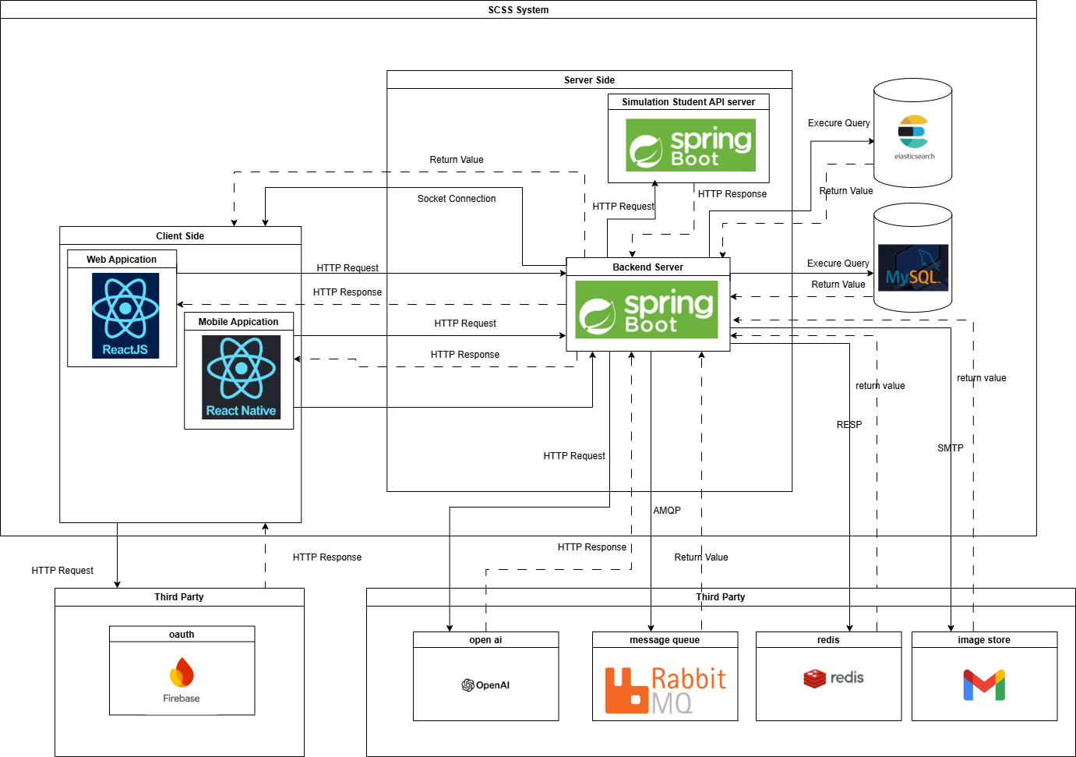

[Figure 11 - Overall System Architecture](https://drive.google.com/file/d/11YrXXkibwN2Q1mX3-ymb_7As-R9ACJlE/view?usp=drive_link)

### 1.2. Package Diagram

#### 1.2.1. Web Application Package Diagram

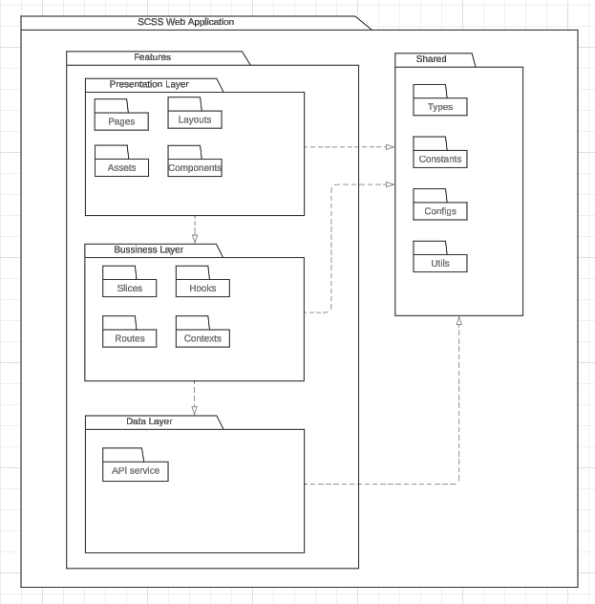

Figure - Web Application Package Diagram

***Package Descriptions***

Table - Web Package Descriptions

|  |  |  |
| --- | --- | --- |
| **No** | **Package** | **Description** |
| 01 | Features | This package include all the features of the application |
| 02 | Pages | The package includes page components for the application |
| 03 | Components | This package includes the detailed components of the page interface |
| 04 | Layouts | This package includes the general layouts of the interface |
| 05 | Assets | This package includes static files used by components and pages. |
| 06 | Routes | This package includes a config URL path for routing to the page component. |
| 07 | Slices | This package includes a state management pattern for a web application |
| 08 | Hooks | This  package includes the custom hooks for components used to handle logic. |
| 09 | Constants | This package includes defines constant for the entire application use |
| 10 | API Service | This package includes API service for frontend |
| 11 | Shared | This package includes all common files used by the application |
| 12 | Types | This  package includes common interfaces for the application |
| 13 | Configs | This package includes all common settings for the application. |
| 14 | Context | This packages includes provider the application |

#### 1.2.2. Mobile Application Package Diagram

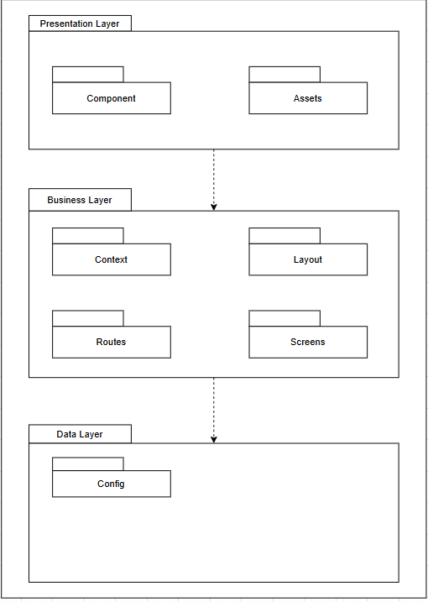

Figure - Mobile Application Package Diagram

***Package Descriptions***

Table - Mobile Package Descriptions

|  |  |  |
| --- | --- | --- |
| **No** | **Package** | **Description** |
| 01 | Components | It contains the reusable building blocks of the app, which are individual components that manage specific pieces of functionality or UI |
| 02 | Assets | It contains static resources such as images, fonts, and other media files used throughout the app. |
| 03 | Context | It stores context files for managing the global state throughout the application (e.g., user authentication, navigation, notifications). |
| 04 | Layout | It holds layout components responsible for structuring the visual appearance of different sections or screens |
| 05 | Routes | It contains the routing logic for the app, defining how users navigate between different screens or features. |
| 06 | Screens | It contains the major screens of the app. Each screen typically represents a full view or page (e.g., Home, Login, Profile) |
| 07 | Config | It stores configuration files, such as environment settings, API endpoints, and other app-specific constants that might be referenced globally. |

#### 1.2.3. Backend Application Package Diagram

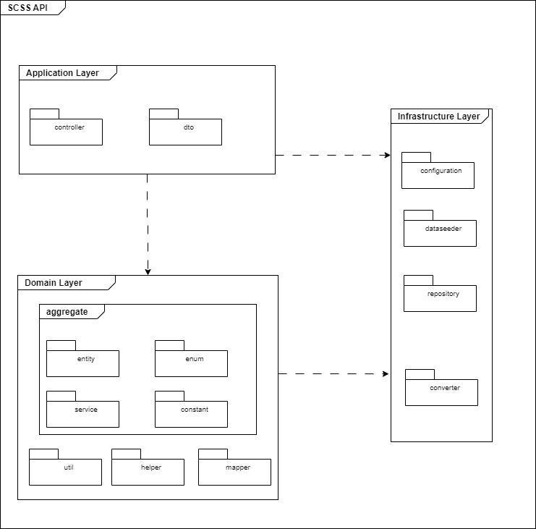

Figure - Backend Application Package Diagram

***Package Descriptions***

Table - Backend Package Descriptions

|  |  |  |
| --- | --- | --- |
| **No** | **Package** | **Description** |
| 01 | Controller | includes the classes that handle HTTP requests and call the relevant domain-layer business logic. They also take care of addressing errors and creating responses. |
| 02 | DTO | contains the classes that act as a bridge between the domain model and the client. They make sure that just the information that is required is visible by encapsulating data delivered to or from the client. |
| 03 | Entity | Defines the business objects and their relationships. |
| 04 | Enum | Contains enumerations that represent fixed sets of constants used across the domain. |
| 05 | Util | Contains utility classes with reusable methods that help the domain logic but do not belong to any specific entity. |
| 06 | Helper | Provides helper functions that facilitate domain-related operations. |
| 07 | Mapper | Manages the mapping between entities and DTOs, ensuring data is converted between different representations. |
| 08 | Configuration | Stores classes related to configuring application settings, such as database connections, security, or other environment-specific setups. |
| 09 | DataSeeder | Holds classes responsible for populating the database with initial or test data. |
| 10 | Repository | Contains interfaces and classes that handle communication with the data storage layer, allowing CRUD operations on domain entities. |
| 11 | Converter | Provides classes for converting data between different types, formats, or structures, such as mapping domain models to persistent data models. |

## 2. Database Design

### 2.1. Database

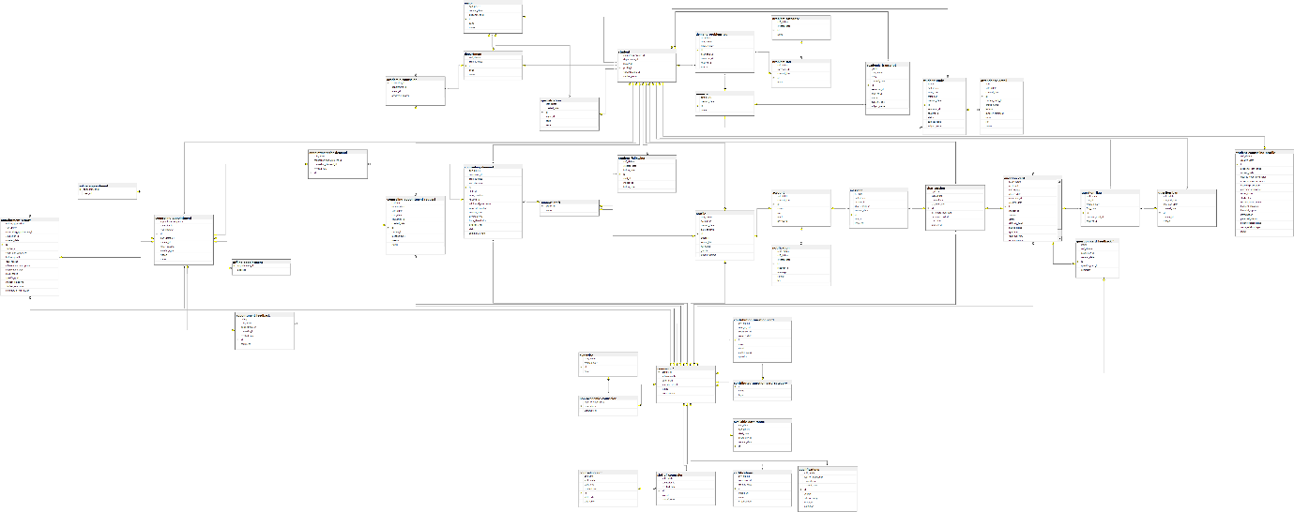

[Figure 15 - Database Diagram](https://drive.google.com/file/d/1922uFt3N7GcSsel0mpKLQZccEeXJgX8i/view?usp=drive_link)

### 2.2. Data Dictionary

#### 2.2.1. Academic counselor table

Table - Academic counselor Table

|  |  |  |  |  |  |  |
| --- | --- | --- | --- | --- | --- | --- |
| **No** | **Field name** | **Type** | **Unique** | **Not null** | **PK/FK** | **Notes** |
| 1 | counselor_id | bigint | X | X | PK |  |
| 2 | department_id | bigint |  | X | FK |  |
| 3 | major_id | bigint |  | X | FK |  |
| 4 | academic_degree | varchar(255) |  | X | FK |  |

#### 2.2.2. Academic_transcript table

Table - Academic transcript table

|  |  |  |  |  |  |  |
| --- | --- | --- | --- | --- | --- | --- |
| No | Field name | Type | Unique | Not null | PK/FK | Notes |
| 1 | id | BIGINT | X |  | PK |  |
| 2 | grade | DECIMAL(38,2) |  | X |  |  |
| 3 | soft_delete | BIT(1) |  | X |  |  |
| 4 | term | INT |  | X |  |  |
| 5 | created_date | DATETIME(6) |  | X |  |  |
| 6 | semester_id | BIGINT |  |  |  |  |
| 7 | student_id | BIGINT |  | X |  |  |
| 8 | subject_code | VARCHAR(255) |  | X |  |  |
| 9 | subject_name | VARCHAR(255) |  | X |  |  |
| 10 | status | enum |  |  |  | Has value:   * NOT_PASSED * NOT_STARTED * PASSED * STUDYING |

#### 2.2.2. Account table

Table - Account table

|  |  |  |  |  |  |  |
| --- | --- | --- | --- | --- | --- | --- |
| **No** | **Field name** | **Type** | **Unique** | **Not null** | **PK/FK** | **Notes** |
| 1 | id | bigint | X | X | PK |  |
| 2 | soft_delete | bigint |  | X |  |  |
| 3 | created_date | bigint |  | X |  |  |
| 4 | status | varchar(20) |  | X |  |  |
| 5 | role | varchar(50) |  | X |  |  |
| 6 | email | varchar(255) | X |  |  |  |
| 7 | password | varchar(255) |  |  |  |  |

#### 2.2.3. Appointment feedback Table

Table - Appointment feedback Table

|  |  |  |  |  |  |  |
| --- | --- | --- | --- | --- | --- | --- |
| **No** | **Field name** | **Type** | **Unique** | **Not null** | **PK/FK** | **Notes** |
| 1 | id | bigint | X | X | PK |  |
| 2 | rating | decimal(38,2) |  | X |  |  |
| 3 | soft_delete | bit(1) |  | X |  |  |
| 4 | appointment_id | bigint | X | X | FK |  |
| 5 | created_date | varchar(255) |  | X |  |  |
| 6 | comment | varchar(255) |  |  |  |  |
| 7 | counselor_id | bigint | X | X | FK |  |

#### 2.2.4. Appointment_for_demand table

Table - Appointment_for_demand table

|  |  |  |  |  |  |  |
| --- | --- | --- | --- | --- | --- | --- |
| **No** | **Field name** | **Type** | **Unique** | **Not null** | **PK/FK** | **Notes** |
| 1 | id | bigint | X | X | PK |  |
| 2 | soft_delete | bit(1) |  | X |  |  |
| 3 | counseling_appointment_id | bigint | X | X | FK |  |
| 4 | created_date | bigint |  | X |  |  |
| 5 | counseling_demand_id | bigint |  | X | FK |  |

#### 2.2.5. Appointment_report  table

Table - Appointment_report table

|  |  |  |  |  |  |  |
| --- | --- | --- | --- | --- | --- | --- |
| **No** | **Field name** | **Type** | **Unique** | **Not null** | **PK/FK** | **Notes** |
| 1 | id | bigint | X | X | PK |  |
| 2 | follow_up_needed | bit(1) |  |  |  |  |
| 3 | soft_delete | bit(1) |  |  |  |  |
| 4 | counseling_appointment_id | bigint | X | X | FK |  |
| 5 | counselor_id | bigint | X | X | FK |  |
| 6 | created_date | bigint |  | X |  |  |
| 7 | student_id | bigint | X | X | FK |  |
| 8 | counselor_conclusion | text |  |  |  |  |
| 9 | follow_up_notes | text |  |  |  |  |
| 10 | goal_reason | text |  |  |  |  |
| 11 | intervention_description | varchar(255) |  | X |  |  |
| 12 | intervention_type | varchar(255) |  | X |  |  |
| 13 | main_issues | text |  |  |  |  |
| 14 | specific_goal | text |  |  |  |  |
| 15 | student_emotions | text |  |  |  |  |
| 16 | student_reactions | text |  |  |  |  |
| 17 | summary_of_discussion | text |  |  |  |  |

#### 2.2.6. attendance_detail table

Table - attendance_detail table

|  |  |  |  |  |  |  |
| --- | --- | --- | --- | --- | --- | --- |
| **No** | **Field name** | **Type** | **Unique** | **Not null** | **PK/FK** | **Notes** |
| 1 | id | BIGINT |  | X | PK |  |
| 2 | date | DATE |  | X |  |  |
| 3 | soft_delete | BIT(1) |  | X |  |  |
| 4 | created_date | DATETIME(6) |  | X |  |  |
| 5 | student_study_id | BIGINT |  | X | FK |  |
| 6 | group_name | VARCHAR(255) |  | X |  |  |
| 7 | lecturer | VARCHAR(255) |  | X |  |  |
| 8 | lecturer_comment | VARCHAR(255) |  |  |  |  |
| 9 | room | VARCHAR(255) |  | X |  |  |
| 10 | slot | VARCHAR(255) |  | X |  |  |
| 11 | status | ENUM |  |  |  | Has values:   * ABSENT * FUTURE * PRESENT |

#### 2.2.7. Available_date_range table

Table 47 - Available_date_range table

|  |  |  |  |  |  |  |
| --- | --- | --- | --- | --- | --- | --- |
| **No** | **Field name** | **Type** | **Unique** | **Not null** | **PK/FK** | **Notes** |
| 1 | id | bigint | X | X | PK |  |
| 2 | end_date | date |  | X |  |  |
| 3 | soft_delete | bit(1) |  | X |  |  |
| 4 | start_date | date |  | X |  |  |
| 5 | counselor_id | bigint | X | X | FK |  |
| 6 | created_date | bigint |  | X |  |  |

#### 2.2.8. certifications table

Table 48 – certifications table

|  |  |  |  |  |  |  |
| --- | --- | --- | --- | --- | --- | --- |
| **No** | **Field name** | **Type** | **Unique** | **Not null** | **PK/FK** | **Notes** |
| 1 | id | BIGINT |  | X | PK |  |
| 2 | soft_delete | BIT(1) |  | X |  |  |
| 3 | counselor_id | BIGINT |  | X | FK |  |
| 4 | created_date | DATETIME(6) |  | X |  |  |
| 5 | image_url | VARCHAR(255) |  |  |  |  |
| 6 | name | VARCHAR(255) |  | X |  |  |
| 7 | organization | VARCHAR(255) |  | X |  |  |

#### 2.2.9. Chat_session table

Table 49 - Chat_session table

|  |  |  |  |  |  |  |
| --- | --- | --- | --- | --- | --- | --- |
| **No** | **Field name** | **Type** | **Unique** | **Not null** | **PK/FK** | **Notes** |
| 1 | id | bigint | X | X | PK |  |
| 2 | is_closed | bit(1) |  | X |  |  |
| 3 | soft_delete | bit(1) |  | X |  |  |
| 4 | counselor_id | bigint |  | X | FK |  |
| 5 | created_date | bigint |  | X |  |  |
| 6 | last_interaction_date | datetime(6) |  | X |  |  |
| 7 | question_card_id | bigint |  | X | FK |  |
| 8 | start_date | datetime(6) |  | X |  |  |
| 9 | student_id | bigint |  | X | FK |  |

#### 2.2.10. contributed_question_card_category table

Table - contributed_question_card_category table

|  |  |  |  |  |  |  |
| --- | --- | --- | --- | --- | --- | --- |
| **No** | **Field name** | **Type** | **Unique** | **Not null** | **PK/FK** | **Notes** |
| 1 | id | BIGINT |  | X | PK |  |
| 2 | name | VARCHAR(255) |  | X |  |  |
| 3 | type | ENUM |  | X |  | Has value:   * ACADEMIC * NON_ACADEMIC |

#### 2.2.11. contribution_question_card table

Table - contribution_question_card table

|  |  |  |  |  |  |  |
| --- | --- | --- | --- | --- | --- | --- |
| **No** | **Field name** | **Type** | **Unique** | **Not null** | **PK/FK** | **Notes** |
| 1 | id | BIGINT |  | X | PK |  |
| 2 | soft_delete | BIT(1) |  | X | FK |  |
| 3 | category_id | BIGINT |  | X | FK |  |
| 4 | counselor_id | BIGINT |  | X |  |  |
| 5 | created_date | DATETIME(6) |  | X |  |  |
| 6 | answer | TEXT |  |  |  |  |
| 7 | detail | TEXT |  |  |  |  |
| 8 | question | VARCHAR(255) |  |  |  |  |
| 9 | public_status | ENUM |  | X |  | Has value:   * HIDE * VISIBLE |

#### 2.2.12. Counseling_appointment table

Table - Counseling_appointment table

|  |  |  |  |  |  |  |
| --- | --- | --- | --- | --- | --- | --- |
| **No** | **Field name** | **Type** | **Unique** | **Not null** | **PK/FK** | **Notes** |
| 1 | id | bigint | X | X | PK |  |
| 2 | appointment_request_id | bigint | X |  | FK |  |
| 3 | counselor_id | bigint | X |  | FK |  |
| 4 | end_datetime | datetime(6) |  | X |  |  |
| 5 | start_datetime | datetime(6) |  | X |  |  |
| 6 | student_id | bigint | X |  | FK |  |
| 7 | meeting_type | enum |  |  |  | Has value:   * OFFLINE * ONLINE |
| 8 | status | enum |  |  |  | Has value:   * ABSENT * ATTEND. * CANCELED * EXPIRED * WAITING |
| 9 | cancel_reason | text |  |  |  |  |
| 10 | reason | text |  |  |  |  |

#### 2.2.13. Counseling_appointment_request table

Table - Counseling_appointment_request

|  |  |  |  |  |  |  |
| --- | --- | --- | --- | --- | --- | --- |
| **No** | **Field name** | **Type** | **Unique** | **Not null** | **PK/FK** | **Notes** |
| 1 | id | bigint | X | X | PK |  |
| 2 | end_time | time(6) |  |  |  |  |
| 3 | require_date | date |  |  |  |  |
| 4 | soft_delete | bit(1) |  | X |  |  |
| 5 | start_time | time(6) |  |  |  |  |
| 6 | counselor_id | bigint | X |  | FK |  |
| 7 | created_date | bigint |  | X |  |  |
| 8 | student_id | bigint | X |  | FK |  |
| 9 | reason | varchar(255) |  |  |  |  |
| 10 | meeting_type | enum |  |  |  | Has value:   * OFFLINE * ONLINE |
| 11 | status | enum |  |  |  | Has value:   * APPROVED * DENIED * EXPIRED * WAITING |

#### 2.2.14. Counseling_demand Table

Table - Counseling_demand Table

|  |  |  |  |  |  |  |
| --- | --- | --- | --- | --- | --- | --- |
| **No** | **Field name** | **Type** | **Unique** | **Not null** | **PK/FK** | **Notes** |
| 1 | id | bigint | X | X | PK |  |
| 2 | soft_delete | bit(1) |  | X |  |  |
| 3 | counselor_id | bigint | X |  | FK |  |
| 4 | created_date | bigint |  | X |  |  |
| 5 | end_datetime | datetime(6) |  |  |  |  |
| 6 | staff_id | bigint | X | X | FK |  |
| 7 | start_datetime | datetime(6) |  |  |  |  |
| 8 | student_id | bigint | X |  | FK |  |
| 9 | contact_note | text |  |  |  |  |
| 10 | summarize_note | text |  |  |  |  |
| 11 | status | enum |  | X |  | Has value:   * PROCESSING * SOLVE * 'WAITING |
| 12 | issue_description | TEXT |  | X |  |  |
| 13 | demand_type | ENUM |  | X |  | Has values:   * ACADEMIC * NON_ACADEMIC |
| 14 | priority_level | ENUM |  |  |  | Has values:   * HIGH * LOW * MEDIUM * 'URGENT |
| 15 | additional_information | TEXT |  |  |  |  |
| 16 | cause_description | TEXT |  |  |  |  |

#### 2.2.15. Counseling_slot table

Table - Counseling_slot table

|  |  |  |  |  |  |  |
| --- | --- | --- | --- | --- | --- | --- |
| **No** | **Field name** | **Type** | **Unique** | **Not null** | **PK/FK** | **Notes** |
| 1 | id | bigint | X | X | PK |  |
| 2 | end_time | time(6) |  | X |  |  |
| 3 | soft_delete | bit(1) |  | X |  |  |
| 4 | start_time | time(6) |  | X |  |  |
| 5 | created_date | bigint |  | X |  |  |
| 6 | slot_code | varchar(255) |  | X |  |  |
| 7 | slot_name | varchar(255) |  | X |  |  |

#### 2.2.12. Counselor table

Table - Counselor table

|  |  |  |  |  |  |  |
| --- | --- | --- | --- | --- | --- | --- |
| **No** | **Field name** | **Type** | **Unique** | **Not null** | **PK/FK** | **Notes** |
| 1 | profile_id | bigint | X | X | PK |  |
| 2 | achievements | TEXT |  |  |  |  |
| 3 | other_skills | TEXT |  |  |  |  |
| 4 | specialized_skills | TEXT |  |  |  |  |
| 5 | work_history | TEXT |  |  |  |  |
| 6 | status | enum |  | X |  | Has value   * AVAILABLE * UNAVAILABLE |

#### 2.2.16. Counselor_slot table

Table - Counselor_slot table

|  |  |  |  |  |  |  |
| --- | --- | --- | --- | --- | --- | --- |
| **No** | **Field name** | **Type** | **Unique** | **Not null** | **PK/FK** | **Notes** |
| 1 | counselor_id | bigint | X | X | FK |  |
| 2 | slot_id | bigint | X | X | FK |  |

#### 2.2.17. Demand_problem_tag table

Table - Demand_problem_tag table

|  |  |  |  |  |  |  |
| --- | --- | --- | --- | --- | --- | --- |
| **No** | **Field name** | **Type** | **Unique** | **Not null** | **PK/FK** | **Notes** |
| 1 | id | bigint | X | X | PK |  |
| 2 | is_excluded | bit(1) |  | X |  |  |
| 3 | soft_delete | bit(1) |  | X |  |  |
| 4 | created_date | bigint |  | X |  |  |
| 5 | prob_tag_id | bigint | X | X | FK |  |
| 6 | semester_id | bigint | X |  | FK |  |
| 7 | student_id | bigint | X | X | FK |  |
| 8 | source | text |  | X |  |  |

#### 2.2.18. Department table

Table - Department table

|  |  |  |  |  |  |  |
| --- | --- | --- | --- | --- | --- | --- |
| **No** | **Field name** | **Type** | **Unique** | **Not null** | **PK/FK** | **Notes** |
| 1 | id | bigint | X | X | PK |  |
| 2 | soft_delete | bit(1) |  | X |  |  |
| 3 | created_date | bigint |  | X |  |  |
| 4 | code | varchar(255) | X | X |  |  |
| 5 | name | varchar(255) | X | X |  |  |

#### 2.2.19. Expertise table

Table - Expertise table

|  |  |  |  |  |  |  |
| --- | --- | --- | --- | --- | --- | --- |
| **No** | **Field name** | **Type** | **Unique** | **Not null** | **PK/FK** | **Notes** |
| 1 | id | bigint | X | X | PK |  |
| 2 | soft_delete | bit(1) |  | X |  |  |
| 3 | created_date | bigint |  | X |  |  |
| 4 | name | varchar(255) |  | X |  |  |

#### 2.2.20. Login_type table

Table - Login_type table

|  |  |  |  |  |  |  |
| --- | --- | --- | --- | --- | --- | --- |
| **No** | **Field name** | **Type** | **Unique** | **Not null** | **PK/FK** | **Notes** |
| 1 | id | bigint | X | X | PK |  |
| 2 | soft_delete | bit(1) |  | X |  |  |
| 3 | account_id | bigint |  |  | FK |  |
| 4 | created_date | bigint |  | X |  |  |
| 5 | method | varchar(20) |  | X |  |  |
| 6 | password | varchar(255) |  |  |  |  |

#### 2.2.21. Major table

Table - Major table

|  |  |  |  |  |  |  |
| --- | --- | --- | --- | --- | --- | --- |
| **No** | **Field name** | **Type** | **Unique** | **Not null** | **PK/FK** | **Notes** |
| 1 | id | bigint | X | X | PK |  |
| 2 | soft_delete | bit(1) |  | X |  |  |
| 3 | created_date | bigint |  | X |  |  |
| 4 | department_id | bigint | X |  | FK |  |
| 5 | code | varchar(255) | X | X |  |  |
| 6 | name | varchar(255) | X | X |  |  |

#### 2.2.22. Message table

Table - Message table

|  |  |  |  |  |  |  |
| --- | --- | --- | --- | --- | --- | --- |
| **No** | **Field name** | **Type** | **Unique** | **Not null** | **PK/FK** | **Notes** |
| 1 | id | bigint | X | X | PK |  |
| 2 | is_read | bit(1) |  | X |  |  |
| 3 | soft_delete | bit(1) |  | X |  |  |
| 4 | account_id | bigint | X | X | FK |  |
| 5 | chat_session_id | bigint | X | X | FK |  |
| 6 | created_date | bigint |  | X |  |  |
| 7 | sent_at | datetime(6) |  | X |  |  |
| 8 | content | text |  | X |  |  |

#### 2.2.23. Non_academic_counselor table

Table - Non_academic_counselor table

|  |  |  |  |  |  |  |
| --- | --- | --- | --- | --- | --- | --- |
| **No** | **Field name** | **Type** | **Unique** | **Not null** | **PK/FK** | **Notes** |
| 1 | counselor_id | bigint | X | X | PK, FK |  |
| 2 | industry_experience | int |  | X |  |  |
| 3 | expertise_id | bigint | X | X | FK |  |

#### 2.2.24. Notification table

Table - Notification table

|  |  |  |  |  |  |  |
| --- | --- | --- | --- | --- | --- | --- |
| **No** | **Field name** | **Type** | **Unique** | **Not null** | **PK/FK** | **Notes** |
| 1 | id | bigint | X | X | PK |  |
| 2 | read_status | bit(1) |  | X |  |  |
| 3 | soft_delete | bit(1) |  | X |  |  |
| 4 | created_date | bigint |  | X |  |  |
| 5 | receiver_id | bigint | X | X | FK |  |
| 6 | message | varchar(1000) |  | X |  |  |
| 7 | sender | varchar(255) |  | X |  |  |
| 8 | title | varchar(255) |  | X |  |  |

#### 2.2.25. Offline_appointment  table

Table - Offline_appointment table

|  |  |  |  |  |  |  |
| --- | --- | --- | --- | --- | --- | --- |
| **No** | **Field name** | **Type** | **Unique** | **Not null** | **PK/FK** | **Notes** |
| 1 | appointment_id | bigint | X | X | PK, FK |  |
| 2 | address | varchar(255) |  |  |  |  |

#### 2.2.26. Online_appointment table

Table - Online_appointment table

|  |  |  |  |  |  |  |
| --- | --- | --- | --- | --- | --- | --- |
| **No** | **Field name** | **Type** | **Unique** | **Not null** | **PK/FK** | **Notes** |
| 1 | appointment_id | bigint | X | X | PF, FK |  |
| 2 | meet_url | varchar(255) |  |  |  |  |

#### 2.2.27. Problem_category  table

Table - Problem_category table

|  |  |  |  |  |  |  |
| --- | --- | --- | --- | --- | --- | --- |
| **No** | **Field name** | **Type** | **Unique** | **Not null** | **PK/FK** | **Notes** |
| 1 | id | bigint | X | X | PK |  |
| 2 | soft_delete | bit(1) |  | X |  |  |
| 3 | created_date | bigint |  | X |  |  |
| 4 | name | text |  | X |  |  |

#### 2.2.28. Problem_tag  table

Table - Problem_tag table

|  |  |  |  |  |  |  |
| --- | --- | --- | --- | --- | --- | --- |
| **No** | **Field name** | **Type** | **Unique** | **Not null** | **PK/FK** | **Notes** |
| 1 | id | bigint | X | X | PK |  |
| 2 | soft_delete | bigint |  | X |  |  |
| 3 | category_id | bigint | X | X | FK |  |
| 4 | created_date | bigint |  | X |  |  |
| 5 | name | varchar(255) |  | X |  |  |

#### 2.2.29. Profile  table

Table - Profile table

|  |  |  |  |  |  |  |
| --- | --- | --- | --- | --- | --- | --- |
| **No** | **Field name** | **Type** | **Unique** | **Not null** | **PK/FK** | **Notes** |
| 1 | id | bigint | X | X | PK |  |
| 2 | soft_delete | bit(1) |  | X |  |  |
| 3 | account_id | bigint | X |  | FK |  |
| 4 | created_date | bigint |  | X |  |  |
| 5 | date_of_birth | bigint |  |  |  |  |
| 6 | address | varchar(255) |  |  |  |  |
| 7 | avatar_link | varchar(255) |  |  |  |  |
| 8 | full_name | varchar(255) |  | X |  |  |
| 9 | phone_numer | varchar(255) |  |  |  |  |
| 10 | gender | enum |  |  |  | Has value:   * FEMALE * MALE |

#### 2.2.30. qualifications table

Table – qualifications table

|  |  |  |  |  |  |  |
| --- | --- | --- | --- | --- | --- | --- |
| **No** | **Field name** | **Type** | **Unique** | **Not null** | **PK/FK** | **Notes** |
| 1 | id | bigint | X | X | PK |  |
| 2 | soft_delete | BIT(1) |  | X |  |  |
| 3 | year_of_graduation | INT |  |  |  |  |
| 4 | counselor_id | BIGINT |  | X | FK |  |
| 5 | created_date | DATETIME(6) |  | X |  |  |
| 6 | degree | VARCHAR(255) |  | X |  |  |
| 7 | field_of_study | VARCHAR(255) |  | X |  |  |
| 8 | image_url | VARCHAR(255) |  |  |  |  |
| 9 | institution | VARCHAR(255) |  | X |  |  |

#### 2.2.31. Question_ban table

Table - Question_ban table

|  |  |  |  |  |  |  |
| --- | --- | --- | --- | --- | --- | --- |
| **No** | **Field name** | **Type** | **Unique** | **Not null** | **PK/FK** | **Notes** |
| 1 | id | bigint | X | X | PK |  |
| 2 | soft_delete | bit(1) |  | X |  |  |
| 3 | ban_end_date | datetime(6) |  | X |  |  |
| 4 | ban_start_date | datetime(6) |  | X |  |  |
| 5 | created_date | bigint |  | X |  |  |
| 6 | student_id | bigint | X | X | FK |  |
| 7 | reason | text |  | X |  |  |

#### 2.2.32. Question_card  table

Table - Question_card table

|  |  |  |  |  |  |  |
| --- | --- | --- | --- | --- | --- | --- |
| **No** | **Field name** | **Type** | **Unique** | **Not null** | **PK/FK** | **Notes** |
| 1 | id | bigint | X | X | PK |  |
| 2 | is_accepted | bit(1) |  | X |  |  |
| 3 | is_closed | bit(1) |  | X |  |  |
| 4 | soft_delete | bit(1) |  | X |  |  |
| 5 | closed_date | datetime(6) |  |  |  |  |
| 6 | counselor_id | bigint |  |  | FK |  |
| 7 | created_date | bigint |  | X |  |  |
| 8 | student_id | bigint |  | X | FK |  |
| 9 | answer | varchar(255) |  |  |  |  |
| 10 | detail | text |  | X |  |  |
| 11 | question_type | enum |  | X |  | Has value:   * ACADEMIC * NON_ACADEMIC |
| 12 | status | enum |  | X |  | Has value:   * LAGGED * PENDING * REJECTED * VERIFIED |
| 13 | review_reason | TEXT |  |  |  |  |
| 14 | title | TEXT |  |  |  |  |
| 15 | difficulty_level | enum |  |  |  | Has value:   * Easy * Hard * Medium |
| 16 | public_status | ENUM |  | X |  | Has value:   * HIDE * PENDING * VISIBLE |

#### 2.2.33. Question_flag  table

Table - Question_flag table

|  |  |  |  |  |  |  |
| --- | --- | --- | --- | --- | --- | --- |
| **No** | **Field name** | **Type** | **Unique** | **Not null** | **PK/FK** | **Notes** |
| 1 | id | bigint | X | X | PK |  |
| 2 | soft_delete | bit(1) |  | X |  |  |
| 3 | ban_id | bigint | X | X | FK |  |
| 4 | created_date | bigint |  | X |  |  |
| 5 | flag_date | datetime(6) |  | X |  |  |
| 6 | question_card_id | bigint | X | X | FK |  |
| 7 | student_id | bigint | X | X | FK |  |
| 8 | reason | text |  | X |  |  |

#### 2.2.34. Semester table

Table - Semester table

|  |  |  |  |  |  |  |
| --- | --- | --- | --- | --- | --- | --- |
| **No** | **Field name** | **Type** | **Unique** | **Not null** | **PK/FK** | **Notes** |
| 1 | id | bigint | X | X | PK |  |
| 2 | soft_delete | bit(1) |  | X |  |  |
| 3 | created_date | bigint |  | X |  |  |
| 4 | name | varchar(100) | X | X |  |  |

#### 2.2.35. slot_of_counselor table

Table - slot_of_counselor table

|  |  |  |  |  |  |  |
| --- | --- | --- | --- | --- | --- | --- |
| **No** | **Field name** | **Type** | **Unique** | **Not null** | **PK/FK** | **Notes** |
| 1 | id | bigint | X | X | PK |  |
| 2 | soft_delete | bit(1) |  | X |  |  |
| 3 | created_date | bigint |  | X |  |  |
| 4 | slot_id | varchar(100) | X | X | FK |  |
| 5 | day_of_week | enum |  | X |  | Has value:   * FRIDAY * MONDAY * SATURDAY * SUNDAY * THURSDAY * TUESDAY WEDNESDAY |
| 6 | counselor_id | bigint |  | X | FK |  |

#### 2.2.36. Specialization table

Table - Specialization table

|  |  |  |  |  |  |  |
| --- | --- | --- | --- | --- | --- | --- |
| **No** | **Field name** | **Type** | **Unique** | **Not null** | **PK/FK** | **Notes** |
| 1 | id | bigint | X | X | PK |  |
| 2 | soft_delete | bit(1) |  | X |  |  |
| 3 | created_date | bigint |  | X |  |  |
| 4 | major_id | bigint | X |  | FK |  |
| 5 | code | varchar(255) |  | X |  |  |
| 6 | name | varchar(255) |  | X |  |  |

#### 2.2.37. Student table

Table - Student table

|  |  |  |  |  |  |  |
| --- | --- | --- | --- | --- | --- | --- |
| **No** | **Field name** | **Type** | **Unique** | **Not null** | **PK/FK** | **Notes** |
| 1 | profile_id | bigint | X | X | PK |  |
| 2 | counseling_profile_id | bigint | X |  | FK |  |
| 3 | department_id | bigint | X |  | FK |  |
| 4 | major_id | bigint | X |  | FK |  |
| 5 | specialization_id | bigint |  |  | FK |  |
| 6 | student_code | varchar(255) | X | X |  |  |

#### 2.2.38. Student_counseling_profile table

Table - Student_counseling_profile table

|  |  |  |  |  |  |  |
| --- | --- | --- | --- | --- | --- | --- |
| **No** | **Field name** | **Type** | **Unique** | **Not null** | **PK/FK** | **Notes** |
| 1 | id | bigint | X | X | PK |  |
| 2 | soft_delete | bit(1) |  | X |  |  |
| 3 | created_date | bigint |  | X |  |  |
| 4 | academic_difficulties | varchar(500) |  |  |  |  |
| 5 | career_goals | varchar(500) |  |  |  |  |
| 6 | desired_counseling_fields | varchar(500) |  |  |  |  |
| 7 | extracurricular_activities | varchar(500) |  |  |  |  |
| 8 | internship_program | varchar(500) |  |  |  |  |
| 9 | part_time_experience | varchar(500) |  |  |  |  |
| 10 | stress_factors | varchar(500) |  |  |  |  |
| 11 | study_plan | varchar(500) |  |  |  |  |
| 12 | current_health_status | varchar(255) |  |  |  |  |
| 13 | financial_situation | varchar(255) |  |  |  |  |
| 14 | financial_support | varchar(255) |  |  |  |  |
| 15 | introduction | text |  |  |  |  |
| 16 | personal_interests | varchar(255) |  |  |  |  |
| 17 | psychological_status | varchar(255) |  |  |  |  |
| 18 | social_relationships | varchar(255) |  |  |  |  |
| 19 | status | enum |  | X |  | Has value:   * REJECTED * UNVERIFIED * VERIFIED |

#### 2.2.39. student_following table

Table - student_following table

|  |  |  |  |  |  |  |
| --- | --- | --- | --- | --- | --- | --- |
| **No** | **Field name** | **Type** | **Unique** | **Not null** | **PK/FK** | **Notes** |
| 1 | id | bigint | X | X | PK |  |
| 2 | soft_delete | BIT(1) |  | X |  |  |
| 3 | created_date | DATETIME(6) |  | X |  |  |
| 4 | follow_date | DATETIME(6) |  | X | PK |  |
| 5 | staff_id | BIGINT |  | X | PK |  |
| 6 | student_id | BIGINT |  | X |  |  |
| 7 | follow_note | TEXT |  |  |  |  |

#### 2.2.40. student_study table

Table - student_study table

|  |  |  |  |  |  |  |
| --- | --- | --- | --- | --- | --- | --- |
| **No** | **Field name** | **Type** | **Unique** | **Not null** | **PK/FK** | **Notes** |
| 1 | id |  |  | X | PK |  |
| 2 | grade | DECIMAL(38,2) |  |  |  |  |
| 3 | soft_delete | BIT(1) |  | X |  |  |
| 4 | soft_delete | DATE |  | X |  |  |
| 5 | total_slot | INT |  | X |  |  |
| 6 | created_date | DATETIME(6) |  | X |  |  |
| 7 | semester_id | BIGINT |  | X | FK |  |
| 8 | student_id | BIGINT |  | X | FK |  |
| 9 | subject_code | VARCHAR(255) |  | X |  |  |
| 10 | subject_name | VARCHAR(255) |  | X |  |  |
| 11 | status | ENUM |  | X |  | Has value:   * NOT_PASSED * NOT_STARTED * PASSED * STUDYING |

#### 2.2.41. Support_staff  table

Table - Support_staff table

|  |  |  |  |  |  |  |
| --- | --- | --- | --- | --- | --- | --- |
| **No** | **Field name** | **Type** | **Unique** | **Not null** | **PK/FK** | **Notes** |
| 1 | profile_id | bigint | X | X | PK |  |
| 2 | status | enum |  | X |  | Has value:   * AVAILABLE * UNAVAILABLE |

#### 2.2.42. Topic table

Table - Topic table

|  |  |  |  |  |  |  |
| --- | --- | --- | --- | --- | --- | --- |
| **No** | **Field name** | **Type** | **Unique** | **Not null** | **PK/FK** | **Notes** |
| 1 | id | bigint | X | X | PK |  |
| 2 | soft_delete | bit(1) |  | X |  |  |
| 3 | created_date | bigint |  | X | FK |  |
| 4 | name | varchar(255) |  | X |  |  |
| 5 | type | enum |  | X |  | Has value:   * ACADEMIC * NON_ACADEMIC |

#### 2.2.43. Certifications table

Table - Certifications table

|  |  |  |  |  |  |  |
| --- | --- | --- | --- | --- | --- | --- |
| **No** | **Field name** | **Type** | **Unique** | **Not null** | **PK/FK** | **Notes** |
| 1 | id | bigint | X | X | PK |  |
| 2 | soft_delete | bit(1) |  | X |  |  |
| 3 | counselor_id | bigint |  | X | FK |  |
| 4 | created_date | DATETIME(6) |  | X |  |  |
| 5 | image_url | varchar(255) |  |  |  |  |
| 6 | name | varchar(255) |  | X |  |  |
| 7 | organization | varchar(255) |  | X |  |  |

#### 2.2.44. Contributed_question_card_category table

Table - Contributed_question_card_category table

|  |  |  |  |  |  |  |
| --- | --- | --- | --- | --- | --- | --- |
| **No** | **Field name** | **Type** | **Unique** | **Not null** | **PK/FK** | **Notes** |
| 1 | id | bigint | X | X | PK |  |
| 2 | name | varchar (255) |  | X |  |  |
| 3 | type | ENUM |  | X | FK | Has values:   * ACADEMIC * NON_ACADEMIC |

#### 2.2.45. contribution_question_card table

Table - contribution_question_card table

|  |  |  |  |  |  |  |
| --- | --- | --- | --- | --- | --- | --- |
| **No** | **Field name** | **Type** | **Unique** | **Not null** | **PK/FK** | **Notes** |
| 1 | id | bigint | X | X | PK |  |
| 2 | soft_delete | BIT(1) |  | X |  |  |
| 3 | category_id | BIGINT |  | X | FK |  |
| 4 | counselor_id | BIGINT |  | X | FK |  |
| 5 | created_date | DATETIME(6) |  | X |  |  |
| 6 | answer | VARCHAR(255) |  |  |  |  |
| 7 | question | VARCHAR(255) |  |  |  |  |
| 8 | title | VARCHAR(255) |  |  |  |  |
| 9 | status | ENUM |  | X |  | Has values:   * REJECTED * VERIFIED |

#### 2.2.46. qualifications table

Table - qualifications table

|  |  |  |  |  |  |  |
| --- | --- | --- | --- | --- | --- | --- |
| **No** | **Field name** | **Type** | **Unique** | **Not null** | **PK/FK** | **Notes** |
| 1 | id | bigint | X | X | PK |  |
| 2 | soft_delete | BIT(1) |  | X |  |  |
| 3 | year_of_graduation | INT |  |  |  |  |
| 4 | counselor_id | BIGINT |  | X | FK |  |
| 5 | created_date | DATETIME(6) |  | X |  |  |
| 6 | degree | VARCHAR(255) |  | X |  |  |
| 7 | field_of_study | VARCHAR(255) |  | X |  |  |
| 8 | image_url | VARCHAR(255) |  |  |  |  |
| 9 | institution | VARCHAR(255) |  | X |  |  |

## 3. Detailed Design

### 3.1 Booking, handling, and tracking counseling appointments:

#### 3.1.1. Class Diagram

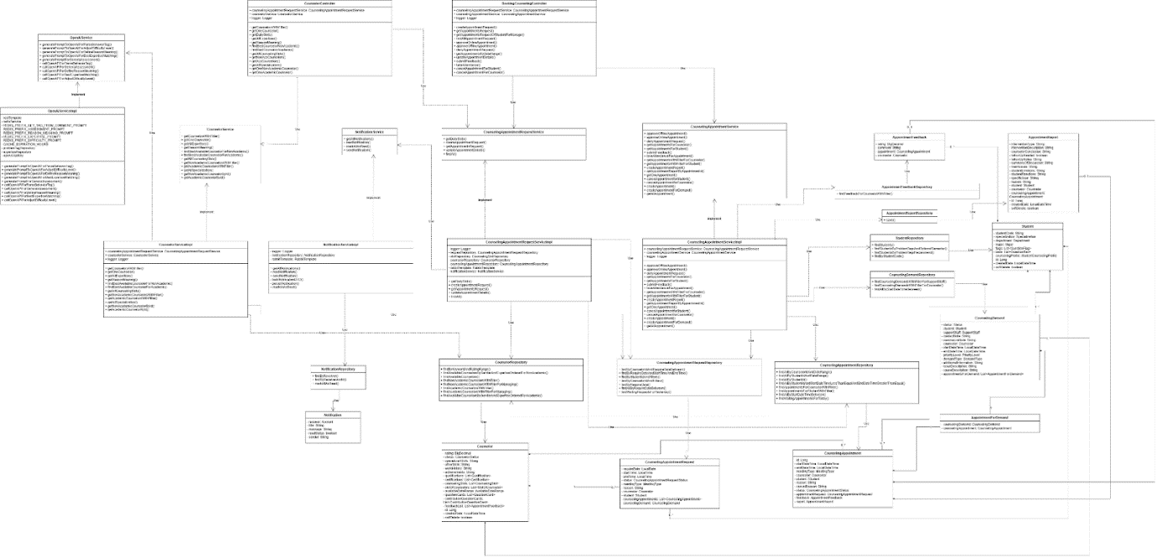

Figure - Booking, handling, and tracking counseling appointments class diagram

##### 3.1.1.1. Class Specification

###### 3.1.1.1.1. CounselorController class

Table - CounselorController class

|  |  |  |  |  |
| --- | --- | --- | --- | --- |
| **No** | **Attribute** | **Data Type** | **Visibility** | **Description** |
| 1 | counselingAppointmentRequestService | CounselingAppointmentRequestService | Public |  |
| 2 | counselorService | CounselorService | Public |  |
| 3 | logger | Logger | Public |  |

Table - CounselorController method class

|  |  |  |  |
| --- | --- | --- | --- |
| **No** | **Method** | **Visibility** | **Description** |
| 1 | createAppointmentRequest() | Public |  |
| 2 | getAppointmentsRequest() | Public |  |
| 3 | getAppointmentsRequestOfStudentForManage() | Public |  |
| 4 | findAllAppointmentRequest() | Public |  |
| 5 | approveOnlineAppointment() | Public |  |
| 6 | approveOfflineAppointment() | Public |  |
| 7 | denyAppointmentRequest() | Public |  |
| 8 | getAppointmentsByDateRange() | Public |  |
| 9 | updateAppointmentDetails() | Public |  |
| 10 | submitFeedback() | Public |  |
| 11 | takeAttendance() | Public |  |
| 12 | cancelAppointmentForStudent() | Public |  |
| 13 | cancelAppointmentForCounselor() | Public |  |

###### 3.1.1.1.2. CounselorService class

Table - CounselorService method class

|  |  |  |  |
| --- | --- | --- | --- |
| **No** | **Method** | **Visibility** | **Description** |
| 1 | getCounselorsWithFilter() | Public |  |
| 2 | getOneCounselor() | Public |  |
| 3 | getAllExpertises() | Public |  |
| 4 | getReasonMeaning() | Public |  |
| 5 | findBestAvailableCounselorForNonAcademic() | Public |  |
| 6 | findBestAvailableCounselorForAcademic() | Public |  |
| 7 | getAllCounselingSlots() | Public |  |
| 8 | getNonAcademicCounselorsWithFilter() | Public |  |
| 9 | getAcademicCounselorsWithFilter() | Public |  |
| 10 | getAllSpecialization() | Public |  |
| 11 | getNonAcademicCounselorById() | Public |  |
| 12 | getAcademicCounselorById() | Public |  |

###### 3.1.1.1.3. CounselorServiceImpl class

Table - CounselorServiceImpl class

|  |  |  |  |  |
| --- | --- | --- | --- | --- |
| **No** | **Attribute** | **Data Type** | **Visibility** | **Description** |
| 1 | counselingAppointmentRequestService | CounselingAppointmentRequestService | Public |  |
| 2 | logger | Logger | Public |  |

Table - CounselorServiceImpl method class

|  |  |  |  |
| --- | --- | --- | --- |
| **No** | **Method** | **Visibility** | **Description** |
| 1 | getCounselorsWithFilter() | Public |  |
| 2 | getOneCounselor() | Public |  |
| 3 | getAllExpertises() | Public |  |
| 4 | getReasonMeaning() | Public |  |
| 5 | findBestAvailableCounselorForNonAcademic() | Public |  |
| 6 | findBestAvailableCounselorForAcademic() | Public |  |
| 7 | getAllCounselingSlots() | Public |  |
| 8 | getNonAcademicCounselorsWithFilter() | Public |  |
| 9 | getAcademicCounselorsWithFilter() | Public |  |
| 10 | getAllSpecialization() | Public |  |
| 11 | getAllSpecialization() | Public |  |
| 12 | getNonAcademicCounselorById() | Public |  |
| 13 | getAcademicCounselorById() | Public |  |

###### 3.1.1.1.4. NotificationServiceImpl class

Table - NotificationServiceImpl class

|  |  |  |  |  |
| --- | --- | --- | --- | --- |
| **No** | **Attribute** | **Data Type** | **Visibility** | **Description** |
| 1 | logger | Logger | Private |  |
| 2 | notificationRepository | NotificationRepository | Private |  |
| 3 | rabbitTemplate | RabbitTemplate | Private |  |

Table - NotificationServiceImp method class

|  |  |  |  |
| --- | --- | --- | --- |
| **No** | **Method** | **Visibility** | **Description** |
| 1 | getAllNotifications() | Public |  |
| 2 | readNotification() | Public |  |
| 3 | sendNotification() | Public |  |
| 4 | buildNotificationDTO() | Private |  |
| 5 | persistNotification() | Private |  |
| 6 | markAllAsRead() | Public |  |

###### 3.1.1.1.5. CounselingAppointmentRequestServiceImpl class

Table – CounselingAppointmentRequestServiceImpl class

|  |  |  |  |  |
| --- | --- | --- | --- | --- |
| **No** | **Attribute** | **Data Type** | **Visibility** | **Description** |
| 1 | logger | Logger | Private |  |
| 2 | requestRepository | CounselingAppointmentRequestRepository | Private |  |
| 3 | slotRepository | CounselingSlotRepository | Private |  |
| 4 | counselorRepository | CounselorRepository | Private |  |
| 5 | counselingAppointmentRepository | CounselingAppointmentRepository | Private |  |
| 6 | rabbitTemplate | RabbitTemplate | Private |  |
| 7 | notificationService | NotificationService | Private |  |

Table - CounselingAppointmentRequestServiceImpl method class

|  |  |  |  |
| --- | --- | --- | --- |
| **No** | **Method** | **Visibility** | **Description** |
| 1 | getDailySlots() | Public |  |
| 2 | createAppointmentRequest() | Public |  |
| 3 | getAppointmentsRequest() | Public |  |
| 4 | updateAppointmentDetails() | Public |  |
| 5 | findAll() | Public |  |

###### 3.1.1.1.6. BookingCounselingController class

Table - BookingCounselingController class

|  |  |  |  |  |
| --- | --- | --- | --- | --- |
| **No** | **Attribute** | **Data Type** | **Visibility** | **Description** |
| 1 | counselingAppointmentRequestService | CounselingAppointmentRequestService | Public |  |
| 2 | counselingAppointmentService | CounselingAppointmentService | Public |  |
| 3 | logger | Logger | Public |  |

Table - BookingCounselingController method class

|  |  |  |  |
| --- | --- | --- | --- |
| **No** | **Method** | **Visibility** | **Description** |
| 1 | createAppointmentRequest() | Public |  |
| 2 | getAppointmentsRequest() | Public |  |
| 3 | getAppointmentsRequestOfStudentForManage() | Public |  |
| 4 | findAllAppointmentRequest() | Public |  |
| 5 | approveOnlineAppointment() | Public |  |
| 6 | approveOfflineAppointment() | Public |  |
| 7 | denyAppointmentRequest() | Public |  |
| 8 | getAppointmentsByDateRange() | Public |  |
| 9 | updateAppointmentDetails() | Public |  |
| 10 | submitFeedback() | Public |  |
| 11 | takeAttendance() | Public |  |
| 12 | cancelAppointmentForStudent() | Public |  |
| 13 | cancelAppointmentForCounselor() | Public |  |

###### 3.1.1.1.7. CounselorRepository class

Table - CounselorRepository class

|  |  |  |  |
| --- | --- | --- | --- |
| **No** | **Method** | **Visibility** | **Description** |
| 1 | findByKeywordAndRatingRange() | Public |  |
| 2 | findAvailableCounselorsByGenderAndExpertiseOrderedForNonAcademic() | Public |  |
| 3 | findAvailableCounselors() | Public |  |
| 4 | findNonAcademicCounselorsWithFilter() | Public |  |
| 5 | findNonAcademicCounselorsWithFilterForManaging() | Public |  |
| 6 | findAcademicCounselorsWithFilter() | Public |  |
| 7 | findAcademicCounselorsWithFilterForManaging() | Public |  |
| 8 | findAvailableCounselorsByGenderAndExpertiseOrderedForAcademic() | Public |  |

###### 3.1.1.1.8. CounselingAppointmentRequestService class

Table – CounselingAppointmentRequestService method class

|  |  |  |  |
| --- | --- | --- | --- |
| **No** | **Method** | **Visibility** | **Description** |
| 1 | getDailySlots() | Public |  |
| 2 | createAppointmentRequest() | Public |  |
| 3 | getAppointmentsRequest() | Public |  |
| 4 | updateAppointmentDetails() | Public |  |
| 5 | findAll() | Public |  |

###### 3.1.1.1.9. OpenAIServiceImpl class

Table - OpenAIServiceImpl class

|  |  |  |  |  |
| --- | --- | --- | --- | --- |
| **No** | **Attribute** | **Data Type** | **Visibility** | **Description** |
| 1 | restTemplate |  | Private |  |
| 2 | redisService |  | Private |  |
| 3 | REDIS_PREFIX_GET_TAG_FROM_COMMENT_PROMPT |  | Private |  |
| 4 | REDIS_PREFIX_ASSESSMENT_PROMPT |  | Private |  |
| 5 | REDIS_PREFIX_REASON_MEANING_PROMPT |  | Private |  |
| 6 | REDIS_PREFIX_EXPERTISE_PROMPT |  | Private |  |
| 7 | REDIS_PREFIX_DIFFICULTY_PROMPT |  | Private |  |
| 8 | CACHE_EXPIRATION_HOURS |  | Private |  |
| 9 | problemTagRepository |  | Private |  |
| 10 | expertiseRepository |  | Private |  |
| 11 | openAiApiKey |  | Private |  |

Table - OpenAIServiceImpl method class

|  |  |  |  |
| --- | --- | --- | --- |
| **No** | **Method** | **Visibility** | **Description** |
| 1 | generatePromptToOpenAIForParseBehaviorTag() | Public |  |
| 2 | generatePromptToOpenAIForAdjustDifficultyLevel() | Public |  |
| 3 | generatePromptToOpenAIForDefineReasonMeaning() | Public |  |
| 4 | generatePromptToOpenAIForBestExpertiseMatching() | Public |  |
| 5 | generatePromptForGeneralAssessment() | Public |  |
| 6 | callOpenAPIForParseBehaviorTag() | Public |  |
| 7 | callOpenAPIForGeneralAssessment() | Public |  |
| 8 | callOpenAPIForDefineReasonMeaning() | Public |  |
| 9 | callOpenAPIForBestExpertiseMatching() | Public |  |
| 10 | callOpenAPIForAdjustDifficultyLevel() | Public |  |

###### 3.1.1.1.10. OpenAIServiceImpl class

Table – OpenAIServiceImpl method class

|  |  |  |  |
| --- | --- | --- | --- |
| **No** | **Method** | **Visibility** | **Description** |
| 1 | generatePromptToOpenAIForParseBehaviorTag() | Public |  |
| 2 | generatePromptToOpenAIForAdjustDifficultyLevel() | Public |  |
| 3 | generatePromptToOpenAIForDefineReasonMeaning() | Public |  |
| 4 | generatePromptToOpenAIForBestExpertiseMatching() | Public |  |
| 5 | generatePromptForGeneralAssessment() | Public |  |
| 6 | callOpenAPIForParseBehaviorTag() | Public |  |
| 7 | callOpenAPIForGeneralAssessment() | Public |  |
| 8 | callOpenAPIForDefineReasonMeaning() | Public |  |
| 9 | callOpenAPIForBestExpertiseMatching() | Public |  |
| 10 | callOpenAPIForAdjustDifficultyLevel() | Public |  |

###### 3.1.1.1.11. NotificationService class

Table - NotificationService class

|  |  |  |  |
| --- | --- | --- | --- |
| **No** | **Method** | **Visibility** | **Description** |
| 1 | getAllNotifications() |  |  |
| 2 | readNotification() |  |  |
| 3 | markAllAsRead() |  |  |
| 4 | sendNotification() |  |  |

###### 3.1.1.1.12. OpenAIService class

Table - OpenAIService class

|  |  |  |  |  |
| --- | --- | --- | --- | --- |
| **No** | **Attribute** | **Data Type** | **Visibility** | **Description** |
| 1 | restTemplate |  | Private |  |
| 2 | redisService |  | Private |  |
| 3 | REDIS_PREFIX_GET_TAG_FROM_COMMENT_PROMPT |  | Private |  |
| 4 | REDIS_PREFIX_ASSESSMENT_PROMPT |  | Private |  |
| 5 | REDIS_PREFIX_REASON_MEANING_PROMPT |  | Private |  |
| 6 | REDIS_PREFIX_EXPERTISE_PROMPT |  | Private |  |
| 7 | REDIS_PREFIX_DIFFICULTY_PROMPT |  | Private |  |
| 8 | CACHE_EXPIRATION_HOURS |  | Private |  |
| 9 | problemTagRepository |  | Private |  |
| 10 | expertiseRepository |  | Private |  |
| 11 | openAiApiKey |  | Private |  |

Table - OpenAIService method class

|  |  |  |  |
| --- | --- | --- | --- |
| **No** | **Method** | **Visibility** | **Description** |
| 1 | generatePromptToOpenAIForParseBehaviorTag() | Public |  |
| 2 | generatePromptToOpenAIForAdjustDifficultyLevel() | Public |  |
| 3 | generatePromptToOpenAIForDefineReasonMeaning() | Public |  |
| 4 | generatePromptToOpenAIForBestExpertiseMatching() | Public |  |
| 5 | generatePromptForGeneralAssessment() | Public |  |
| 6 | callOpenAPIForParseBehaviorTag() | Public |  |
| 7 | callOpenAPIForGeneralAssessment() | Public |  |
| 8 | callOpenAPIForDefineReasonMeaning() | Public |  |
| 9 | callOpenAPIForBestExpertiseMatching() | Public |  |
| 10 | callOpenAPIForAdjustDifficultyLevel() | Public |  |

###### 3.1.1.1.13. NotificationRepository class

Table - NotificationRepository class

|  |  |  |  |
| --- | --- | --- | --- |
| **No** | **Method** | **Visibility** | **Description** |
| 1 | findByReceiver() | Public |  |
| 2 | findByReceiverAndId() | Public |  |
| 3 | markAllAsRead() | Public |  |

###### 3.1.1.1.14. Notification class

Table - Notification class

|  |  |  |  |  |
| --- | --- | --- | --- | --- |
| **No** | **Attribute** | **Data Type** | **Visibility** | **Description** |
| 1 | receiver | Account | Private |  |
| 2 | title | String | Private |  |
| 3 | message | String | Private |  |
| 4 | readStatus | boolean | Private |  |
| 5 | sender | String | Private |  |

###### 3.1.1.1.15 . CounselingAppointmentService class

Table - CounselingAppointmentService method class

|  |  |  |  |
| --- | --- | --- | --- |
| **No** | **Method** | **Visibility** | **Description** |
| 1 | approveOfflineAppointment() | Public |  |
| 2 | approveOnlineAppointment() | Public |  |
| 3 | denyAppointmentRequest() | Public |  |
| 4 | getAppointmentsForCounselor() | Public |  |
| 5 | getAppointmentsForStudent() | Public |  |
| 6 | submitFeedback() | Public |  |
| 7 | takeAttendanceForAppointment() | Public |  |
| 8 | getAppointmentsWithFilterForCounselor() | Public |  |
| 9 | getAppointmentsWithFilterForStudent() | Public |  |
| 10 | createAppointmentReport() | Public |  |
| 11 | getAppointmentReportByAppointmentId() | Public |  |
| 12 | getOneAppointment() | Public |  |
| 13 | cancelAppointmentforStudent() | Public |  |
| 14 | cancelAppointmentforCounselor() | Public |  |
| 15 | createAppointment() | Public |  |
| 16 | createAppointmentForDemand() | Public |  |
| 17 | getAllAppointment() | Public |  |

###### 3.1.1.1.16 . CounselingAppointmentServiceImpl class

Table - CounselingAppointmentServiceImpl class

|  |  |  |  |  |
| --- | --- | --- | --- | --- |
| **No** | **Attribute** | **Data Type** | **Visibility** | **Description** |
| 1 | counselingAppointmentRequestService | CounselingAppointmentRequestService | Public |  |
| 2 | counselingAppointmentService | CounselingAppointmentService | Public |  |
| 3 | logger | Logger | Public |  |

Table - CounselingAppointmentServiceImpl method class

|  |  |  |  |
| --- | --- | --- | --- |
| **No** | **Method** | **Visibility** | **Description** |
| 1 | approveOfflineAppointment() | Public |  |
| 2 | approveOnlineAppointment() | Public |  |
| 3 | denyAppointmentRequest() | Public |  |
| 4 | createAppointmentReport() | Public |  |
| 5 | getAppointmentsForCounselor() | Public |  |
| 6 | getAppointmentsForStudent() | Public |  |
| 7 | submitFeedback() | Public |  |
| 8 | takeAttendanceForAppointment() | Public |  |
| 9 | getAppointmentsWithFilterForCounselor() | Public |  |
| 10 | getAppointmentsWithFilterForStudent() | Public |  |
| 11 | getAppointmentReportByAppointmentId() | Public |  |
| 12 | getOneAppointment() | Public |  |
| 13 | cancelAppointmentforStudent() | Public |  |
| 14 | cancelAppointmentforCounselor() | Public |  |
| 15 | createAppointment() | Public |  |
| 16 | createAppointmentForDemand() | Public |  |
| 17 | getAllAppointment() | Public |  |

###### 3.1.1.1.17 . AppointmentFeedback class

Table - AppointmentFeedback class

|  |  |  |  |  |
| --- | --- | --- | --- | --- |
| **No** | **Attribute** | **Data Type** | **Visibility** | **Description** |
| 1 | rating | BigDecimal | Private |  |
| 2 | comment | String | Private |  |
| 3 | appointment | CounselingAppointment | Private |  |
| 4 | counselor | Counselor | Private |  |

###### 3.1.1.1.18 . AppointmentFeedbackRepository class

Table - AppointmentFeedbackRepository method class

|  |  |  |  |
| --- | --- | --- | --- |
| **No** | **Method** | **Visibility** | **Description** |
| 1 | findFeedbackForCounselorWithFilter() | Public |  |

###### 3.1.1.1.19 . AppointmentReportRepository class

Table - AppointmentReportRepository method class

|  |  |  |  |
| --- | --- | --- | --- |
| **No** | **Method** | **Visibility** | **Description** |
| 1 | save() | Public |  |

###### 3.1.1.1.20 . AppointmentReport class

Table - AppointmentReport class

|  |  |  |  |  |
| --- | --- | --- | --- | --- |
| **No** | **Attribute** | **Data Type** | **Visibility** | **Description** |
| 1 | interventionType | String | Private |  |
| 2 | interventionDescription | String | Private |  |
| 3 | counselorConclusion | String | Private |  |
| 4 | followUpNeeded | boolean | Private |  |
| 5 | followUpNotes | String | Private |  |
| 6 | summaryOfDiscussion | String | Private |  |
| 7 | mainIssues | String | Private |  |
| 8 | studentEmotions | String | Private |  |
| 9 | studentReactions | String | Private |  |
| 10 | specificGoal | String | Private |  |
| 11 | reason | String | Private |  |
| 12 | student | Student | Private |  |
| 13 | counselor | Counselor | Private |  |
| 14 | counselingAppointment | List<CounselingAppointment> | Private |  |
| 15 | id | Long | Private |  |
| 16 | createdDate | LocalDateTime | Private |  |
| 17 | softDelete | boolean | Private |  |

###### 3.1.1.1.21 . CounselingAppointmentRequestRepository class

Table - CounselingAppointmentRequestRepository method class

|  |  |  |  |
| --- | --- | --- | --- |
| **No** | **Method** | **Visibility** | **Description** |
| 1 | findByCounselorIdAndRequireDateBetween() | Public |  |
| 2 | findByRequireDateAndStartTimeAndEndTime() | Public |  |
| 3 | findByStudentIdAndFilters() | Public |  |
| 4 | findByCounselorIdAndFilters() | Public |  |
| 5 | findByRequireDate() | Public |  |
| 6 | findAllByRequireDateBetween() | Public |  |
| 7 | findWaitingRequestsForYesterday() | Public |  |

###### 3.1.1.1.22. Counselor class

Table - Counselor class

|  |  |  |  |  |
| --- | --- | --- | --- | --- |
| **No** | **Attribute** | **Data Type** | **Visibility** | **Description** |
| 1 | rating | BigDecimal | Private |  |
| 2 | status | CounselorStatus | Private |  |
| 3 | specializedSkills | String | Private |  |
| 4 | otherSkills | String | Private |  |
| 5 | workHistory | String | Private |  |
| 6 | achievements | String | Private |  |
| 7 | qualifications | List<Qualification> | Private |  |
| 8 | certifications | List<Certification> | Private |  |
| 9 | counselingSlots | List<CounselingSlot> | Private |  |
| 10 | slotOfCounselors | List<SlotOfCounselor> | Private |  |
| 11 | availableDateRange | AvailableDateRange | Private |  |
| 12 | questionCards | List<QuestionCard> | Private |  |
| 13 | contributionQuestionCards | List<ContributionQuestionCard> | Private |  |
| 14 | feedbackList | List<AppointmentFeedback> | Private |  |
| 15 | id | Long | Private |  |
| 16 | createdDate | LocalDateTime | Private |  |
| 17 | softDelete | boolean | Private |  |

###### 3.1.1.1.23. CounselingAppointmentRequest class

Table - CounselingAppointmentRequest class

|  |  |  |  |  |
| --- | --- | --- | --- | --- |
| **No** | **Attribute** | **Data Type** | **Visibility** | **Description** |
| 1 | requireDate | LocalDate | Private |  |
| 2 | startTime | LocalTime | Private |  |
| 3 | endTime | LocalTime | Private |  |
| 4 | status | CounselingAppointmentRequestStatus | Private |  |
| 5 | meetingType | MeetingType | Private |  |
| 6 | reason | String | Private |  |
| 7 | counselor | Counselor | Private |  |
| 8 | student | Student | Private |  |
| 9 | counselingAppointments | List<CounselingAppointment> | Private |  |
| 10 | counselingDemand | CounselingDemand | Private |  |

###### 3.1.1.1.24 . CounselingAppointment class

Table - CounselingAppointment class

|  |  |  |  |  |
| --- | --- | --- | --- | --- |
| **No** | **Attribute** | **Data Type** | **Visibility** | **Description** |
| 1 | id | Long | Private |  |
| 2 | startDateTime | LocalDateTime | Private |  |
| 3 | endDateTime | LocalDateTime | Private |  |
| 4 | meetingType | MeetingType | Private |  |
| 5 | counselor | Counselor | Private |  |
| 6 | student | Student | Private |  |
| 7 | reason | String | Private |  |
| 8 | cancelReason | String | Private |  |
| 9 | status | CounselingAppointmentStatus | Private |  |
| 10 | appointmentRequest | CounselingAppointmentRequest | Private |  |
| 11 | feedback | AppointmentFeedback | Private |  |
| 12 | report | AppointmentReport | Private |  |

###### 3.1.1.1.25. AppointmentForDemand class

Table - AppointmentForDemand class

|  |  |  |  |  |
| --- | --- | --- | --- | --- |
| **No** | **Attribute** | **Data Type** | **Visibility** | **Description** |
| 1 | counselingDemand: | CounselingDemand | Private |  |
| 2 | counselingAppointment | CounselingAppointment | Private |  |

###### 3.1.1.1.26 . StudentRepository class

Table - StudentRepository method class

|  |  |  |  |
| --- | --- | --- | --- |
| **No** | **Method** | **Visibility** | **Description** |
| 1 | findStudents() | Public |  |
| 2 | findStudentsByProblemTagsAndOptionalSemester() | Public |  |
| 3 | findStudentsByProblemTagsRecommend() | Public |  |
| 4 | findByStudentCode() | Public |  |

###### 3.1.1.1.27. CounselingDemandRepository class

Table - CounselingDemandRepository method class

|  |  |  |  |
| --- | --- | --- | --- |
| **No** | **Method** | **Visibility** | **Description** |
| 1 | findCounselingDemandsWithFilterForSupportStaff() | Public |  |
| 2 | findCounselingDemandsWithFilterForCounselor() | Public |  |
| 3 | findAllByStartDateTimeBetween() | Public |  |

###### 3.1.1.1.28. CounselingAppointmentRepository class

Table - CounselingAppointmentRepository method class

|  |  |  |  |
| --- | --- | --- | --- |
| **No** | **Method** | **Visibility** | **Description** |
| 1 | findAllByCounselorIdAndDateRange() | Public |  |
| 2 | findAllByStudentIdAndDateRange() | Public |  |
| 3 | findAllByStudentId() | Public |  |
| 4 | findAllByStudentIdAndStartDateTimeLessThanEqualAndEndDateTimeGreaterThanEqual() | Public |  |
| 5 | findAppointmentsForCounselorWithFilter() | Public |  |
| 6 | findAppointmentsForStudentWithFilter() | Public |  |
| 7 | findAllByStartDateTimeBetween() | Public |  |
| 8 | findWaitingAppointmentsForToday() | Public |  |

###### 3.1.1.1.29 . Student class

Table - Student class

|  |  |  |  |  |
| --- | --- | --- | --- | --- |
| **No** | **Attribute** | **Data Type** | **Visibility** | **Description** |
| 1 | studentCode | String | Private |  |
| 2 | specialization | Specialization | Private |  |
| 3 | department | Department | Private |  |
| 4 | major | Major | Private |  |
| 5 | flags | List<QuestionFlag> | Private |  |
| 6 | bans | List<QuestionBan> | Private |  |
| 7 | counselingProfile | StudentCounselingProfile | Private |  |
| 8 | id | Long | Private |  |
| 9 | createdDate | LocalDateTime | Private |  |
| 10 | softDelete | boolean | Private |  |

###### 3.1.1.1.30 . CounselingDemand class

Table - CounselingDemand class

|  |  |  |  |  |
| --- | --- | --- | --- | --- |
| **No** | **Attribute** | **Data Type** | **Visibility** | **Description** |
| 1 | status | Status | Private |  |
| 2 | student | Student | Private |  |
| 3 | supportStaff | SupportStaff | Private |  |
| 4 | contactNote | String | Private |  |
| 5 | summarizeNote | String | Private |  |
| 6 | counselor | Counselor | Private |  |
| 7 | startDateTime | LocalDateTime | Private |  |
| 8 | endDateTime | LocalDateTime | Private |  |
| 9 | priorityLevel | PriorityLevel | Private |  |
| 10 | demandType | DemandType | Private |  |
| 11 | additionalInformation | String | Private |  |
| 12 | issueDescription | String | Private |  |
| 13 | causeDescription | String | Private |  |
| 14 | appointmentsForDemand | List<AppointmentForDemand> | Private |  |

#### 3.1.2. Sequence Diagram

##### 3.1.2.1. Sequence Diagrarm

###### 3.1.2.1.1. Student quick matching counselor

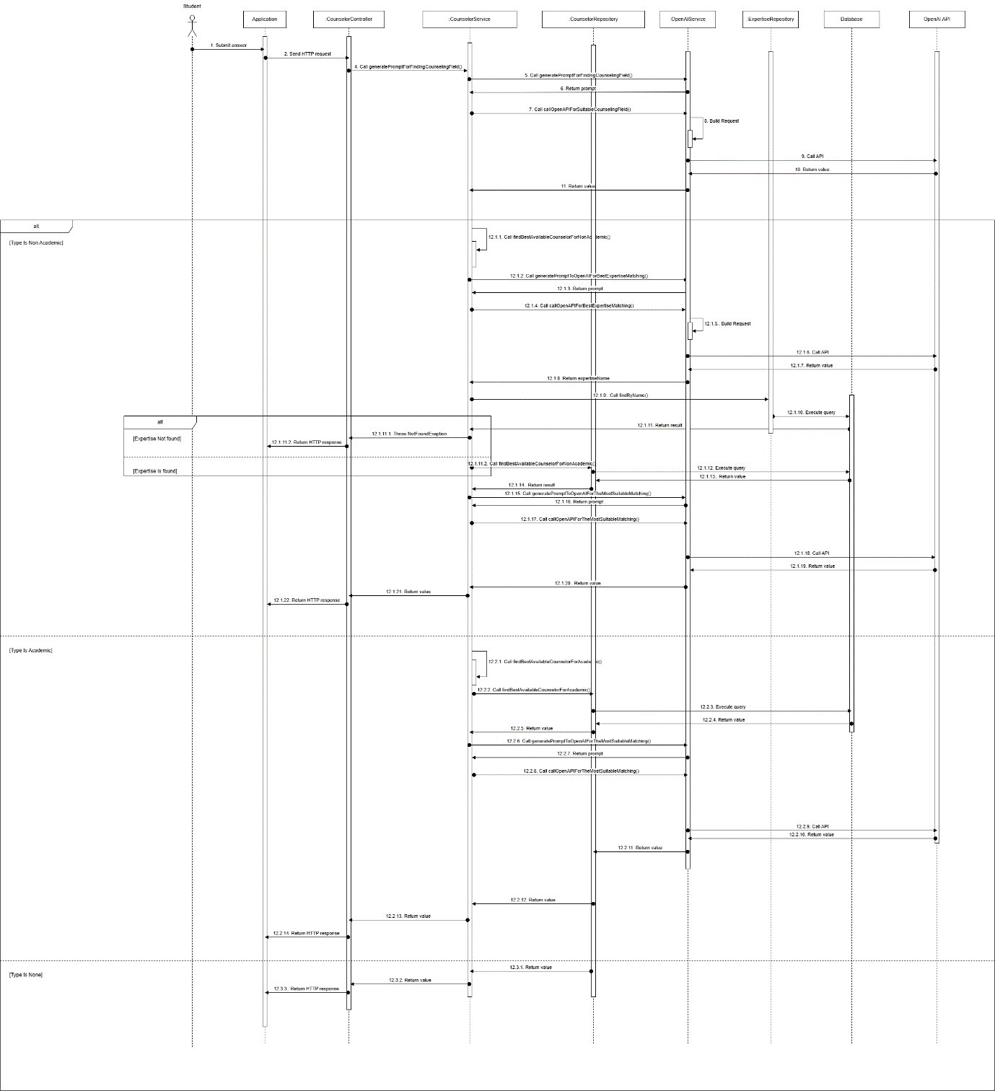

Figure - Student quick matching counselor sequence diagram

3.1.2.1.2. Student creates appointment request

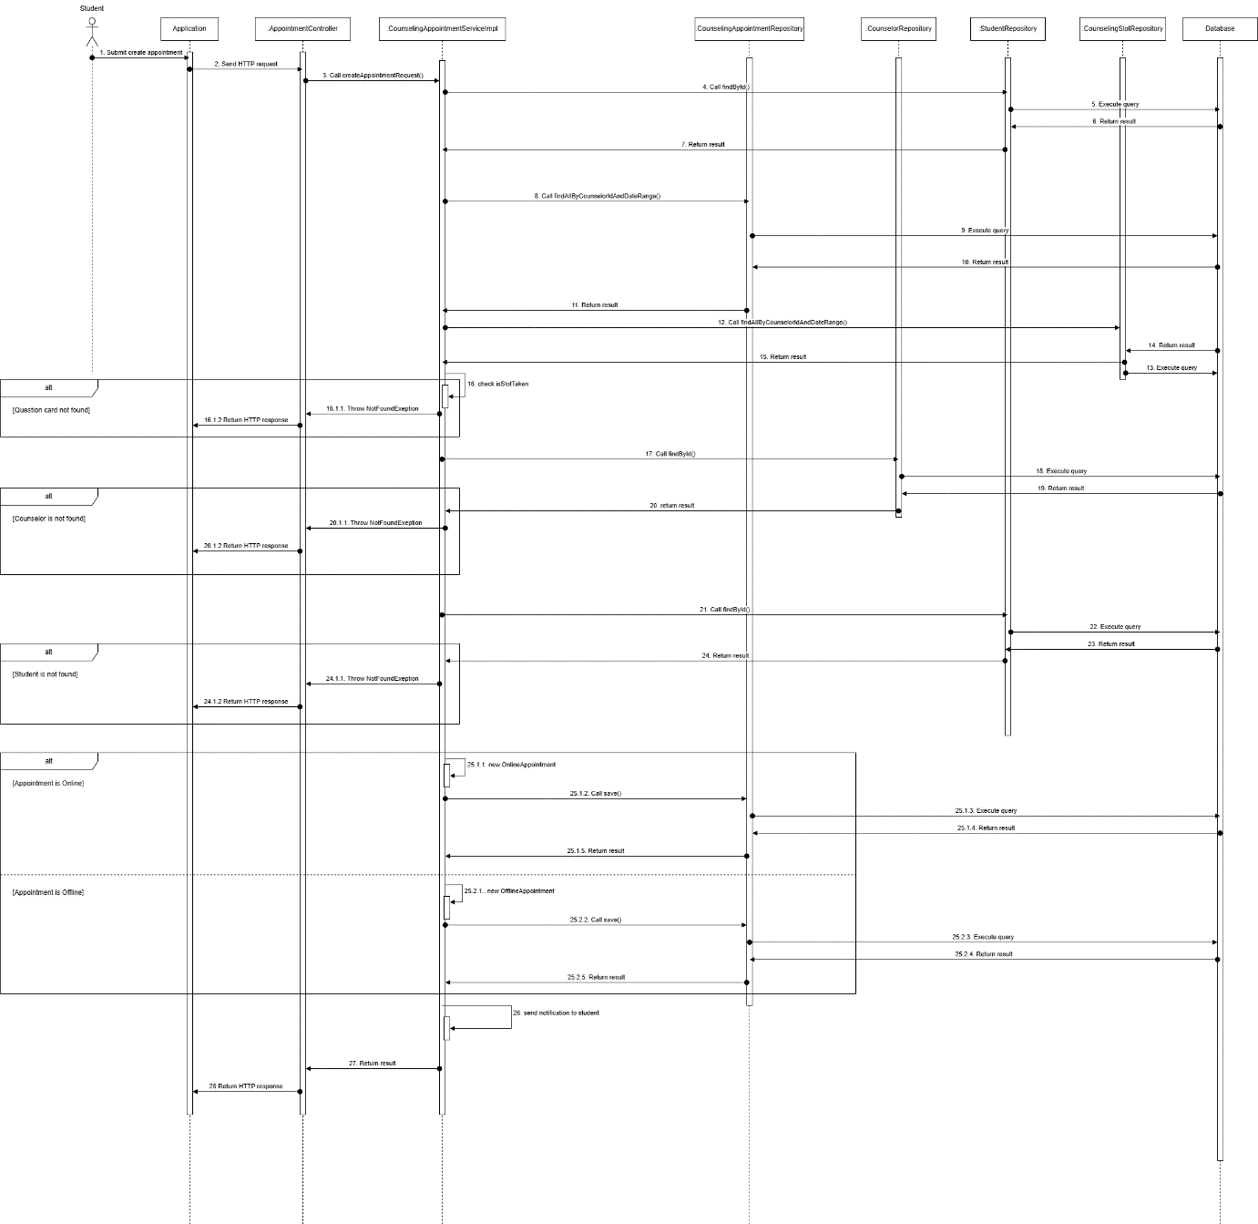

Figure - Student creates appointment request sequence diagram

###### 3.1.2.1.3. Counselor approves appointment request

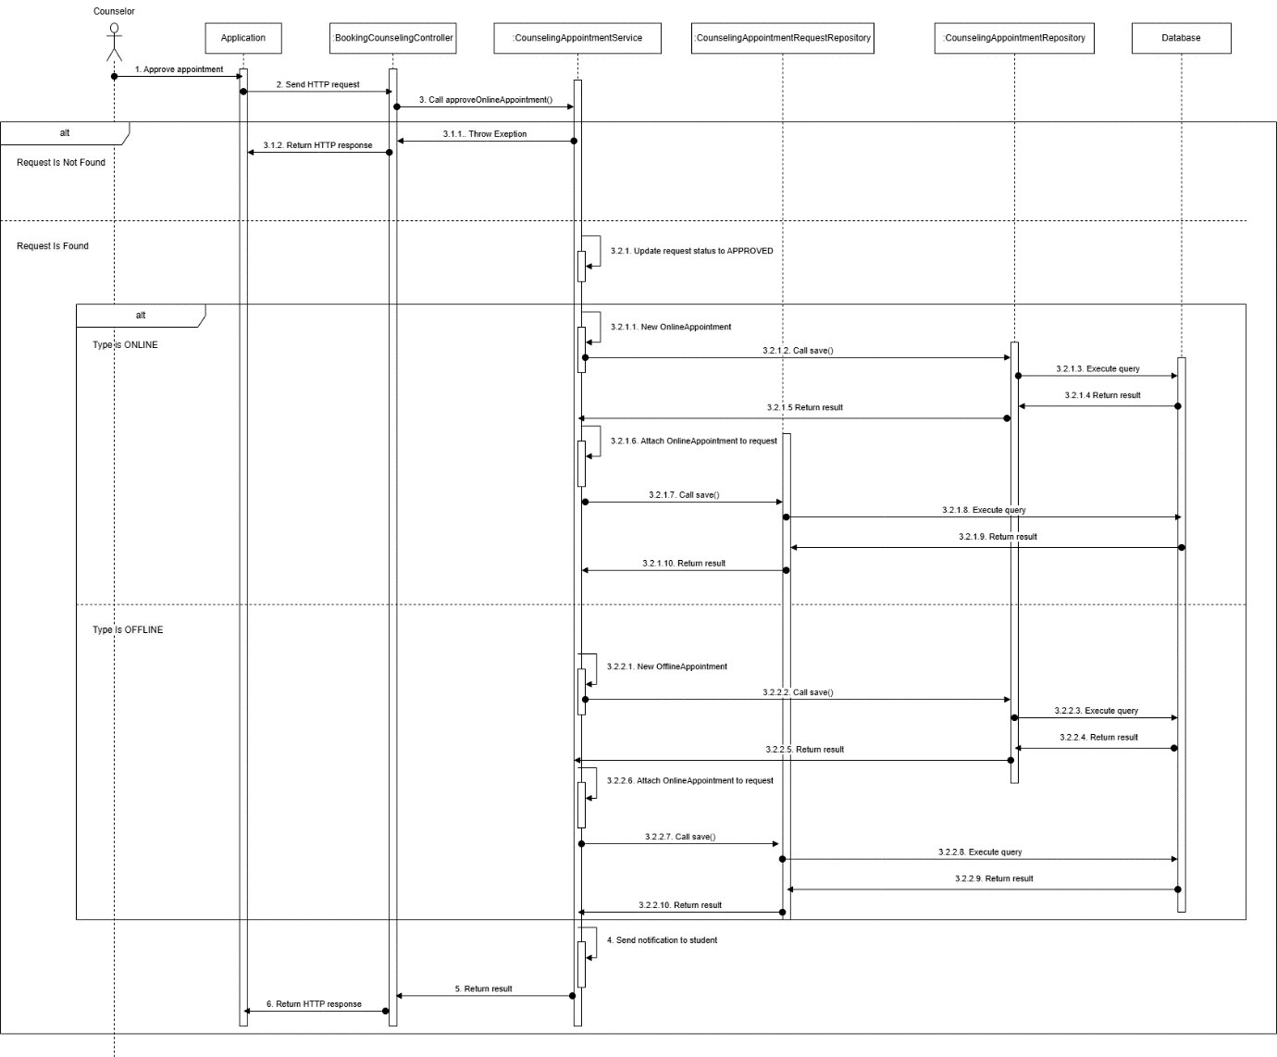

Figure - Counselor Approves appointment request sequence diagram

###### 3.1.2.1.4. Take attendance

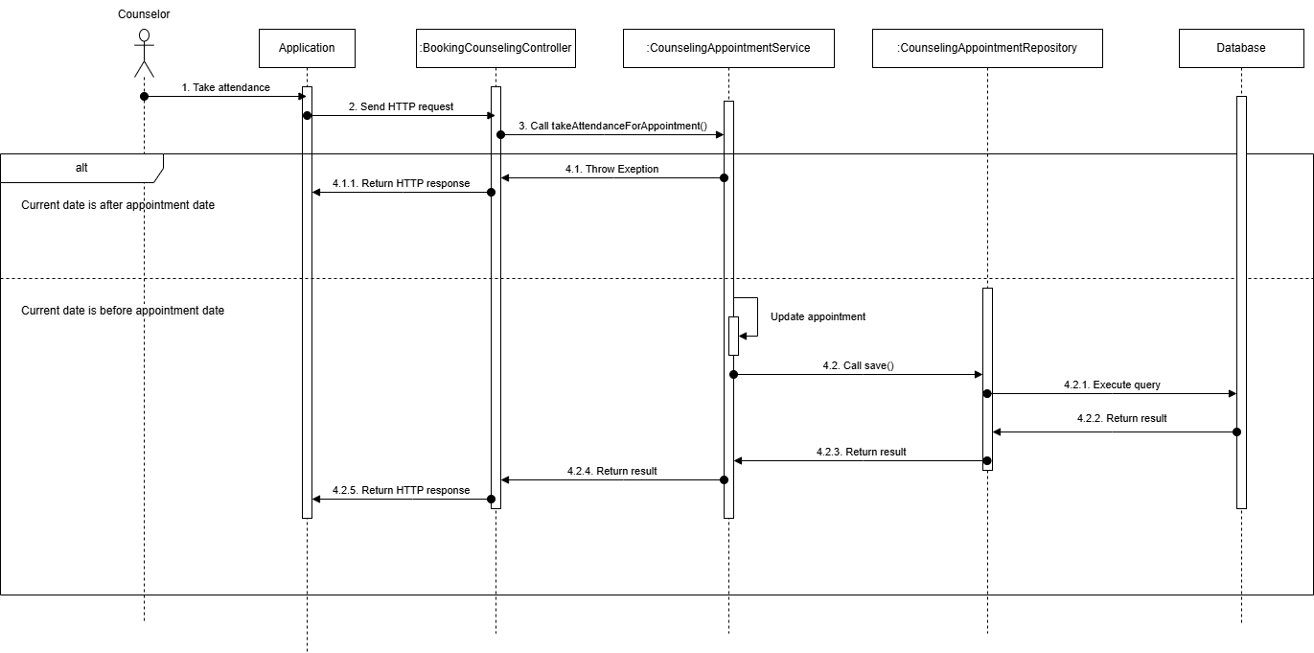

Figure - Take attendance sequence diagram

###### 3.1.2.1.5. Student provide feedback

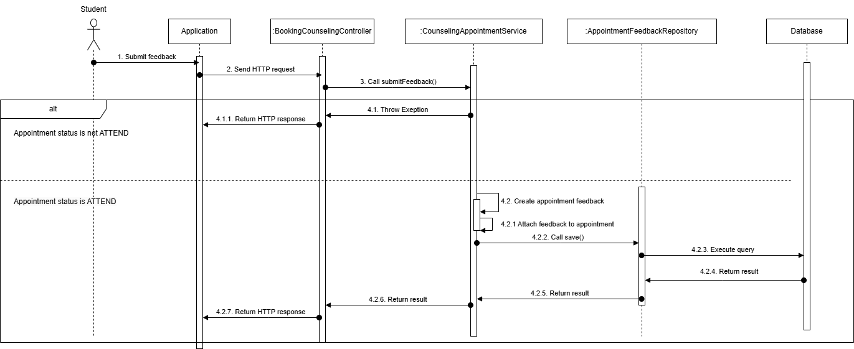

Figure - Student provide feedback sequence diagram

###### 3.1.2.1.6. Counselor cancel appointment

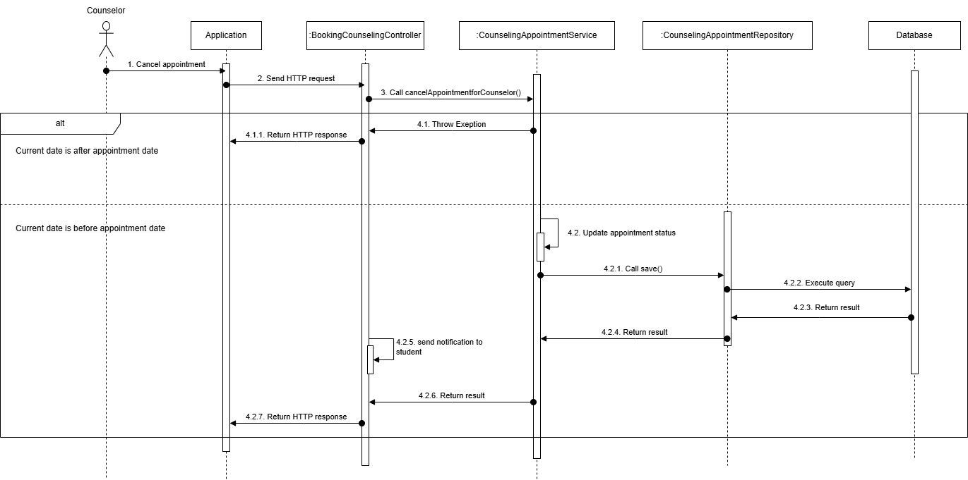

Figure – Counselor cancel appointment sequence diagram

###### 3.1.2.1.7. Student cancel appointment

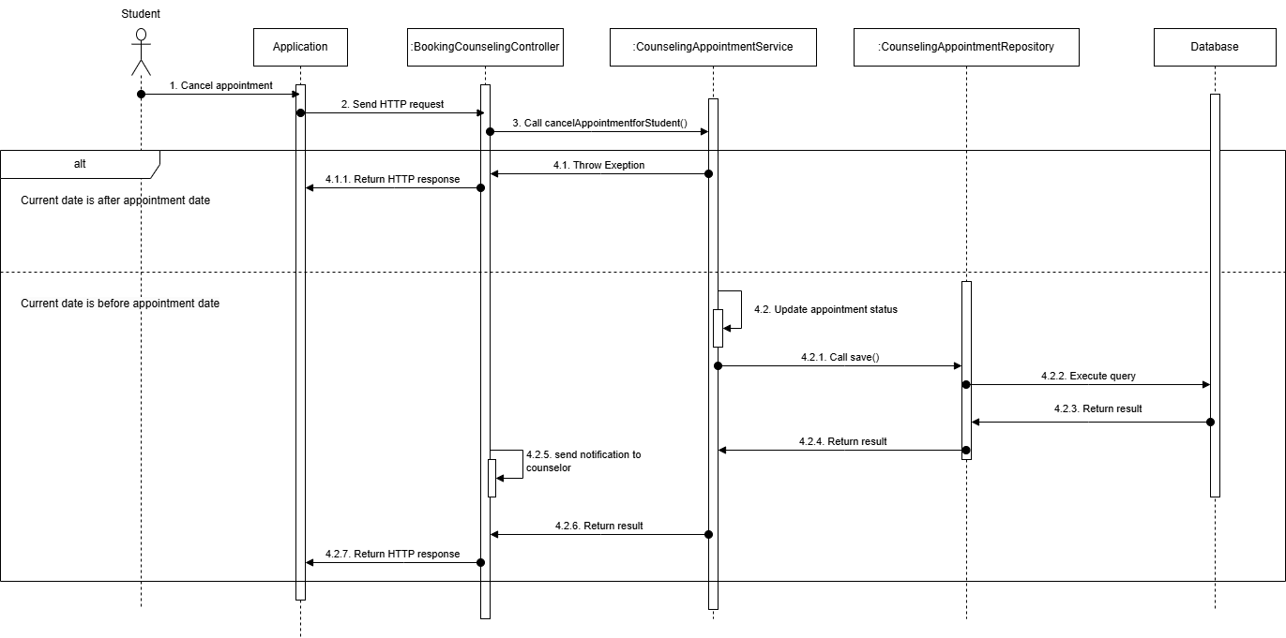

Figure - Student cancel appointment sequence diagram

#### 3.1.3. Activity Diagram

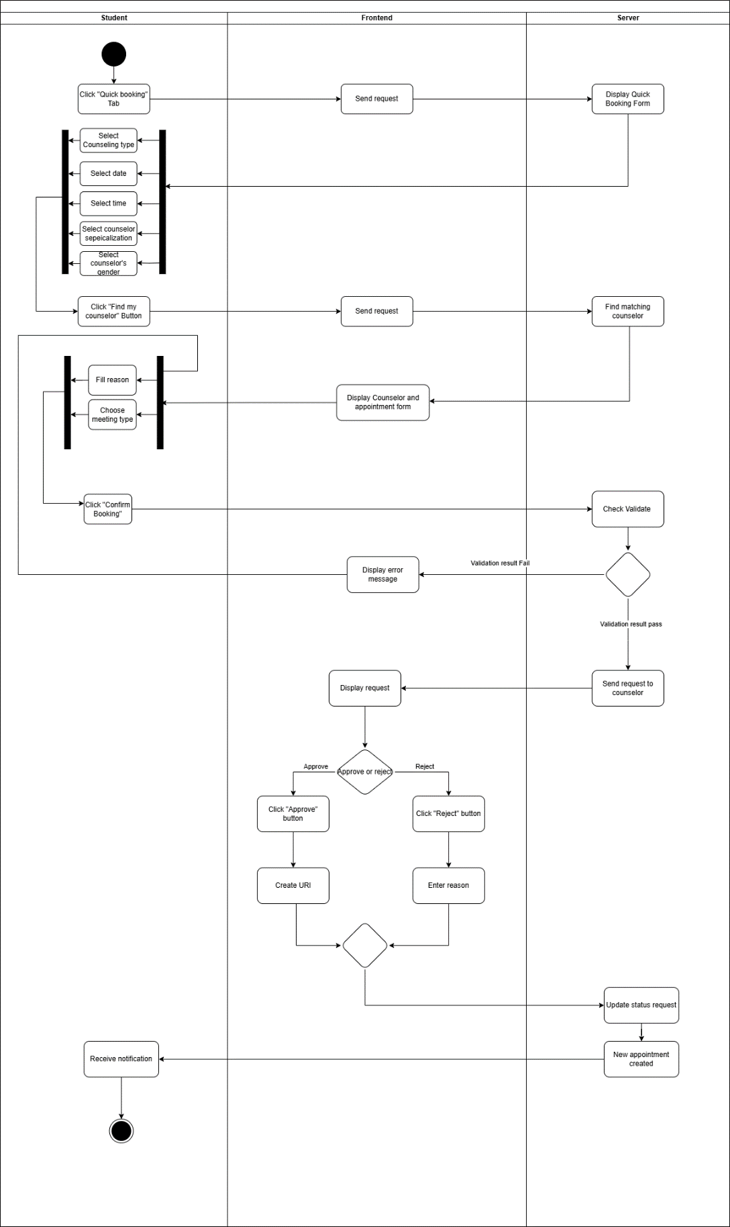3.1.3.1. Create Booking request with quick booking

Figure - Create Booking request with quick booking activity diagram

##### 3.1.3.2. Create booking request with choosing a specific counselor

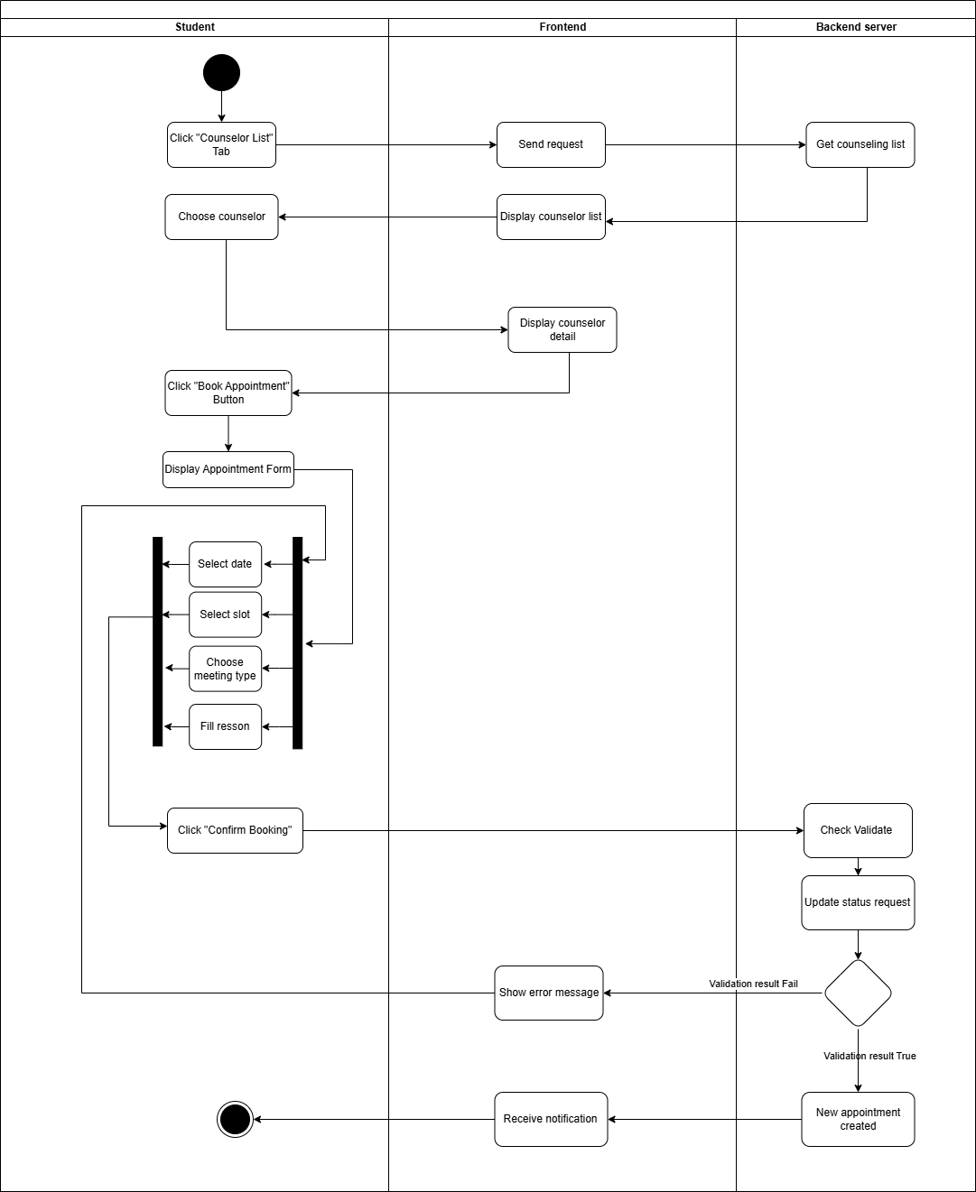

Figure - Create booking request with choosing a specific counselor activity diagram

##### 3.1.3.3. Take attendance

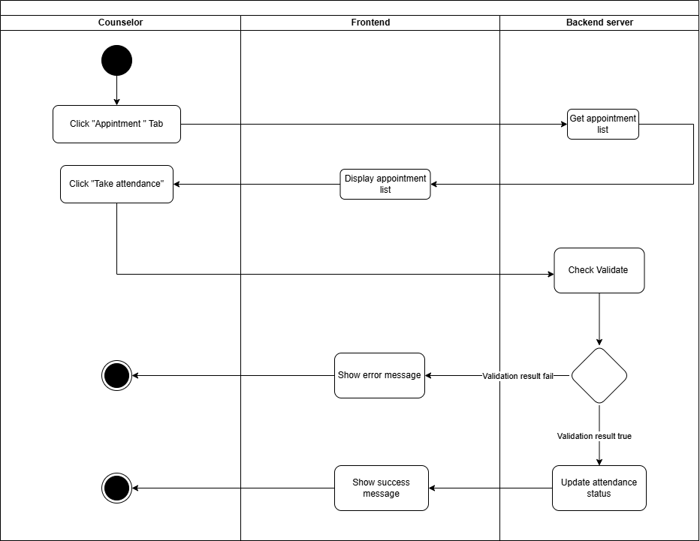

Figure - Take attendance activity diagram

##### 3.1.3.4. Provide Feedback

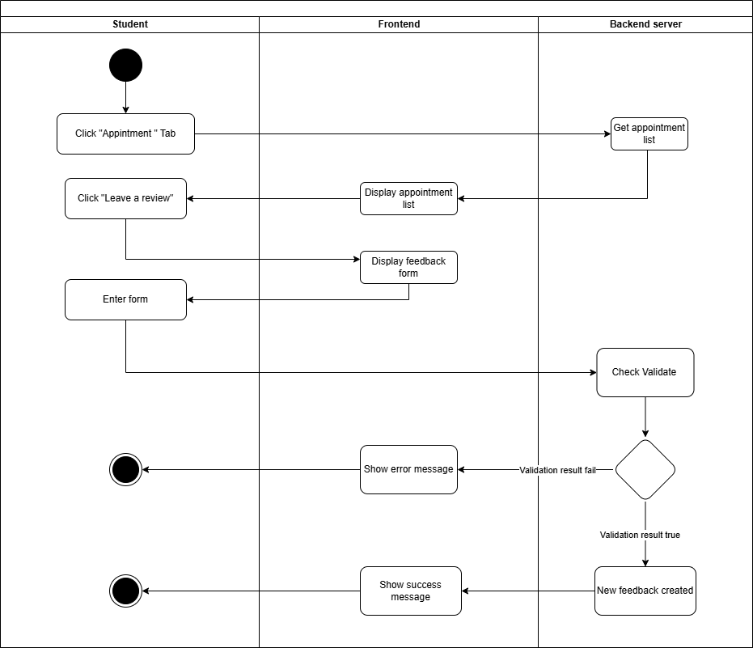

Figure - Provide Feedback activity diagram

##### 3.1.3.5. Cancel Appointment

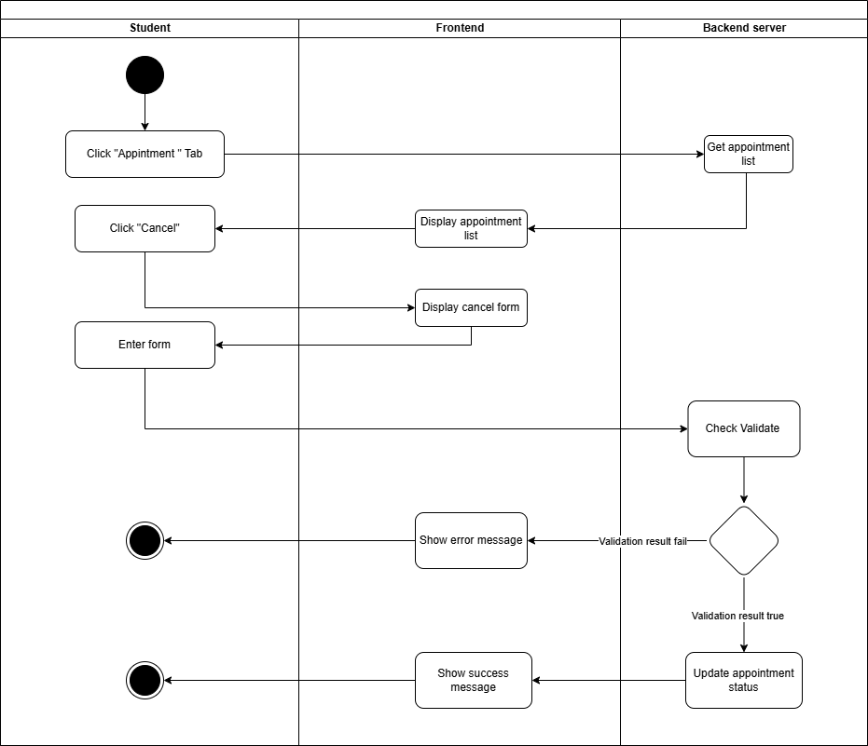

Figure - Cancel Appointment activity diagram

**3.1.3.6. Approve appointment request**

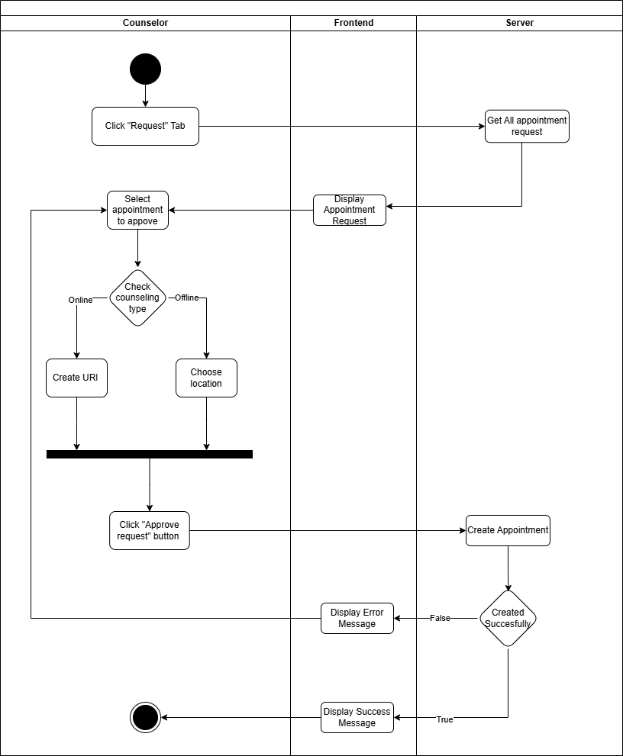

Figure - Approve appointment request activity diagram

**3.1.3.7. Create report**

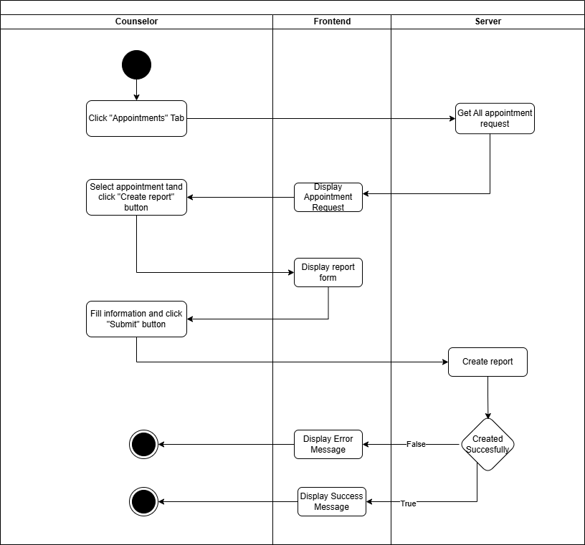

Figure - Create report activity diagram

#### 3.1.4. State Machine Diagram

##### 3.1.4.1. Booking Appointment State Machine Diagram

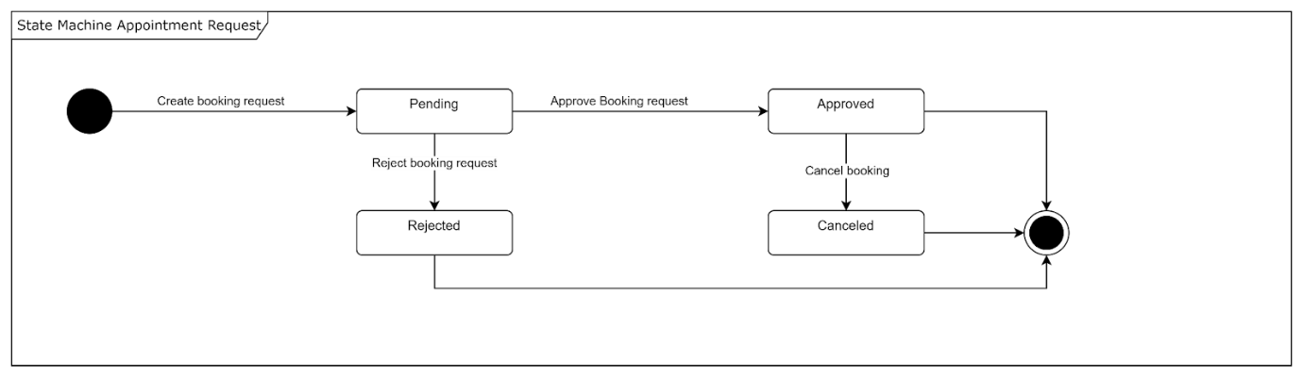

Figure - Booking Appointment State Machine Diagram

##### 3.1.4.2. Taking Appointment State Machine Diagram

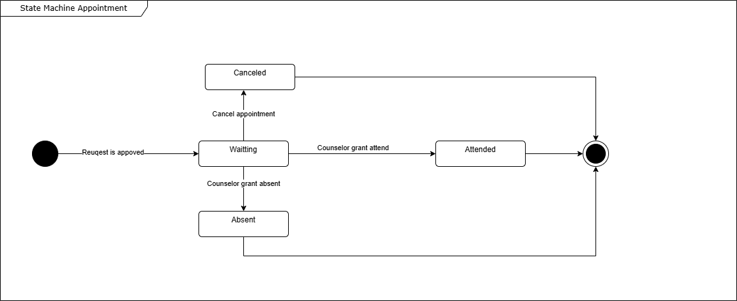

### 3.2. Student Questions and Counselor Support

#### 3.2.1. Class Diagram

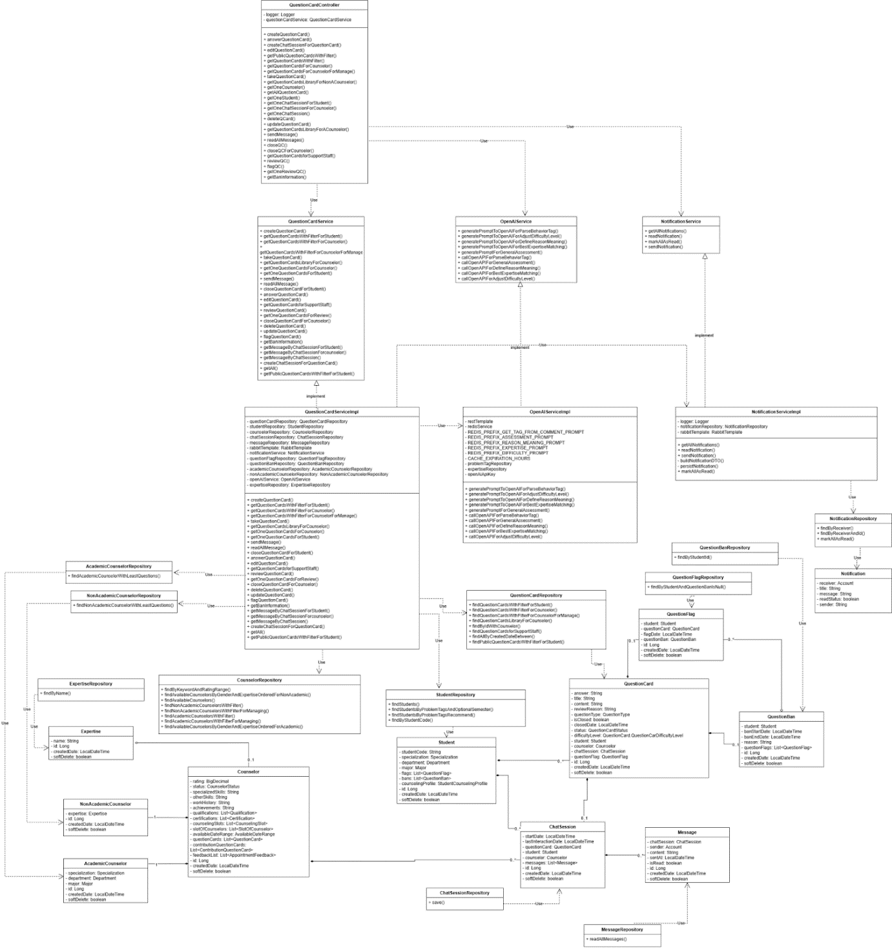

Figure - Student Questions and Counselor Support class diagram

##### 3.2.1.1. Class Specification

###### 3.2.1.1.1. Counselor class

Table - Counselor class

|  |  |  |  |  |
| --- | --- | --- | --- | --- |
| **No** | **Attribute** | **Data Type** | **Visibility** | **Description** |
| 1 | rating | BigDecimal | Private |  |
| 2 | status | CounselorStatus | Private |  |
| 3 | specializedSkills | String | Private |  |
| 4 | otherSkills | String | Private |  |
| 5 | workHistory | String | Private |  |
| 6 | achievements | String | Private |  |
| 7 | qualifications | List<Qualification> | Private |  |
| 8 | certifications | List<Certification> | Private |  |
| 9 | counselingSlots | List<CounselingSlot> | Private |  |
| 10 | slotOfCounselors | List<SlotOfCounselor> | Private |  |
| 11 | availableDateRange | AvailableDateRange | Private |  |
| 12 | questionCards | List<QuestionCard> | Private |  |
| 13 | contributionQuestionCards | List<ContributionQuestionCard> | Private |  |
| 14 | feedbackList | List<AppointmentFeedback> | Private |  |
| 15 | id | Long | Private |  |
| 16 | createdDate | LocalDateTime | Private |  |
| 17 | softDelete | boolean | Private |  |

###### 3.2.1.1.2 . StudentRepository class

Table – StudentRepository method class

|  |  |  |  |
| --- | --- | --- | --- |
| **No** | **Method** | **Visibility** | **Description** |
| 1 | findStudents() | Public |  |
| 2 | findStudentsByProblemTagsAndOptionalSemester() | Public |  |
| 3 | findStudentsByProblemTagsRecommend() | Public |  |
| 4 | findByStudentCode() | Public |  |

###### 3.2.1.1.3. CounselorRepository class

Table – CounselorRepository method class

|  |  |  |  |
| --- | --- | --- | --- |
| **No** | **Method** | **Visibility** | **Description** |
| 1 | findByKeywordAndRatingRange() | Public |  |
| 2 | findAvailableCounselorsByGenderAndExpertiseOrderedForNonAcademic() | Public |  |
| 3 | findAvailableCounselors() | Public |  |
| 4 | findNonAcademicCounselorsWithFilter() | Public |  |
| 5 | findNonAcademicCounselorsWithFilterForManaging() | Public |  |
| 6 | findAcademicCounselorsWithFilter() | Public |  |
| 7 | findAcademicCounselorsWithFilterForManaging() | Public |  |
| 8 | findAvailableCounselorsByGenderAndExpertiseOrderedForAcademic() | Public |  |

###### 3.2.1.1.4. Student class

Table - Student class

|  |  |  |  |  |
| --- | --- | --- | --- | --- |
| **No** | **Attribute** | **Data Type** | **Visibility** | **Description** |
| 1 | studentCode | String | Private |  |
| 2 | specialization | Specialization | Private |  |
| 3 | department | Department | Private |  |
| 4 | major | Major | Private |  |
| 5 | flags | List<QuestionFlag> | Private |  |
| 6 | bans | List<QuestionBan> | Private |  |
| 7 | counselingProfile | StudentCounselingProfile | Private |  |
| 8 | id | Long | Private |  |
| 9 | createdDate | LocalDateTime | Private |  |
| 10 | softDelete | boolean | Private |  |

###### 3.2.1.1.5. QuestionCard class

Table - QuestionCard class

|  |  |  |  |  |
| --- | --- | --- | --- | --- |
| **No** | **Attribute** | **Data Type** | **Visibility** | **Description** |
| 1 | answer | String | Private |  |
| 2 | title | String | Private |  |
| 3 | content | String | Private |  |
| 4 | reviewReason | String | Private |  |
| 5 | questionType | QuestionType | Private |  |
| 6 | isClosed | boolean | Private |  |
| 7 | closedDate | LocalDateTime | Private |  |
| 8 | status | QuestionCardStatus | Private |  |
| 9 | difficultyLevel: | LocalDateTime | Private |  |
| 10 | QuestionCard | QuestionCarDifficultyLevel | Private |  |
| 11 | student | Student | Private |  |
| 12 | counselor | Counselor | Private |  |
| 13 | chatSession | ChatSession | Private |  |
| 14 | questionFlag | QuestionFlag | Private |  |
| 15 | id | Long | Private |  |
| 16 | createdDate | LocalDateTime | Private |  |
| 17 | softDelete | boolean | Private |  |

###### 3.2.1.1.6. QuestionBan class

Table - QuestionBan class

|  |  |  |  |  |
| --- | --- | --- | --- | --- |
| **No** | **Attribute** | **Data Type** | **Visibility** | **Description** |
| 1 | student: | Student | Private |  |
| 2 | banStartDate | LocalDateTime | Private |  |
| 3 | banEndDate | LocalDateTime | Private |  |
| 4 | reason | String | Private |  |
| 5 | questionFlags | List<QuestionFlag> | Private |  |
| 6 | id | Long | Private |  |
| 7 | createdDate: | LocalDateTime | Private |  |
| 8 | softDelete: | boolean | Private |  |

###### 3.2.1.1.7. NotificationService class

Table – NotificationService method class

|  |  |  |  |
| --- | --- | --- | --- |
| **No** | **Method** | **Visibility** | **Description** |
| 1 | getAllNotifications() | Public |  |
| 2 | readNotification() | Public |  |
| 3 | markAllAsRead() | Public |  |
| 4 | sendNotification() | Public |  |

###### 3.2.1.1.8. NotificationServiceImpl class

Table - NotificationServiceImpl class

|  |  |  |  |  |
| --- | --- | --- | --- | --- |
| **No** | **Attribute** | **Data Type** | **Visibility** | **Description** |
| 1 | logger | Logger | Private |  |
| 2 | notificationRepository | NotificationRepository | Private |  |
| 3 | rabbitTemplate | RabbitTemplate | Private |  |

Table - NotificationServiceImpl method class

|  |  |  |  |
| --- | --- | --- | --- |
| **No** | **Method** | **Visibility** | **Description** |
| 1 | getAllNotifications() | Public |  |
| 2 | readNotification() | Public |  |
| 3 | sendNotification() | Public |  |
| 4 | buildNotificationDTO() | Private |  |
| 5 | persistNotification() | Private |  |
| 6 | markAllAsRead() | Public |  |

###### 3.2.1.1.9 . NotificationRepository class

Table - NotificationRepository method class

|  |  |  |  |
| --- | --- | --- | --- |
| **No** | **Method** | **Visibility** | **Description** |
| 1 | findByReceiver() | Public |  |
| 2 | findByReceiverAndId() | Public |  |
| 3 | markAllAsRead() | Public |  |

###### 3.2.1.1.10. Notification class

Table - Notification class

|  |  |  |  |  |
| --- | --- | --- | --- | --- |
| **No** | **Attribute** | **Data Type** | **Visibility** | **Description** |
| 1 | receiver | Account | Private |  |
| 2 | title | String | Private |  |
| 3 | message | String | Private |  |
| 4 | readStatus | boolean | Private |  |
| 5 | sender | String | Private |  |

###### 3.2.1.1.11. ChatSession class

Table - ChatSession class

|  |  |  |  |  |
| --- | --- | --- | --- | --- |
| **No** | **Attribute** | **Data Type** | **Visibility** | **Description** |
| 1 | startDate | LocalDateTime | Private |  |
| 2 | startDate | LocalDateTime | Private |  |
| 3 | questionCard | QuestionCard | Private |  |
| 4 | student | Student | Private |  |
| 5 | counselor | Counselor | Private |  |
| 6 | messages | List<Message> | Private |  |
| 7 | id | Long | Private |  |
| 8 | createdDate | LocalDateTime | Private |  |
| 9 | softDelete | boolean | Private |  |

###### 3.2.1.1.12. Message class

Table - Message class

|  |  |  |  |  |
| --- | --- | --- | --- | --- |
| **No** | **Attribute** | **Data Type** | **Visibility** | **Description** |
| 1 | chatSession | ChatSession | Private |  |
| 2 | sender | Account | Private |  |
| 3 | content | String | Private |  |
| 4 | sentAt | LocalDateTime | Private |  |
| 6 | isRead | boolean | Private |  |
| 7 | id | Long | Private |  |
| 8 | createdDate | LocalDateTime | Private |  |
| 9 | softDelete | boolean | Private |  |

###### 3.2.1.1.13. MessageRepository class

Table - MessageRepository method class

|  |  |  |  |
| --- | --- | --- | --- |
| **No** | **Method** | **Visibility** | **Description** |
| 1 | readAllMessages() | Public |  |

###### 3.2.1.1.14. MessageRepository class

Table - MessageRepository method class

|  |  |  |  |
| --- | --- | --- | --- |
| **No** | **Method** | **Visibility** | **Description** |
| 1 | save() | Public |  |

###### 3.2.1.1.15. QuestionFlag class

Table - QuestionFlag class

|  |  |  |  |  |
| --- | --- | --- | --- | --- |
| **No** | **Attribute** | **Data Type** | **Visibility** | **Description** |
| 1 | student | Student | Private |  |
| 2 | questionCard | QuestionCard | Private |  |
| 3 | flagDate | LocalDateTime | Private |  |
| 4 | questionBan | QuestionBan | Private |  |
| 6 | isRead | boolean | Private |  |
| 7 | id | Long | Private |  |
| 8 | createdDate | LocalDateTime | Private |  |
| 9 | softDelete | boolean | Private |  |

###### 3.2.1.1.16. QuestionFlagRepository class

Table - QuestionFlagRepository class

|  |  |  |  |
| --- | --- | --- | --- |
| **No** | **Method** | **Visibility** | **Description** |
| 1 | findByStudentAndQuestionBanIsNull() | Public |  |

###### 3.2.1.1.17. QuestionBanRepository class

Table - QuestionBanRepository method class

|  |  |  |  |
| --- | --- | --- | --- |
| **No** | **Method** | **Visibility** | **Description** |
| 1 | findByStudentId() | Public |  |

###### 3.2.1.1.18. QuestionCardServiceImpl class

Table - QuestionCardServiceImpl class

|  |  |  |  |  |
| --- | --- | --- | --- | --- |
| **No** | **Attribute** | **Data Type** | **Visibility** | **Description** |
| 1 | questionCardRepository | QuestionCardRepository | Private |  |
| 2 | studentRepository | StudentRepository | Private |  |
| 3 | counselorRepository | CounselorRepository | Private |  |
| 4 | chatSessionRepository | ChatSessionRepository | Private |  |
| 5 | messageRepository | MessageRepository | Private |  |
| 6 | rabbitTemplate | RabbitTemplate | Private |  |
| 7 | notificationService | NotificationService | Private |  |
| 8 | questionFlagRepository | QuestionFlagRepository | Private |  |
| 9 | questionBanRepository | QuestionBanRepository | Private |  |
| 10 | academicCounselorRepository | AcademicCounselorRepository | Private |  |
| 11 | nonAcademicCounselorRepository | NonAcademicCounselorRepository | Private |  |
| 12 | openAIService | OpenAIService | Private |  |
| 13 | expertiseRepository | ExpertiseRepository | Private |  |

Table - QuestionCardServiceImpl method class

|  |  |  |  |
| --- | --- | --- | --- |
| **No** | **Method** | **Visibility** | **Description** |
| 1 | createQuestionCard() | Public |  |
| 2 | getQuestionCardsWithFilterForStudent() | Public |  |
| 3 | getQuestionCardsWithFilterForCounselor() | Public |  |
| 4 | getQuestionCardsWithFilterForCounselorForManage() | Public |  |
| 5 | takeQuestionCard() | Public |  |
| 6 | getQuestionCardsLibraryForCounselor() | Public |  |
| 7 | getOneQuestionCardsForCounselor() | Public |  |
| 8 | getOneQuestionCardsForStudent() | Public |  |
| 9 | sendMessage() | Public |  |
| 10 | readAllMessage() | Public |  |
| 11 | closeQuestionCardForStudent() | Public |  |
| 12 | answerQuestionCard() | Public |  |
| 13 | editQuestionCard() | Public |  |
| 14 | getQuestionCardsforSupportStaff() | Public |  |
| 15 | reviewQuestionCard() | Public |  |
| 16 | getOneQuestionCardsForReview() | Public |  |
| 17 | closeQuestionCardForCounselor() | Public |  |
| 18 | deleteQuestionCard() | Public |  |
| 19 | updateQuestionCard() | Public |  |
| 20 | flagQuestionCard() | Public |  |
| 21 | getBanInformation() | Public |  |
| 22 | getMessageByChatSessionForStudent() | Public |  |
| 23 | getMessageByChatSessionForCounselor() | Public |  |
| 24 | getMessageByChatSession() | Public |  |
| 25 | createChatSessionForQuestionCard() | Public |  |
| 26 | getAll() | Public |  |
| 27 | getPublicQuestionCardsWithFilterForStudent() | Public |  |

###### 3.2.1.1.19. QuestionCardController class

Table - QuestionCardController class

|  |  |  |  |  |
| --- | --- | --- | --- | --- |
| **No** | **Attribute** | **Data Type** | **Visibility** | **Description** |
| 1 | logger | Logger | Private |  |
| 2 | questionCardService | QuestionCardService | Private |  |

Table - QuestionCardController method class

|  |  |  |  |
| --- | --- | --- | --- |
| **No** | **Method** | **Visibility** | **Description** |
| 1 | createQuestionCard() | Public |  |
| 2 | answerQuestionCard() | Public |  |
| 3 | createChatSessionForQuestionCard() | Public |  |
| 4 | editQuestionCard() | Public |  |
| 5 | getPublicQuestionCardsWithFilter() | Public |  |
| 6 | getQuestionCardsWithFilter() | Public |  |
| 7 | getQuestionCardsForCounselor() | Public |  |
| 8 | getQuestionCardsForCounselorForManage() | Public |  |
| 9 | takeQuestionCard() | Public |  |
| 10 | getQuestionCardsLibraryForNonACounselor() | Public |  |
| 11 | getOneCounselor() | Public |  |
| 12 | getAllQuestionCard() | Public |  |
| 13 | getOneStudent() | Public |  |
| 14 | getOneChatSessionForStudent() | Public |  |
| 15 | getOneChatSessionForCounselor() | Public |  |
| 16 | getOneChatSession() | Public |  |
| 17 | deleteQCard() | Public |  |
| 18 | updateQuestionCard() | Public |  |
| 19 | getQuestionCardsLibraryForACounselor() | Public |  |
| 20 | sendMessage() | Public |  |
| 21 | readAllMessages() | Public |  |
| 22 | closeQC() | Public |  |
| 23 | closeQCForCounselor() | Public |  |
| 24 | getQuestionCardsforSupportStaff() | Public |  |
| 25 | reviewQC() | Public |  |
| 26 | flagQC() | Public |  |
| 27 | getOneReviewQC() | Public |  |
| 28 | getBanInformation() | Public |  |

###### 3.2.1.1.20. QuestionCardController class

Table - QuestionCardController method class

|  |  |  |  |
| --- | --- | --- | --- |
| **No** | **Method** | **Visibility** | **Description** |
| 1 | createQuestionCard() | Public |  |
| 2 | getQuestionCardsWithFilterForStudent() | Public |  |
| 3 | getQuestionCardsWithFilterForCounselor() | Public |  |
| 4 | getQuestionCardsWithFilterForCounselorForManage() | Public |  |
| 5 | takeQuestionCard() | Public |  |
| 6 | getQuestionCardsLibraryForCounselor() | Public |  |
| 7 | getOneQuestionCardsForCounselor() | Public |  |
| 8 | getOneQuestionCardsForStudent() | Public |  |
| 9 | sendMessage() | Public |  |
| 10 | readAllMessage() | Public |  |
| 11 | closeQuestionCardForStudent() | Public |  |
| 12 | answerQuestionCard() | Public |  |
| 13 | editQuestionCard() | Public |  |
| 14 | getQuestionCardsforSupportStaff() | Public |  |
| 15 | reviewQuestionCard() | Public |  |
| 16 | getOneQuestionCardsForReview() | Public |  |
| 17 | closeQuestionCardForCounselor() | Public |  |
| 18 | deleteQuestionCard() | Public |  |
| 19 | updateQuestionCard() | Public |  |
| 20 | flagQuestionCard() | Public |  |
| 21 | getBanInformation() | Public |  |
| 22 | getMessageByChatSessionForStudent() | Public |  |
| 23 | getMessageByChatSessionForcounselor() | Public |  |
| 24 | getMessageByChatSession() | Public |  |
| 25 | createChatSessionForQuestionCard() | Public |  |
| 26 | getAll() | Public |  |
| 27 | getPublicQuestionCardsWithFilterForStudent() | Public |  |

###### 3.2.1.1.21. OpenAIService class

Table - OpenAIService method class

|  |  |  |  |
| --- | --- | --- | --- |
| **No** | **Method** | **Visibility** | **Description** |
| 1 | generatePromptToOpenAIForParseBehaviorTag() | Public |  |
| 2 | generatePromptToOpenAIForAdjustDifficultyLevel() | Public |  |
| 3 | generatePromptToOpenAIForDefineReasonMeaning() | Public |  |
| 4 | generatePromptToOpenAIForBestExpertiseMatching() | Public |  |
| 5 | generatePromptForGeneralAssessment() | Public |  |
| 6 | callOpenAPIForParseBehaviorTag() | Public |  |
| 7 | callOpenAPIForGeneralAssessment() | Public |  |
| 8 | callOpenAPIForDefineReasonMeaning() | Public |  |
| 9 | callOpenAPIForBestExpertiseMatching() | Public |  |
| 10 | callOpenAPIForAdjustDifficultyLevel() | Public |  |

###### 3.2.1.1.22. QuestionCardRepository class

Table - QuestionCardRepository method class

|  |  |  |  |
| --- | --- | --- | --- |
| **No** | **Method** | **Visibility** | **Description** |
| 1 | findQuestionCardsWithFilterForStudent() | Public |  |
| 2 | findQuestionCardsWithFilterForCounselor() | Public |  |
| 3 | findQuestionCardsWithFilterForCounselorForManage() | Public |  |
| 4 | findQuestionCardsLibraryForCounselor() | Public |  |
| 5 | findByIdWithCounselor() | Public |  |
| 6 | findQuestionCardsforSupportStaff() | Public |  |
| 7 | findAllByCreatedDateBetween() | Public |  |
| 8 | findPublicQuestionCardsWithFilterForStudent() | Public |  |

###### 3.2.1.1.23. OpenAIService class

Table - OpenAIService class

|  |  |  |  |  |
| --- | --- | --- | --- | --- |
| **No** | **Attribute** | **Data Type** | **Visibility** | **Description** |
| 1 | restTemplate |  | Private |  |
| 2 | redisService |  | Private |  |
| 3 | REDIS_PREFIX_GET_TAG_FROM_COMMENT_PROMPT |  | Private |  |
| 4 | REDIS_PREFIX_ASSESSMENT_PROMPT |  | Private |  |
| 5 | REDIS_PREFIX_REASON_MEANING_PROMPT |  | Private |  |
| 6 | REDIS_PREFIX_EXPERTISE_PROMPT |  | Private |  |
| 7 | REDIS_PREFIX_DIFFICULTY_PROMPT |  | Private |  |
| 8 | CACHE_EXPIRATION_HOURS |  | Private |  |
| 9 | problemTagRepository |  | Private |  |
| 10 | expertiseRepository |  | Private |  |
| 11 | openAiApiKey |  | Private |  |

Table - OpenAIService method class

|  |  |  |  |
| --- | --- | --- | --- |
| **No** | **Method** | **Visibility** | **Description** |
| 1 | generatePromptToOpenAIForParseBehaviorTag() | Public |  |
| 2 | generatePromptToOpenAIForAdjustDifficultyLevel() | Public |  |
| 3 | generatePromptToOpenAIForDefineReasonMeaning() | Public |  |
| 4 | generatePromptToOpenAIForBestExpertiseMatching() | Public |  |
| 5 | generatePromptForGeneralAssessment() | Public |  |
| 6 | callOpenAPIForParseBehaviorTag() | Public |  |
| 7 | callOpenAPIForGeneralAssessment() | Public |  |
| 8 | callOpenAPIForDefineReasonMeaning() | Public |  |
| 9 | callOpenAPIForBestExpertiseMatching() | Public |  |
| 10 | callOpenAPIForAdjustDifficultyLevel() | Public |  |

###### 3.2.1.1.24. NonAcademicCounselor class

Table - NonAcademicCounselor class

|  |  |  |  |  |
| --- | --- | --- | --- | --- |
| **No** | **Attribute** | **Data Type** | **Visibility** | **Description** |
| 1 | expertise | Expertise | Private |  |
| 2 | id | Long | Private |  |
| 3 | createdDate | LocalDateTime | Private |  |
| 4 | softDelete | boolean | Private |  |

###### 3.2.1.1.25. AcademicCounselor class

Table - AcademicCounselor class

|  |  |  |  |  |
| --- | --- | --- | --- | --- |
| **No** | **Attribute** | **Data Type** | **Visibility** | **Description** |
| 1 | specialization | Specialization | Private |  |
| 2 | department | Department | Private |  |
| 3 | major | Major | Private |  |
| 4 | id | Long | Private |  |
| 5 | createdDate | LocalDateTime | Private |  |
| 6 | softDelete | boolean | Private |  |

###### 3.2.1.1.26. ExpertiseRepository class

Table - ExpertiseRepository method class

|  |  |  |  |
| --- | --- | --- | --- |
| **No** | **Method** | **Visibility** | **Description** |
| 1 | findByName() | Public |  |

###### 3.2.1.1.27. AcademicCounselorRepository class

Table - AcademicCounselorRepository method class

|  |  |  |  |
| --- | --- | --- | --- |
| **No** | **Method** | **Visibility** | **Description** |
| 1 | findAcademicCounselorWithLeastQuestions() | Public |  |

###### 3.2.1.1.28. NonAcademicCounselorRepository class

Table - NonAcademicCounselorRepository method class

|  |  |  |  |
| --- | --- | --- | --- |
| **No** | **Method** | **Visibility** | **Description** |
| 1 | findNonAcademicCounselorWithLeastQuestions() | Public |  |

###### 3.2.1.1.29. Expertise class

Table - Expertise class

|  |  |  |  |  |
| --- | --- | --- | --- | --- |
| **No** | **Attribute** | **Data Type** | **Visibility** | **Description** |
| 1 | name | String | Private |  |
| 2 | id | Long | Private |  |
| 3 | createdDate | LocalDateTime | Private |  |
| 4 | softDelete | boolean | Private |  |

#### 3.2.2. Sequence Diagram

##### 3.2.2.1. Student create question card

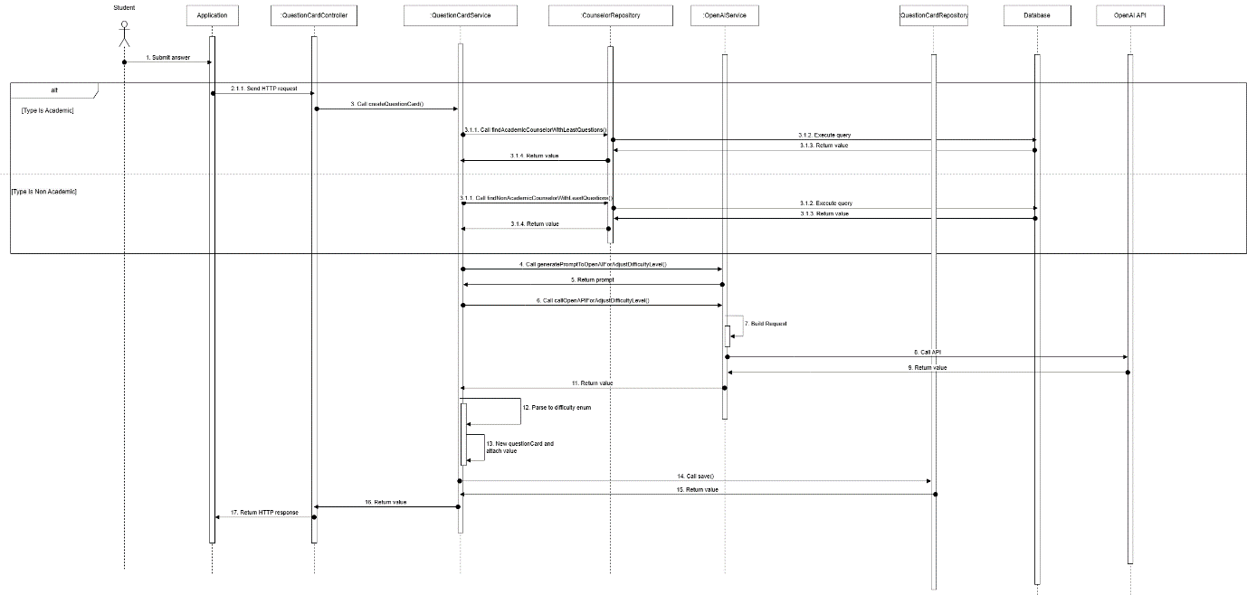

Figure - Student create question card sequence diagram

##### 3.2.2.2. Counselor answer question sequence diagram

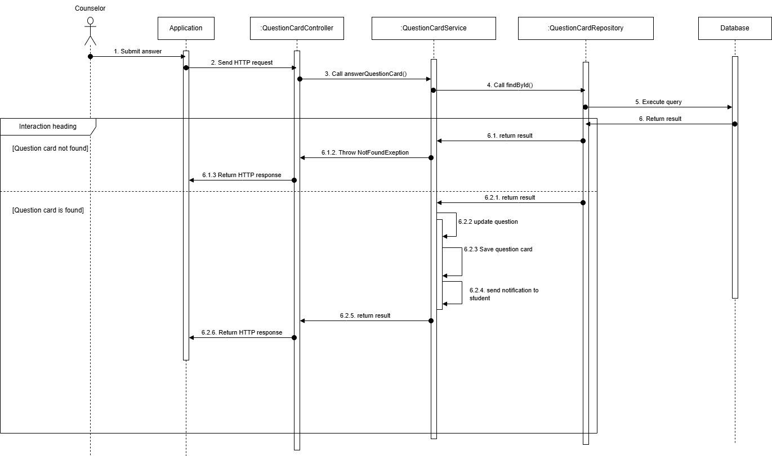

Figure – Counselor answer question sequence diagram

##### 3.2.2.3. Counselor closes question sequence diagram

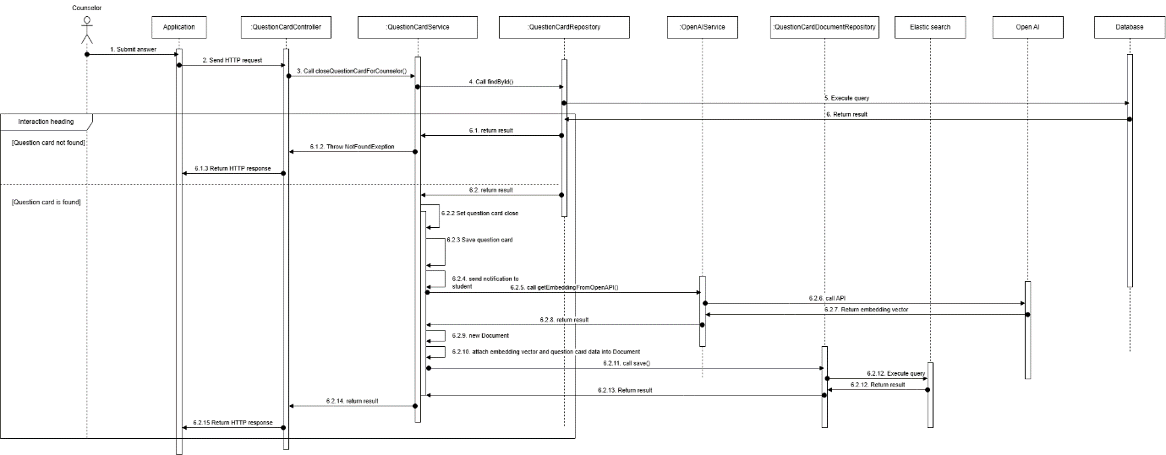

Figure - Counselor closes question sequence diagram

##### 3.2.2.4. Student accepts question sequence diagram

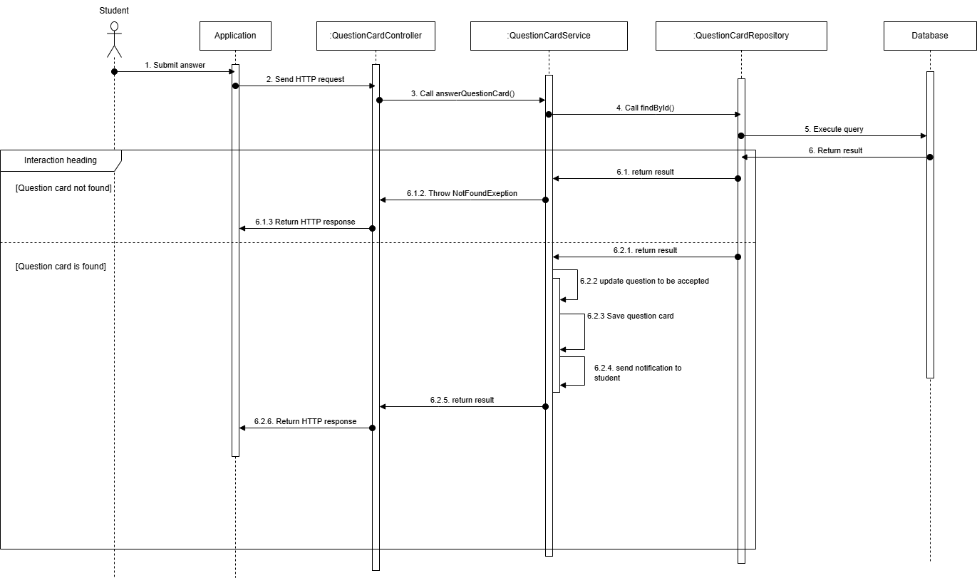

Figure - Student accepts question sequence diagram

##### 3.2.2.5 Student initiate chat sequence diagram

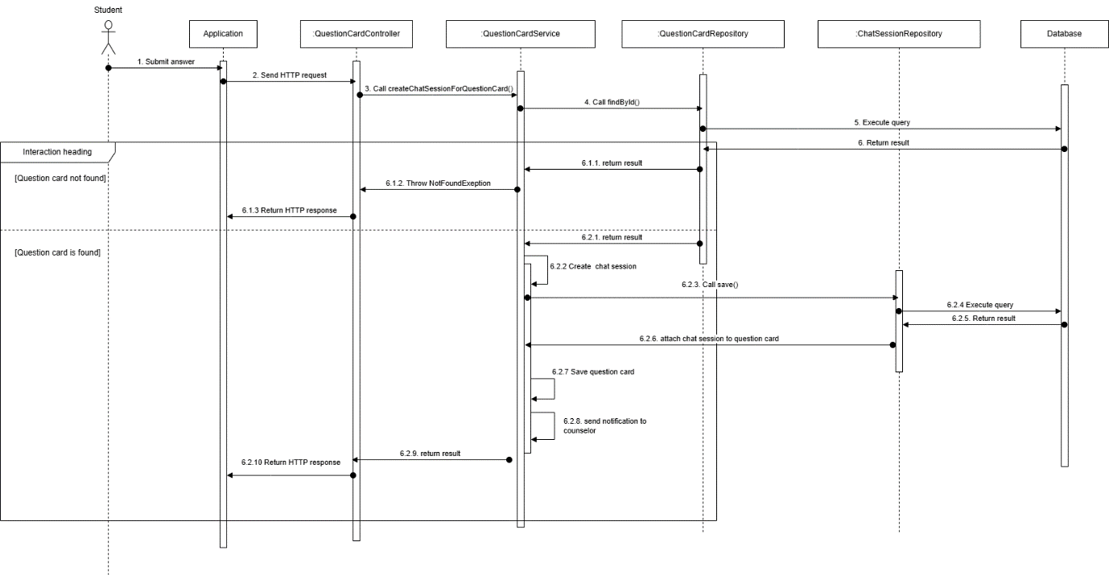

Figure - Student initiate chat sequence diagram

#### 3.2.3. Activity Diagram

##### 3.2.3.1. Create question activity diagram

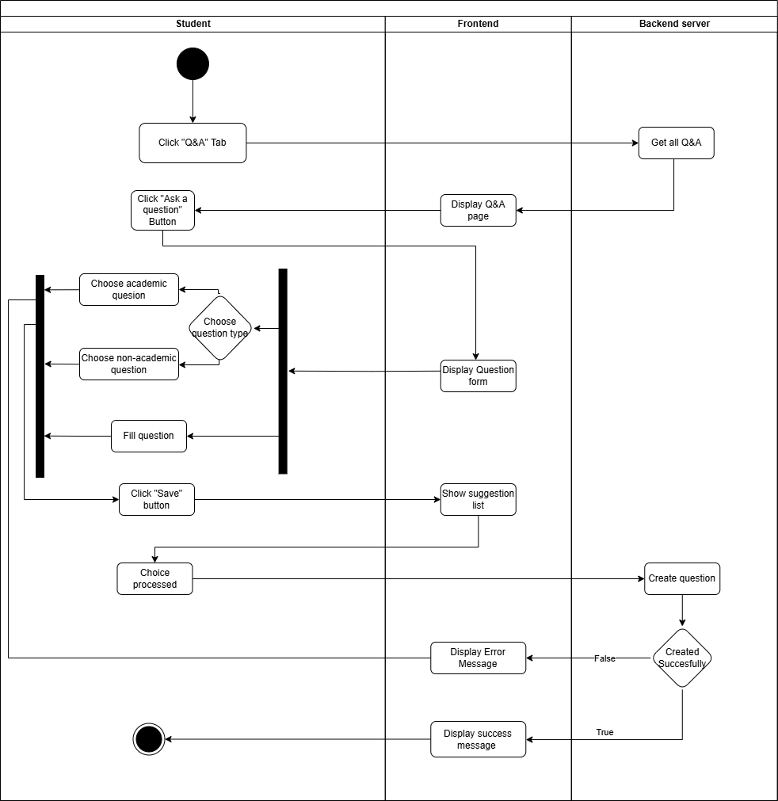

Figure - Create question activity diagram

##### 3.2.3.2. Answer question activity diagram

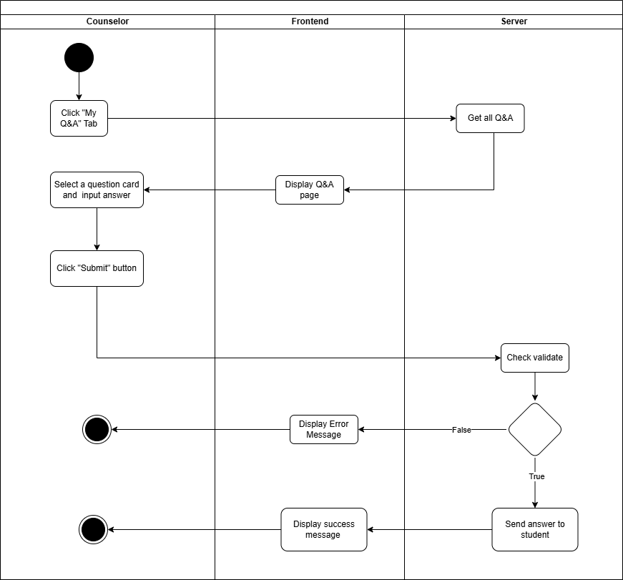

Figure - Answer question activity diagram

##### 3.2.3.3. Flag question activity diagram

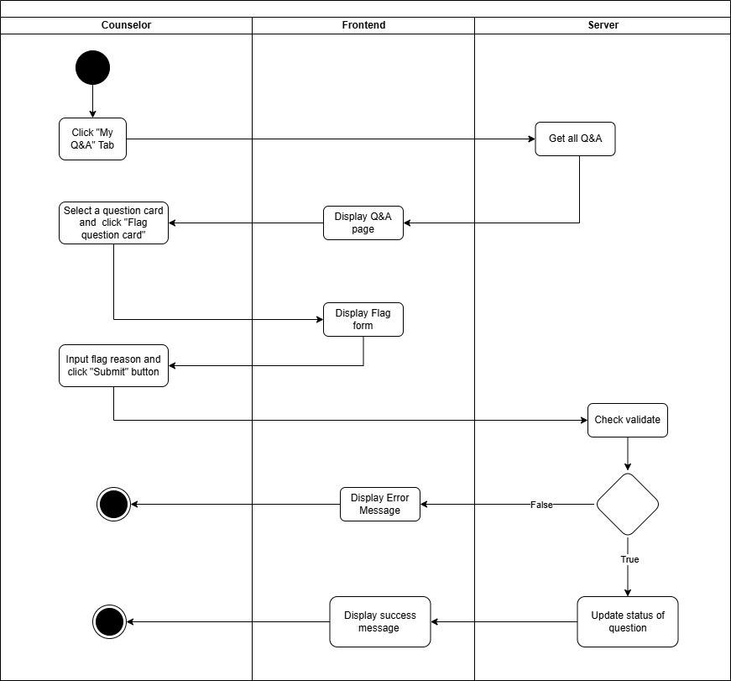

Figure - Flag question activity diagram

##### 3.2.3.4. Close question activity diagram

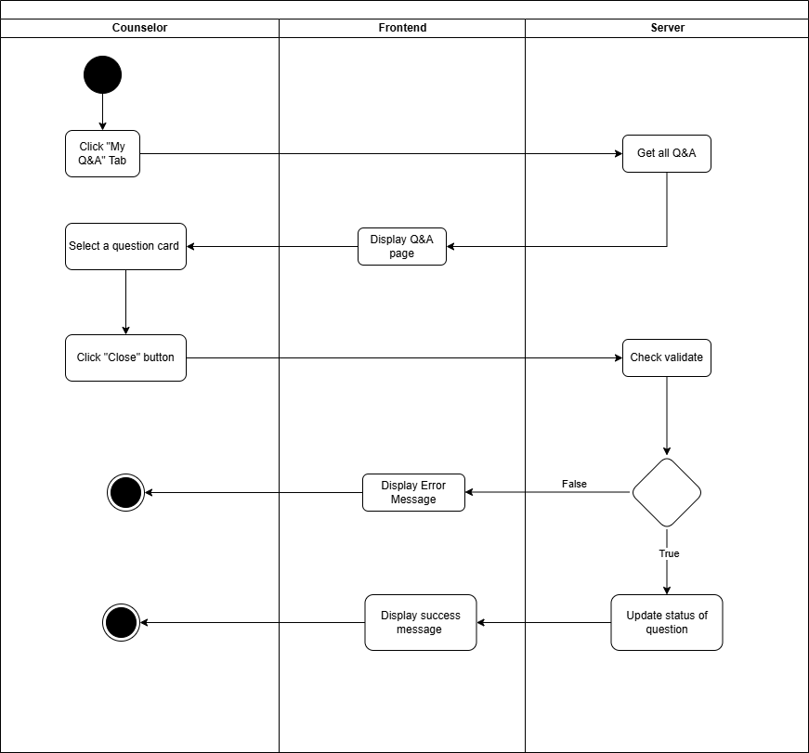

Figure - Close question activity diagram

##### 3.2.3.5. Chat in session activity diagram

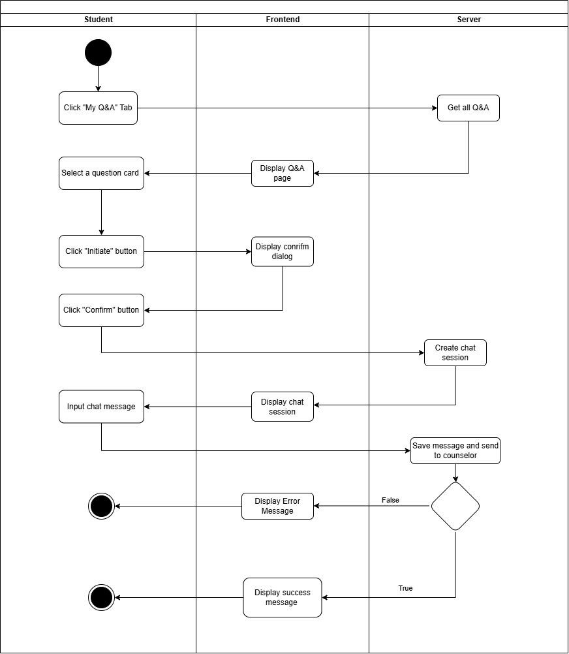

Figure - Chat in session activity diagram

#### 3.2.4. State Machine Diagram

##### 3.2.4.1. Q&A State Machine Diagram

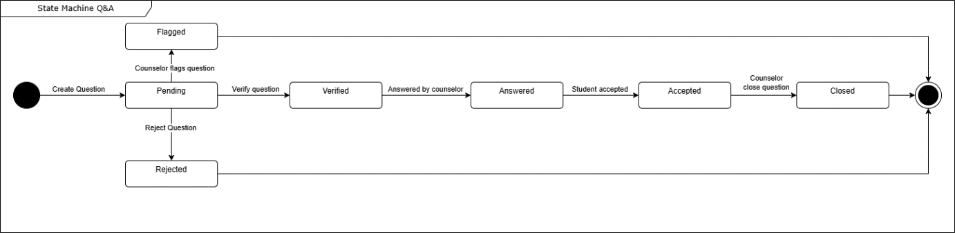

Figure - Q&A State Machine Diagram

### 3.3. Staff-Driven Student Support and Counselor Matching for student’s demand

#### 3.3.1. Class Diagram

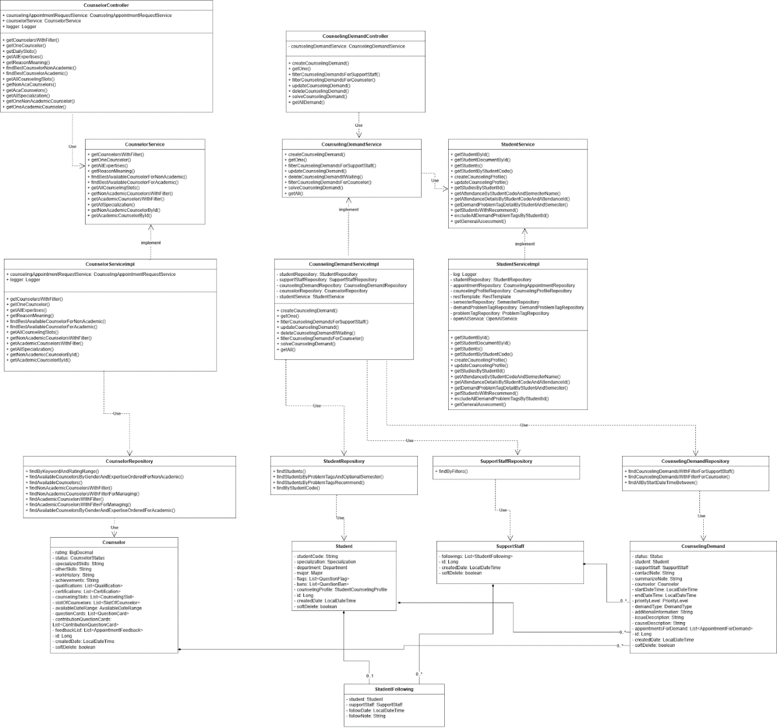

Figure - Staff-Driven Student Support and Counselor Matching for student’s demand class diagram

##### 3.3.1.1. Class Specification

###### 3.3.1.1.1. CounselorController class

Table - CounselorController class

|  |  |  |  |  |
| --- | --- | --- | --- | --- |
| **No** | **Attribute** | **Data Type** | **Visibility** | **Description** |
| 1 | counselingAppointmentRequestService | CounselingAppointmentRequestService | Public |  |
| 2 | counselorService | CounselorService | Public |  |
| 3 | logger | Logger | Public |  |

Table - CounselorController method class

|  |  |  |  |
| --- | --- | --- | --- |
| **No** | **Method** | **Visibility** | **Description** |
| 1 | createAppointmentRequest() | Public |  |
| 2 | getAppointmentsRequest() | Public |  |
| 3 | getAppointmentsRequestOfStudentForManage() | Public |  |
| 4 | findAllAppointmentRequest() | Public |  |
| 5 | approveOnlineAppointment() | Public |  |
| 6 | approveOfflineAppointment() | Public |  |
| 7 | denyAppointmentRequest() | Public |  |
| 8 | getAppointmentsByDateRange() | Public |  |
| 9 | updateAppointmentDetails() | Public |  |
| 10 | submitFeedback() | Public |  |
| 11 | takeAttendance() | Public |  |
| 12 | cancelAppointmentForStudent() | Public |  |
| 13 | cancelAppointmentForCounselor() | Public |  |

###### 3.3.1.1.2. CounselorService class

Table – CounselorService method class

|  |  |  |  |
| --- | --- | --- | --- |
| **No** | **Method** | **Visibility** | **Description** |
| 1 | getCounselorsWithFilter() | Public |  |
| 2 | getOneCounselor() | Public |  |
| 3 | getAllExpertises() | Public |  |
| 4 | getReasonMeaning() | Public |  |
| 5 | findBestAvailableCounselorForNonAcademic() | Public |  |
| 6 | findBestAvailableCounselorForAcademic() | Public |  |
| 7 | getAllCounselingSlots() | Public |  |
| 8 | getNonAcademicCounselorsWithFilter() | Public |  |
| 9 | getAcademicCounselorsWithFilter() | Public |  |
| 10 | getAllSpecialization() | Public |  |
| 11 | getNonAcademicCounselorById() | Public |  |
| 12 | getAcademicCounselorById() | Public |  |

###### 3.3.1.1.3. CounselorServiceImpl class

Table - CounselorServiceImpl class

|  |  |  |  |  |
| --- | --- | --- | --- | --- |
| **No** | **Attribute** | **Data Type** | **Visibility** | **Description** |
| 1 | counselingAppointmentRequestService | CounselingAppointmentRequestService | Public |  |
| 2 | logger | Logger | Public |  |

Table - CounselorServiceImpl method class

|  |  |  |  |
| --- | --- | --- | --- |
| **No** | **Method** | **Visibility** | **Description** |
| 1 | getCounselorsWithFilter() | Public |  |
| 2 | getOneCounselor() | Public |  |
| 3 | getAllExpertises() | Public |  |
| 4 | getReasonMeaning() | Public |  |
| 5 | findBestAvailableCounselorForNonAcademic() | Public |  |
| 6 | findBestAvailableCounselorForAcademic() | Public |  |
| 7 | getAllCounselingSlots() | Public |  |
| 8 | getNonAcademicCounselorsWithFilter() | Public |  |
| 9 | getAcademicCounselorsWithFilter() | Public |  |
| 10 | getAllSpecialization() | Public |  |
| 11 | getAllSpecialization() | Public |  |
| 12 | getNonAcademicCounselorById() | Public |  |
| 13 | getAcademicCounselorById() | Public |  |

###### 3.3.1.1.4. CounselorRepository class

Table - CounselorRepository method class

|  |  |  |  |
| --- | --- | --- | --- |
| **No** | **Method** | **Visibility** | **Description** |
| 1 | findByKeywordAndRatingRange() | Public |  |
| 2 | findAvailableCounselorsByGenderAndExpertiseOrderedForNonAcademic() | Public |  |
| 3 | findAvailableCounselors() | Public |  |
| 4 | findNonAcademicCounselorsWithFilter() | Public |  |
| 5 | findNonAcademicCounselorsWithFilterForManaging() | Public |  |
| 6 | findAcademicCounselorsWithFilter() | Public |  |
| 7 | findAcademicCounselorsWithFilterForManaging() | Public |  |
| 8 | findAvailableCounselorsByGenderAndExpertiseOrderedForAcademic() | Public |  |

###### 3.3.1.1.5. Counselor class

Table - Counselor class

|  |  |  |  |  |
| --- | --- | --- | --- | --- |
| **No** | **Attribute** | **Data Type** | **Visibility** | **Description** |
| 1 | rating | BigDecimal | Private |  |
| 2 | status | CounselorStatus | Private |  |
| 3 | specializedSkills | String | Private |  |
| 4 | otherSkills | String | Private |  |
| 5 | workHistory | String | Private |  |
| 6 | achievements | String | Private |  |
| 7 | qualifications | List<Qualification> | Private |  |
| 8 | certifications | List<Certification> | Private |  |
| 9 | counselingSlots | List<CounselingSlot> | Private |  |
| 10 | slotOfCounselors | List<SlotOfCounselor> | Private |  |
| 11 | availableDateRange | AvailableDateRange | Private |  |
| 12 | questionCards | List<QuestionCard> | Private |  |
| 13 | contributionQuestionCards | List<ContributionQuestionCard> | Private |  |
| 14 | feedbackList | List<AppointmentFeedback> | Private |  |
| 15 | id | Long | Private |  |
| 16 | createdDate | LocalDateTime | Private |  |
| 17 | softDelete | boolean | Private |  |

###### 3.3.1.1.6. Student class

Table - Student class

|  |  |  |  |  |
| --- | --- | --- | --- | --- |
| **No** | **Attribute** | **Data Type** | **Visibility** | **Description** |
| 1 | studentCode | String | Private |  |
| 2 | specialization | Specialization | Private |  |
| 3 | department | Department | Private |  |
| 4 | major | Major | Private |  |
| 5 | flags | List<QuestionFlag> | Private |  |
| 6 | bans | List<QuestionBan> | Private |  |
| 7 | counselingProfile | StudentCounselingProfile | Private |  |
| 8 | id | Long | Private |  |
| 9 | createdDate | LocalDateTime | Private |  |
| 10 | softDelete | boolean | Private |  |

###### 3.3.1.1.7. CounselingDemand class

Table - CounselingDemand class

|  |  |  |  |  |
| --- | --- | --- | --- | --- |
| **No** | **Attribute** | **Data Type** | **Visibility** | **Description** |
| 1 | status | Status | Private |  |
| 2 | student | Student | Private |  |
| 3 | supportStaff | SupportStaff | Private |  |
| 4 | contactNote | String | Private |  |
| 5 | summarizeNote | String | Private |  |
| 6 | counselor | Counselor | Private |  |
| 7 | startDateTime | LocalDateTime | Private |  |
| 8 | endDateTime | LocalDateTime | Private |  |
| 9 | priorityLevel | PriorityLevel | Private |  |
| 10 | demandType | DemandType | Private |  |
| 11 | additionalInformation | String | Private |  |
| 12 | issueDescription | String | Private |  |
| 13 | causeDescription | String | Private |  |
| 14 | appointmentsForDemand | List<AppointmentForDemand> | Private |  |
| 15 | id | Long | Private |  |
| 16 | createdDate | LocalDateTime | Private |  |
| 17 | softDelete | boolean | Private |  |

###### 3.3.1.1.8. StudentFollowing class

Table - StudentFollowing class

|  |  |  |  |  |
| --- | --- | --- | --- | --- |
| **No** | **Attribute** | **Data Type** | **Visibility** | **Description** |
| 1 | student | Student | Private |  |
| 2 | supportStaff | SupportStaff | Private |  |
| 3 | followDate | LocalDateTime | Private |  |
| 4 | followNote | String | Private |  |

###### 3.3.1.1.9. StudentRepository class

Table – StudentRepository method class

|  |  |  |  |
| --- | --- | --- | --- |
| **No** | **Method** | **Visibility** | **Description** |
| 1 | findStudents() | Public |  |
| 2 | findStudentsByProblemTagsAndOptionalSemester() | Public |  |
| 3 | findStudentsByProblemTagsRecommend() | Public |  |
| 4 | findByStudentCode() | Public |  |

###### 3.3.1.1.10. SupportStaffRepository class

Table - SupportStaffRepository method class

|  |  |  |  |
| --- | --- | --- | --- |
| **No** | **Method** | **Visibility** | **Description** |
| 1 | findByFilters() | Public |  |

###### 3.3.1.1.11. CounselingDemandController class

Table - CounselingDemandController class

|  |  |  |  |  |
| --- | --- | --- | --- | --- |
| **No** | **Attribute** | **Data Type** | **Visibility** | **Description** |
| 1 | counselingDemandService | CounselingDemandService | Private |  |

Table - CounselingDemandController method class

|  |  |  |  |
| --- | --- | --- | --- |
| **No** | **Method** | **Visibility** | **Description** |
| 1 | createCounselingDemand() | Public |  |
| 2 | getOne() | Public |  |
| 3 | filterCounselingDemandsForSupportStaff() | Public |  |
| 4 | filterCounselingDemandsForCounselor() | Public |  |
| 5 | updateCounselingDemand() | Public |  |
| 6 | deleteCounselingDemand() | Public |  |
| 7 | solveCounselingDemand() | Public |  |
| 8 | getAllDemand() | Public |  |

###### 3.3.1.1.12. CounselingDemandRepository class

Table - CounselingDemandRepository method class

|  |  |  |  |
| --- | --- | --- | --- |
| **No** | **Method** | **Visibility** | **Description** |
| 1 | findCounselingDemandsWithFilterForSupportStaff() | Public |  |
| 2 | findCounselingDemandsWithFilterForCounselor() | Public |  |
| 3 | findAllByStartDateTimeBetween() | Public |  |

###### 3.3.1.1.13. SupportStaff class

Table - SupportStaff class

|  |  |  |  |  |
| --- | --- | --- | --- | --- |
| **No** | **Attribute** | **Data Type** | **Visibility** | **Description** |
| 1 | following: | List<StudentFollowing> | Private |  |
| 2 | id | SupportStaLongff | Private |  |
| 3 | createdDate | LocalDateTime | Private |  |
| 4 | softDelete | boolean | Private |  |

###### 3.3.1.1.14. CounselingDemandService class

Table - CounselingDemandService method class

|  |  |  |  |
| --- | --- | --- | --- |
| **No** | **Method** | **Visibility** | **Description** |
| 1 | createCounselingDemand() | Public |  |
| 2 | getOne() | Public |  |
| 3 | filterCounselingDemandsForSupportStaff() | Public |  |
| 4 | updateCounselingDemand() | Public |  |
| 5 | deleteCounselingDemandIfWaiting() | Public |  |
| 6 | filterCounselingDemandsForCounselor() | Public |  |
| 7 | solveCounselingDemand() | Public |  |
| 8 | getAll() | Public |  |

###### 3.3.1.1.15. CounselingDemandService class

Table - CounselingDemandService method class

|  |  |  |  |
| --- | --- | --- | --- |
| **No** | **Method** | **Visibility** | **Description** |
| 1 | getStudentById() | Public |  |
| 2 | getStudentDocumentById() | Public |  |
| 3 | getStudents() | Public |  |
| 4 | getStudentByStudentCode() | Public |  |
| 5 | createCounselingProfile() | Public |  |
| 6 | updateCounselingProfile() | Public |  |
| 7 | getStudiesByStudentId() | Public |  |
| 8 | getAttendanceByStudentCodeAndSemesterName() | Public |  |
| 9 | getAttendanceDetailsByStudentCodeAndAttendanceId() | Public |  |
| 10 | getDemandProblemTagDetailByStudentAndSemester() | Public |  |
| 11 | getStudentsWithRecommend() | Public |  |
| 12 | excludeAllDemandProblemTagsByStudentId() | Public |  |
| 13 | getGeneralAssessment() | Public |  |

###### 3.3.1.1.16. CounselingDemandServiceImpl class

Table - CounselingDemandServiceImpl class

|  |  |  |  |  |
| --- | --- | --- | --- | --- |
| **No** | **Attribute** | **Data Type** | **Visibility** | **Description** |
| 1 | studentRepository | CounselingAppointmentRequestService | Public |  |
| 2 | counselingDemandRepository | CounselingDemandRepository | Public |  |
| 3 | counselorRepository | CounselorRepository | Public |  |
| 4 | studentService: | StudentService |  |  |

Table - CounselingDemandServiceImpl method class

|  |  |  |  |
| --- | --- | --- | --- |
| **No** | **Method** | **Visibility** | **Description** |
| 1 | createCounselingDemand() | Public |  |
| 2 | getOne() | Public |  |
| 3 | filterCounselingDemandsForSupportStaff() | Public |  |
| 4 | updateCounselingDemand() | Public |  |
| 5 | deleteCounselingDemandIfWaiting() | Public |  |
| 6 | filterCounselingDemandsForCounselor() | Public |  |
| 7 | solveCounselingDemand() | Public |  |
| 8 | getAll() | Public |  |

###### 3.3.1.1.17. CounselingDemandService class

Table - CounselingDemandService method class

|  |  |  |  |
| --- | --- | --- | --- |
| **No** | **Method** | **Visibility** | **Description** |
| 1 | getStudentById() | Public |  |
| 2 | getStudentDocumentById() | Public |  |
| 3 | getStudents() | Public |  |
| 4 | getStudentByStudentCode() | Public |  |
| 5 | createCounselingProfile() | Public |  |
| 6 | updateCounselingProfile() | Public |  |
| 7 | getStudiesByStudentId() | Public |  |
| 8 | getAttendanceByStudentCodeAndSemesterName() | Public |  |
| 9 | getAttendanceDetailsByStudentCodeAndAttendanceId() | Public |  |
| 10 | getDemandProblemTagDetailByStudentAndSemester() | Public |  |
| 11 | getStudentsWithRecommend() | Public |  |
| 12 | excludeAllDemandProblemTagsByStudentId() | Public |  |
| 13 | getGeneralAssessment() | Public |  |

###### 3.3.1.1.18. StudentServiceImpl class

Table - StudentServiceImpl class

|  |  |  |  |  |
| --- | --- | --- | --- | --- |
| **No** | **Attribute** | **Data Type** | **Visibility** | **Description** |
| 1 | log: Logger | CounselingAppointmentRequestService | Public |  |
| 2 | studentRepository | CounselingDemandRepository | Public |  |
| 3 | appointmentRepository | CounselingAppointmentRepository | Public |  |
| 4 | counselingProfileRepository | CounselingProfileRepository | Public |  |
| 5 | restTemplate | RestTemplate | Public |  |
| 6 | semesterRepository | SemesterRepository | Public |  |
| 7 | demandProblemTagRepositor | DemandProblemTagRepository | Public |  |
| 8 | openAIService | OpenAIService | Public |  |
| 9 | problemTagRepository | ProblemTagRepository | Public |  |

Table - StudentServiceImpl method class

|  |  |  |  |
| --- | --- | --- | --- |
| **No** | **Method** | **Visibility** | **Description** |
| 1 | getStudentById() | Public |  |
| 2 | getStudentDocumentById() | Public |  |
| 3 | getStudents() | Public |  |
| 4 | getStudentByStudentCode() | Public |  |
| 5 | createCounselingProfile() | Public |  |
| 6 | updateCounselingProfile() | Public |  |
| 7 | getStudiesByStudentId() | Public |  |
| 8 | getAttendanceByStudentCodeAndSemesterName() | Public |  |
| 9 | getAttendanceDetailsByStudentCodeAndAttendanceId() | Public |  |
| 10 | getDemandProblemTagDetailByStudentAndSemester() | Public |  |
| 11 | + getStudentsWithRecommend() | Public |  |
| 12 | excludeAllDemandProblemTagsByStudentId() | Public |  |
| 13 | getGeneralAssessment() | Public |  |

#### 3.3.2. Sequence Diagram

##### 3.3.2.1. Support staff follows student sequence diagram

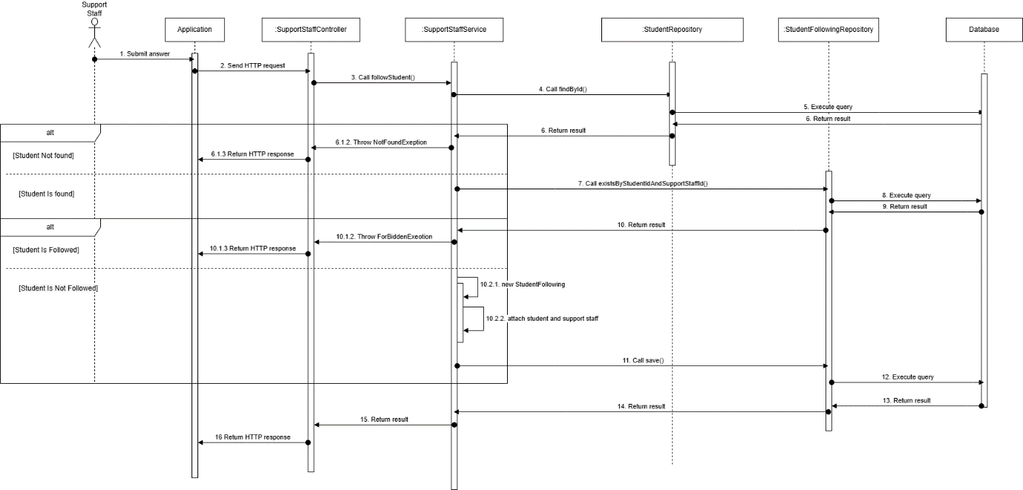

Figure - Support staff follows student sequence diagram

##### 3.3.2.2. Support staff create demand card sequence diagram

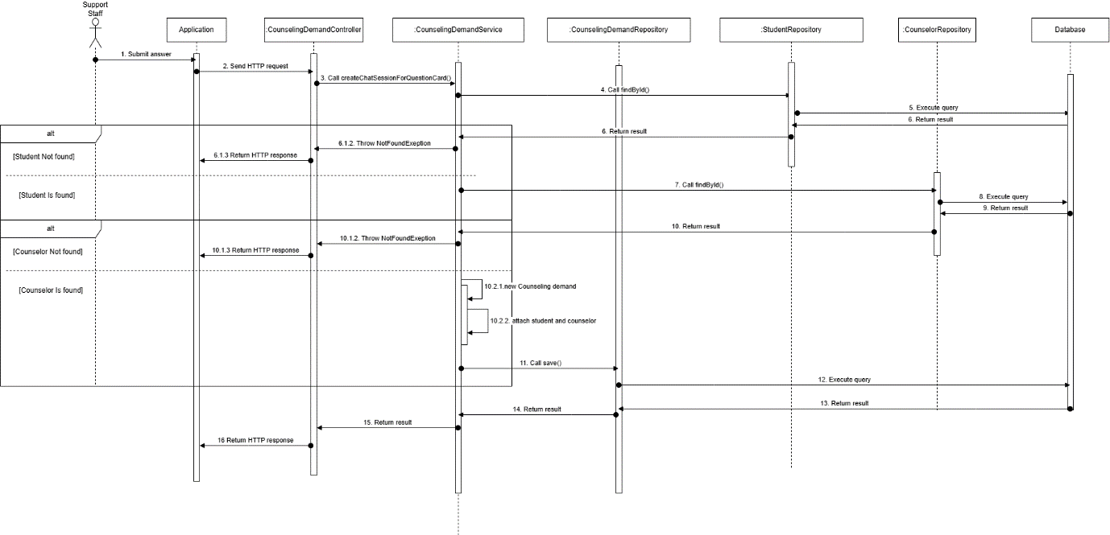

Figure 46 – Support staff create demand card sequence diagram

##### 3.3.2.3. Counselor creates appointment and attach to demand card sequence diagram

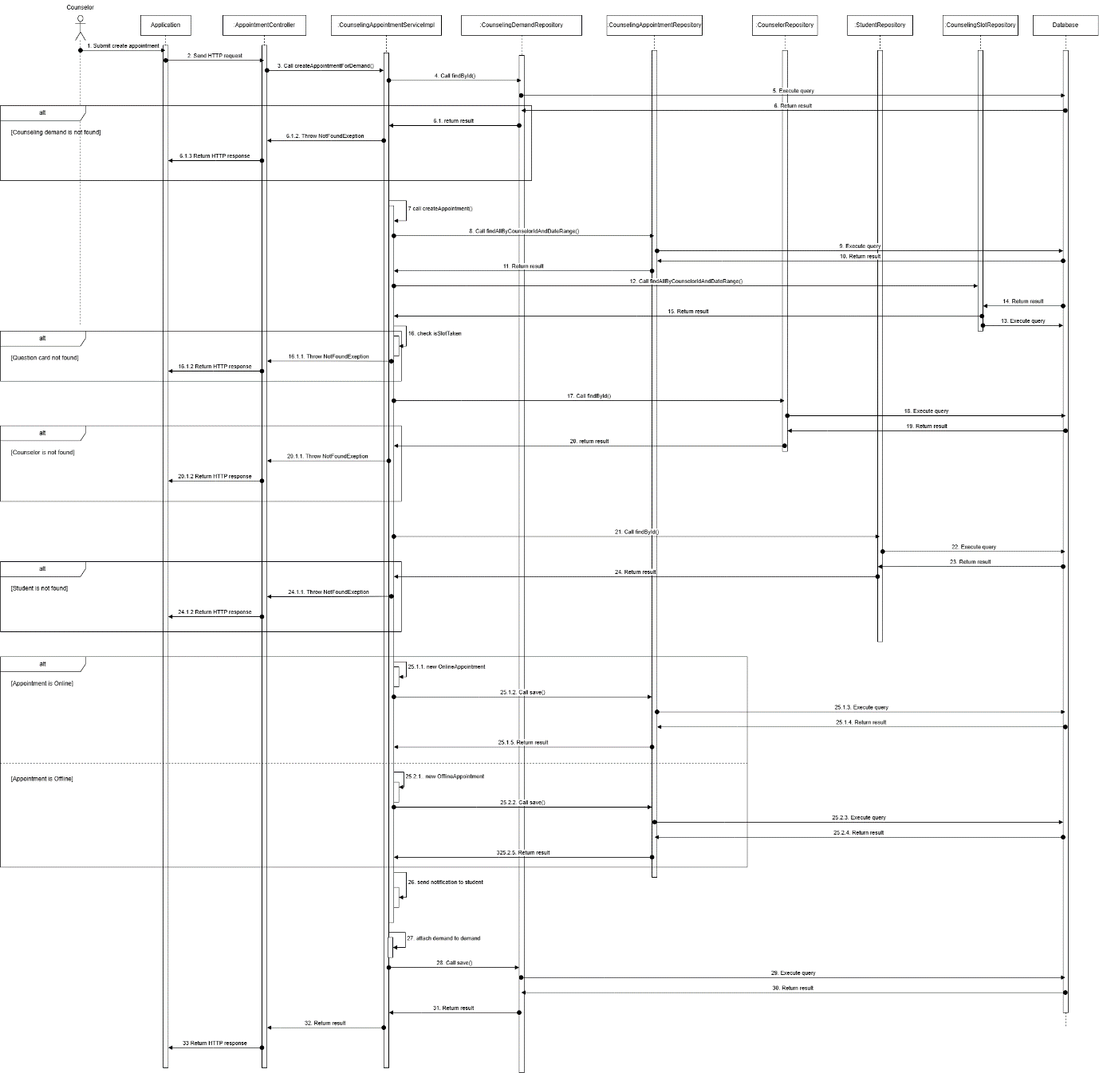

Figure 47 - Counselor creates appointment and attach to demand cardsequence diagram

##### 3.3.2.4. Counselor solves demand card sequence diagram

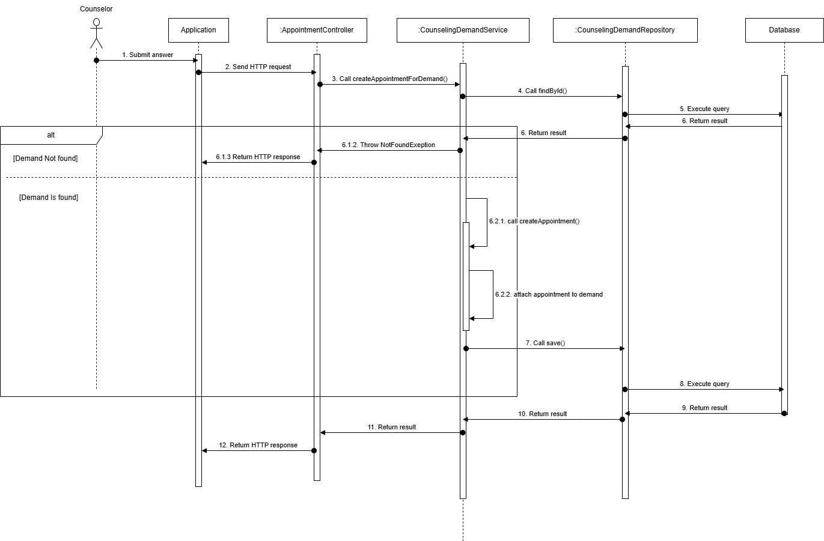

Figure 47 – Counselor solves demand card student sequence diagram

#### 3.3.3. Activity Diagram

##### 3.3.3.1. Staff Create demand card for mapping counselor with student activity diagram

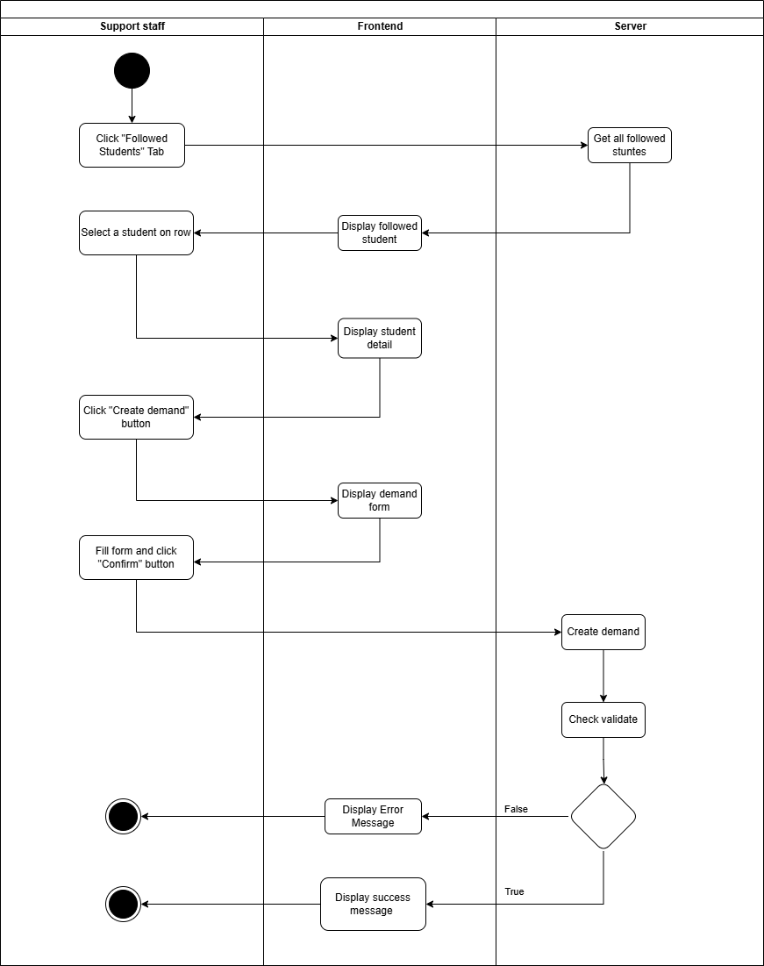

Figure - Staff Create demand card for mapping counselor with student activity diagram

##### 3.3.3.1. Counselor Create appointment for demand if student need activity diagram

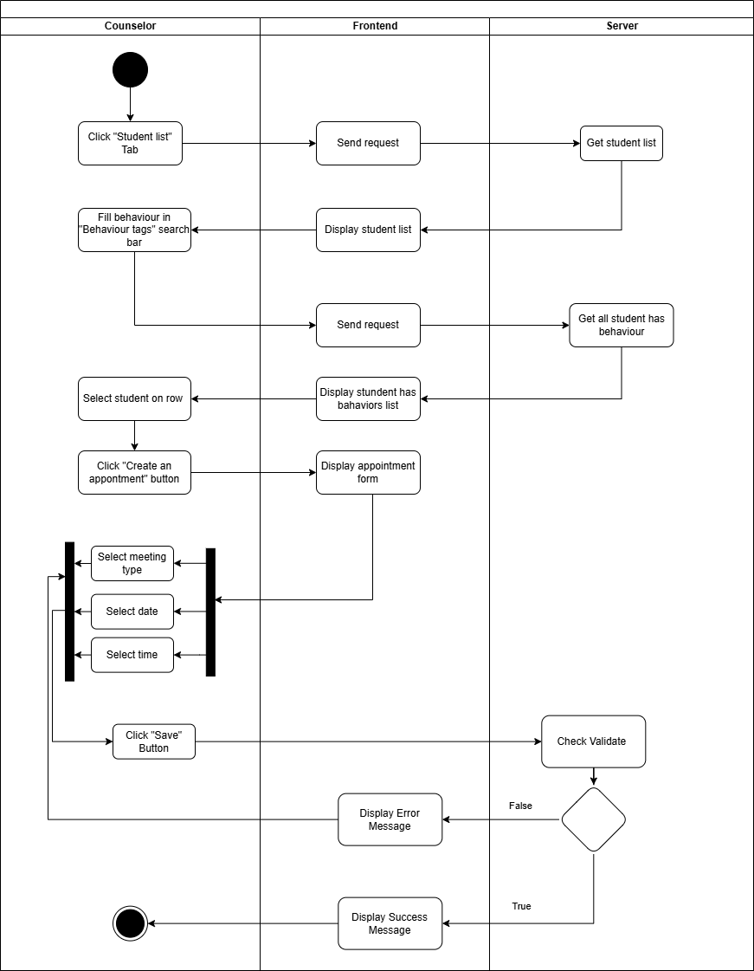

Figure - Counselor Create appointment for demand if student need activity diagram

##### 3.3.3.2. Staff Follow student activity diagram

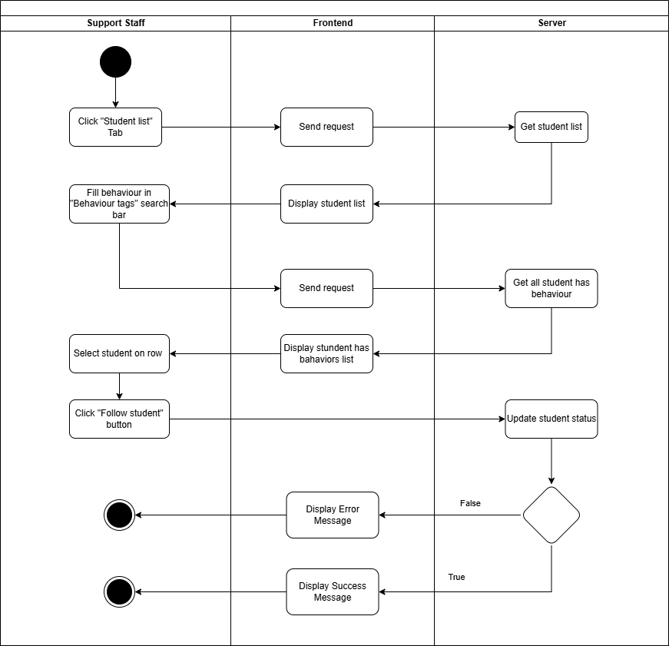

Figure - Staff Follow student activity diagram

##### 3.3.3.3. Staff Unfollow student activity diagram

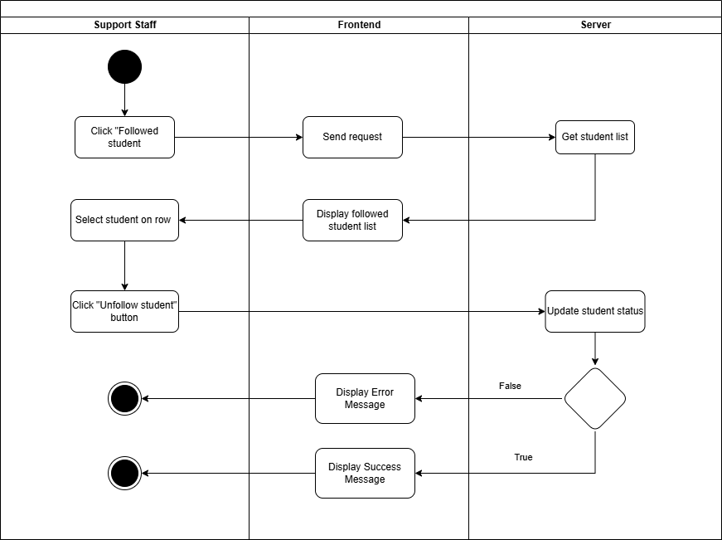

Figure - Staff Unfollow student activity diagram

##### 3.3.3.4. Solve demand activity diagram

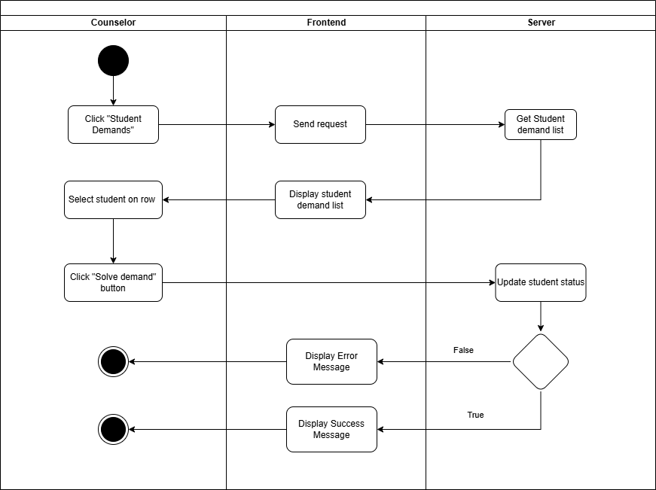

Figure - Solve demand activity diagram

#### 3.3.4. State Machine Diagram

##### 3.3.4.1. Demand Mapping State Machine Diagram

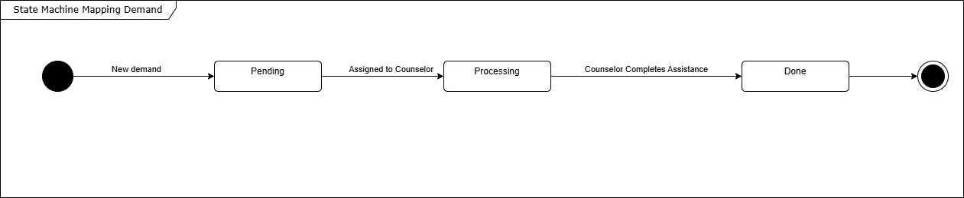

Figure -Demand Mapping State Machine Diagram

# V. Software Testing Documentation

## 1. Overall Description

**1.1. Test Model**

In the SCSS Project, we apply Agile testing for the following purposes:  Quickly adapt to projects that changed rapidly and continuously.  Test cases are ready for execution when finishing the implementation.  Detecting errors in the system early allows for quick correction.

**1.2. Test Levels**

Integration testing: Ensure every module works appropriately together in the system.

System testing: Ensure that the SCSS system meets the design specification and other requirements.

**1.3. Testing Types**

Functional test: Ensure that all functions in the system meet its requirements.

User Interface test: Ensure that all elements of the UI are correctly presented.

## 2. Test Strategy

### 2.1. Testing Types

Functional test: Ensure that all functions in the system meet its requirements.

API test: Ensure that all APIs in the system process and return required data correctly.

User Interface test: Ensure that all elements of the UI are correctly presented.

### 2.2. Test Levels

Table - Test Levels

|  |  |  |  |
| --- | --- | --- | --- |
| **Type of Tests** | **Test Level** | | |
| **Integration** | **System** | **Acceptance** |
| Function test | X | X | X |
| User interface test | X | X | X |

**2.3. Supporting Tools**

Table - Supporting Tools

|  |  |  |  |
| --- | --- | --- | --- |
| Purpose | Tool | Vendor/In-house | Version |
| User interface testing on web application | Google Chrome | Vendor (Google) | 124.0.6367.60 |
| User interface testing on mobile application | Android Emulator | Vendor (Android Studio) | 9.0 |
| User interface testing on mobile application | Physical mobile device | Vendor (Android Device) | 9.0 |
| API test, Integration test | Postman | Vendor (Postman) | 11.18 |

## 3. Test Plan

### 3.1. Human Resources

Table - Human Resources

|  |  |  |
| --- | --- | --- |
| **Worker/Doer** | **Role** | **Specific Responsibilities/Comments** |
| Trình Vĩnh Phát | Leader | Planning, assigning test functions to members and verifying test results. |
| Vũ Ngọc Hải Đăng | Member | Execute test and report |
| Đoàn Tiến Phát | Member | Execute test and report |
| Phạm Trần Sơn Nguyên | Member | Execute test and report |
| Nguyễn An Khánh | Member | Execute test and report |

**3.2. Test Environment**

Table - Test Environment

|  |  |  |  |
| --- | --- | --- | --- |
| **Purpose** | **Tool** | **Provider** | **Version** |
| User interface testing on web application | Google Chrome | Google Chrome | 119.0.6045.200 |
| User interface testing on mobile application | Android Emulator  Physical mobile device | Android studio Android Device | 9.0 |
| API test, Integration test | Postman | Postman | 11.18 |

**3.3. Test Milestones**

Table - Test Milestones

|  |  |  |
| --- | --- | --- |
| **Milestone Task** | **Start Date** | **End Date** |
| Create test plan | 15/10/2024 | 21/10/2024 |
| Create test cases for Web application | 21/10/2024 | 20/11/2024 |
| Create test cases for APIs | 20/11/2024 | 29/11/2024 |
| Create test cases for Mobile application | 29/11/2024 | 05/12/2024 |
| Create report for testing | 05/12/2024 | 10/12/2024 |

## 4. Test Cases & Test Reports

Test Cases & test reports:[GFA24SE27-Test-Report](https://docs.google.com/spreadsheets/d/1hvsthMjcUTw9Bgdl9XRwjIgiAAiwfSyVjGNcgt06Gzo/edit?usp=sharing)

# VI. Release Package & User Guides

## 1. Deliverable Package

Table - Deliverable Package

|  |  |  |
| --- | --- | --- |
| **No.** | **Deliverable Item** | **Description** |
| 1 | Source Codes | Web: [Frontend.zip](https://drive.google.com/file/d/178jBcB9dLVSknZ2j1u8xB83JxwOjFmVe/view?usp=drive_link)  Backend:  [SCSS_Backend_Server.zip](https://drive.google.com/file/d/1V9xV3sul-VEdIiW40CK-hwJinptc9IGP/view?usp=sharing)  [Simulation_Student_Data_Server.zip](https://drive.google.com/file/d/1o1P7m7w44_Hj8V1AY7rd5Ld8CTnkFo1r/view?usp=drive_link)  Mobile: |
| 2 | Database Script(s) | [SCSS.sql](https://drive.google.com/file/d/1V9xV3sul-VEdIiW40CK-hwJinptc9IGP/view?usp=sharing)  [Simulation_Student_Data_Server_Server_Database_Script.sql](https://drive.google.com/file/d/1-DJ_OU0kC2FI0kfJqOzGbt8YK9WFV4cW/view?usp=drive_link) |
| 3 | Final Report Document | A document file that summarizes the project information. |
| 4 | Test Cases Document | [GFA24SE27-Test-Report](https://docs.google.com/spreadsheets/d/1hvsthMjcUTw9Bgdl9XRwjIgiAAiwfSyVjGNcgt06Gzo/edit?usp=sharing) |
| 5 | Slide | [FA24SE111_HuynhCongVietNgu_LeVoMinhThu_Slide](https://drive.google.com/file/d/1usW1x0fpabSQRJP_Xi3FOqWWknwBBsNV/view?usp=drive_link) |

## 2. Installation Guides

**2.1 System Requirements**

**2.1.1 Hardware requirements**

**2.1.1.1 Website application**

Table - Website application

|  |  |  |
| --- | --- | --- |
| **PC** | **Minimum** | **Recommended** |
| Internet connection | Cable, Wi-fi | Cable, Wi-fi |
| Processor | Intel Core i5 | Intel Core i7 |
| Memory | 8GB RAM | 16GB RAM |
| Storage | HDD 256GB | SSD 256GB |
| Web Browser | Google Chrome  Internet Explorer | Google Chrome v.124.0.6367.60  Internet Explorer IE.11 |

#### 2.1.1.2 Mobile application

Table - Mobile application

|  |  |  |
| --- | --- | --- |
| **Mobile** | **Minimum** | **Recommended** |
| Internet connection | Cable, Wi-fi | Cable, Wi-fi |
| Processor | Qualcomm SM4250 | Qualcomm Snapdragon 680 |
| Memory | 8GB | 32GB |
| Storage | 105.46MB | 120.00MB |
| Operating System | Android 12 | Android 14 |

#### *2.1.2* Software requirements

Table - Software requirements

|  |  |  |
| --- | --- | --- |
| **Component** | **Name and Version** | **Description** |
| Operating System | Windows 10 | Operating system for building production |
| DBMS | MySQL | Used to manage database |
| Java spring boot | Java spring boot 3.3.2 | Use to run back-end server |
| ReactJS | ReactJS 18.3.1 | Use to run front-end server |
| ReactNative | ReactNative 0.74.3 | Use to run mobile application |
| IDE | Visual Studio, Intellij, Android Studio | Use to write, edit and run code |

### 2.2. Installation Instruction

#### 2.2.1. Environment Setup

##### 2.2.1.1. Mobile Application Development

**Step1:** Download Visual Studio Code:

* Go to the [Visual Studio Code download page](https://code.visualstudio.com/download).
* Download the latest stable version of Visual Studio Code (version 1.95 or newer).

**Step2:** Install Visual Studio Code:

* Follow the on-screen instructions to install Visual Studio Code on your machine.

**Step 3:** Setup for React Native Development:

* Open Visual Studio Code after installation.
* Install the **React Native CLI** if you haven't already by opening a terminal and running:  
  Npx create-expo-app scss-mobile
* Install **Node.js** (required for React Native) from [Node.js website](https://nodejs.org/).

**Step 4:** Install Required Extensions in Visual Studio Code:

* Open Visual Studio Code.
* Go to the **Extensions** view by clicking on the Extensions icon in the Activity Bar.
* Search for and install the **React Native Tools** extension to enhance support for React Native development.

##### 2.2.1.2. Web application

Step 1: Install Visual Studio Code:

* Download the [Visual Studio Code setup file.](https://code.visualstudio.com/Download)
* After the download is complete, run the VSCodeUserSetup.exe file.
* Click Next to proceed with the installation. Then, agree to the terms of use.
* Choose the installation location (it's recommended to keep the default) and click Next.
* In the subsequent steps, continue clicking Next until the installation is complete.

Step 2: Install npm through Visual Studio Code or you can install npm via NodeJS: [Link.](https://nodejs.org/en/)

##### 2.2.1.3. Back-end Server

###### 2.2.1.3.1. Install Intellij

Step 1: Go to the JetBrains Website

1. Open your web browser and navigate to the JetBrains IntelliJ IDEA homepage at<https://www.jetbrains.com/idea/>.

Step 2: Choose the IntelliJ IDEA Edition

1. On the IntelliJ IDEA homepage, click the Download button.
2. You’ll see two editions:
   * Ultimate: A paid edition with full features for professional development.
   * Community: A free edition suitable for learning and open-source projects.
3. Select the edition that fits your needs, then click Download.

Step 3: Download IntelliJ IDEA for Your Operating System

1. The download page will detect your operating system (Windows, macOS, or Linux) automatically.
2. Click the Download button for your operating system.

Step 4: Run the Installation File

1. Once the download completes, open the installation file (.exe on Windows, .dmg on macOS, or .tar.gz on Linux).
2. On Windows:
   * Double-click the .exe file and follow the installation instructions.
3. On macOS:
   * Open the .dmg file, then drag and drop the IntelliJ IDEA icon into the Applications folder.
4. On Linux:
   * Extract the .tar.gz file and move the folder to a suitable location. You can add an alias or shortcut to open IntelliJ from the terminal.

Step 5: Launch IntelliJ IDEA and Initial Setup

1. Open IntelliJ IDEA for the first time.
2. Choose Do not import settings if this is your first installation.
3. IntelliJ will prompt you to configure initial settings such as theme (Light or Dark), plugins, and other options. Choose your preferred settings.
4. Once done, click Start using IntelliJ IDEA to begin.

###### 2.2.1.3.2. Install Environment

Step 1: Install Java 21 or Higher

1. Download Java: Visit the [Oracle JDK](https://www.oracle.com/java/technologies/downloads/) or [OpenJDK](https://openjdk.org/) website and download Java 21 or higher.
2. Install:
   * Windows/macOS: Follow the installer’s instructions.
   * Linux: Use a package manager (e.g., sudo apt install openjdk-21-jdk on Ubuntu).
3. Set JAVA_HOME Environment Variable (if needed): Point JAVA_HOME to your Java installation path.
4. Verify: Run java -version to ensure Java is correctly installed.

Step 2: Install Maven 3.9.8 or Higher

1. Download Maven: Go to the [Maven download page](https://maven.apache.org/download.cgi) and download version 3.9.8 or higher.
2. Install:
   * Windows/macOS: Extract and move the folder to a suitable location (e.g., C:\Program Files\Apache\Maven).
   * Linux: Extract and move to a system directory (e.g., /usr/local/apache-maven).
3. Add to PATH: Ensure the Maven bin directory is in your PATH.
4. Verify: Run mvn -version to check the Maven installation.

Step 3: Install Git

1. Download and Install Git: Go to [Git’s official website](https://git-scm.com/downloads) and download the appropriate version for your OS.
2. Clone the Project: Run the following command in your terminal or command prompt:  
   git clone <project-repo-url>

###### 2.2.1.3.3 Simulation Student Data Server

Step 1: Clone source code from github

1. Access source code online through link: <https://github.com/Capstone-FA24SE111-GFA24SE27/scss-student-data-API-server>

Copy source code URL 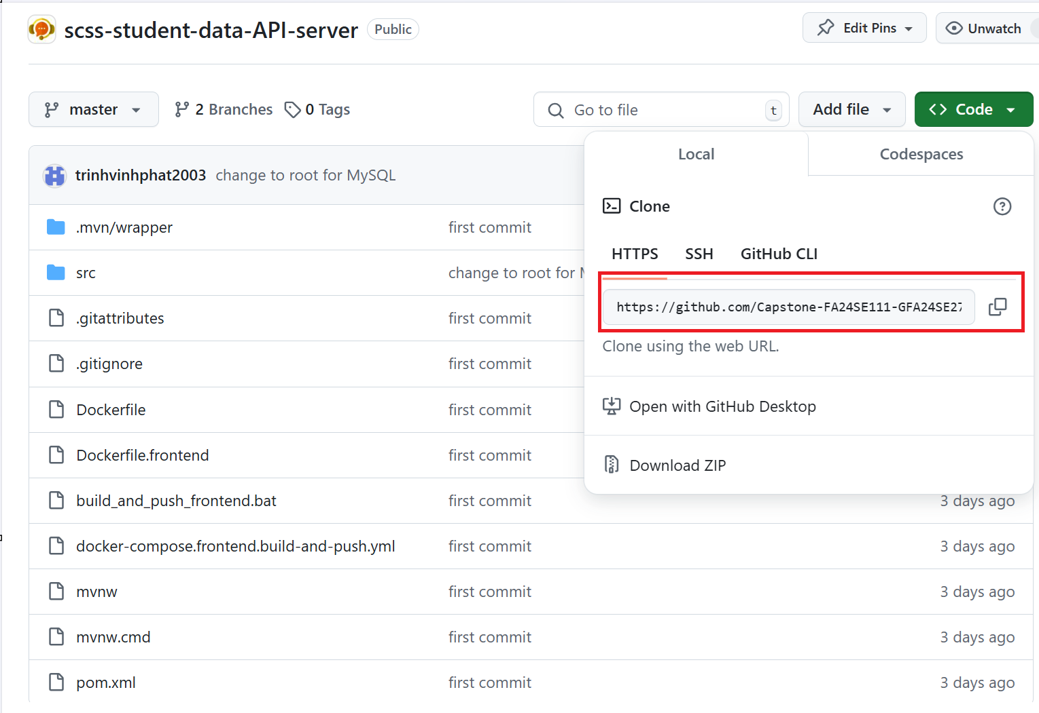

Open terminal and run 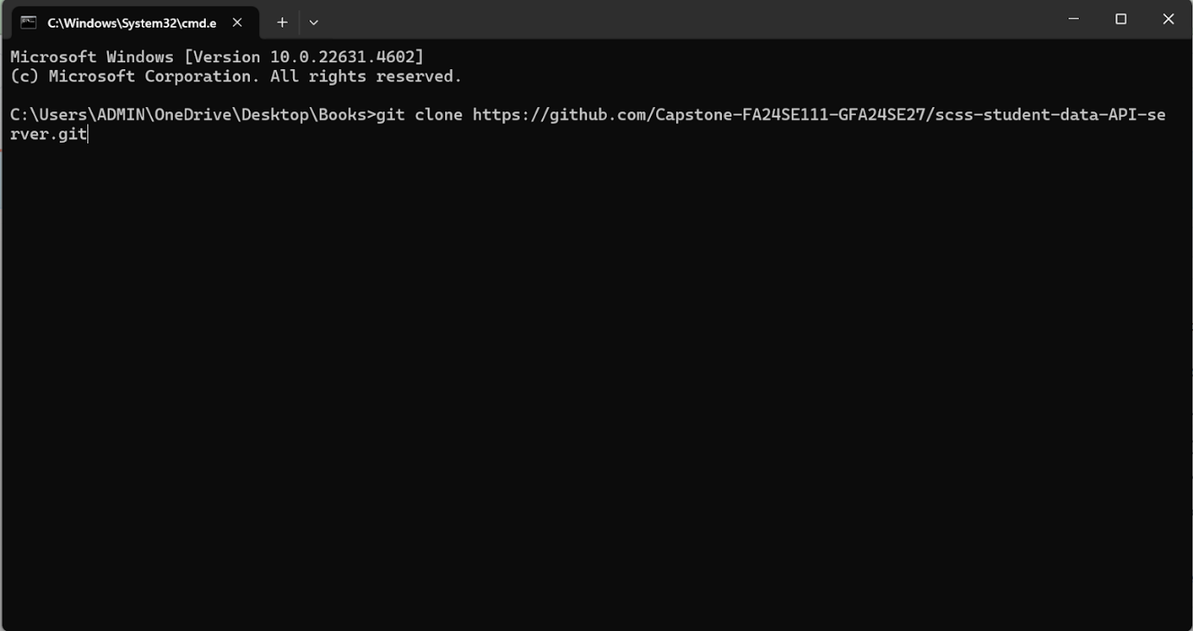

After clone project, you will get folder with source code 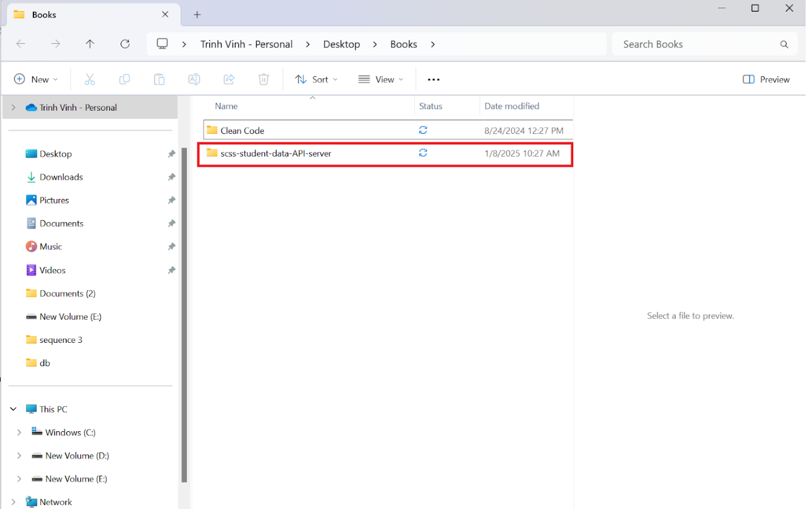

Step 2: Open source code with coding editor

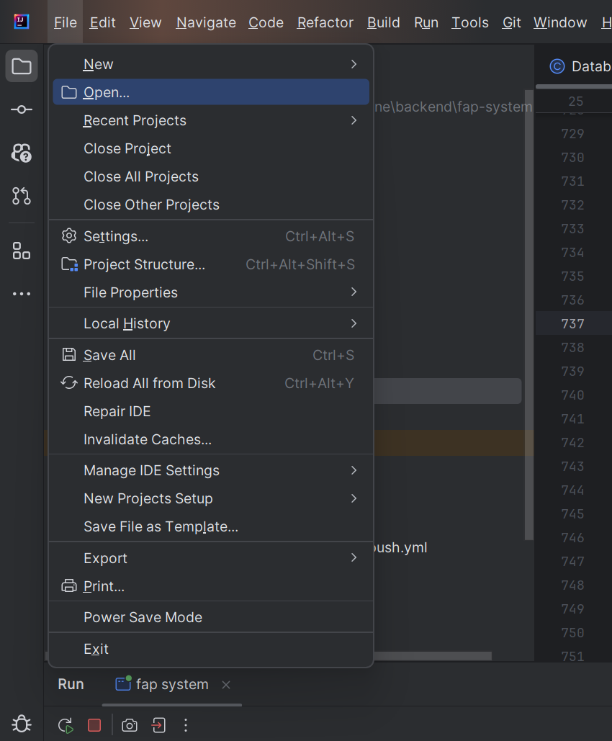Open intellj, click file -> open

Select folder containing source code and click OK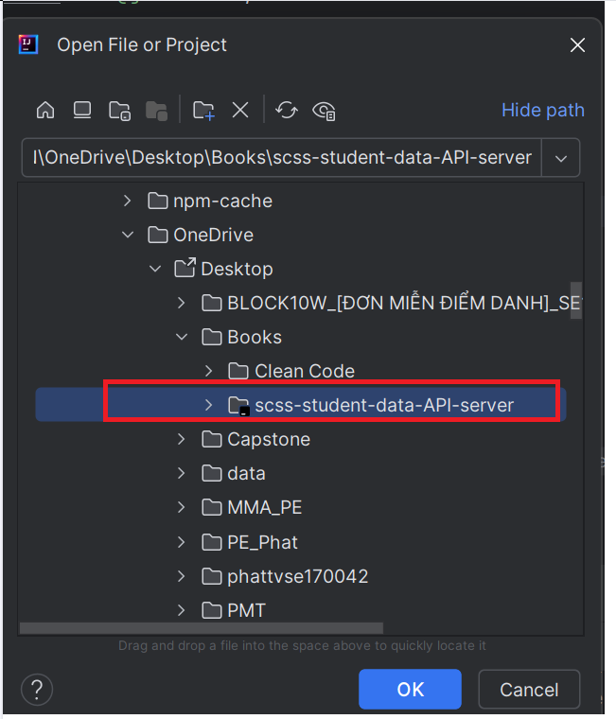

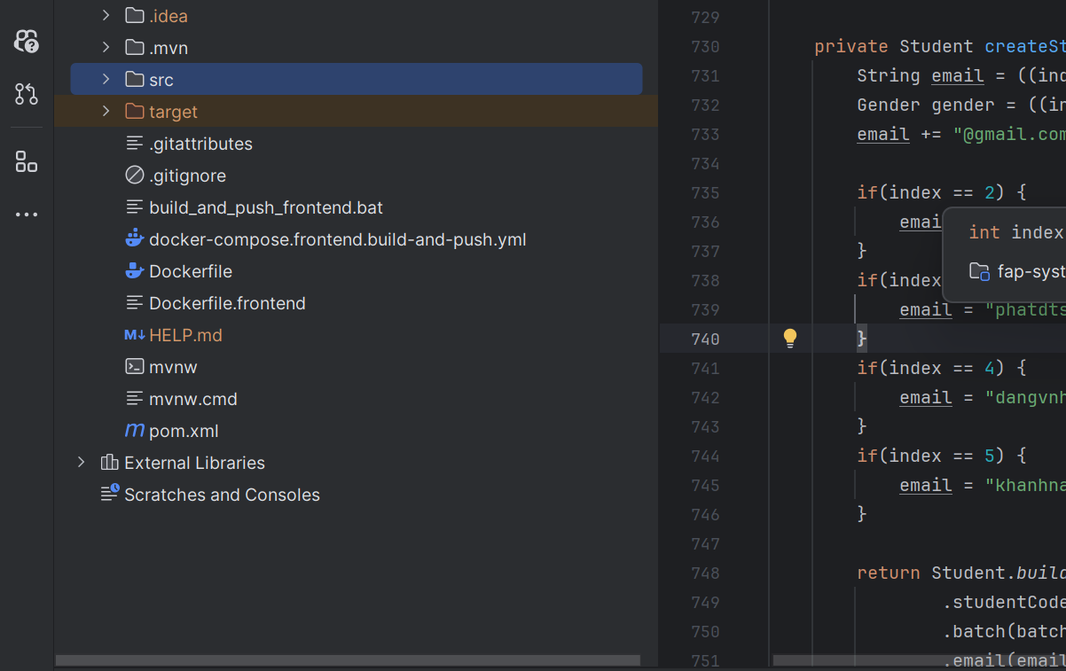Folder will be opened in intellj

###### 2.2.1.3.4. SCSS Server

Step 1: Clone source code from github

1. Access source code online through link: <https://github.com/Capstone-FA24SE111-GFA24SE27/scss-backend>

Copy source code URL 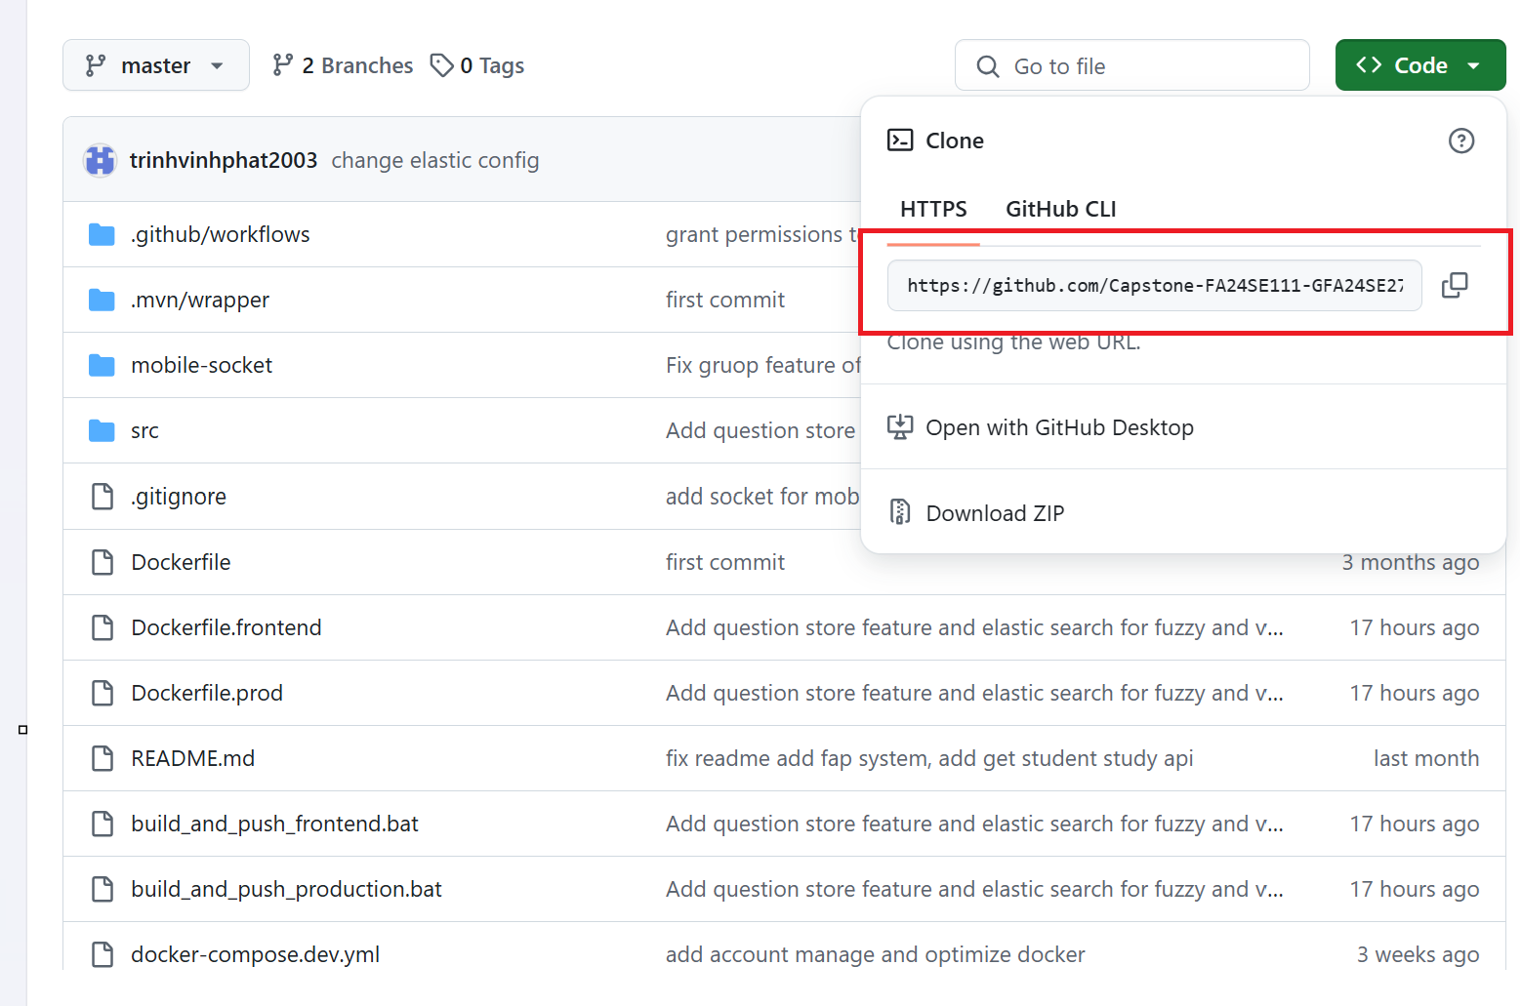

Open terminal and run 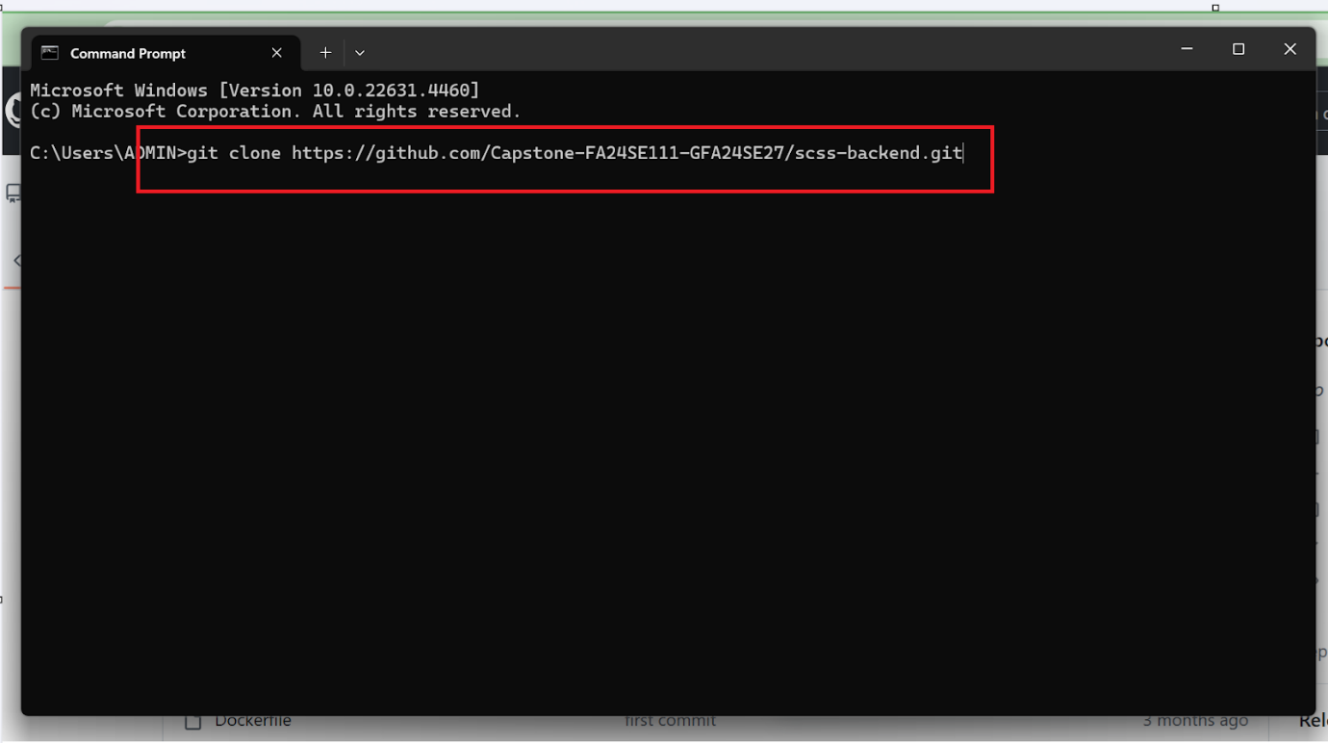

After clown project, you will get folder with source code 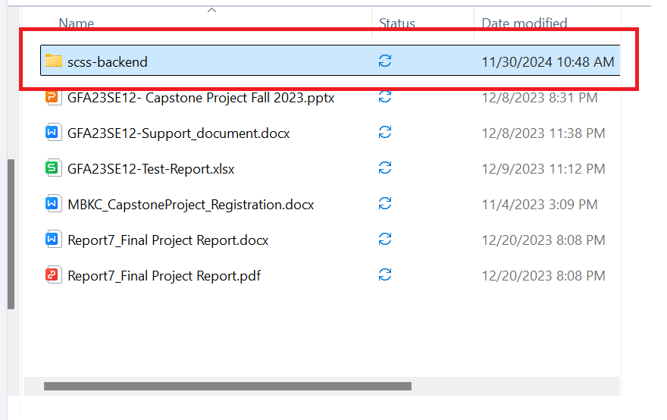

Step 2: Set up service using by system

Open Docker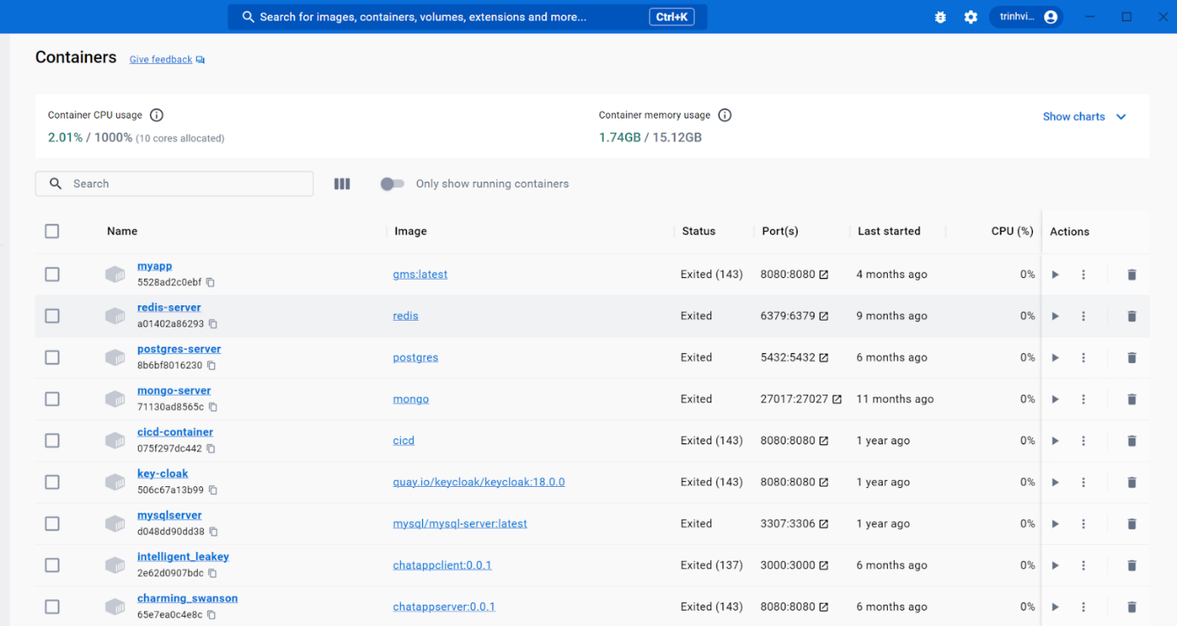

Run CMD command at root of project 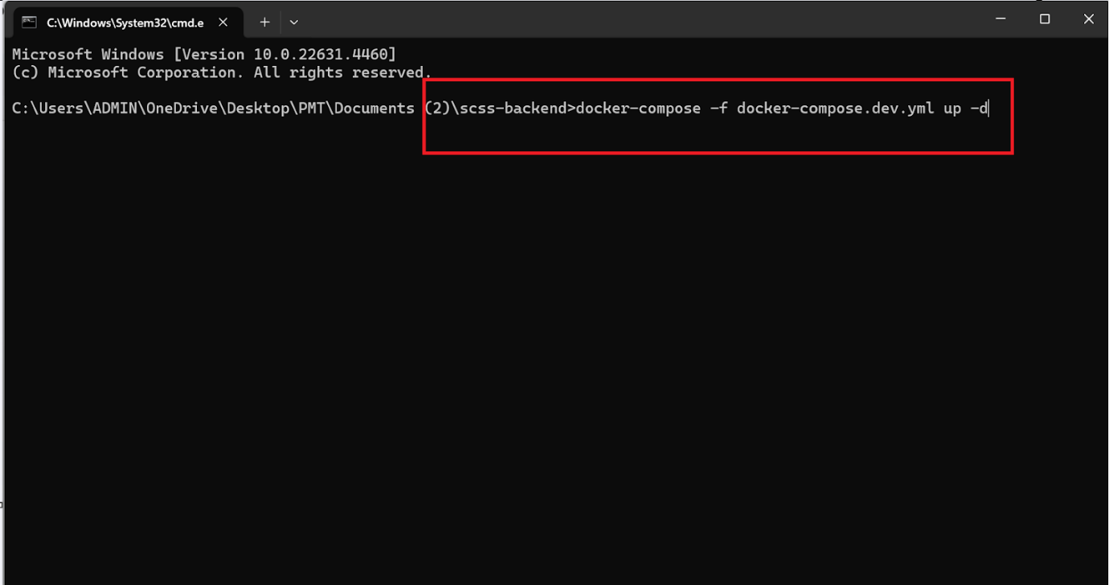

After waiting for service to up, some necessary container will up 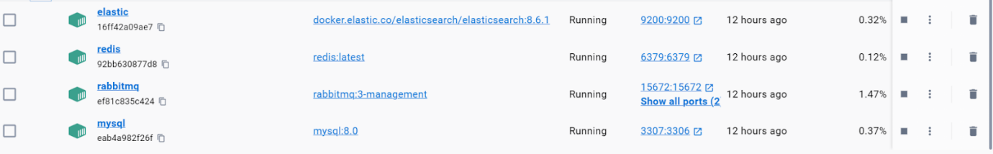

Step 3: Open source code with coding editor

Open intellj, click file -> open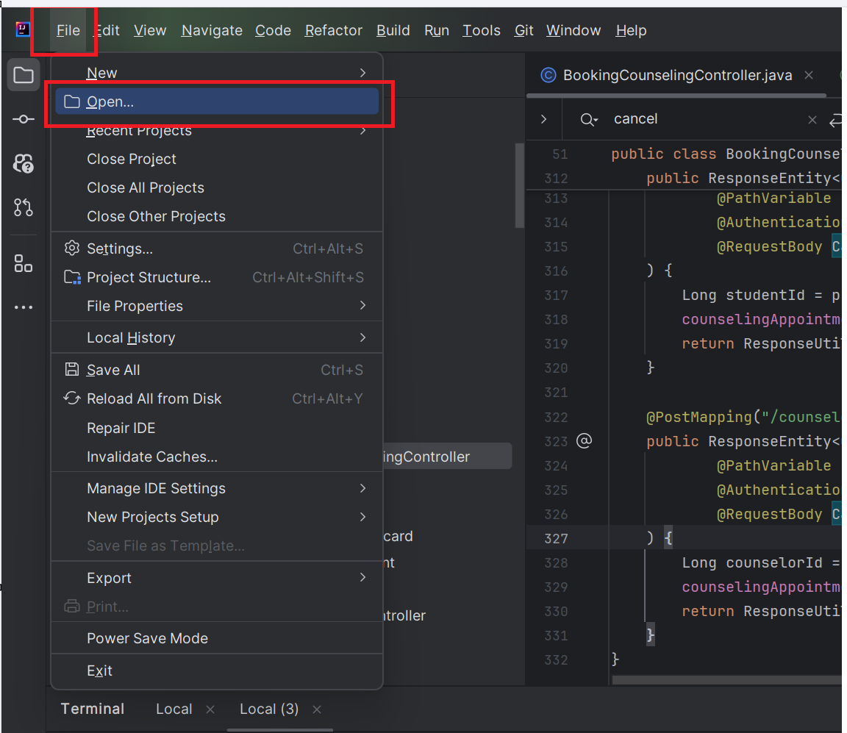

Select folder containing source code and click OK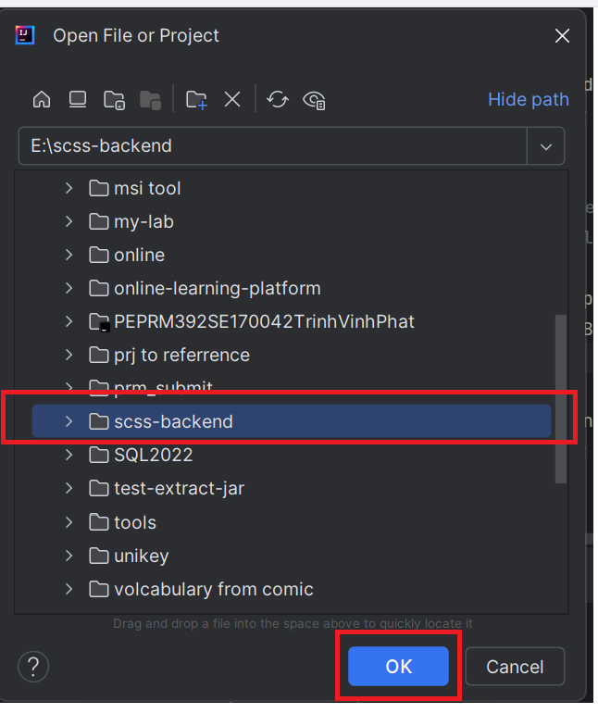

Folder will be opened in intellj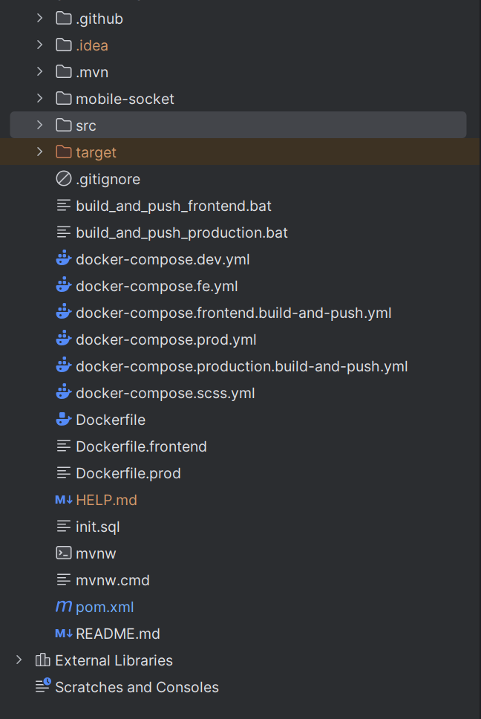

###### 2.2.1.3.5. Run Server

Step 1: Run Student Data Simulation Server

In intellj, click icon terminal at the left corner to open terminal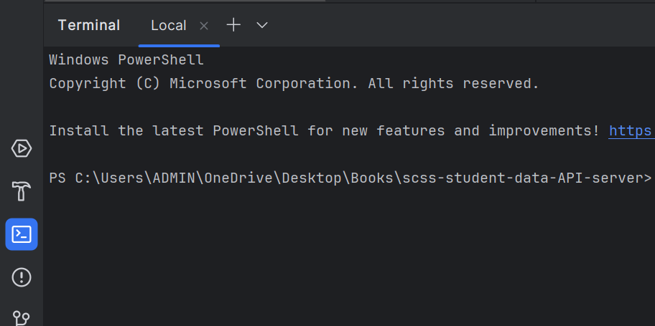

Run command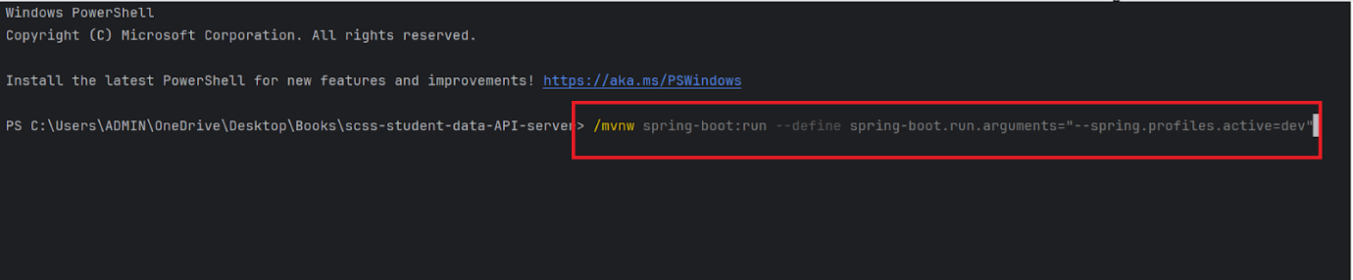

Waiting for application to finish building and up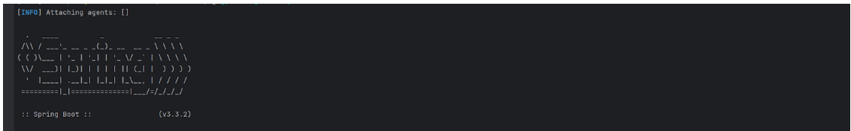

Step 2: Run SCSS Server

In intellj, click icon terminal at the left corner to open terminal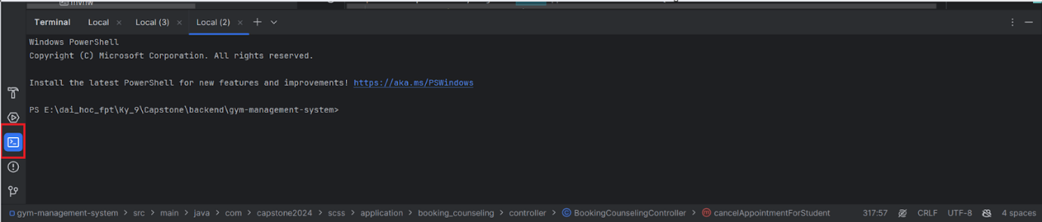

Run command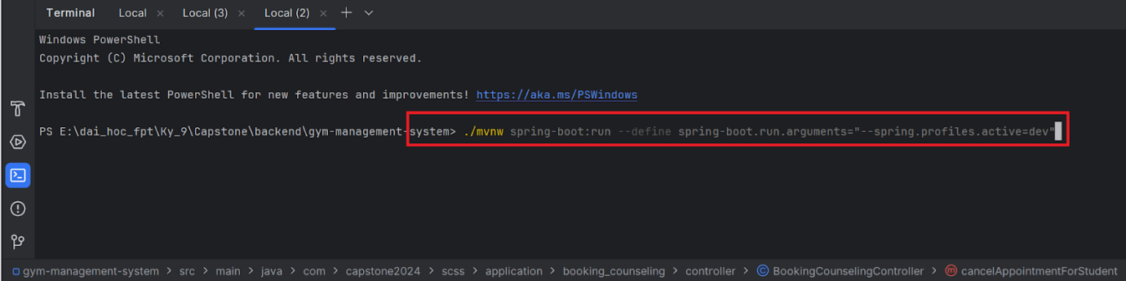

Waiting for application to finish building and up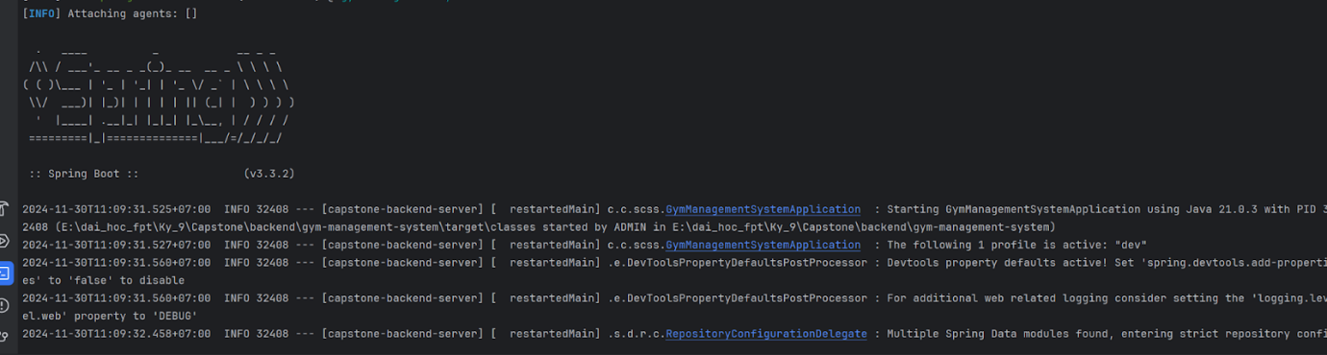

**2.2.2. Run Frontend web application**

Step 1: Clone the repository or extract “SCSS_WebApplication.zip” and open folder with Visual Studio Code.

Step 2: Create .env file at root of the project with content: *VITE_SERVER_BASE_URL=http://scss-server.southafricanorth.cloudapp.azure.com*

Step 3: Open the terminal and enter npm install:

Open terminal and enter npm install:

* npm i
* npm run dev

##### 2.2.4. Run Frontend mobile application

Step 1: Access source code online through link: <https://github.com/Capstone-FA24SE111-GFA24SE27/scss-mobile>

Step 2: Copy the source code URL:

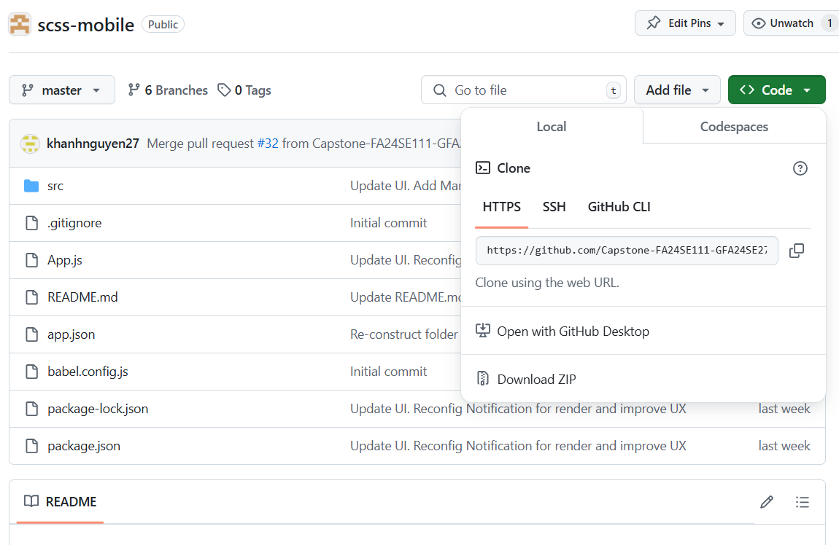

Step 3 : Clone this repository by opening terminal, input this command and press Enter: .

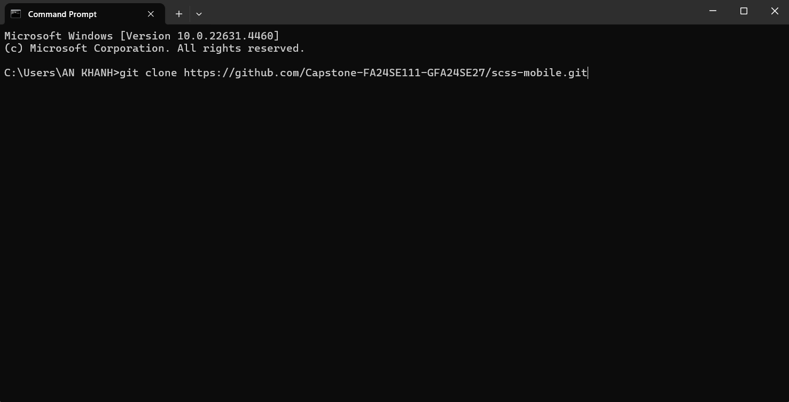

Step 4: Open the code folder with Visual Studio Code.

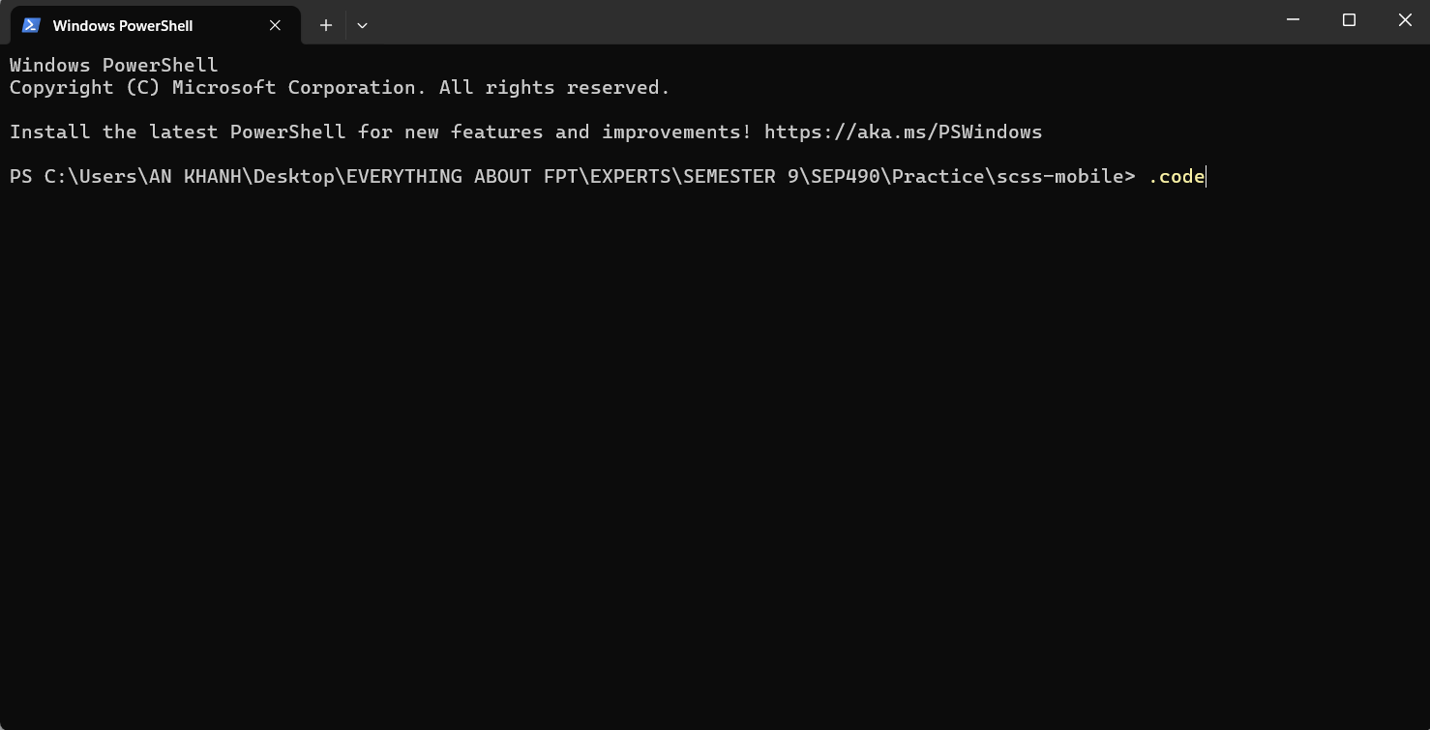

Step 5: After VS Code open with scss- folder, open VS Code terminal, input 2 commands in sequence: “npm install” and press Enter to install “node_modules” folder, then “npm run android” and press Enter to start mobile application





## 3. User Manual

### 3.1. Overview

### 3.2. Web Application

#### 3.2.1. Authentication

##### 3.2.1.1. Login

###### 3.2.1.1.1. Description

Use this guideline to login into SCSS with an email account. This web application supports login with email account that has been added as a admin, manager, counselor, support staff, student.

###### 3.2.1.1.2. Guide Steps

**Step 1:** Access SCSS at http://scss-fe.azurewebsites.net/ **.** Then fill in “Email” and  “Password”

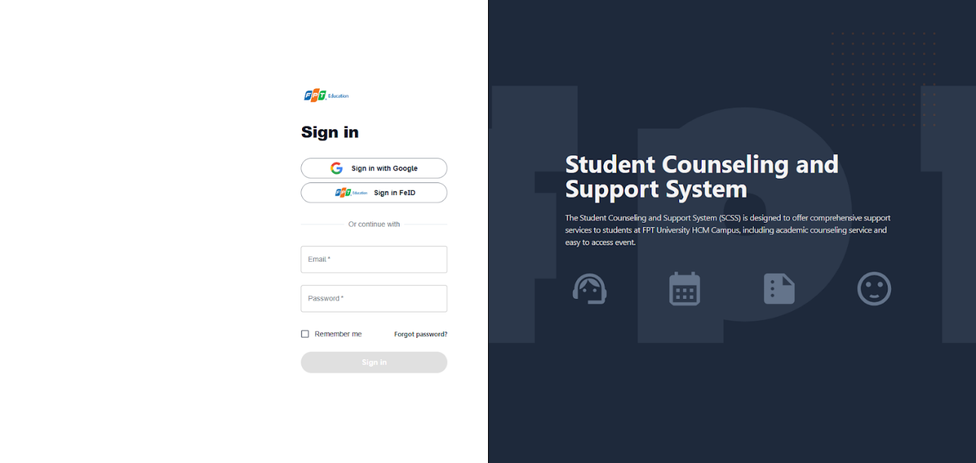

Figure - User Manual - Feature 1 - Step 1

**Step 2:** Click “Sign in” Button

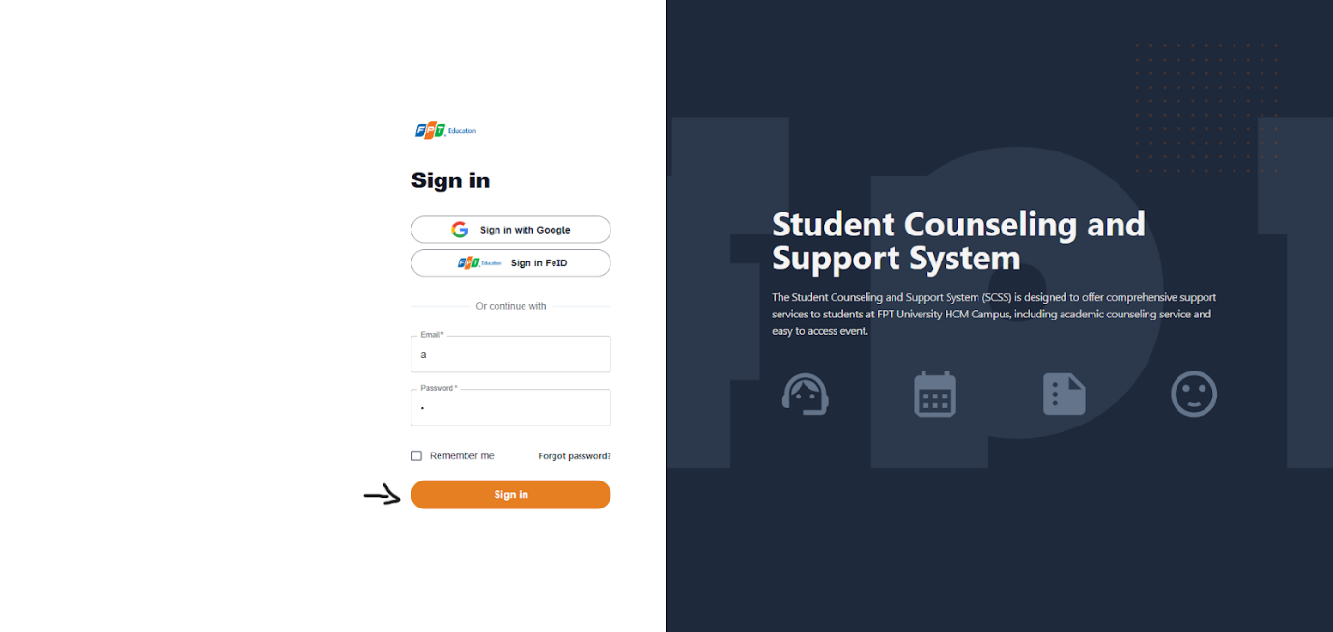

Figure - User Manual - Feature 1 - Step 2

After logging in successfully, user is directed to the Dashboard Page with account authenticated.

##### 3.2.1.2. Reset Password

Use this guide so users can reset their email account password when they forget their password.

###### 3.2.1.2.1. Description

Use this guide so users can reset their email account password when they forget their password.

###### 3.2.1.2.2. Guide Steps

**Step 1:** Access SCSS at http://scss-fe.azurewebsites.net/. Then press “Forgot password”.

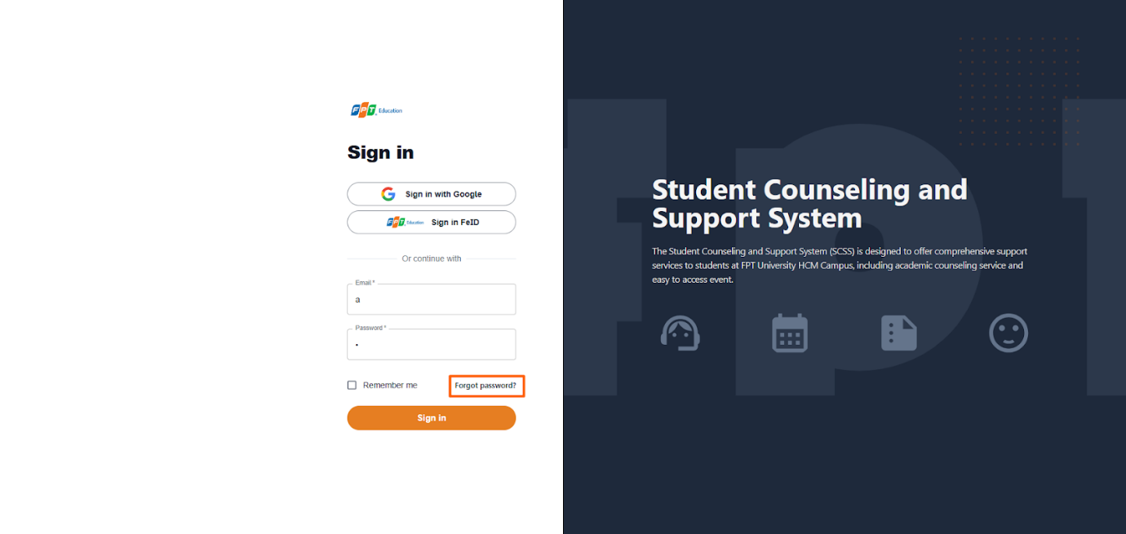

Figure - User Manual - Feature 2 - Step 1

**Step 2:** Then fill in “Email”

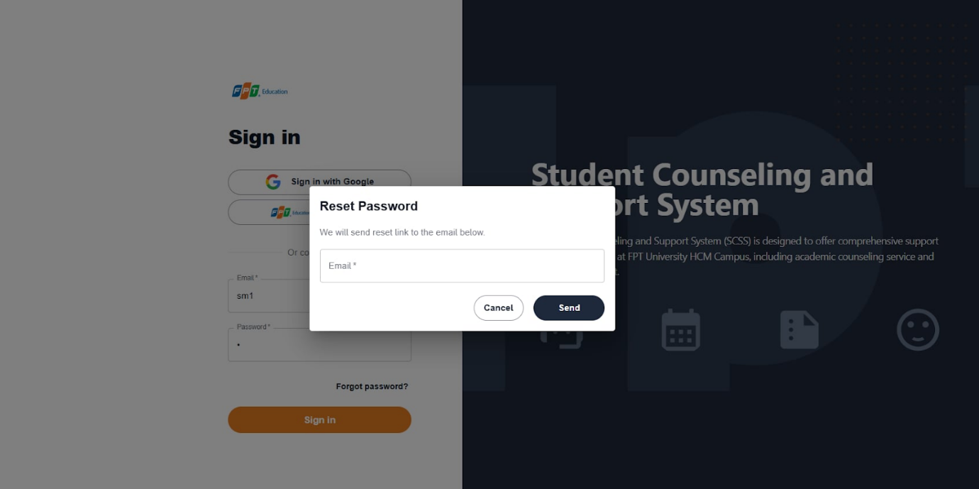

Figure - User Manual - Feature 2 - Step 2

**Step 3:** Click “Send Email” button

After sending the email successfully, the user is redirected to the Verify OTP Page with the email that sent the OTP authentication code.

##### 3.2.1.3. Edit Password

###### 3.2.1.3.1. Description

Use this guide so users can update their email account password when they want to edit their password.

This web application supports updating passwords for actors: Admin, manager, counselor, support staff, student.

###### 3.2.1.3.2. Guide Steps

Step 1: Access SCSS at  http://scss-fe.azurewebsites.net/. After logging in successfully, click the box avatar on the header and click “Settings” menu item.

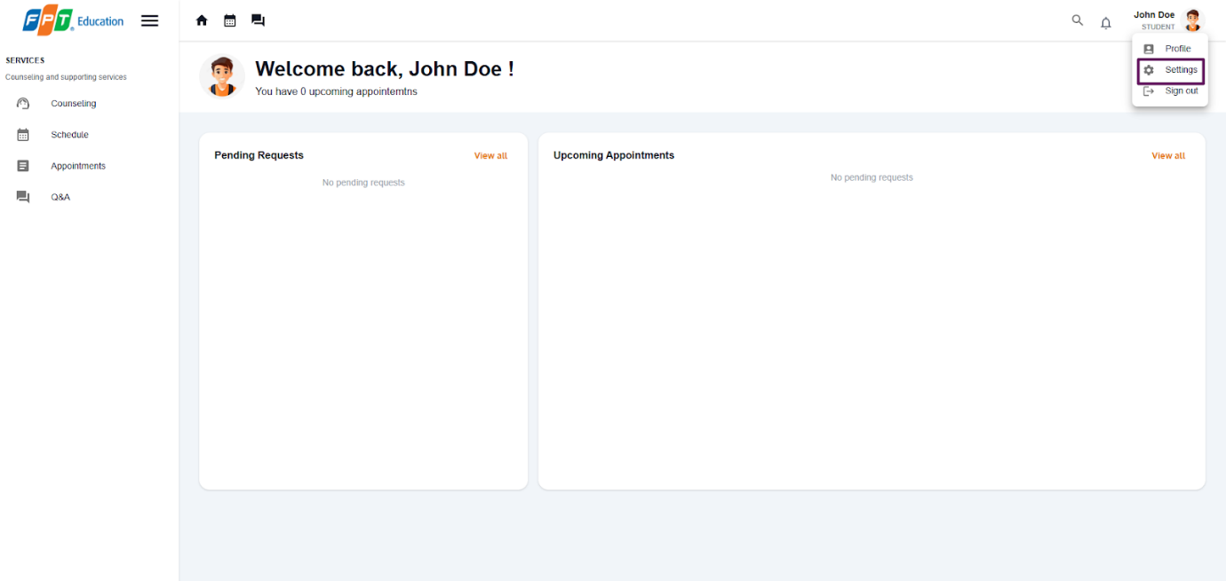

Figure - User Manual - Feature 3 - Step 1

After click “Settings” menu item, the user is redirected to the Settings Page.

**Step 2:** Click menu icon button and click “Edit” button.

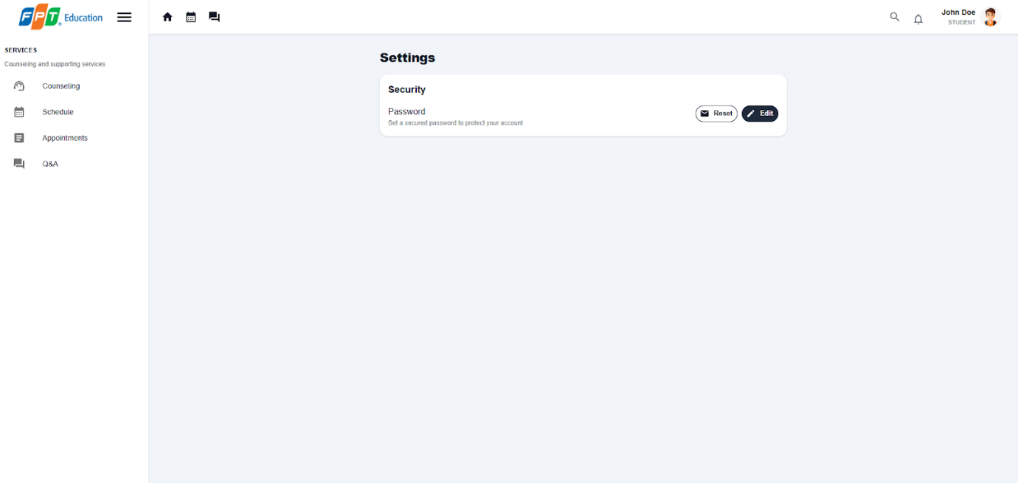

Figure - User Manual - Feature 3 - Step 2

**Step 3:** Fill in “Current password”, “New password” and “Confirm new password”, then click “Save” button

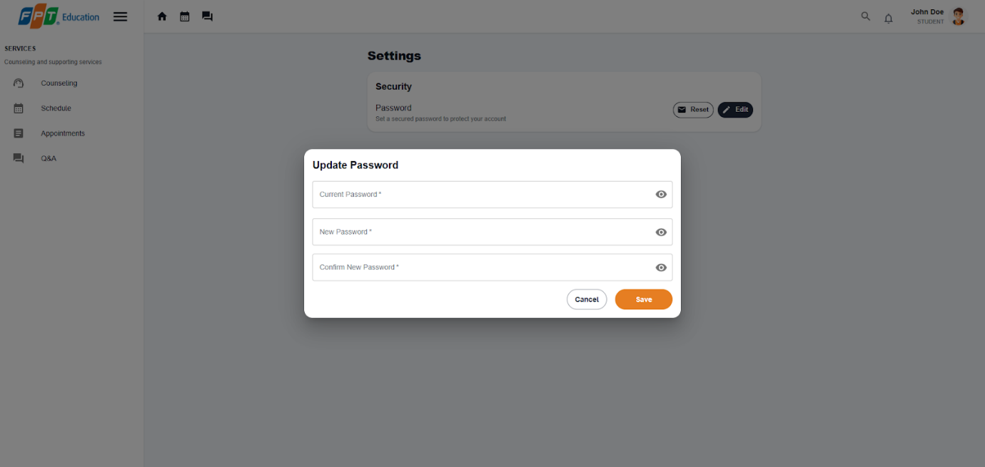

Figure - User Manual - Feature 3 - Step 3

#### 3.2.2.  Booking counseling appointment

##### 3.2.2.1. Quick booking a counselor

###### 3.2.2.1.1. Description

Use this guideline to login into SCSS student account to quick booking counseling appointments.

###### 3.2..2.1.2. Guide steps

Step 1: Access SCSS at http://scss-fe.azurewebsites.net/. Then fill in “Email” and “Password” of the student account.

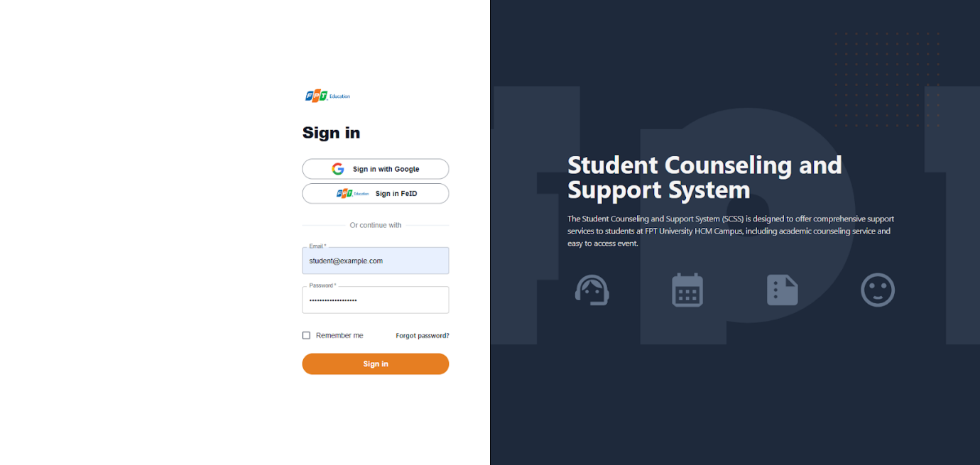

Figure - User Manual - Feature 4 - Step 1

**Step 2:** Click “Sign in ” button.

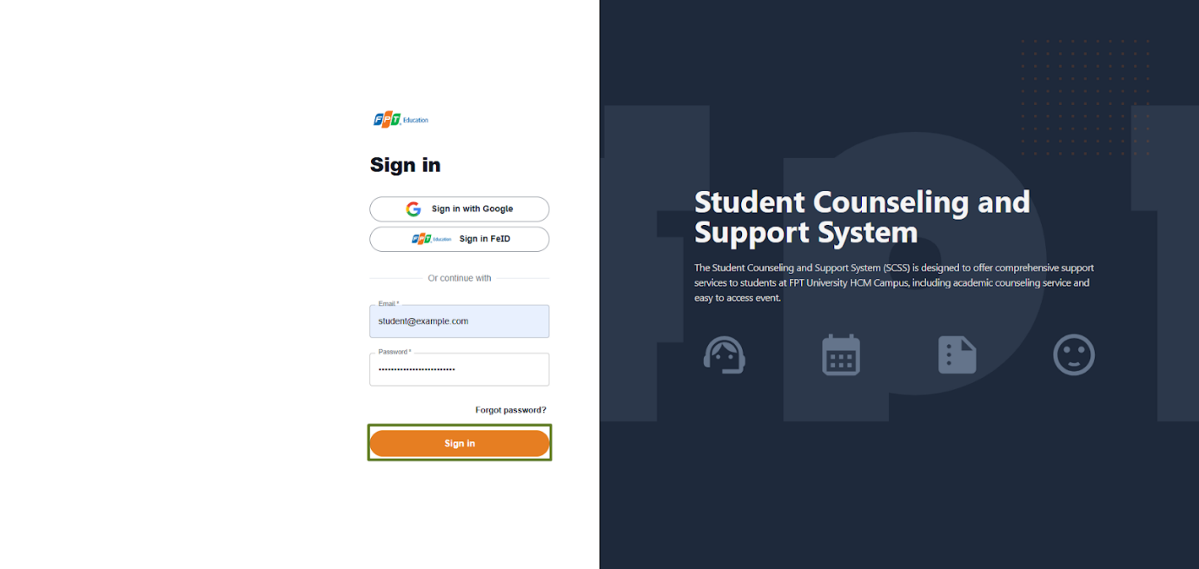

Figure - User Manual - Feature 4 - Step 2

**Step 3:** From the homepage, choose “Counseling” from the left sidebar.

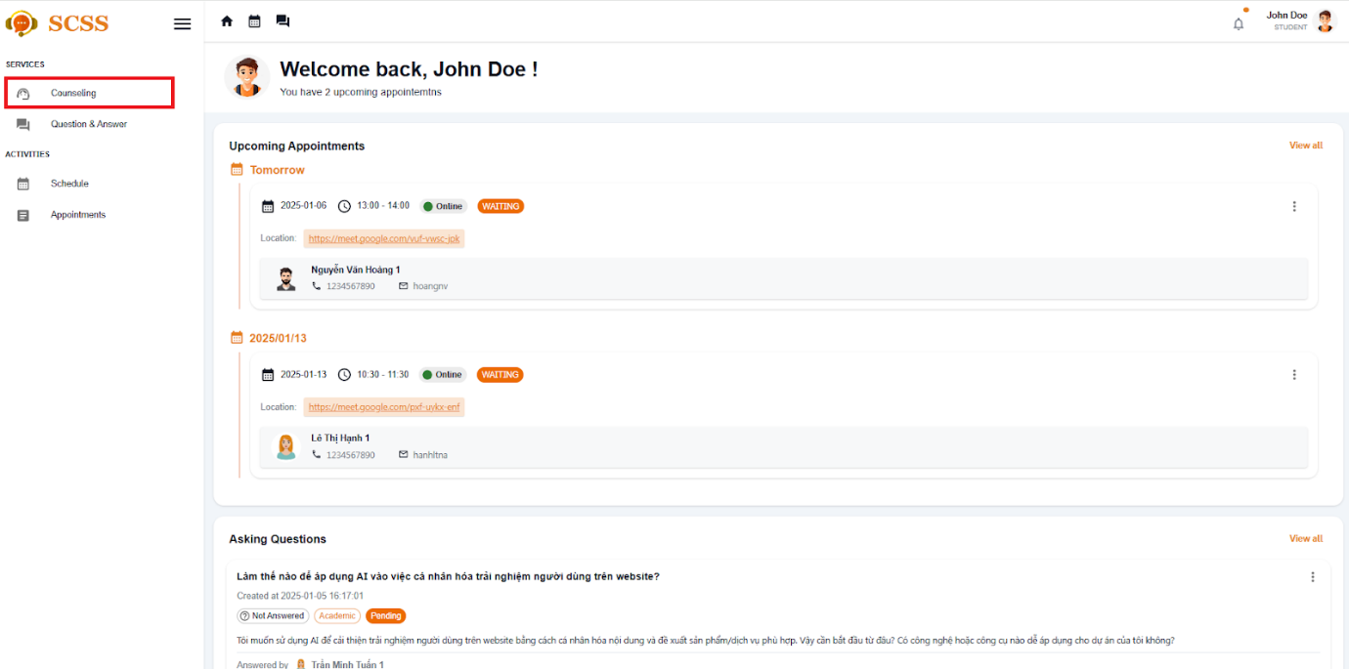

Figure - User Manual - Feature 4 - Step 3

**Step 4:** At Quick Booking tab, enter all the the required information to booking counseling appointment including: Reason, gender (optional), date (optional), slot (optional), gender (optional)

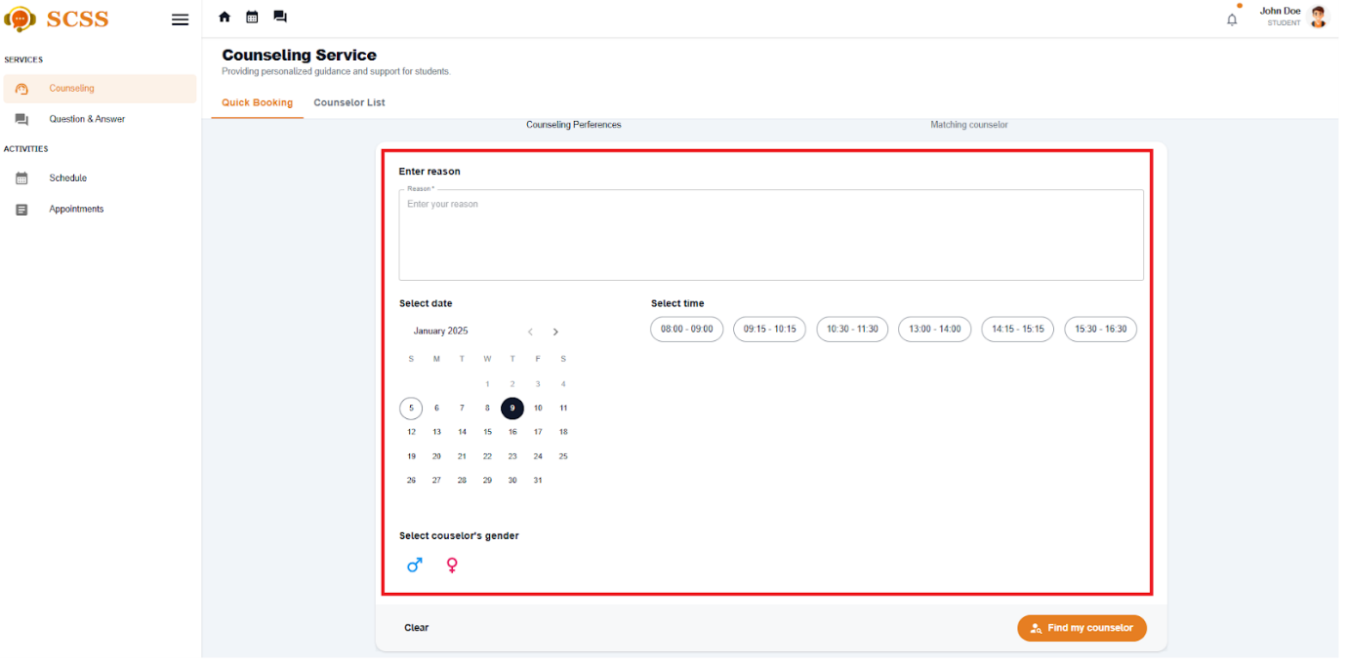

Figure - User Manual - Feature 4 - Step 4

**Step 5:** If you give a valid reason, select the 'Find my counselor' button and the system will find the counselor that matches your preferences.

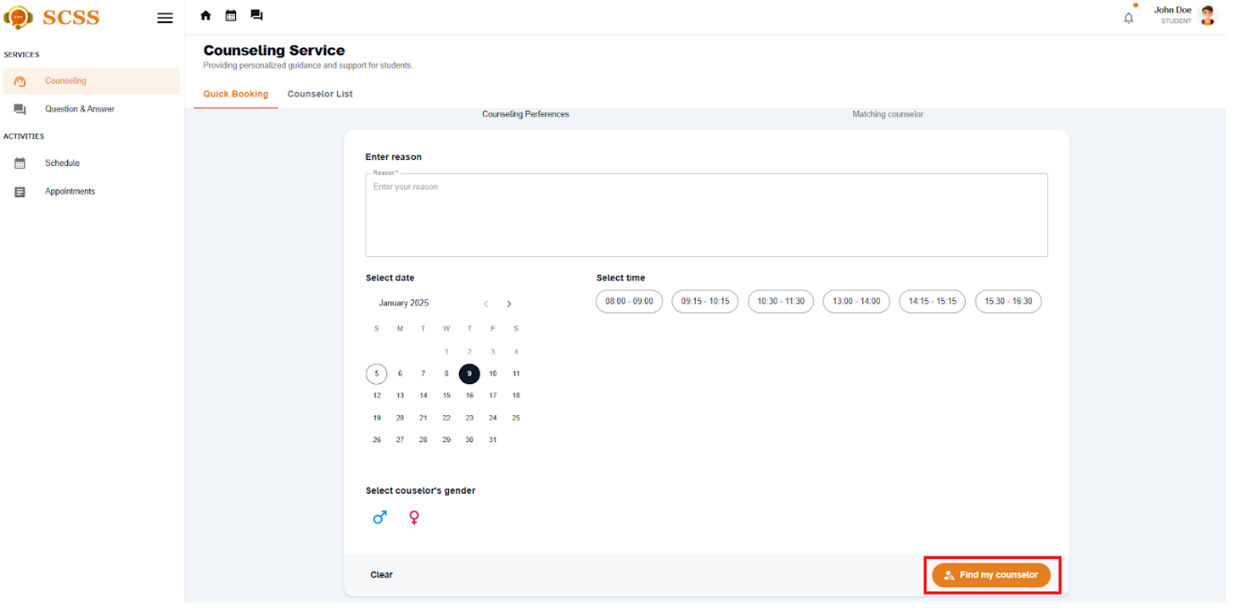

Figure - User Manual - Feature 4 - Step 5

**Step 6:** If there are matched counselors, continue to select your counselor and select date and time (if you haven't), meeting type. Then select the 'Confirm booking' button, after you confirm, booking success.

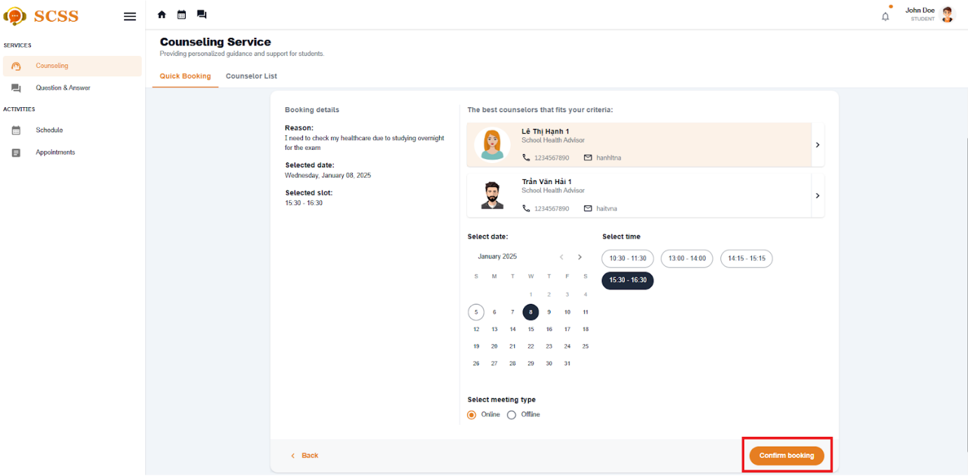

Figure - User Manual - Feature 4 - Step 6

##### 3.2.2.2. Booking a specific counselor

###### 3.2.2.2.1. Description

Use this guideline to login into the SCSS student account to book a specific counselor.

###### 3.2..2.1.2. Guide steps

**Step 1:** Access SCSS at http://scss-fe.azurewebsites.net/. Then fill in “Email” and “Password” of the student account.



Figure - User Manual - Feature 5 - Step 1

**Step 2:** Click “Sign in ” button.



Figure - User Manual - Feature 5 - Step 2

**Step 3:** From the homepage, choose “Counseling” from the left sidebar.

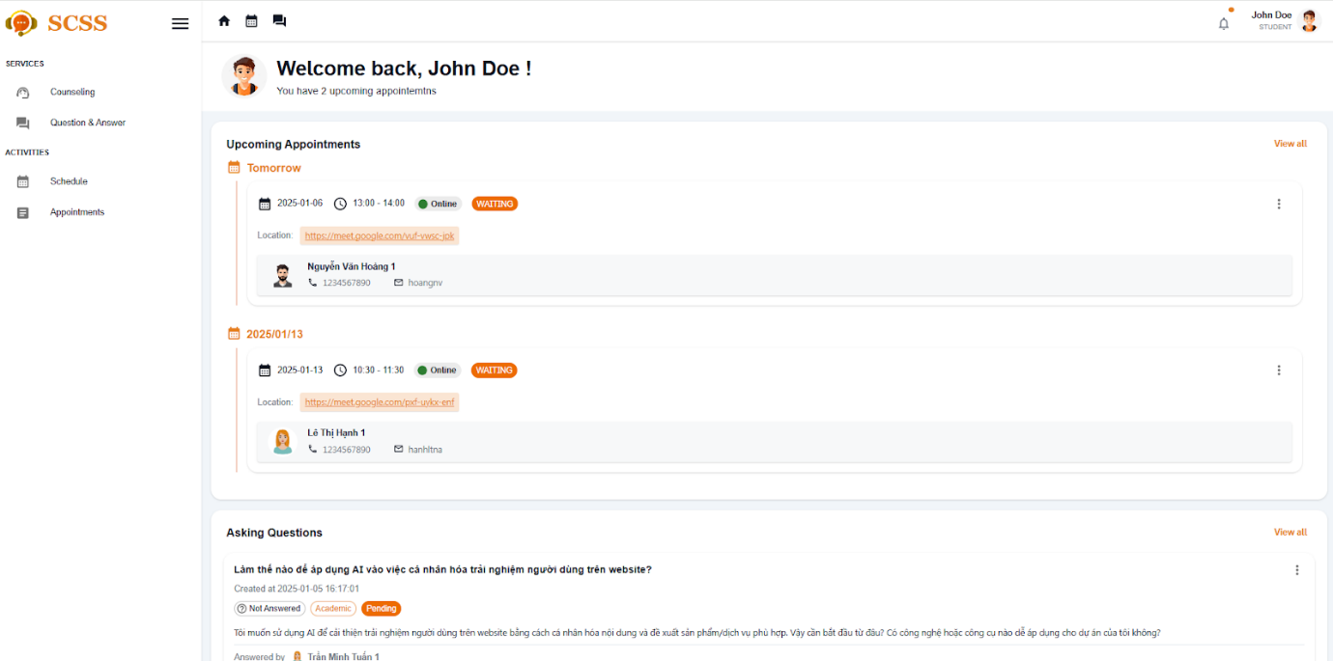

Figure - User Manual - Feature 5 - Step 3

**Step 4:** Select ”Counselor List” tab

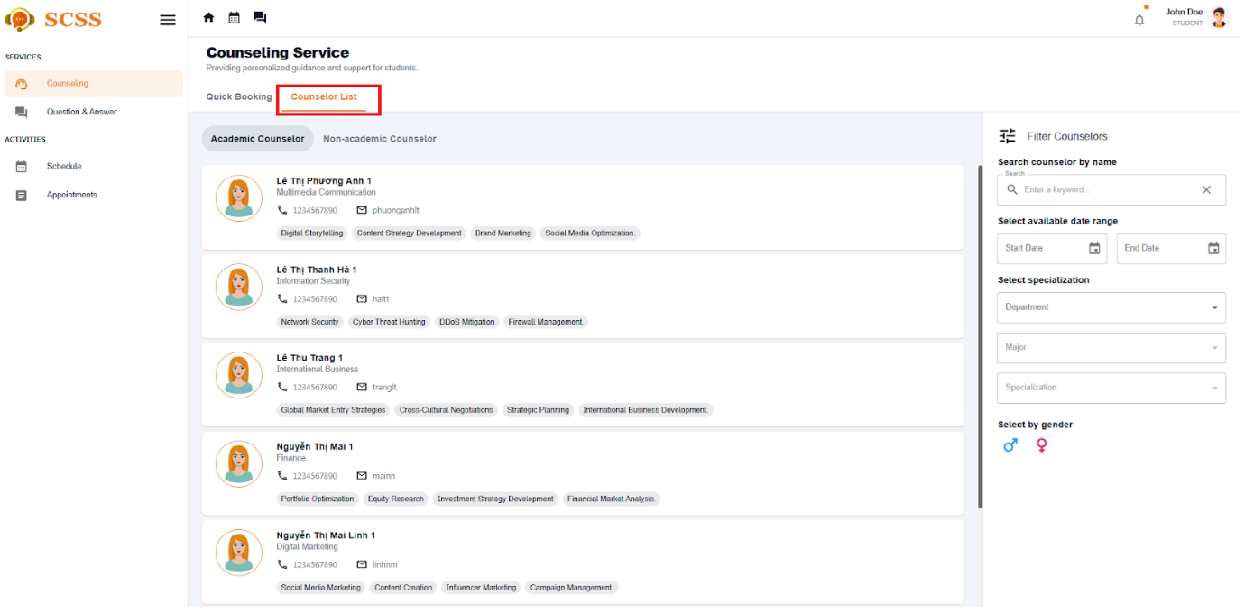

Figure - User Manual - Feature 5 - Step 4

**Step 5:** Select filter options to narrow down counselors based on preferences of students, including: counseling type, availability, department, major, specialization, expertise, gender or search by keyword.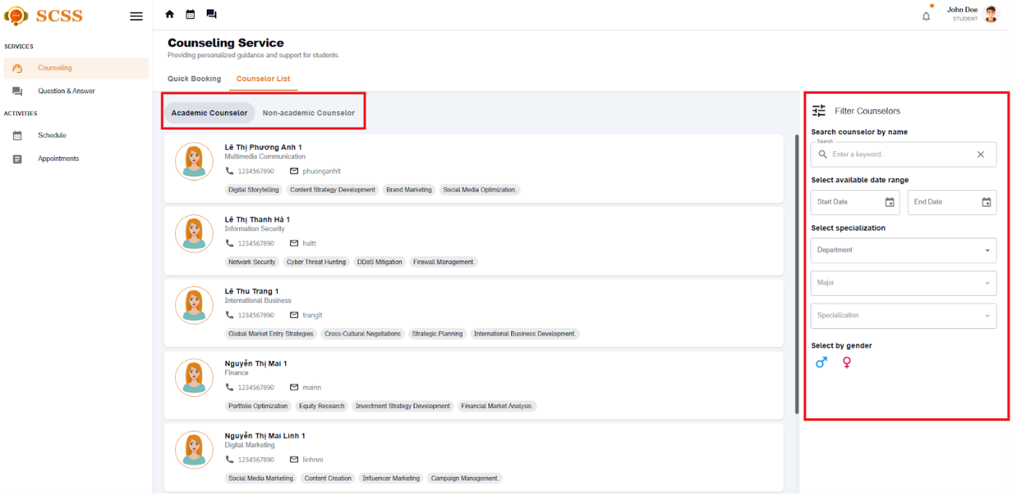

Figure - User Manual - Feature 5 - Step 5

**Step 6:** Select a counselor and click the button “Book counselor”

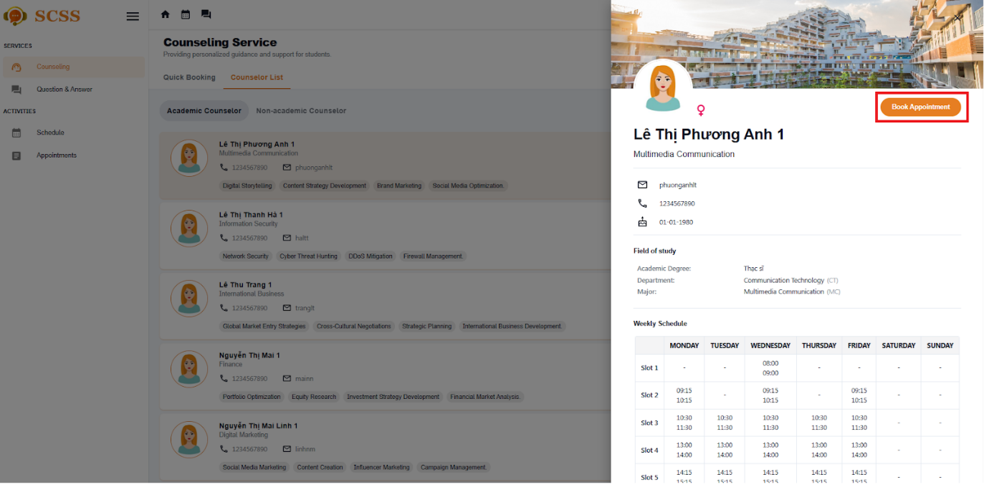

Figure - User Manual - Feature 5 - Step 6

**Step 7:**  Select all the required information to book an appointment including: “Select date”, “Select slot”, “Select meeting type“, Fill “Reason“:

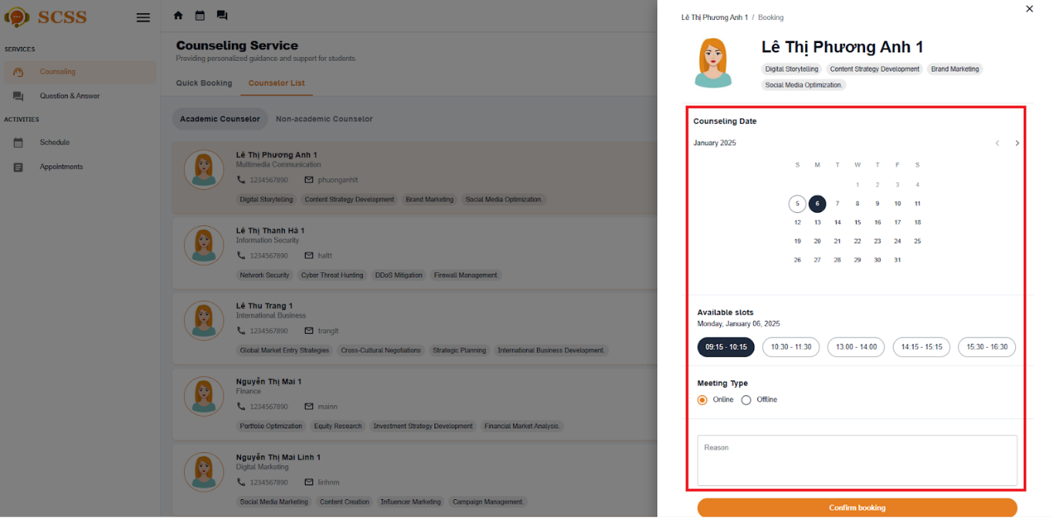

Figure - User Manual - Feature 5 - Step 7

**Step 8:** Select confirm booking, after confirm, booking success

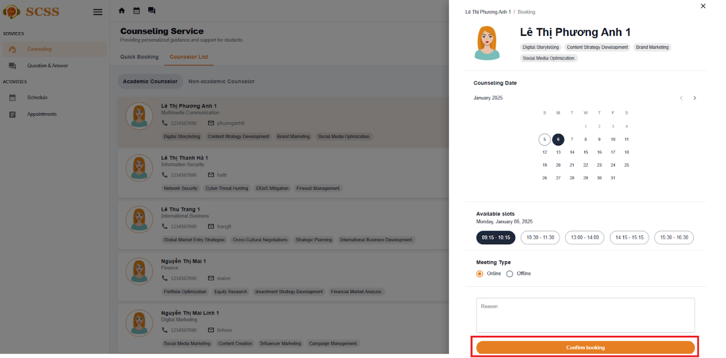

Figure - User Manual - Feature 5 - Step 8

##### 3.2.2.3. Approve an appointment request

###### 3.2.2.3.1. Description

Use this guideline to log into the SCSS counselor account to approve a student appointment request.

###### 3.2.2.3.2. Guide steps

**Step 1:** Access SCSS at http://scss-fe.azurewebsites.net/. Then fill in “Email” and “Password” of the counselor account.



Figure - User Manual - Feature 6 - Step 1

**Step 2:** Click “Sign in ” button.



Figure - User Manual - Feature 6 - Step 2

**Step 3:** From the homepage, choose “Requests” from the left sidebar.

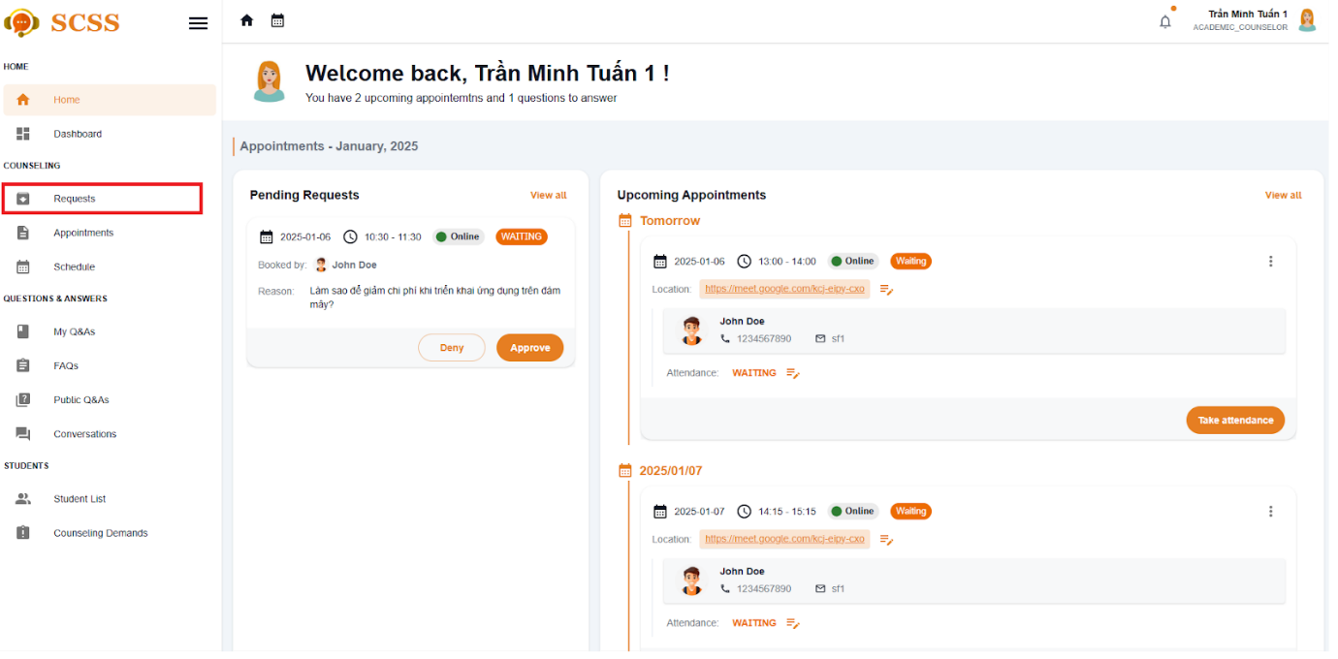

Figure - User Manual - Feature 6 - Step 3

**Step 3:** In “Requests” page, select the ”Approve” button.

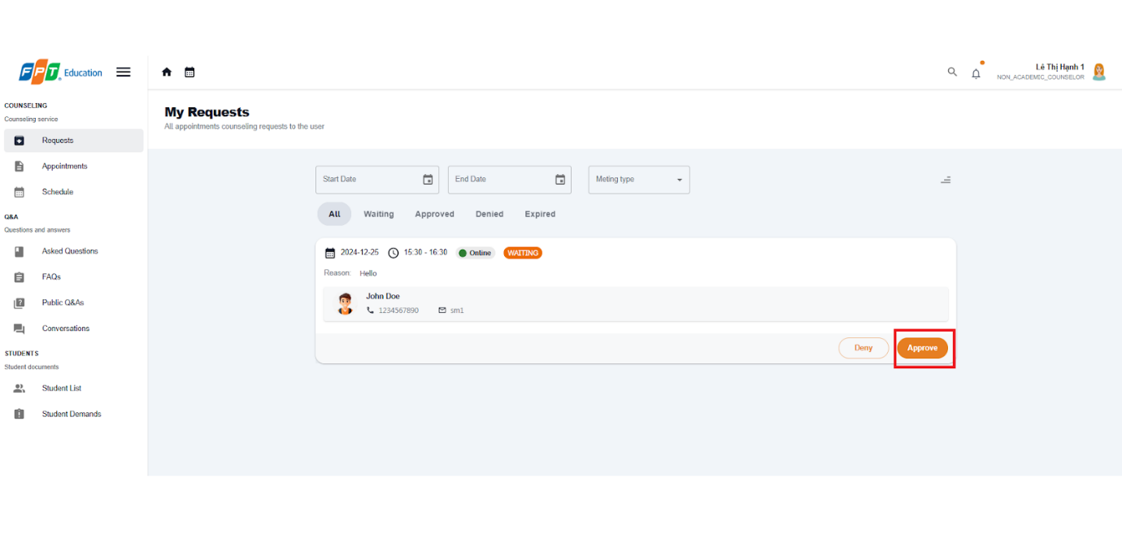

Figure - User Manual - Feature 6 - Step 3

**Step 4:** There is a dialog displayed, if the appointment request meeting type is ”Online”, fill in the meeting URL, if it is ”Offline”, fill in the address. After fill required field, press “Confirm” Button to approve the request.

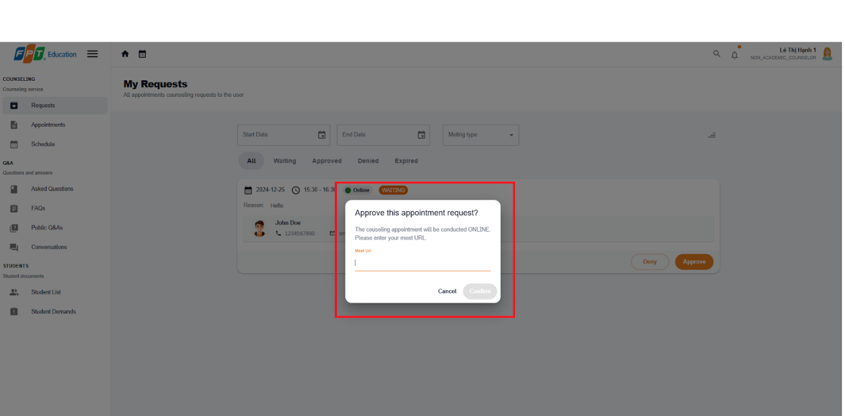

Figure - User Manual - Feature 6 - Step 4

##### 3.2.2.4. Deny an appointment request

###### 3.2.2.4.1. Description

Use this guideline to log into the SCSS counselor account to deny a student appointment request.

###### 3.2.2.4.2. Guide steps

**Step 1:** Access SCSS at http://scss-fe.azurewebsites.net/. Then fill in “Email” and “Password” of the counselor account.



Figure - User Manual - Feature 7 - Step 1

**Step 2:** Click “Sign in ” button.



Figure - User Manual - Feature 7 - Step 2

**Step 3:** From the homepage, choose “Requests” from the left sidebar.

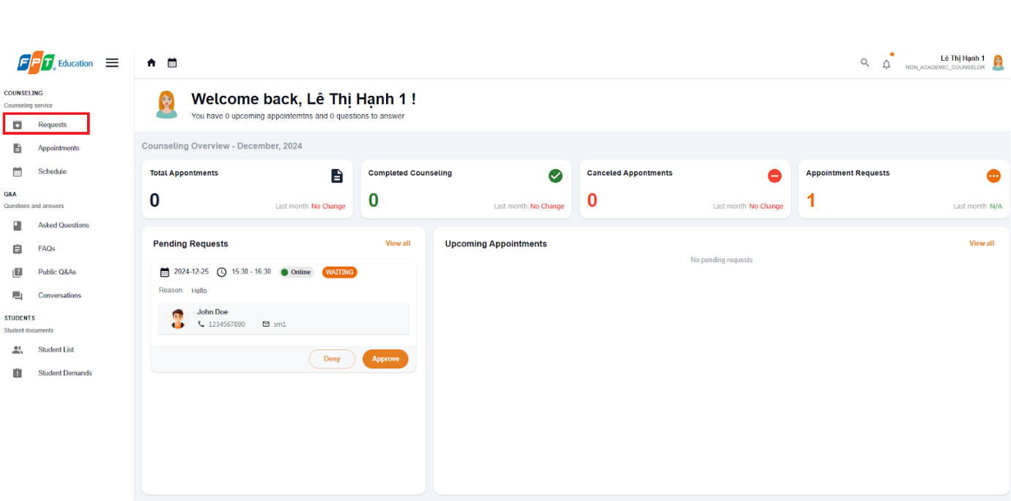

Figure - User Manual - Feature 8 - Step 2

**Step 3:** In “Requests” page, select the ”Deny” button.

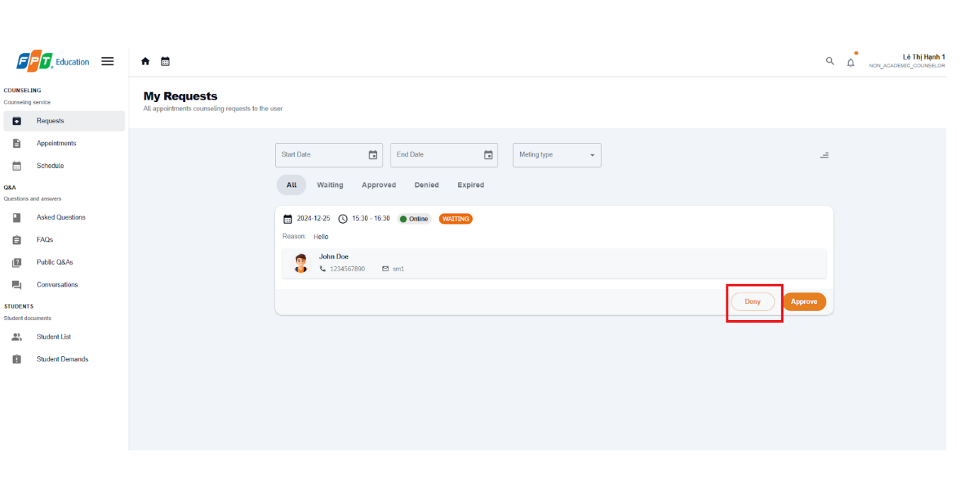

Figure - User Manual - Feature 8 - Step 3

**Step 4:** There is a confirmation dialog displayed, press “Confirm” Button to deny the request.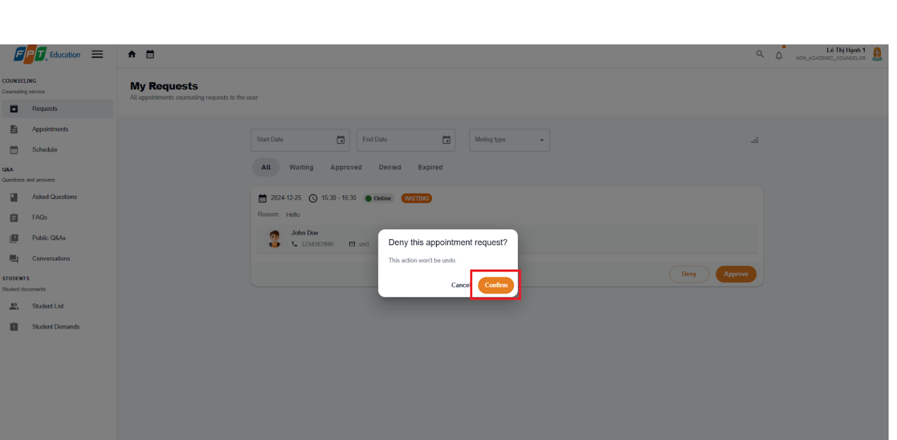

Figure - User Manual - Feature 8 - Step 4

##### 3.2.2.5. Take Attendance for Appointment

###### 3.2.2.5.1. Description

Use this guideline to log into the SCSS counselor account to take attendance for appointment

###### 3.2.2.5.1. Guide Steps:

**Step 1:** Access SCSS at http://scss-fe.azurewebsites.net/. Then fill in “Email” and “Password” of the counselor account.



Figure - User Manual - Feature 9 - Step 1

**Step 2:** Click “Sign in ” button.



Figure - User Manual - Feature 9 - Step 2

**Step 3:** From the homepage, choose “Appointments” from the left sidebar.

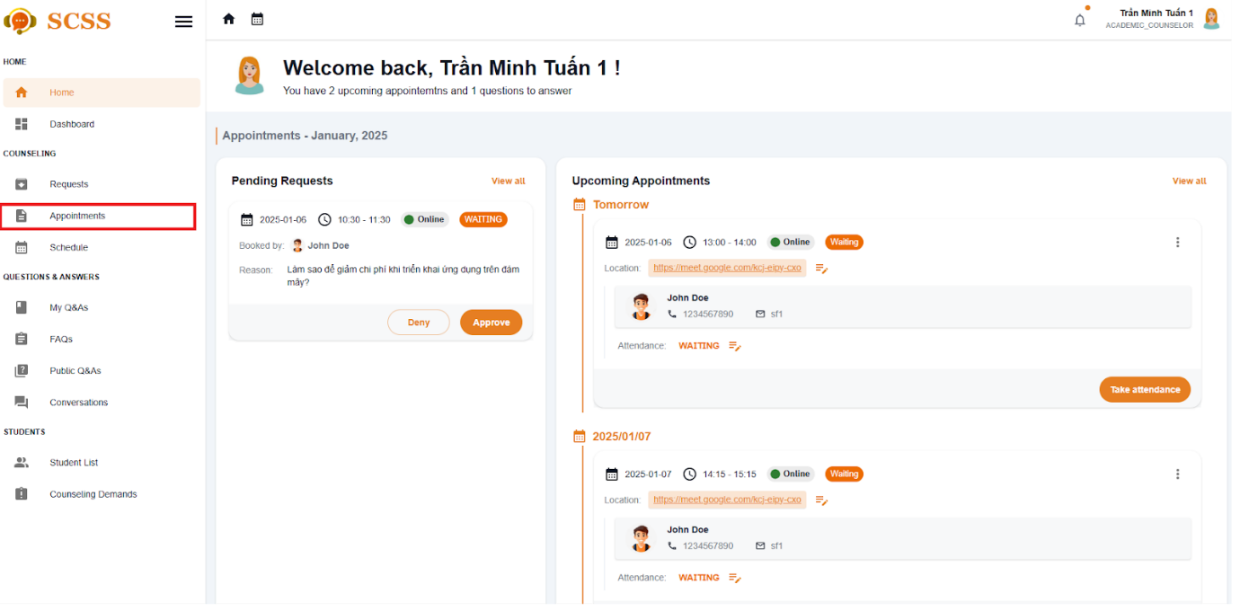

Figure - User Manual - Feature 9 - Step 3

**Step 4:** In “Appointments” page, find an appointment using filter section by meeting date, and status. After finding an appointment, press “Take attendance” button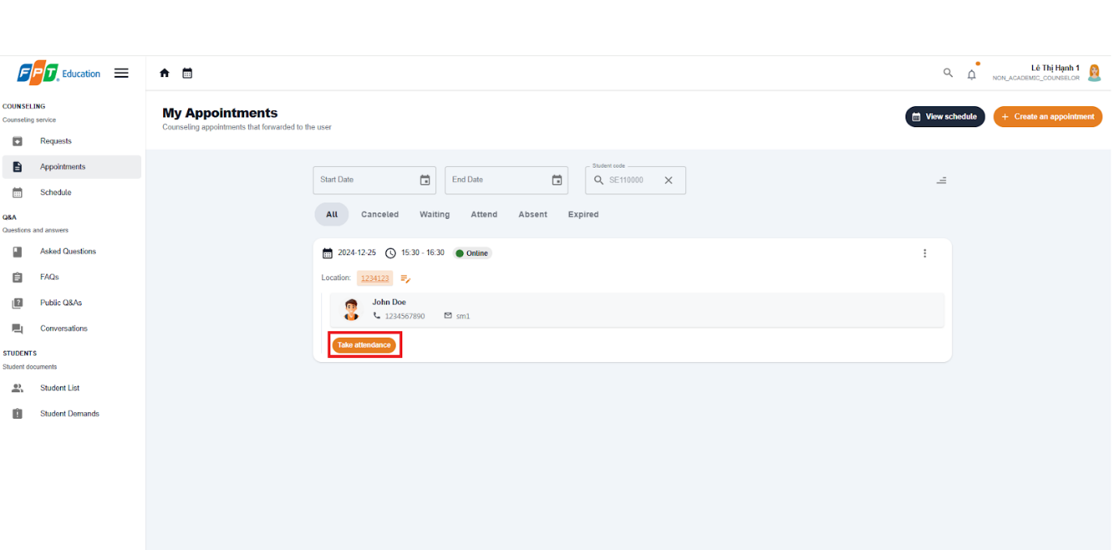

Figure - User Manual - Feature 9 - Step 4

**Step 5:** There will be Take Attendance dialog, a take attendance confirmation will open. Press “ATTEND” or “ABSENT” to change the status of the chosen appointment.

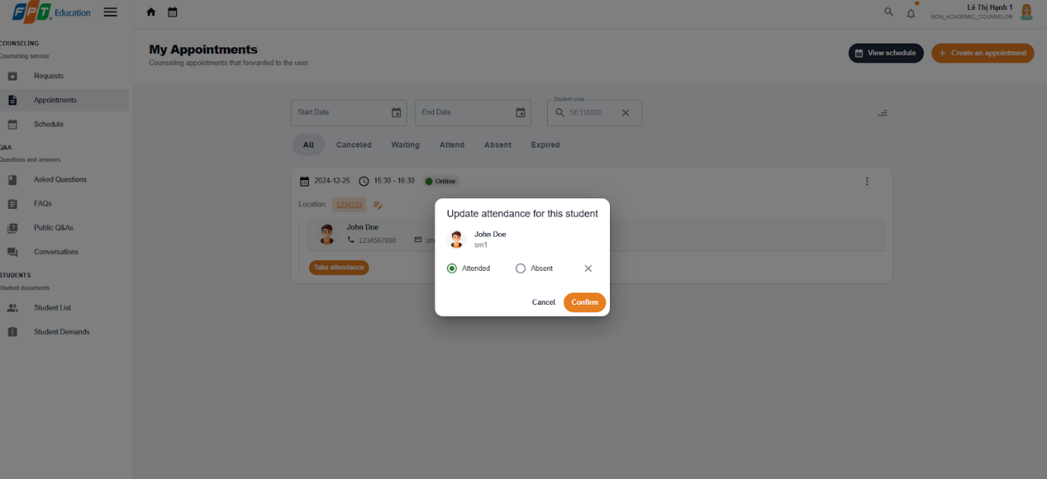

Figure - User Manual - Feature 9 - Step 5

**Step 6:** After taking attendance, the status of appointment will change to “ATTEND” or “ABSENT”

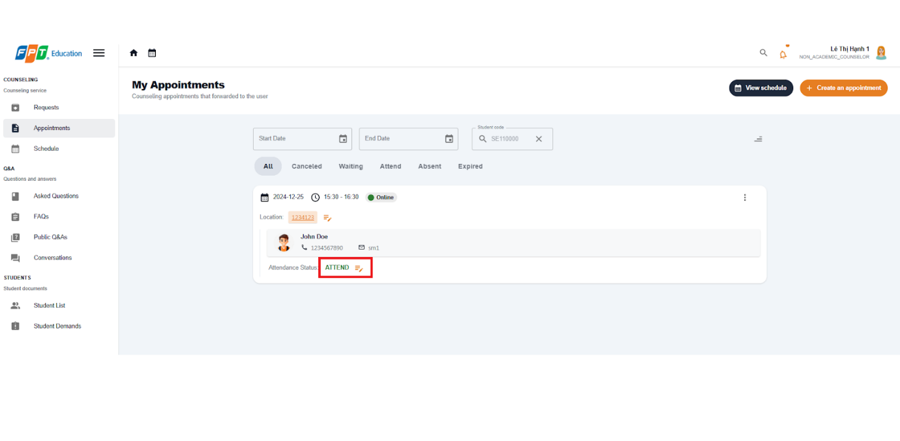

Figure - User Manual - Feature 9 - Step 5

##### 3.2.2.6. Give Feedback for Appointment

###### 3.2.2.6.1. Description

Use this guideline to log into the SCSS student account to write feedback for appointment

###### 3.2.2.6.2. Guide Steps

**Step 1:** Access SCSS at http://scss-fe.azurewebsites.net/. Then fill in “Email” and “Password” of the student account.



Figure - User Manual - Feature 10 - Step 1

**Step 2:** Click “Sign in ” button.



Figure - User Manual - Feature 10 - Step 2

**Step 3:** From the homepage, choose “Appointments” from the left sidebar.



Figure - User Manual - Feature 10 - Step 3

**Step 4:** In Appointment page, find an appointment using filter section by meeting date, and status. After finding a appointment (which status is “ATTEND”), press “Leave a review” button.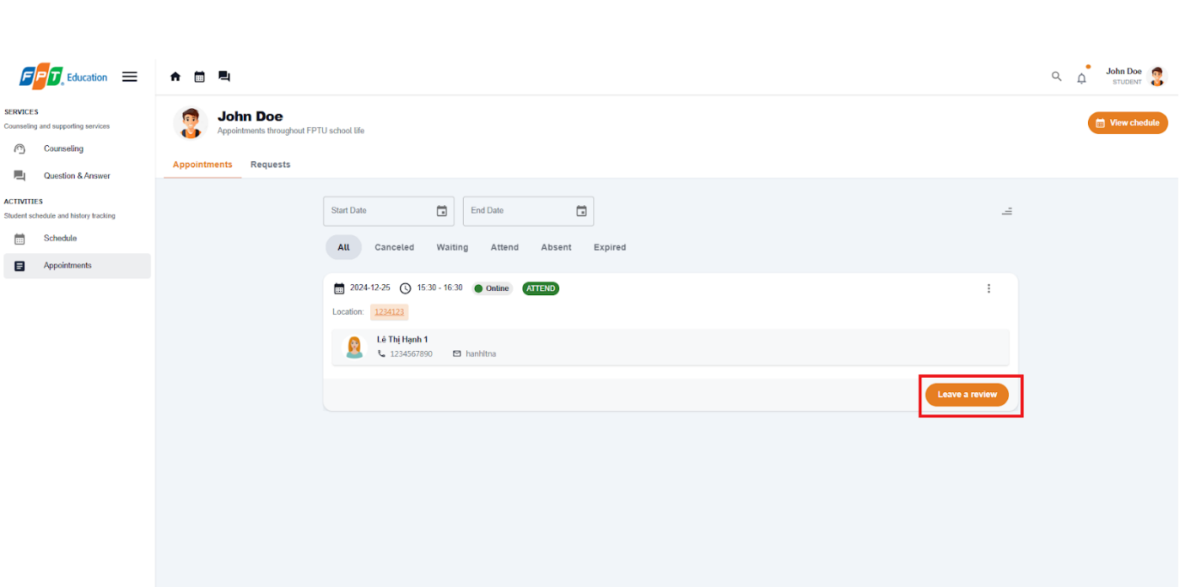

Figure - User Manual - Feature 10 - Step 4

**Step 5:** Fill in feedback content including message and rating. Then submit it by pressing “Save” Button, or cancel by pressing “Cancel” Button

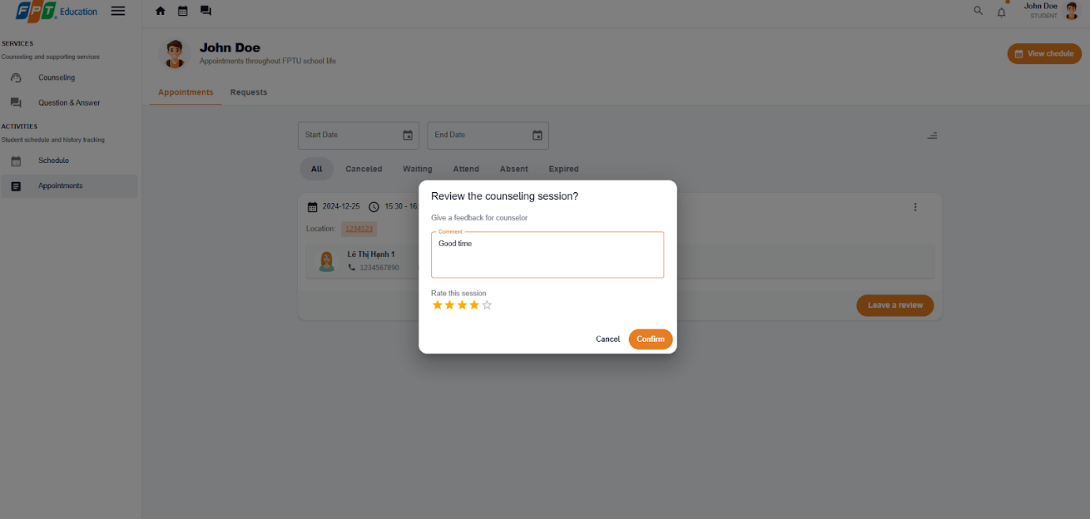

Figure - User Manual - Feature 10 - Step 5

**Step 6:** View feedback after submitting in the appointments page.

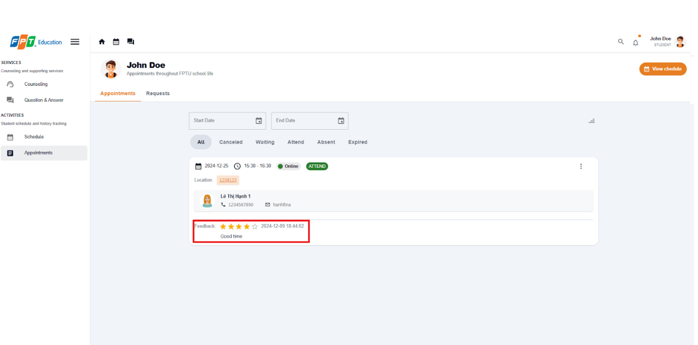

Figure - User Manual - Feature 10 - Step 6

##### 3.2.2.7. Create report for an appointment

###### 3.2.2.7.1. Description

Use this guideline to log into the SCSS student account to write report for appointment

###### 3.2.2.7.2. Guide Steps

**Step 1:** Access SCSS at http://scss-fe.azurewebsites.net/. Then fill in “Email” and “Password” of the counselor account.



Figure - User Manual - Feature 11 - Step 1

**Step 2:** Click “Sign in ” button.



Figure - User Manual - Feature 11 - Step 2

**Step 3:** From the homepage, choose “Appointments” from the left sidebar.



Figure - User Manual - Feature 11 - Step 3

**Step 4:** In the Appointment page, find an appointment using the filter section by meeting date, and status. After finding an appointment (which status is “ATTEND”), press the more vert icon button, then choose the “Create Report” option.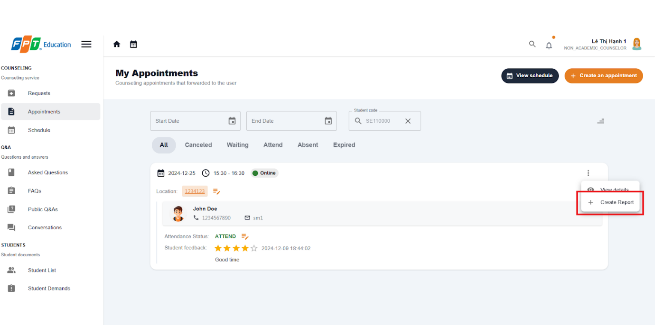

Figure - User Manual - Feature 11 - Step 4

**Step 5:** Fill in the report form which requires 4 steps, including Goal, Content, Conclusion, Intervention. You can select Preview button before submitting to check full report.

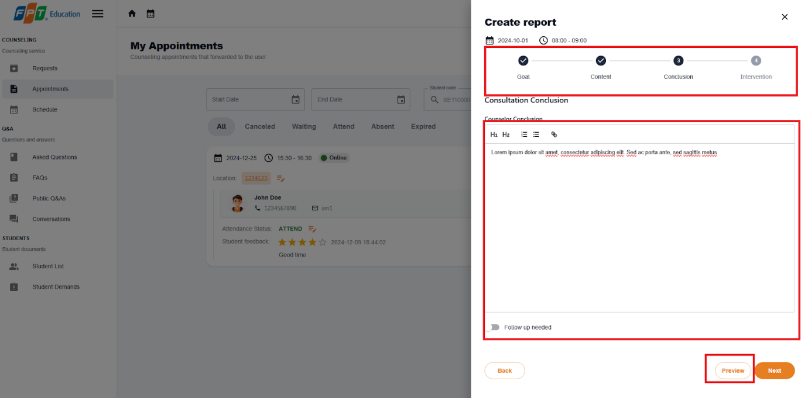

Figure - User Manual - Feature 11 - Step 5

**Step 6:**.Select submit button. After confirmation, report will be created, then select more vert icon button again select View report option.

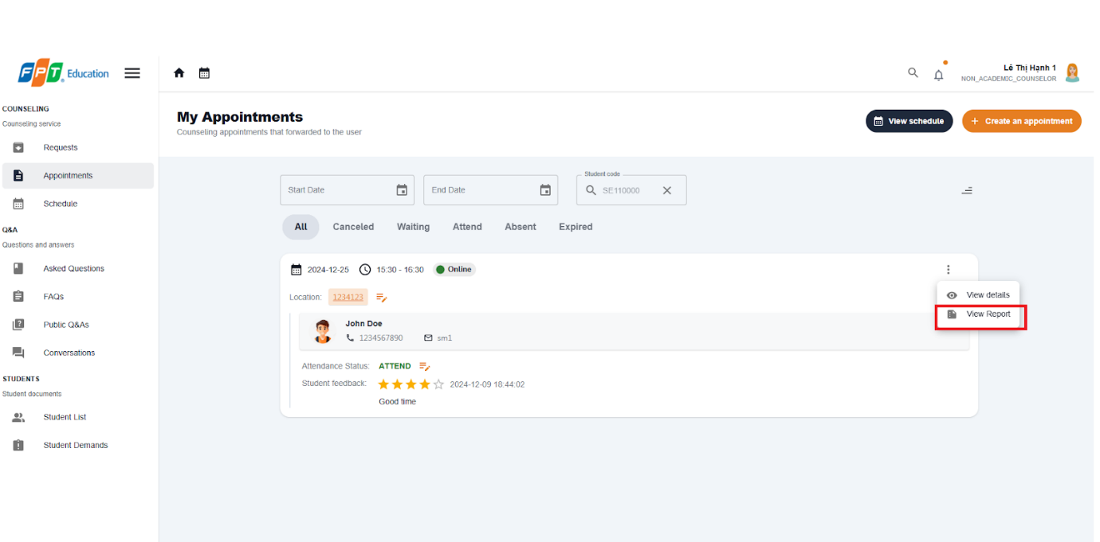

Figure - User Manual - Feature 11 - Step 6

**Step 7:**.Check on newly created report.

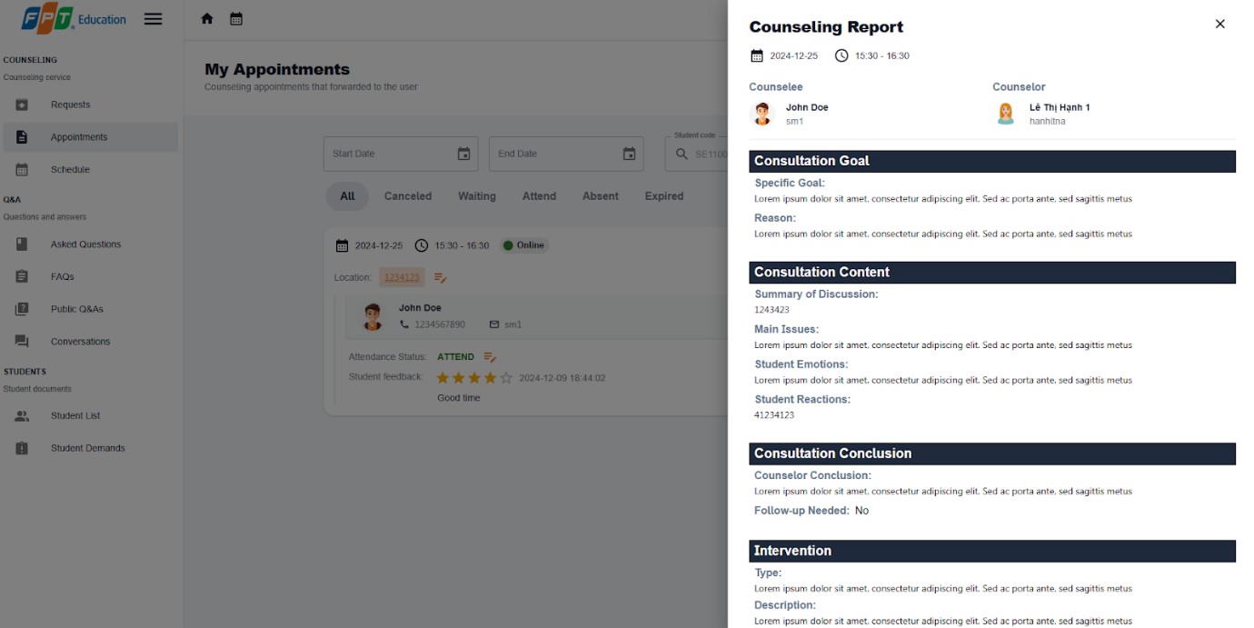

Figure - User Manual - Feature 11 - Step 7

##### 3.2.2.8. Cancel an appointment

###### 3.2.2.8.1. Description

Use this guideline to log into the SCSS student account to cancel an appointment

###### 3.2.2.8.2. Guide Steps:

**Step 1:** Access SCSS at http://scss-fe.azurewebsites.net/. Then fill in “Email” and “Password” of the counselor or student account.



Figure - User Manual - Feature 12 - Step 1

**Step 2:** Click “Sign in ” button.



Figure - User Manual - Feature 12 - Step 2

**Step 3:** From the homepage, choose “Appointments” from the left sidebar.



Figure - User Manual - Feature 12 - Step 3

**Step 4:** In the Appointment page, find an appointment using the filter section by meeting date, and status. After finding an appointment (which status is “ATTEND”), press the more vert icon button, then choose the “Cancel” option.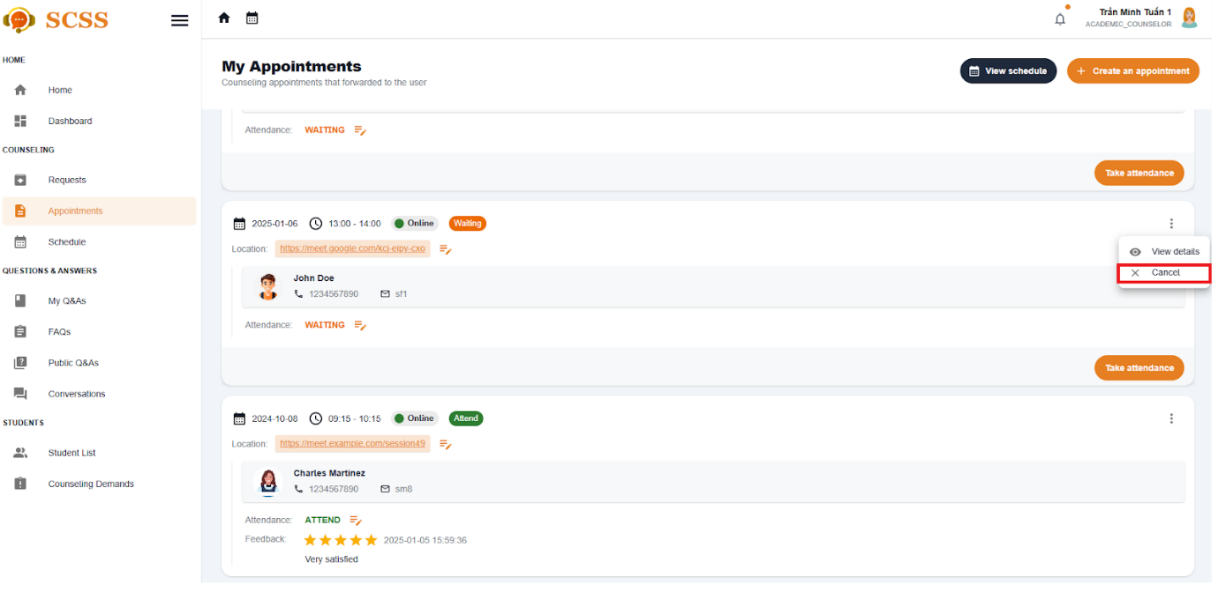

Figure - User Manual - Feature 12 - Step 4

**Step 5:** Fill in the cancel reason, then press the “Confirm” button.

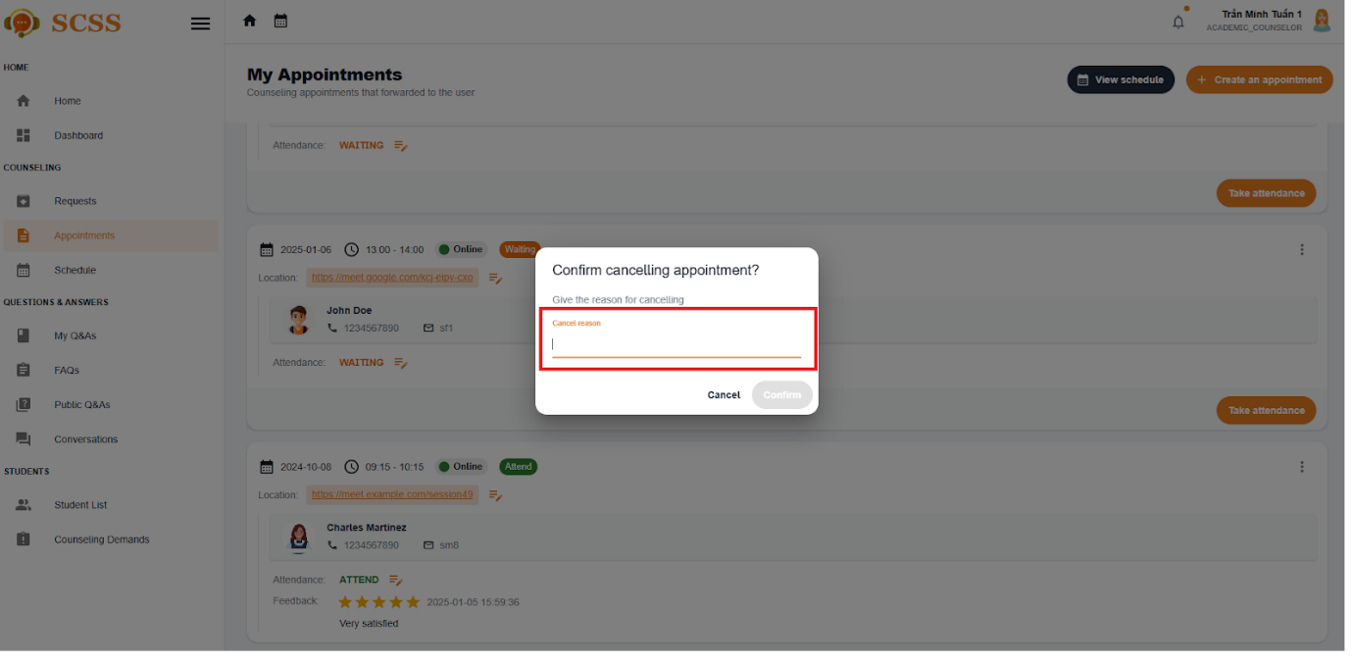

Figure - User Manual - Feature 12 - Step 5

**Step 6:** The appointment status will be  “Canceled”, and both student and counselor can see the cancel the reason.

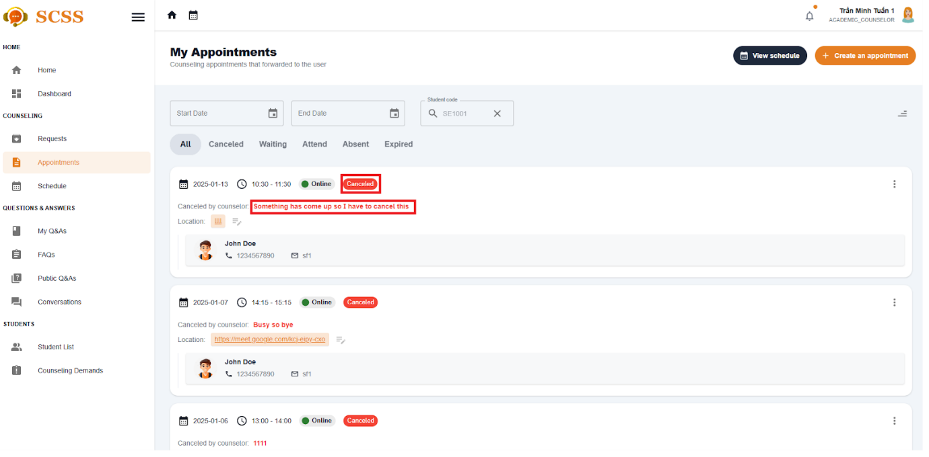

Figure - User Manual - Feature 12 - Step 6

##### 3.2.2.9. View counseling schedule

###### 3.2.2.9.1. Description

Use this guideline to log into the SCSS student account to view counseling shedule

###### 3.2.2.9.2. Guide Steps

**Step 1:** Access SCSS at http://scss-fe.azurewebsites.net/. Then fill in “Email” and “Password” of the counselor or student account.



Figure - User Manual - Feature 13 - Step 1

**Step 2:** Click “Sign in ” button.



Figure - User Manual - Feature 13 - Step 2

**Step 3:** From the homepage, choose “Appointments” from the left sidebar.

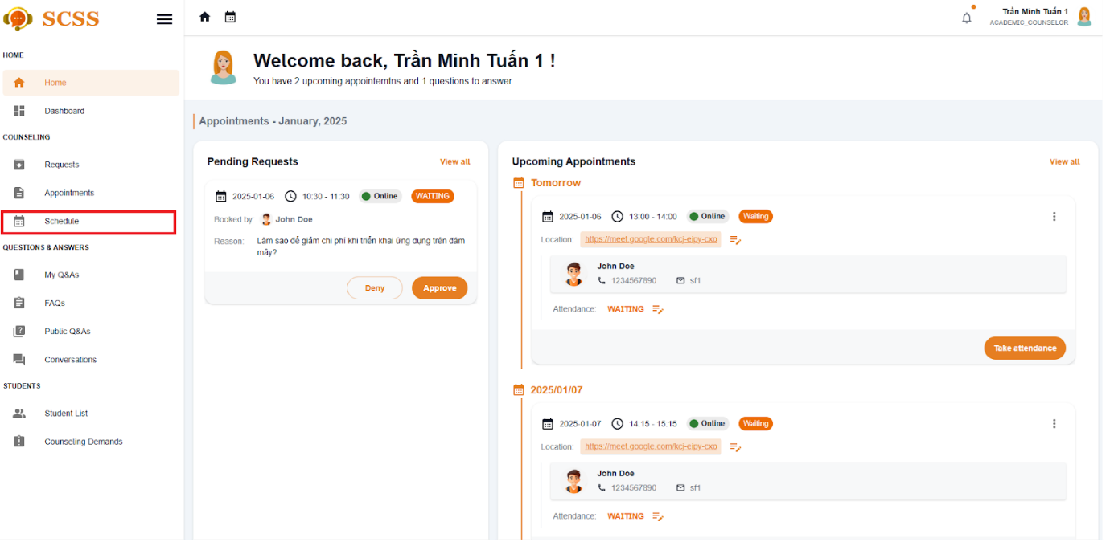

Figure - User Manual - Feature 13 – Step 3

**Step 4:** In the schedule page, students or counselors can view their counseling schedule by monthly, weekly or daily.

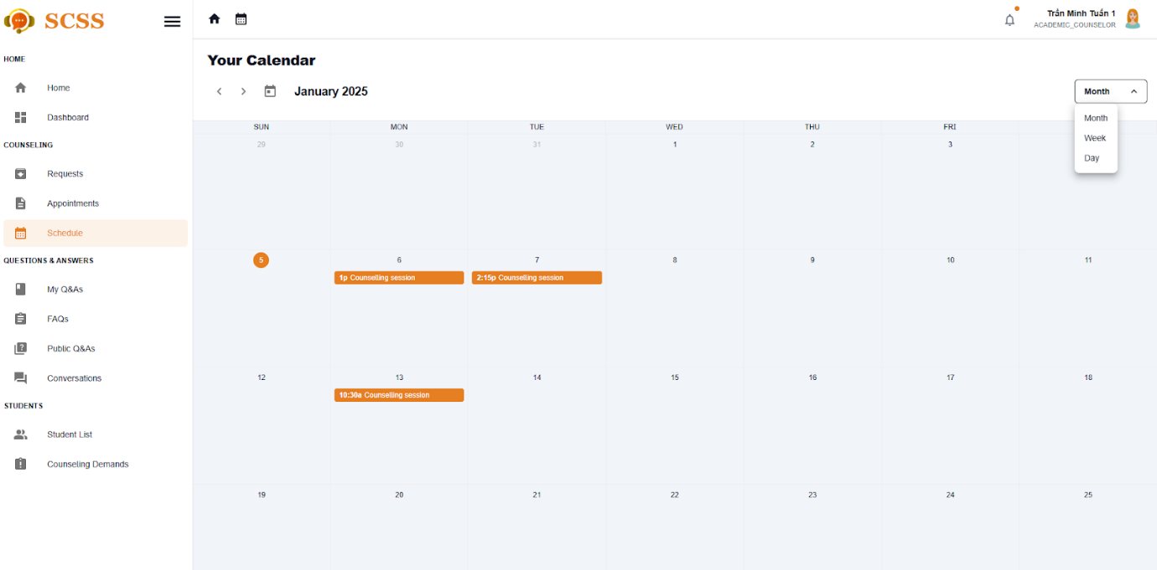

Figure - User Manual - Feature 13 – Step 4.1

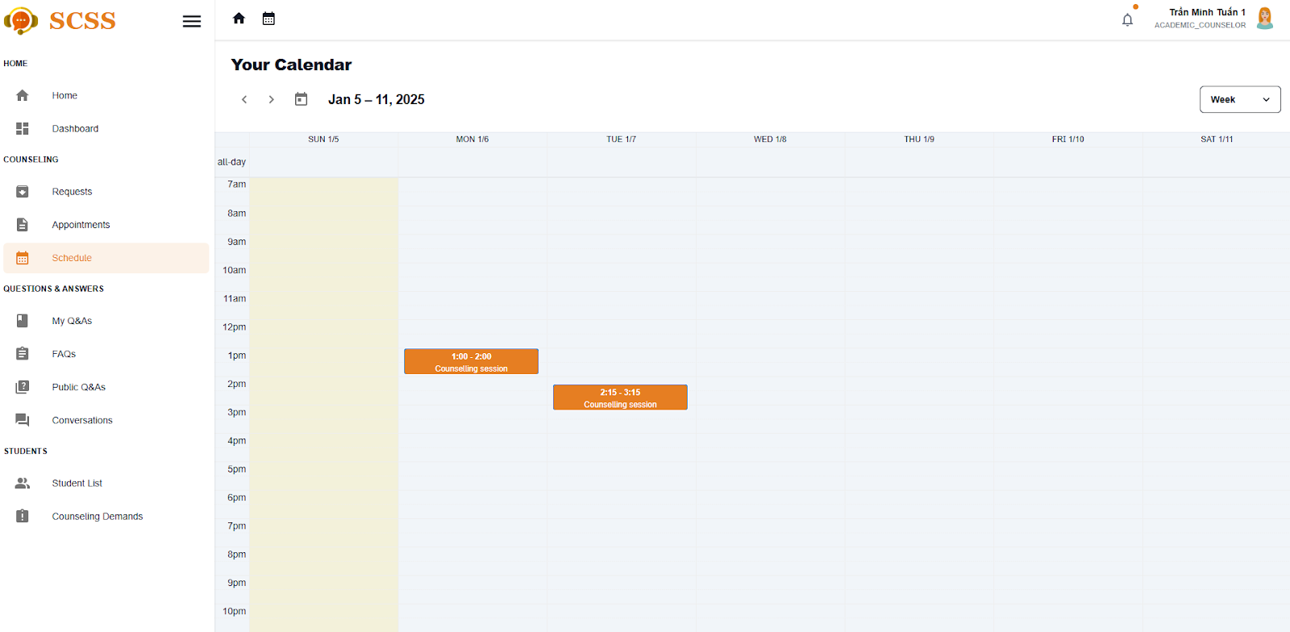

Figure - User Manual - Feature 13 – Step 4.2

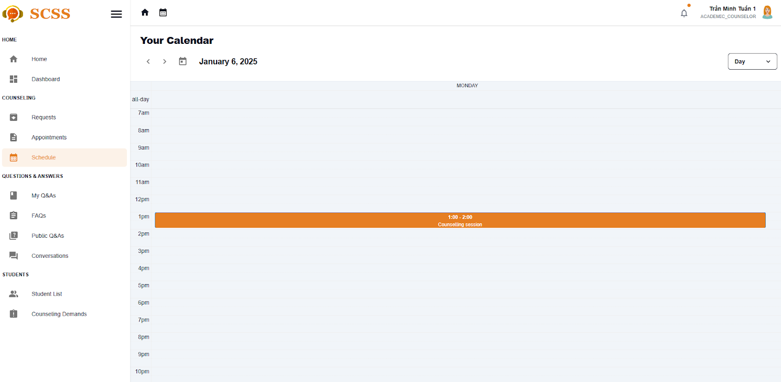

Figure - User Manual - Feature 13 – Step 4.3

**Step 5:** Fill in the cancel reason, then press the “Confirm” button.



Figure - User Manual - Feature 13 – Step 5

**Step 6:** The appointment status will be  “Canceled”, and both student and counselor can see the cancel the reason.



Figure - User Manual - Feature 13 – Step 6

#### 3.2.3. Question and answer

##### 3.2.3.1. Ask a question

###### 3.2.3.1.1 Description

Use this guideline to create a question for counselor

###### 3.2.3.1.2. Guide Steps

**Step 1**: Access SCSS at http://scss-fe.azurewebsites.net/. Then fill in “Email” and “Password” of the student account.



Figure - User Manual - Feature 14 – Step 1

**Step 2:** Click the “Sign in ” button.



Figure - User Manual - Feature 14 – Step 2

**Step 3:** From the homepage, choose “Question & Answer” from the left sidebar.

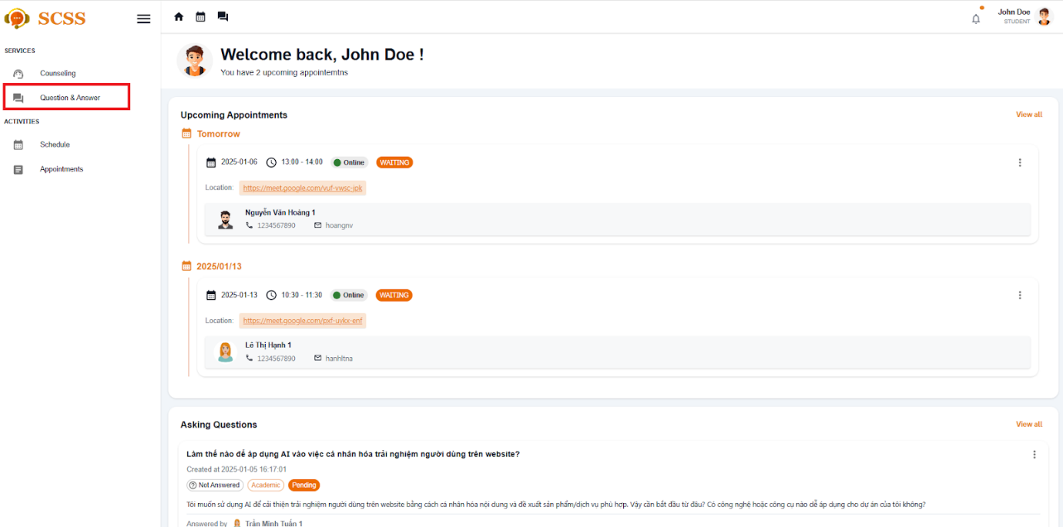

Figure - User Manual - Feature 14 – Step 3

**Step 4:** In Q&A page, choose “Ask a button” at top right

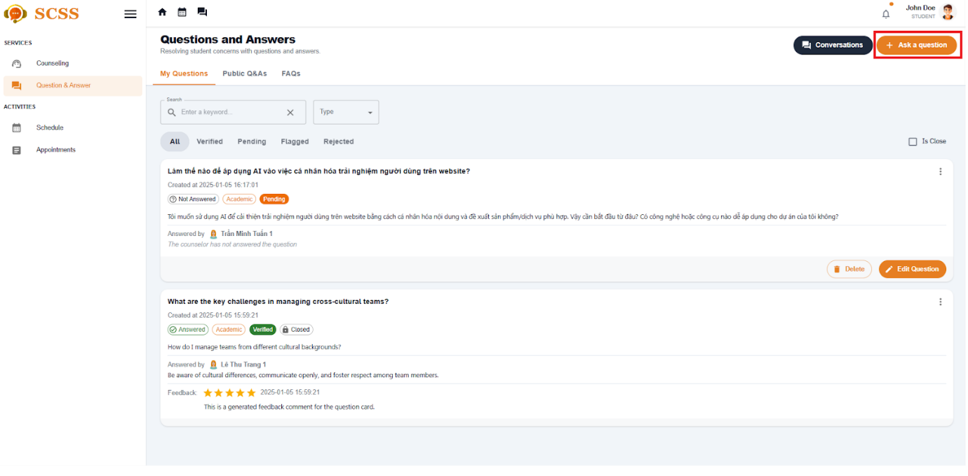

Figure - User Manual - Feature 14 – Step 4

**Step 5:** Fill in question, content, question type and major, department, and expertise, then select  “Submit” button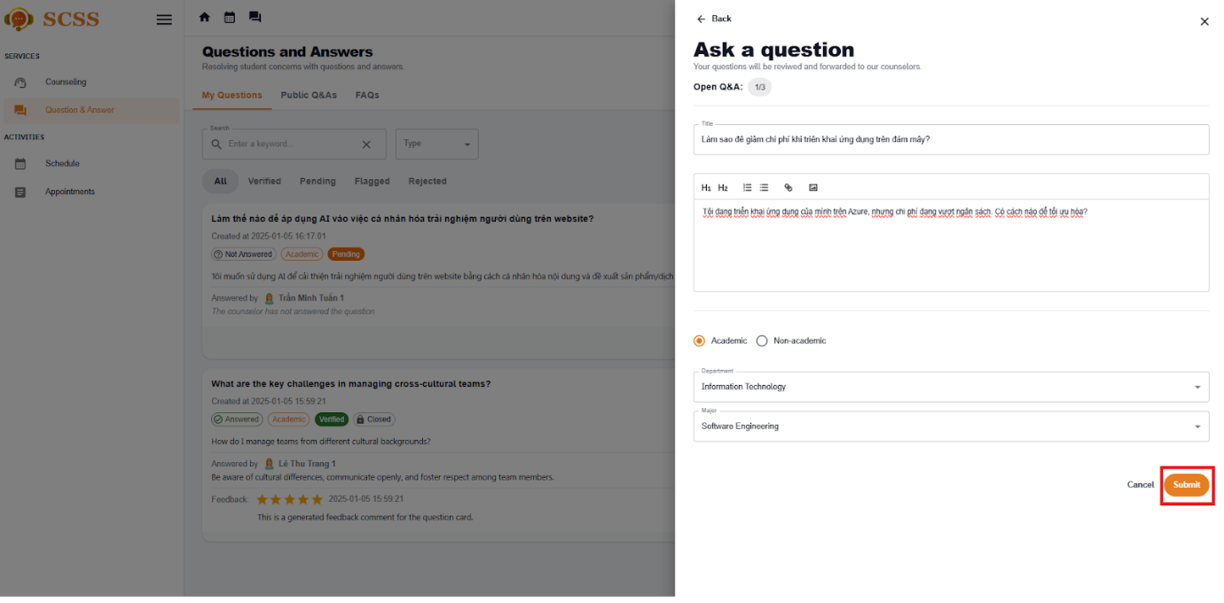

Figure - User Manual - Feature 14 – Step 5

**Step 6:** There a dialog showed up to suggest similar Q&As before submitting. Then choose  “Continue to proceed” and the question will be forwarded to suitable counselors.

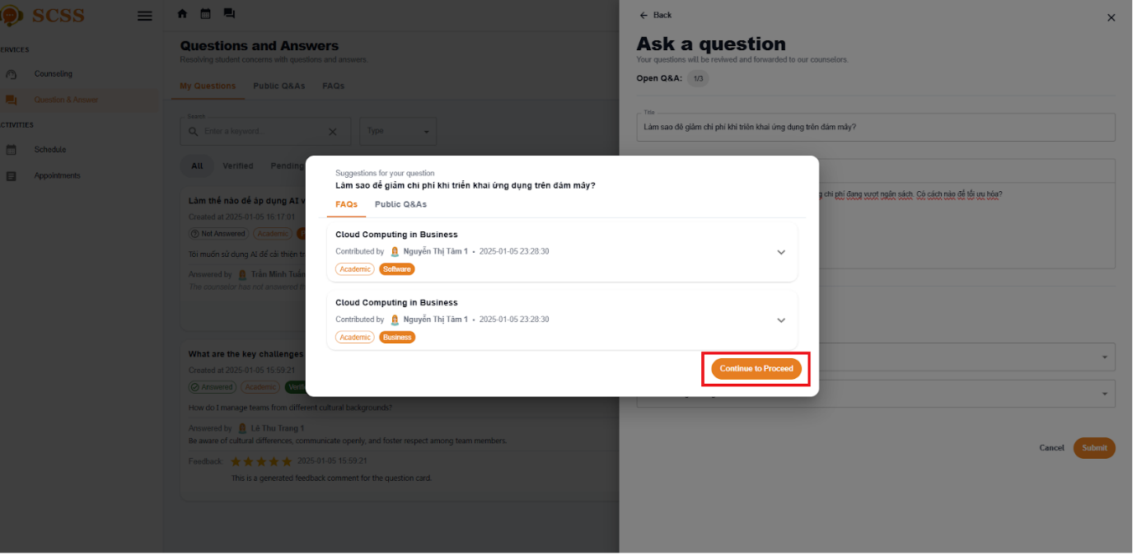

Figure - User Manual - Feature 14 – Step 6

##### 3.2.3.2. Edit a question

###### 3.2.3.1.1 Description

Use this guideline to create a question for counselor

###### 3.2.3.1.2. Guide Steps

**Step 1**: Access SCSS at http://scss-fe.azurewebsites.net/. Then fill in “Email” and “Password” of the student account.



Figure - User Manual - Feature 15 – Step 1

**Step 2:** Click the “Sign in ” button.



Figure - User Manual - Feature 15 – Step 2

**Step 3:** From the homepage, choose “Question & Answer” from the left sidebar.



Figure - User Manual - Feature 15 – Step 3

**Step 4:** Select  “edit question“ button if the question is not answered yet.

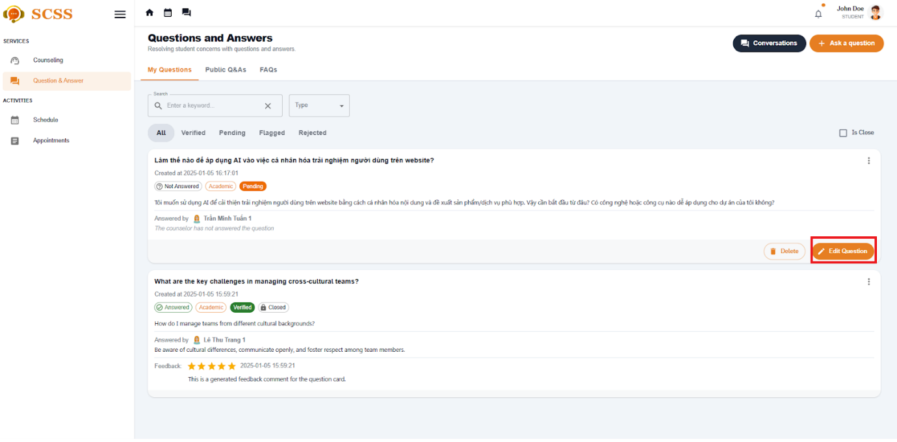

Figure - User Manual - Feature 15 – Step 4

**Step 5:** Update title and content of question then select Save button.

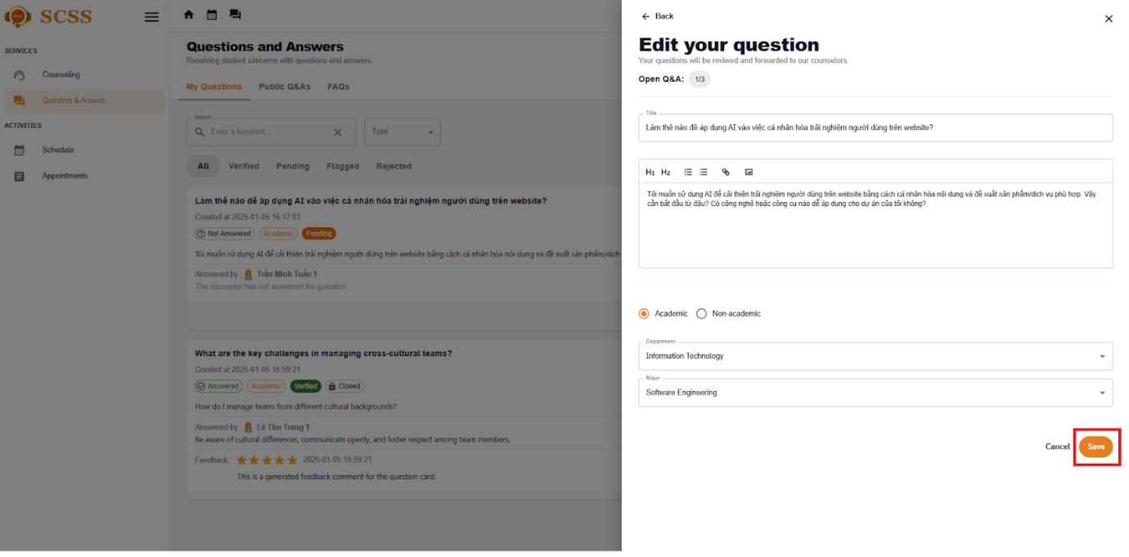

Figure - User Manual - Feature 15 – Step 5

##### 3.2.3.3. Answer a question

###### 3.2.3.3.1 Description

Use this guideline to create a question for counselor

###### 3.2.3.3.2. Guide Steps

**Step 1**: Access SCSS at http://scss-fe.azurewebsites.net/. Then fill in “Email” and “Password” of the counselor account.



Figure - User Manual - Feature 16 – Step 1

**Step 2:** Click the “Sign in ” button.



Figure - User Manual - Feature 16 – Step 2

**Step 3:** From the homepage, choose “My Q&A” from the left sidebar.

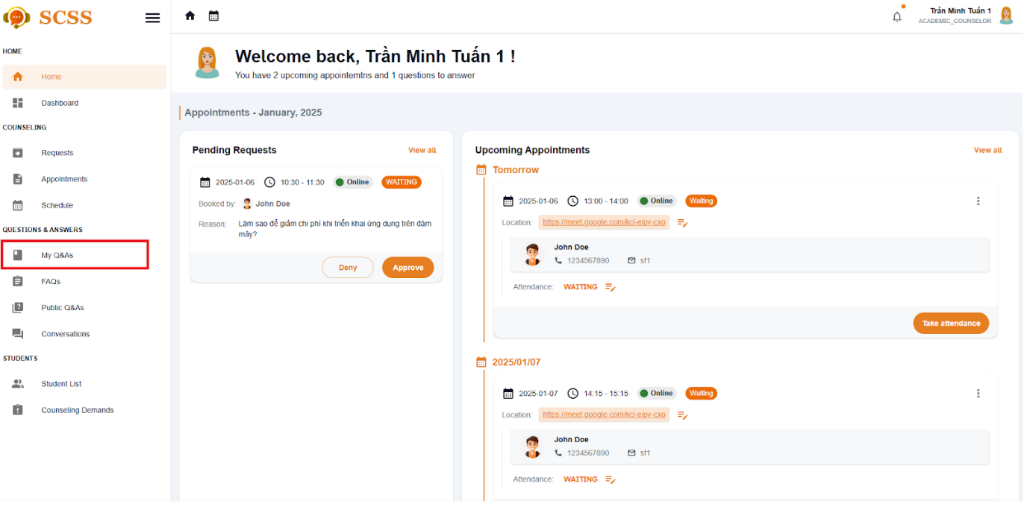

Figure - User Manual - Feature 16 – Step 3

**Step 4:** Select  “Answer“ button and a Answer dialog will show up

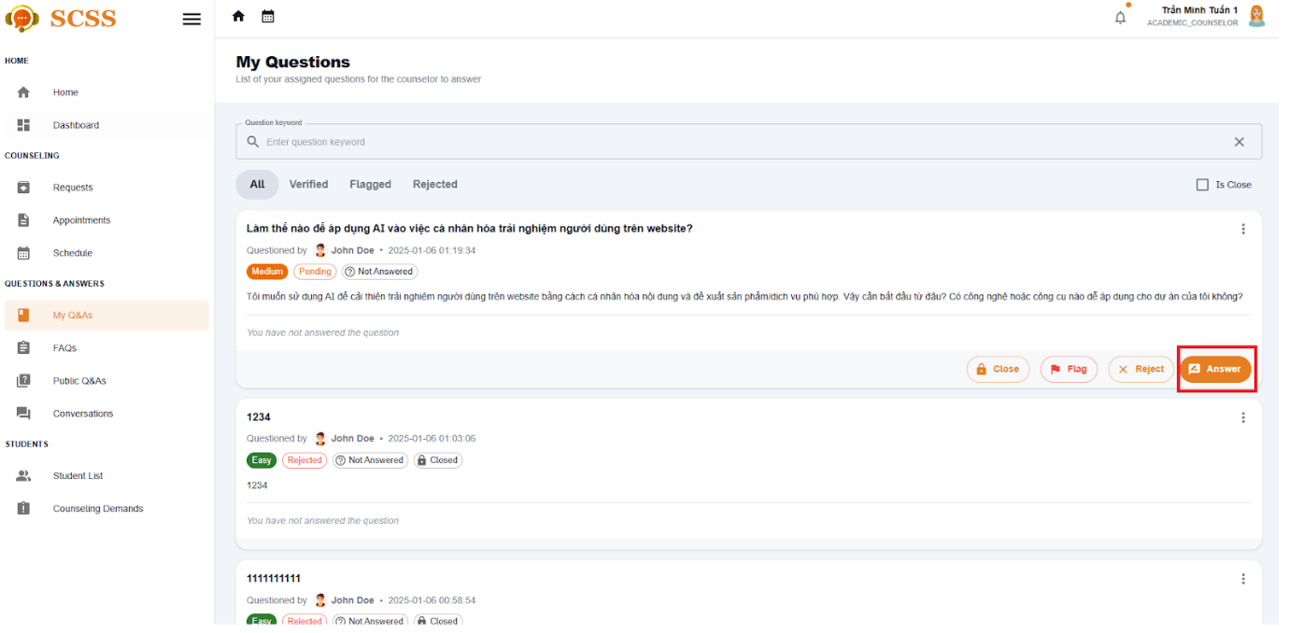

Figure - User Manual - Feature 16 – Step 4

**Step 5:** Fill in the answer for the question then select the Submit button.

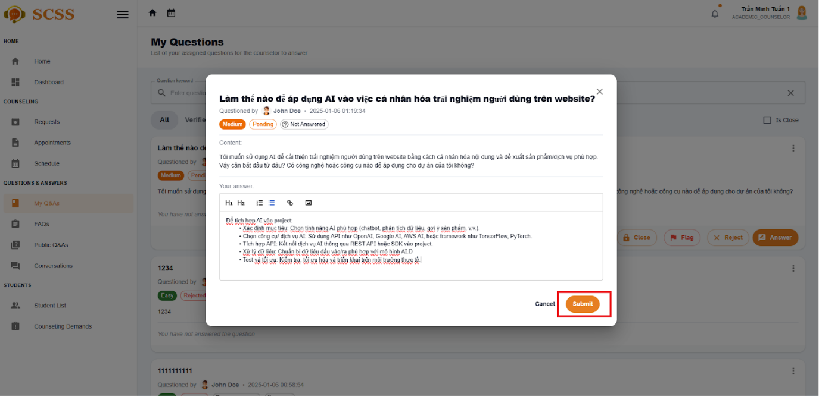

Figure - User Manual - Feature 16 – Step 5

##### 3.2.3.4. Edit your answer

###### 3.2.3.4.1 Description

Use this guideline to create a question for counselor

###### 3.2.3.4.2. Guide Steps

**Step 1**: Access SCSS at http://scss-fe.azurewebsites.net/. Then fill in “Email” and “Password” of the counselor account.



Figure - User Manual - Feature 17 – Step 1

**Step 2:** Click the “Sign in ” button.



Figure - User Manual - Feature 17 – Step 2

**Step 3:** From the homepage, choose “My Q&As” from the left sidebar.



Figure - User Manual - Feature 17 – Step 3

**Step 4:** Select  “Edit your answer·“ button and a Answer dialog will show up

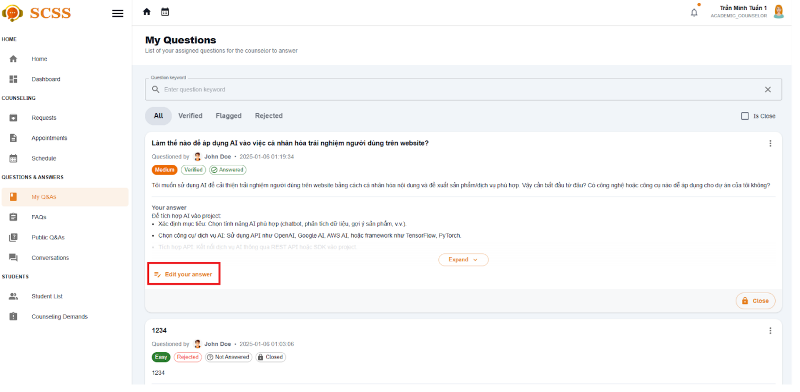

Figure - User Manual - Feature 17 – Step 4

**Step 5:** Fill in the answer for the question then select the save button.



Figure - User Manual - Feature 17 – Step 5

##### 3.2.3.5. Chat about a question

###### 3.2.3.5.1 Description

Use this guideline to create a question for counselor

###### 3.2.3.5.2. Guide Steps

**Step 1**: Access SCSS at http://scss-fe.azurewebsites.net/. Then fill in “Email” and “Password” of the student account.



Figure - User Manual - Feature 18 – Step 1

**Step 2:** Click the “Sign in ” button.



Figure - User Manual - Feature 18 – Step 2

**Step 3:** From the homepage, choose “Question & Answer” from the left sidebar.



Figure - User Manual - Feature 18 – Step 3

**Step 4:** In Q&A page, select the question which has already been answered, and select Start to chat button

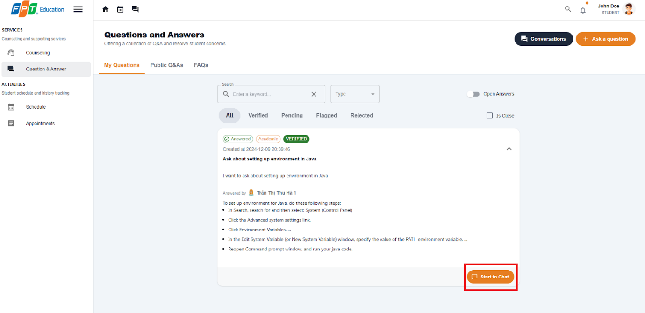

Figure - User Manual - Feature 18 – Step 4

**Step 5:** A chat session will show up and you can chat with the counselor for the question is closed.

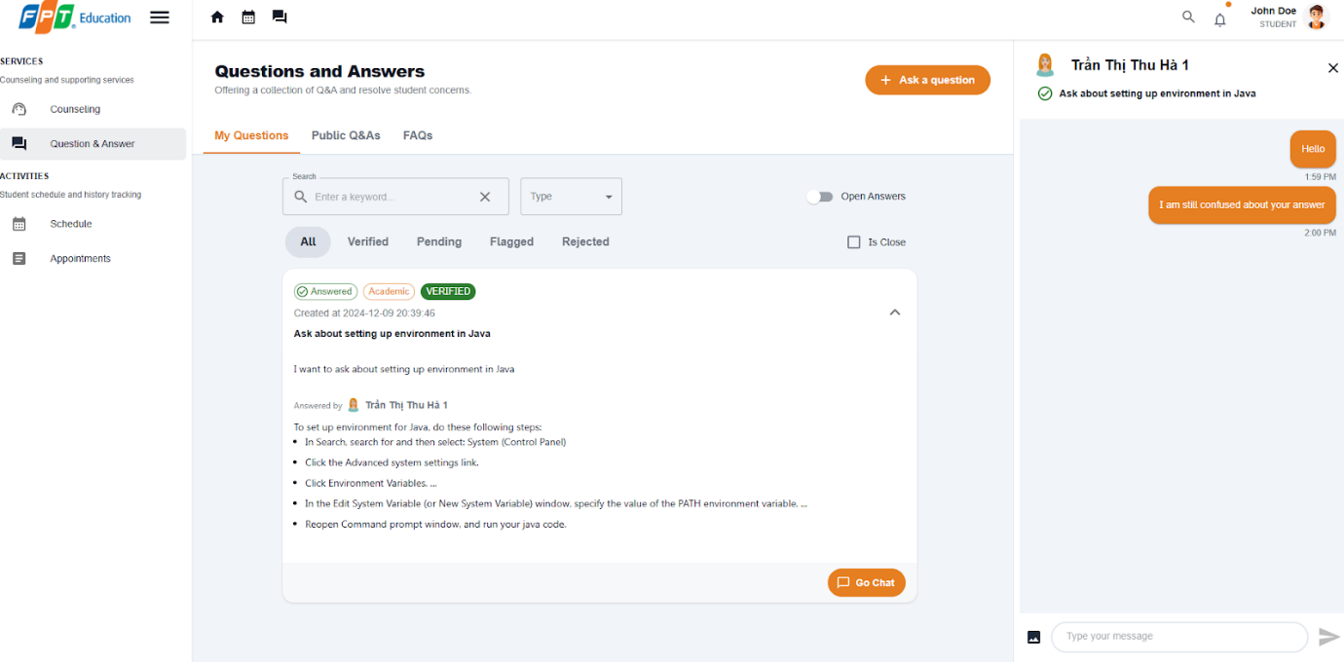

Figure - User Manual - Feature 18 – Step 5

##### 3.2.3.6. Close a question

###### 3.2.3.6.1 Description

Use this guideline to create a question for counselor

###### 3.2.3.6.2. Guide Steps

**Step 1**: Access SCSS at http://scss-fe.azurewebsites.net/. Then fill in “Email” and “Password” of the student account.



Figure - User Manual - Feature 19 – Step 1

**Step 2:** Click the “Sign in ” button.



Figure - User Manual - Feature 19 – Step 2

**Step 3:** From the homepage, choose “My Q&As” from the left sidebar.



Figure - User Manual - Feature 19 – Step 3

**Step 4:** Select  “Close“ button and a confirmation dialog will show up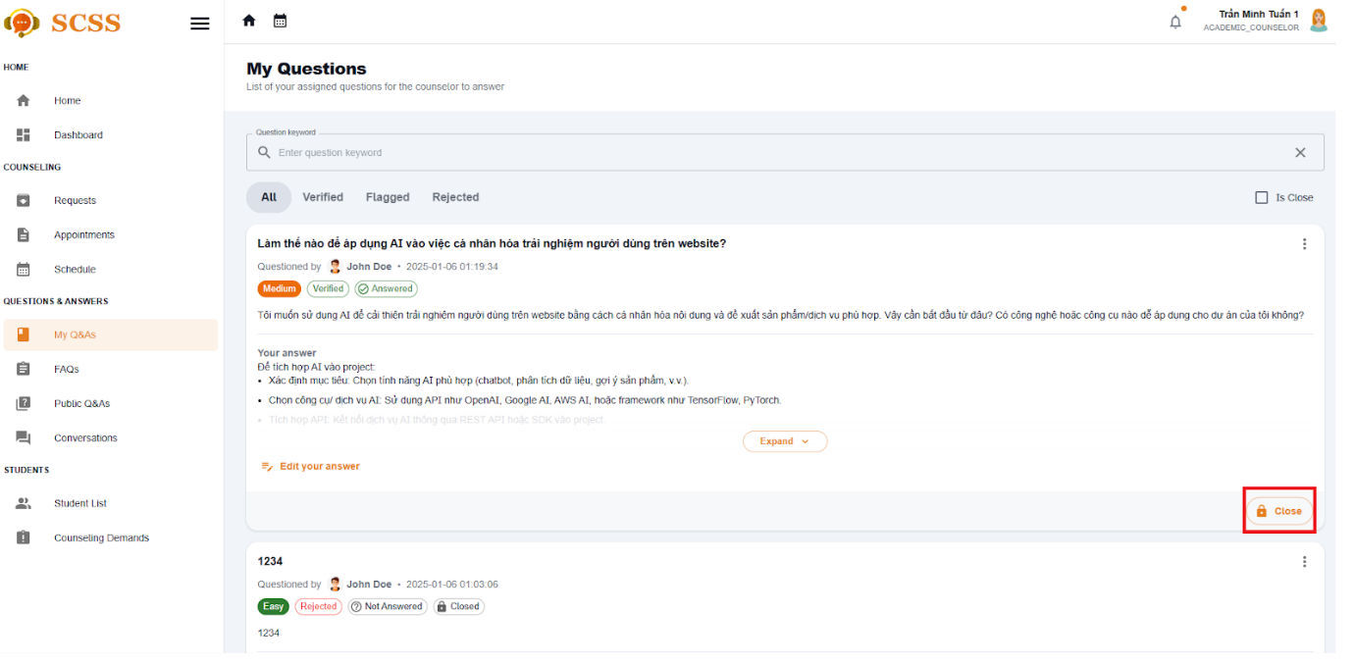

Figure - User Manual - Feature 19 – Step 4

**Step 5:** After confirming, the question will be closed and the asked student will no longer be able to chat.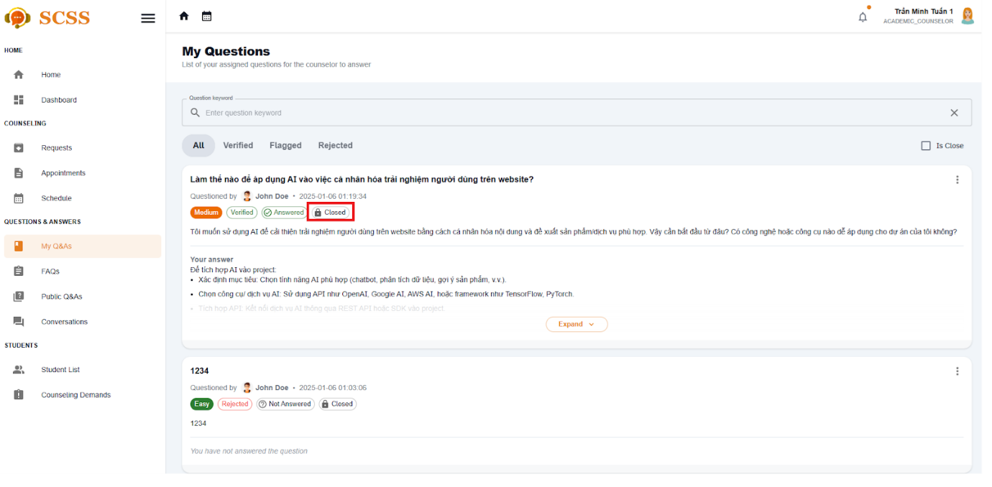

Figure - User Manual - Feature 19 – Step 5

##### 3.2.3.7. Contribute to FAQ

###### 3.2.3.3.7 Description

Use this guideline to create a question for counselor

###### 3.2.3.3.7. Guide Steps

**Step 1**: Access SCSS at http://scss-fe.azurewebsites.net/. Then fill in “Email” and “Password” of the counselor account.



Figure - User Manual - Feature 20 – Step 1

**Step 2:** Click the “Sign in ” button.



Figure - User Manual - Feature 20 – Step 2

**Step 3:** From the homepage, choose “FAQ” from the left sidebar.

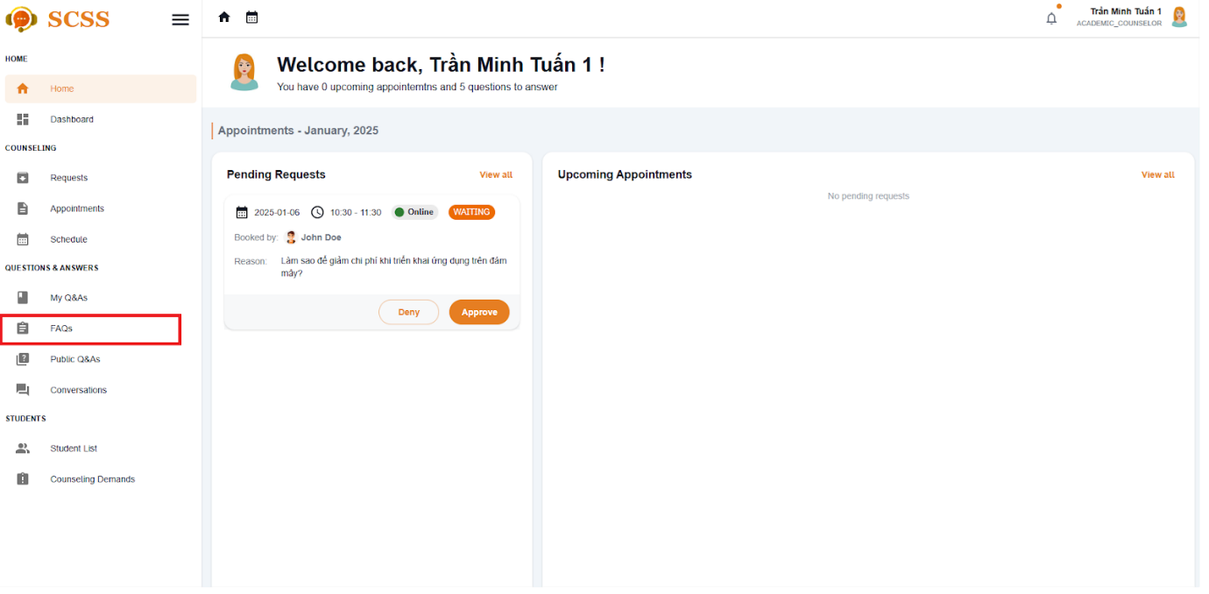

Figure - User Manual - Feature 20 – Step 3

**Step 4:** Select  “Contribute to FAQ“ button in FAQ page 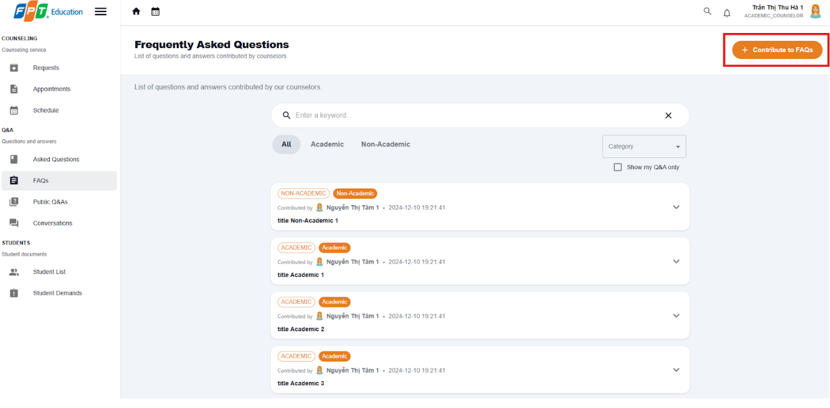

Figure - User Manual - Feature 20 – Step 4

**Step 5:** Enter category, title, question content, answer. Then select “Submit“  button

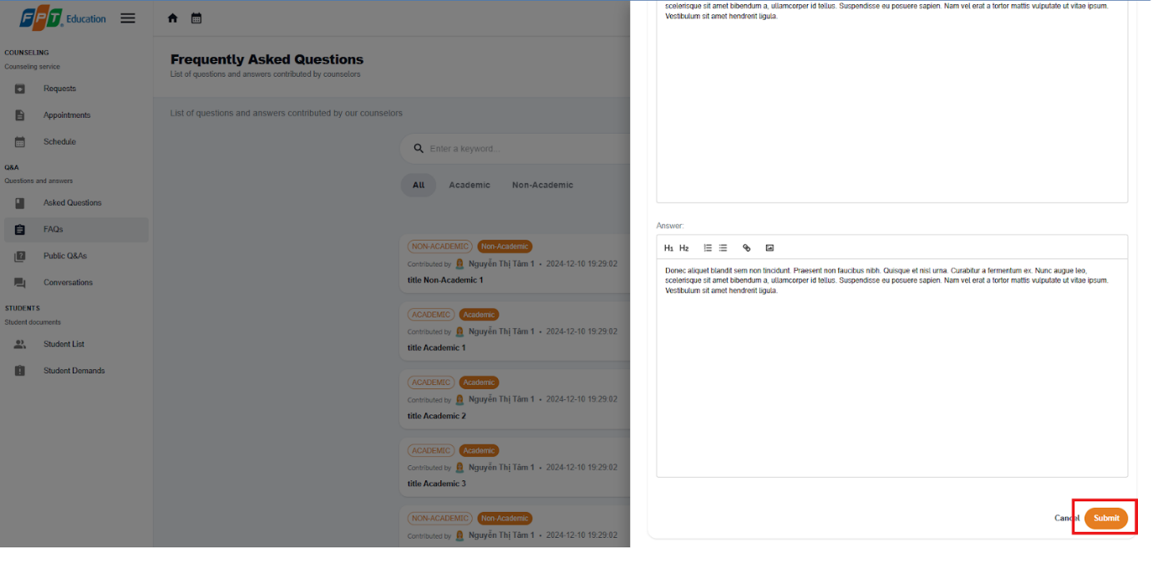

Figure - User Manual - Feature 20 – Step 5

**Step 6:** In the FAQ page, you can select the  “Show my Q&A only“ button to view your created Q&A.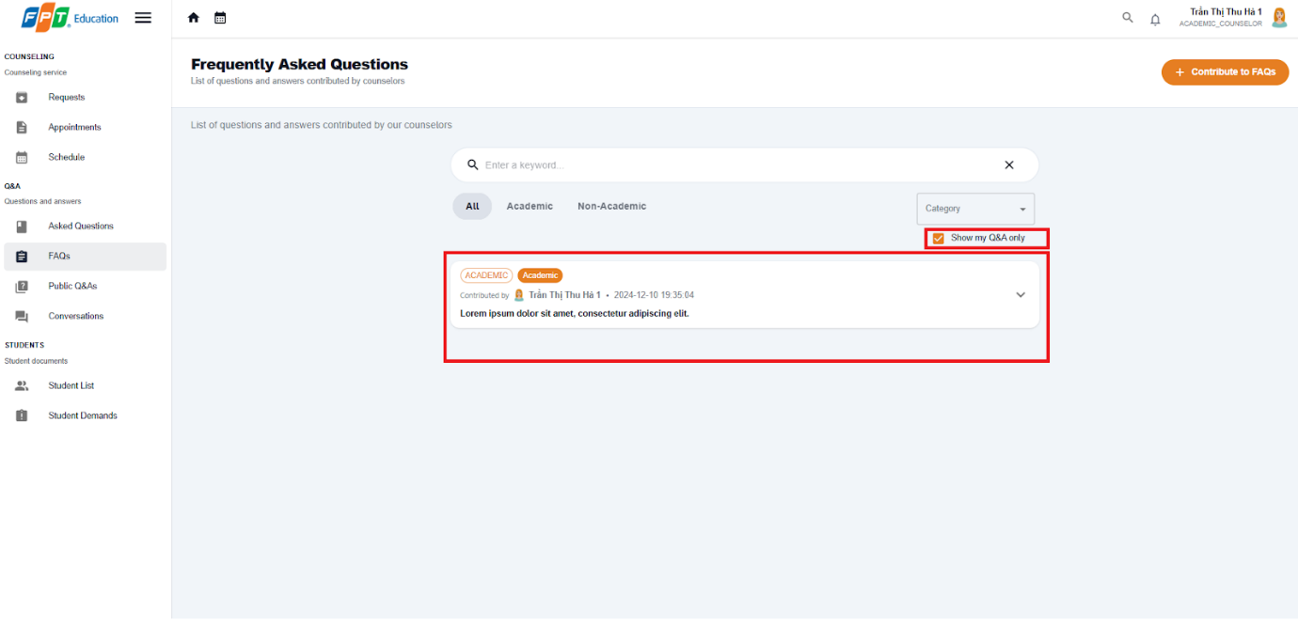

Figure - User Manual - Feature 20 – Step 6

##### 3.2.3.8. Edit contributed FAQ

###### 3.2.3.3.8 Description

Use this guideline to create a question for counselor

###### 3.2.3.3.8. Guide Steps

**Step 1**: Access SCSS at http://scss-fe.azurewebsites.net/. Then fill in “Email” and “Password” of the counselor account.



Figure - User Manual - Feature 21 – Step 1

**Step 2:** Click the “Sign in ” button.



Figure - User Manual - Feature 21 – Step 2

**Step 3:** From the homepage, choose “FAQ” from the left sidebar.



Figure - User Manual - Feature 21 – Step 3

**Step 4:** Select  “Edit“ button in FAQ page 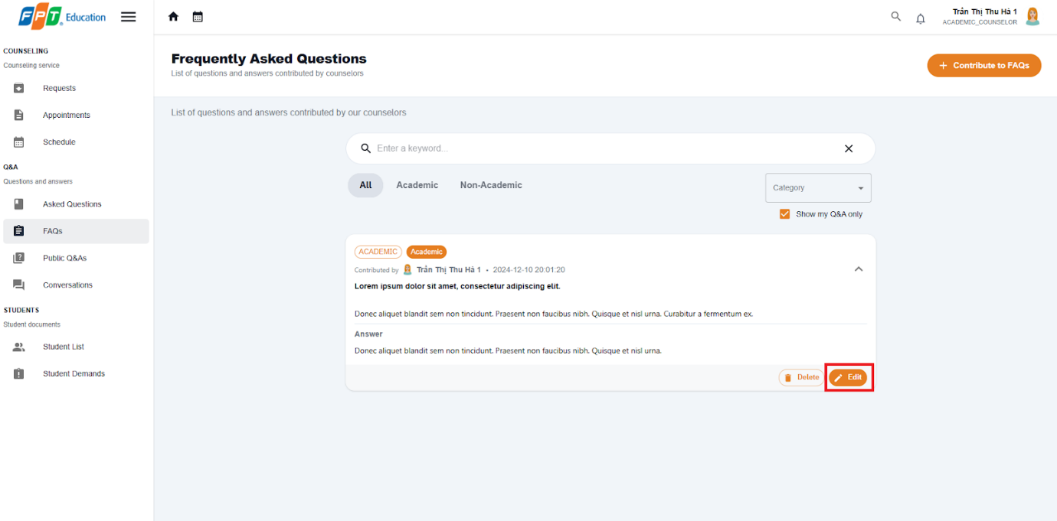

Figure - User Manual - Feature 21 – Step 4

**Step 5:** Enter new category, title, question content, answer. Then select “Submit“  button



Figure - User Manual - Feature 21 – Step 5

**Step 6:** In the FAQ page, you can select the  “Show my Q&A only“ button to view your Q&A.

Figure - User Manual - Feature 21 – Step 6

##### 3.2.3.9. Reject a question

###### 3.2.3.9.1 Description

Use this guideline to reject a question for counselor

###### 3.2.3.9.2. Guide Steps

**Step 1**: Access SCSS at http://scss-fe.azurewebsites.net/. Then fill in “Email” and “Password” of the counselor account.



Figure - User Manual - Feature 22 – Step 1

**Step 2:** Click the “Sign in ” button.



Figure - User Manual - Feature 22 – Step 2

**Step 3:** From the homepage, choose “My Q&A” from the left sidebar.



Figure - User Manual - Feature 22 – Step 3

**Step 4:** Select  “Reject“ button and a Reject dialog will show up

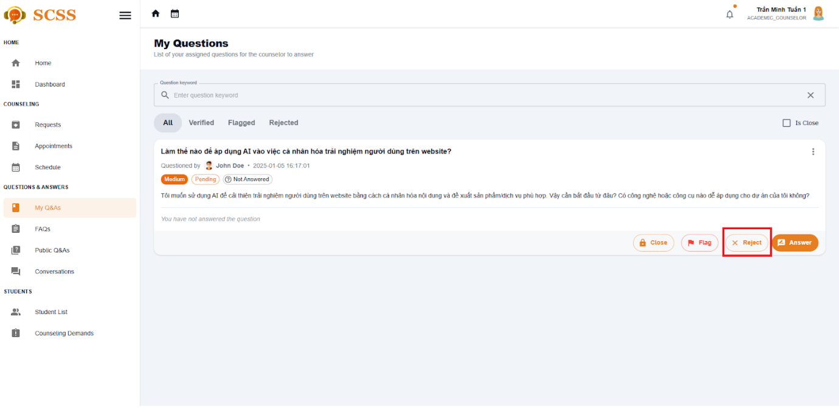

Figure - User Manual - Feature 22 – Step 4

**Step 5:** Fill in the reject reason for the question then select the Submit button.

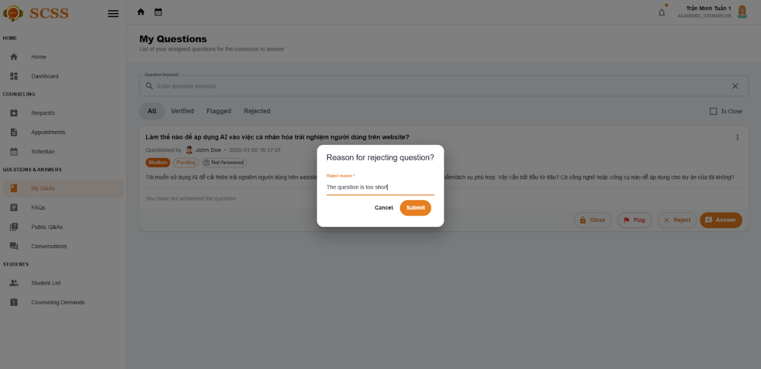

Figure - User Manual - Feature 22 – Step 5

**Step 6:** The reject reason will be showed with rejected status

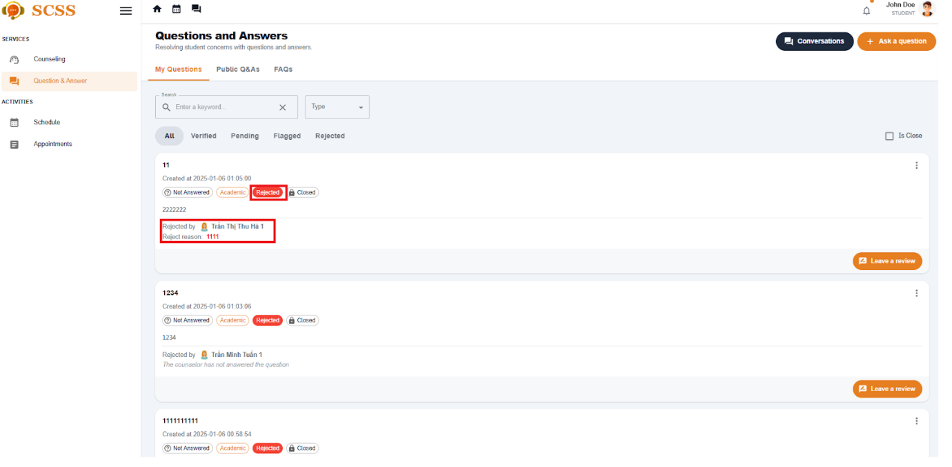

Figure - User Manual - Feature 22 – Step 7

##### 3.2.3.10. Flag a question

###### 3.2.3.10.1 Description

Use this guideline to flag a question for counselor

###### 3.2.3.10.2. Guide Steps

**Step 1**: Access SCSS at http://scss-fe.azurewebsites.net/. Then fill in “Email” and “Password” of the counselor account.



Figure - User Manual - Feature 23 – Step 1

**Step 2:** Click the “Sign in ” button.



Figure - User Manual - Feature 23 – Step 2

**Step 3:** From the homepage, choose “My Q&A” from the left sidebar.



Figure - User Manual - Feature 23 – Step 3

**Step 4:** Select  “Reject“ button and a Reject dialog will show up

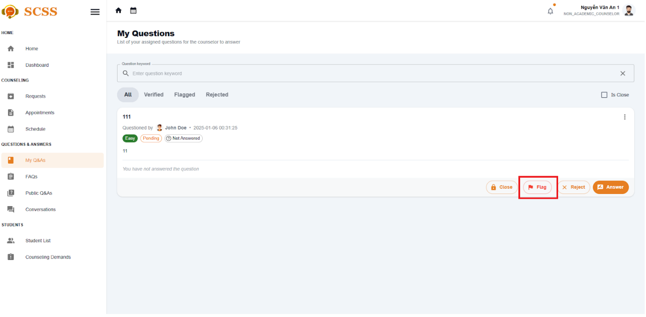

Figure - User Manual - Feature 23 – Step 4

**Step 5:** Fill in the reject reason for the question then select the Submit button.



Figure - User Manual - Feature 23 – Step 5

**Step 6:** The flag reason will be showed with flag status

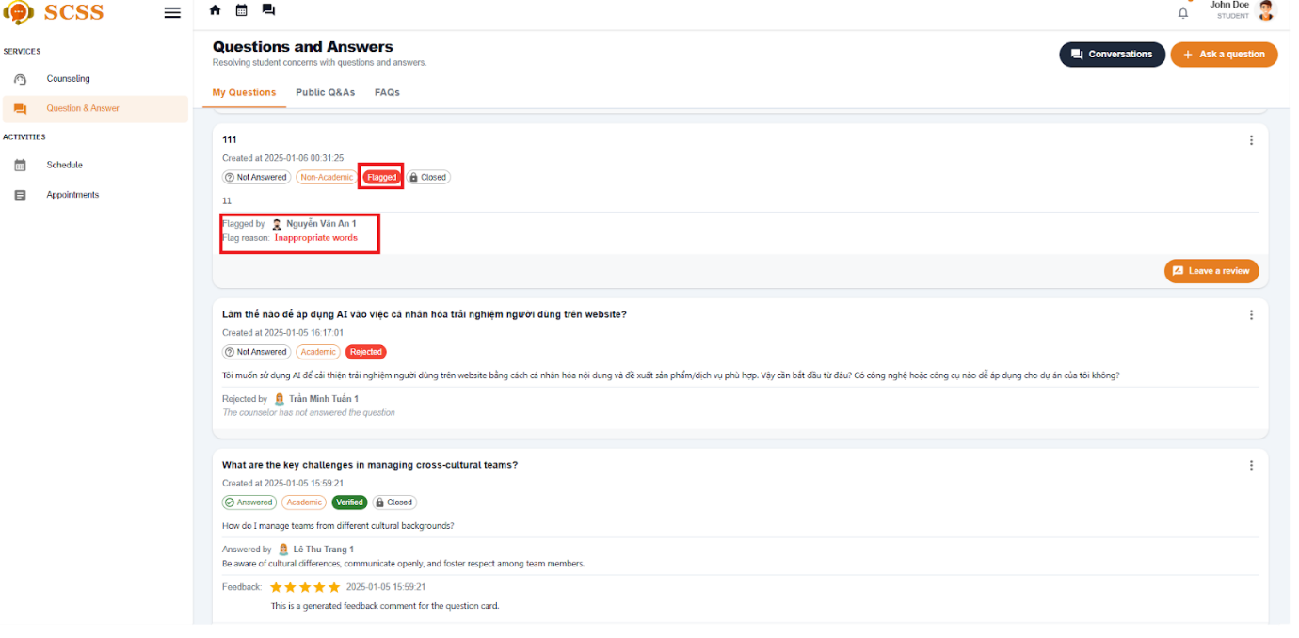

Figure - User Manual - Feature 23 – Step 6

#### 3.2.4. Counseling demand

##### 3.3.4.1. Create counseling demand

###### 3.3.3.3.1 Description

Use this guideline to create a counseling for a student

###### 3.3.3.3.2. Guide Steps

**Step 1**: Access SCSS at http://scss-fe.azurewebsites.net/. Then fill in “Email” and “Password” of the support staff account.



Figure - User Manual - Feature 24 – Step 1

**Step 2:** Click the “Sign in ” button.



Figure - User Manual - Feature 24 – Step 2

**Step 3:** From the homepage, choose “Recommended Students” new problematic students or ”Student List” for all students  from the left sidebar.

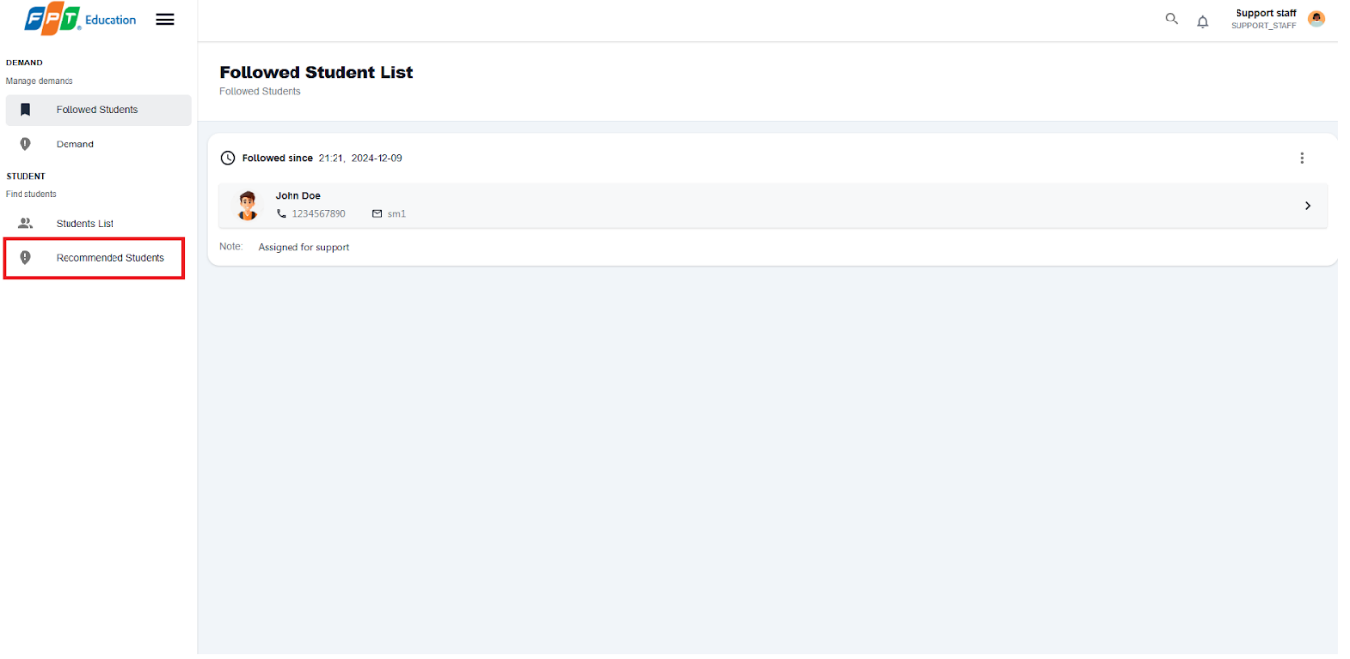

Figure - User Manual - Feature 24 – Step 3

**Step 4:** Select a student, in student detail, select  “Follow Student“ button to the added the student to the Followed List for further actions.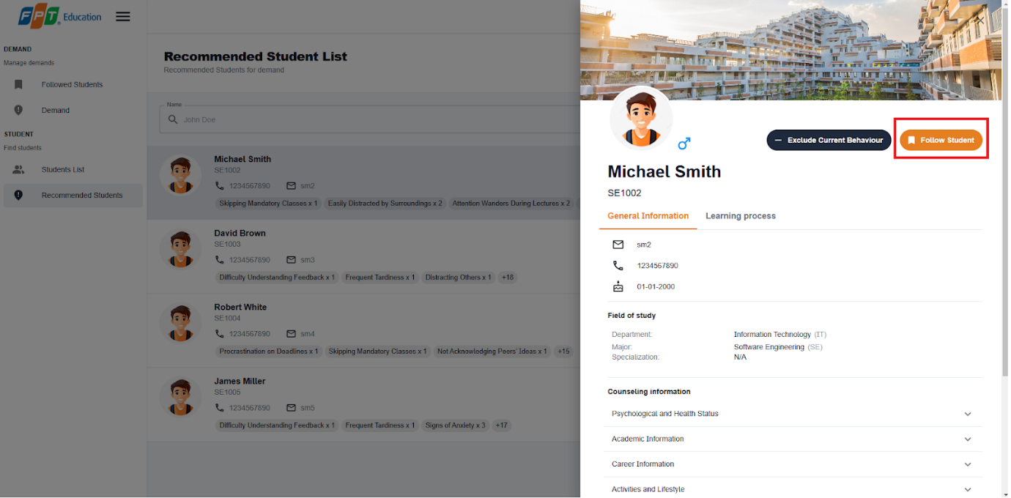

Figure - User Manual - Feature 24 – Step 4

**Step 5:** Choose “Student List” from the left sidebar.

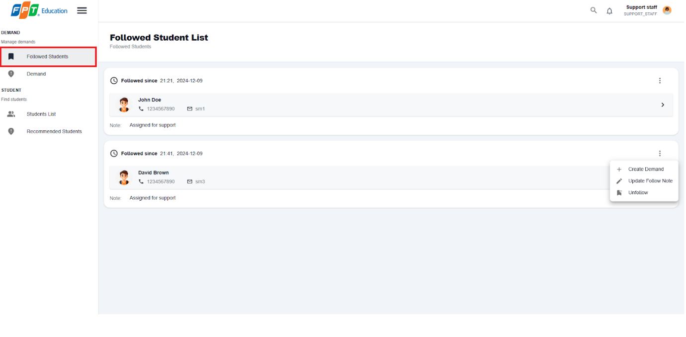

Figure - User Manual - Feature 24 – Step 5

**Step 6:** Select more vert icon button from a student, then select Create Demand option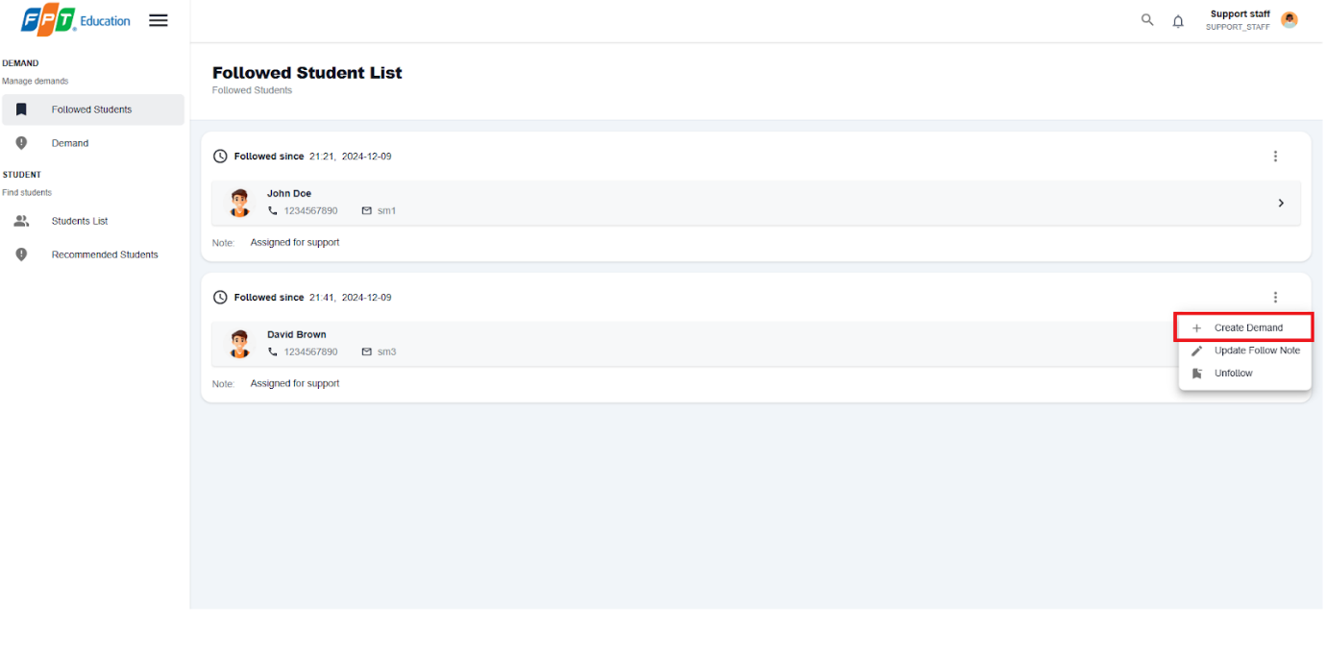

Figure - User Manual - Feature 24 – Step 6

**Step 7:** Select a suitable counselor and fill in counseling demand form

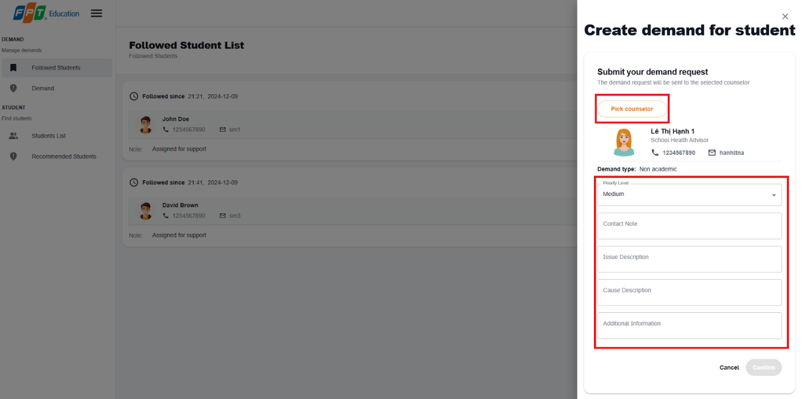

Figure - User Manual - Feature 24 – Step 7

**Step 8:** Select confirm button and new demand will be created

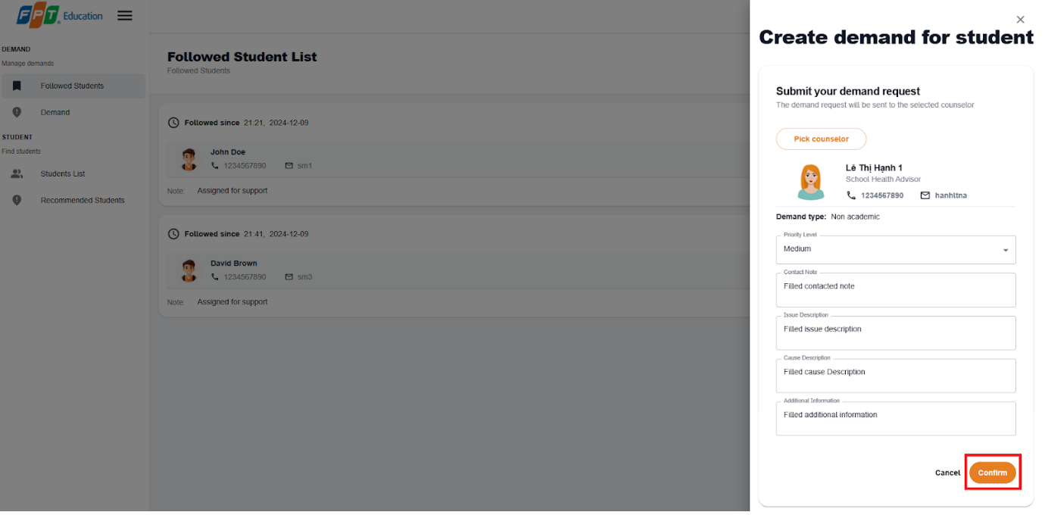

Figure - User Manual - Feature 24 – Step 8

**Step 9:** Choose ” Demand”  from the left sidebar and view your newly created demand

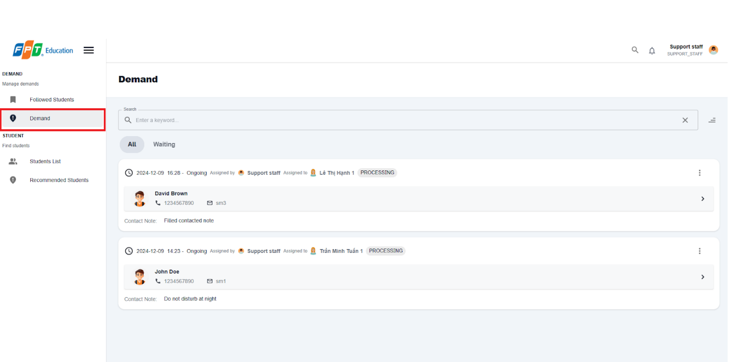

Figure - User Manual - Feature 24 – Step 9

##### 3.3.4.2. Create an appointment from demand

###### 3.3.3.3.1 Description

Use this guideline to create a counseling for a student

###### 3.3.3.3.2. Guide Steps

**Step 1**: Access SCSS at http://scss-fe.azurewebsites.net/. Then fill in “Email” and “Password” of the counselor account.



Figure - User Manual - Feature 25 – Step 1

**Step 2:** Click the “Sign in ” button.



Figure - User Manual - Feature 25 – Step 2

**Step 3:** From the homepage, choose “Student Demands” from the left sidebar.

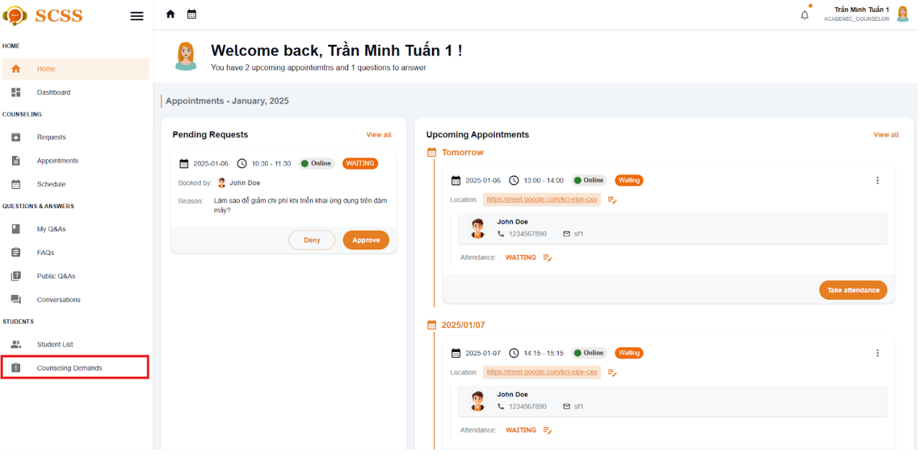

Figure - User Manual - Feature 25 – Step 3

**Step 4:** In Student Demand page, select more vert icon button form a student, then choose “Create an appointment“ option

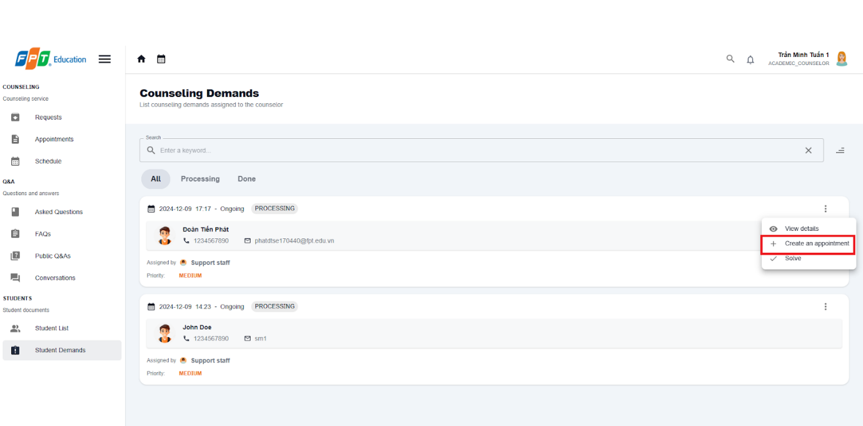

Figure - User Manual - Feature 25 – Step 4

**Step 5:** After filling in counseling fields, then select confirm booking and new appointment with the student will be created.

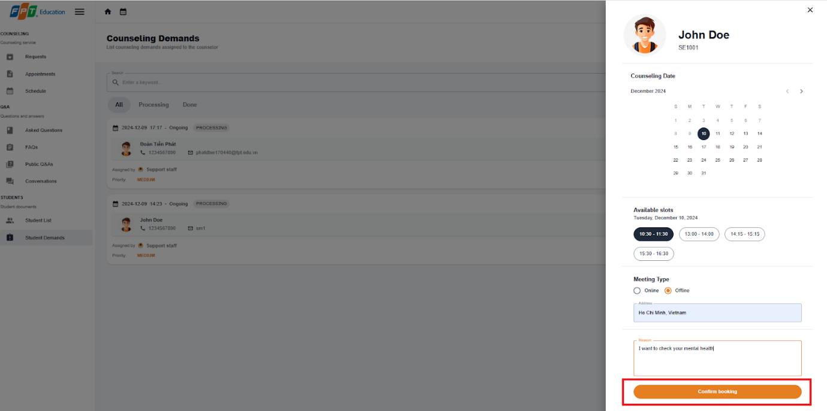

Figure - User Manual - Feature 25 – Step 6

##### 3.3.4.3. Solve a counseling demand

###### 3.3.3.3.1 Description

Use this guideline to create a counseling for a student

###### 3.3.3.3.2. Guide Steps

**Step 1**: Access SCSS at http://scss-fe.azurewebsites.net/. Then fill in “Email” and “Password” of the counselor account.



Figure - User Manual - Feature 26 – Step 1

**Step 2:** Click the “Sign in ” button.



Figure - User Manual - Feature 26 – Step 2

**Step 3:** From the homepage, choose “Student Demands” from the left sidebar.

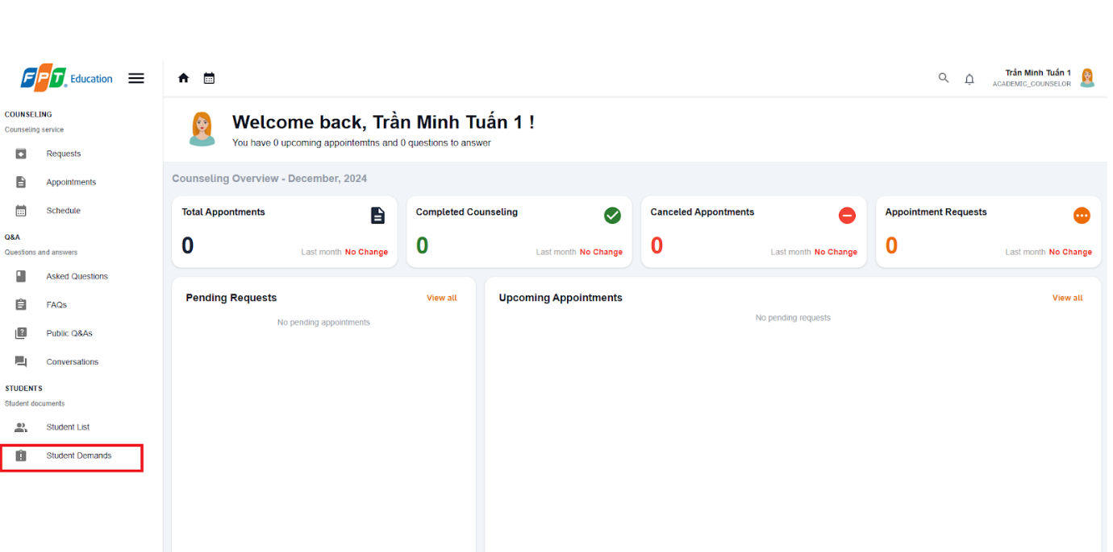

Figure - User Manual - Feature 26 – Step 3

**Step 4:** In Student Demand page, select more vert icon button form a student, then choose “Solve“ option

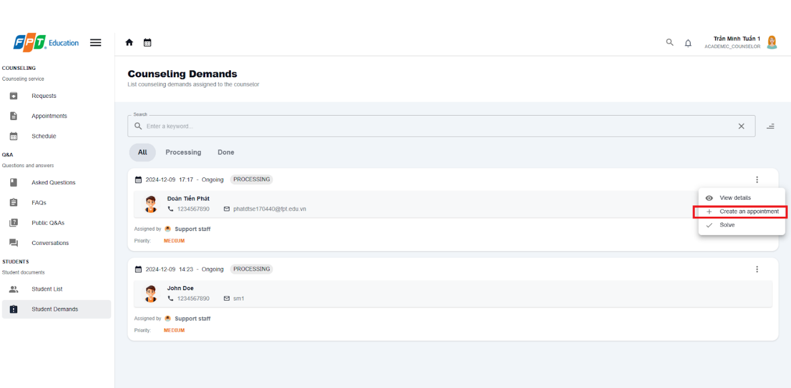

Figure - User Manual - Feature 26 – Step 4

**Step 5:** After filling in the summary field, then select confirm button to solve the demand.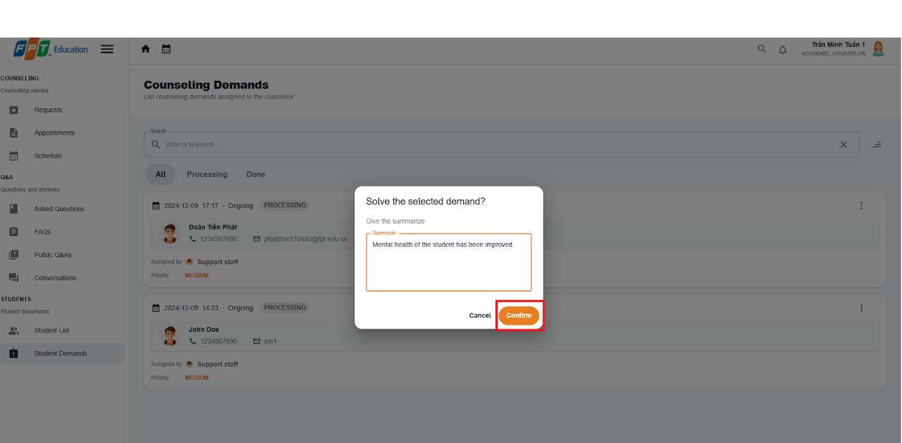

Figure - User Manual - Feature 26 – Step 5

**Step 6:** Solved demand will be marked with DONE status

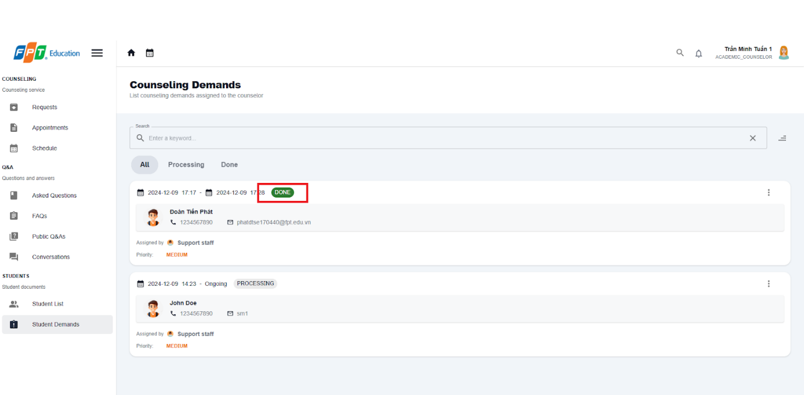

Figure - User Manual - Feature 26 – Step 6

#### 3.2.5. Counselor Management

##### 3.3.5.1. Update counselor availability

###### 3.3.5.1.1 Description

Use this guideline to update counselor availability

###### 3.3.5.1.2 . Guide Steps

**Step 1**: Access SCSS at http://scss-fe.azurewebsites.net/. Then fill in “Email” and “Password” of the manager account.



Figure - User Manual - Feature 27 – Step 1

**Step 2:** Click the “Sign in ” button.



Figure - User Manual - Feature 27 – Step 2

**Step 3:** From the homepage, choose “Counselors Table” from the left sidebar.

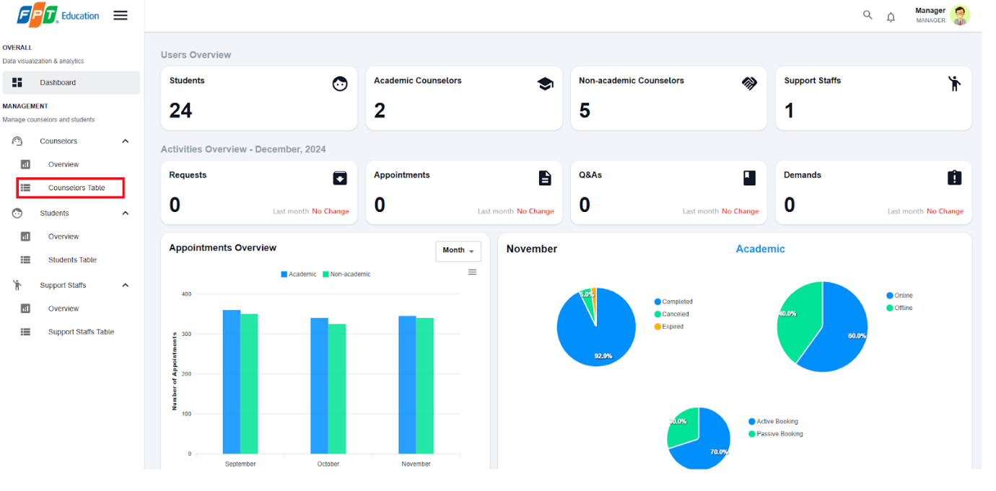

Figure - User Manual - Feature 27 – Step 3

**Step 4:** In Counselor Table page, select a counselor at Full name field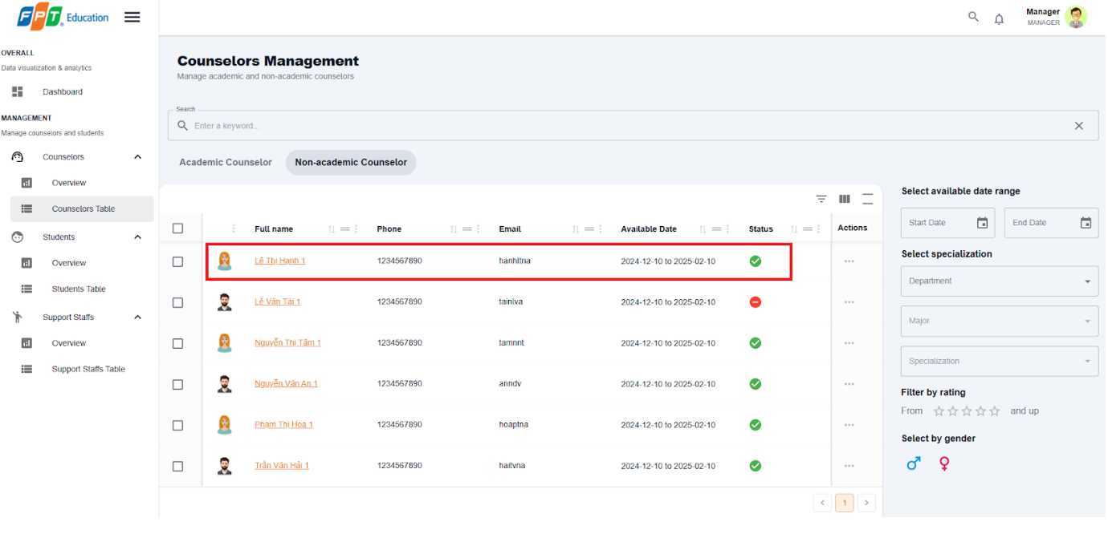

Figure - User Manual - Feature 27 – Step 4

**Step 5:** In Counselor detail management page, select between  “Availability ” and “Unavailability ”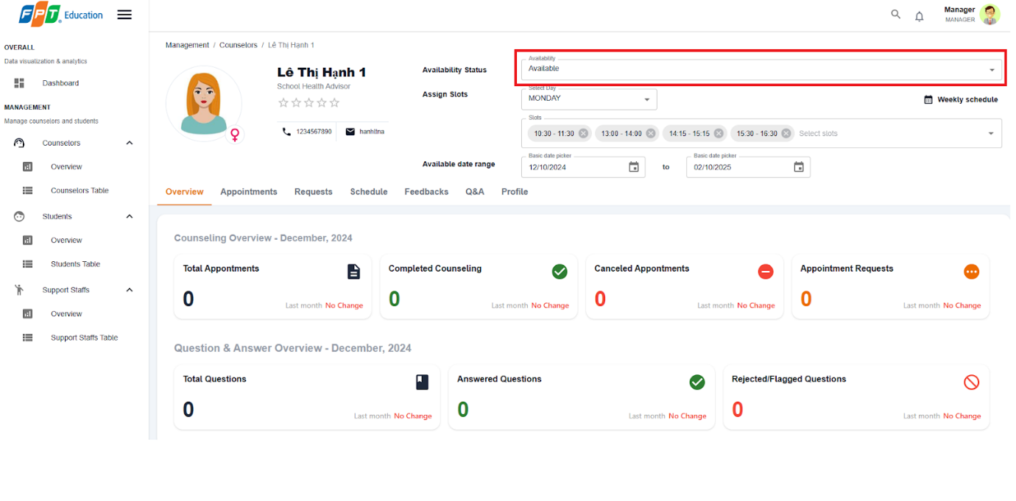

Figure - User Manual - Feature 27 – Step 5

##### 3.3.5.2. Update counselor weekly schedule

###### 3.3.5.2.1 Description

Use this guideline to update counselor availability

###### 3.3.5.2.2 . Guide Steps

**Step 1**: Access SCSS at http://scss-fe.azurewebsites.net/. Then fill in “Email” and “Password” of the manager account.



Figure - User Manual - Feature 28 – Step 1

**Step 2:** Click the “Sign in ” button.



Figure - User Manual - Feature 28 – Step 2

**Step 3:** From the homepage, choose “Counselors Table” from the left sidebar.



Figure - User Manual - Feature 28 – Step 3

**Step 4:** In Counselor Table page, select a counselor at Full name field

Figure - User Manual - Feature 28 – Step 4

**Step 5:** In Counselor detail management page, select from “Select Days” and select slots from “Select slots”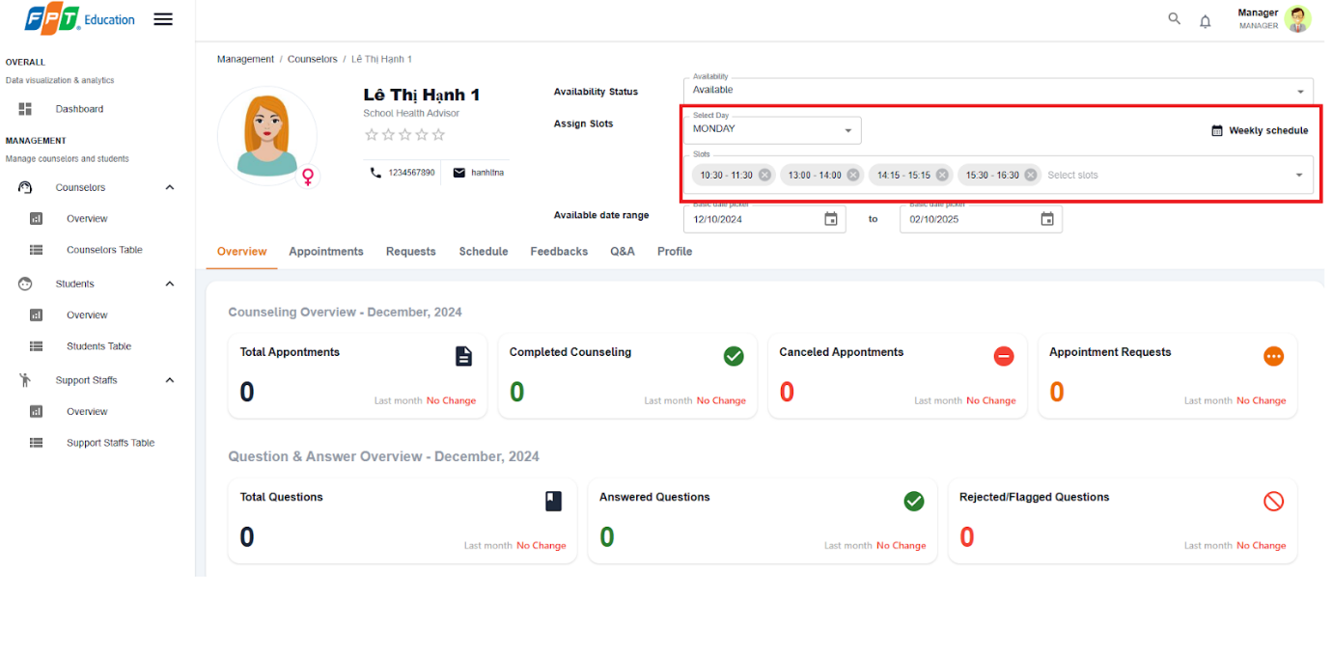

Figure - User Manual - Feature 28 – Step 5

**Step 6:** In Counselor detail management page, select “Weekly Schedule” to view full schedule of the counselor for a week.

##### 3.3.5.3. Update counselor date range

###### 3.3.5.1.1 Description

Use this guideline to update counselor availability

###### 3.3.5.1.2 . Guide Steps

**Step 1**: Access SCSS at http://scss-fe.azurewebsites.net/. Then fill in “Email” and “Password” of the manager account.



Figure - User Manual - Feature 29 – Step 1

**Step 2:** Click the “Sign in ” button.



Figure - User Manual - Feature 29 – Step 2

**Step 3:** From the homepage, choose “Counselors Table” from the left sidebar.



Figure - User Manual - Feature 29 – Step 3

**Step 4:** In Counselor Table page, select a counselor at Full name field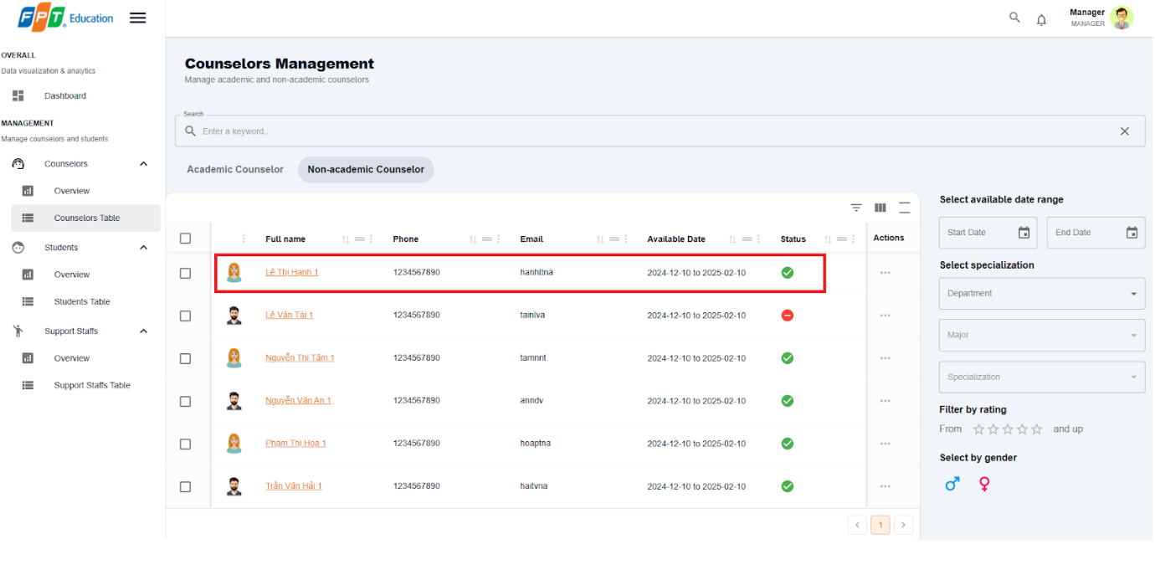

Figure - User Manual - Feature 29 – Step 4

**Step 5:** In Counselor detail management page, pick “Start date” and “End date”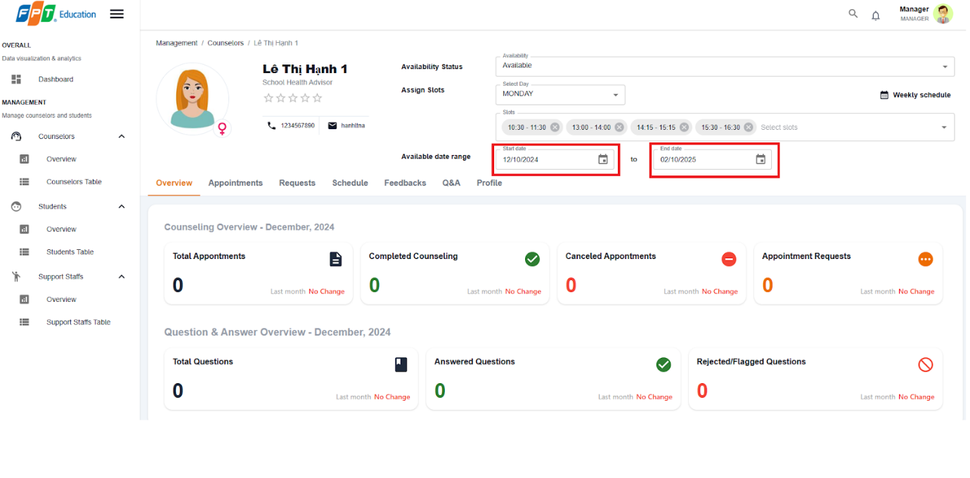

Figure - User Manual - Feature 29 – Step 5

#### 3.2.6. Account Management

##### 3.2.6.1. Create non-academic/academic counselor  account

###### 3.2.6.1.1. Description

Use this guide so administrators can create non-academic or academic counselor account.

###### 3.2.6.1.2. Guide Steps

**Step 1**: Access SCSS at http://scss-fe.azurewebsites.net/. Then fill in “Email” and “Password” of the administrator account.

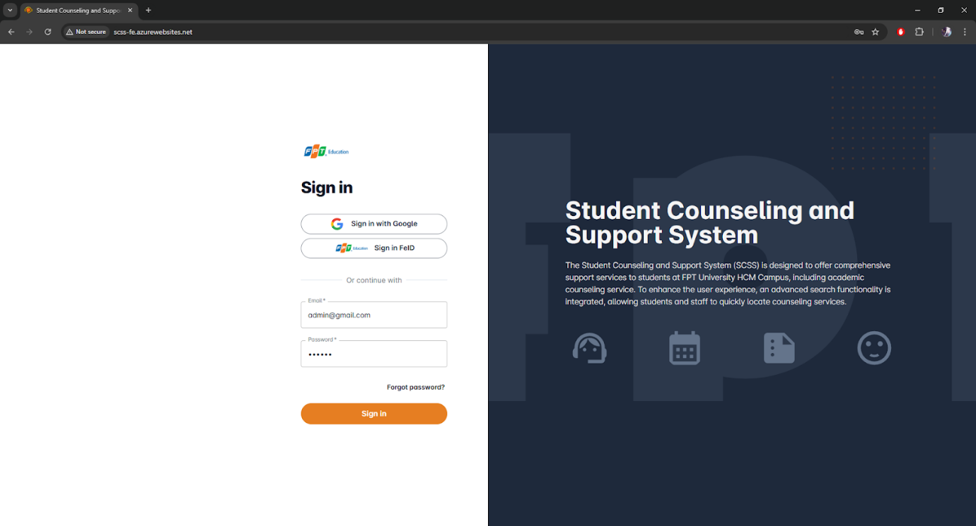

Figure - User Manual - Feature 30 – Step 1

**Step 2:** Click the “Sign in ” button.

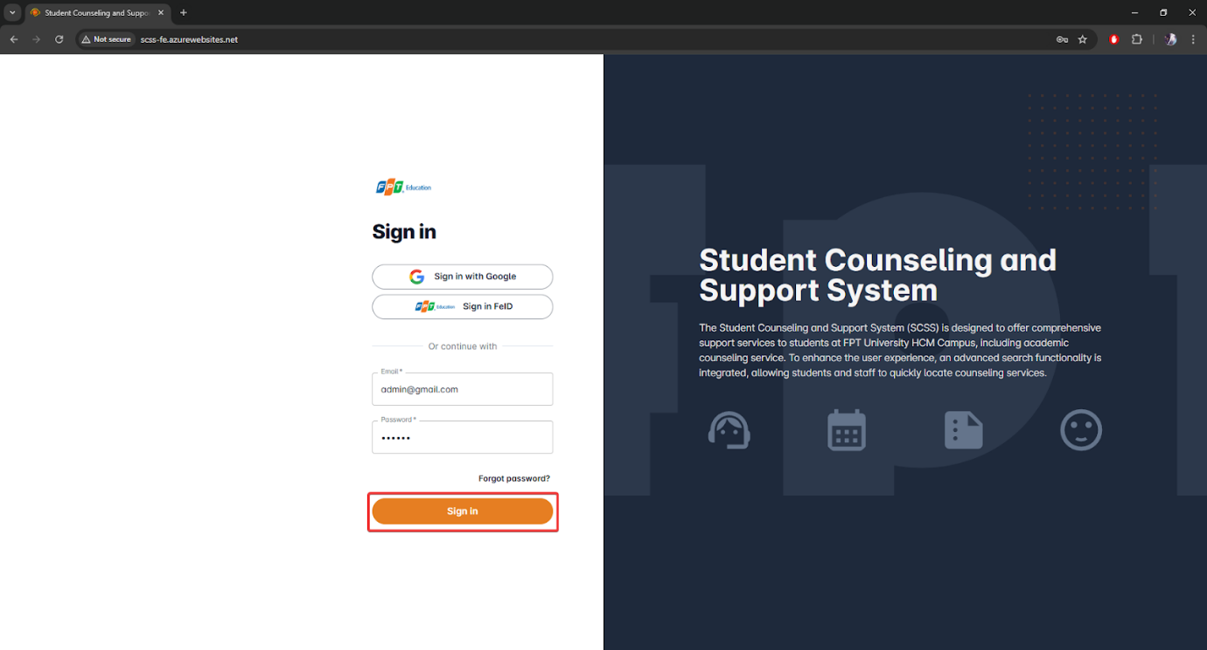

Figure - User Manual - Feature 30 – Step 2

**Step 3:** From the homepage, choose “Create Account” from the left sidebar.

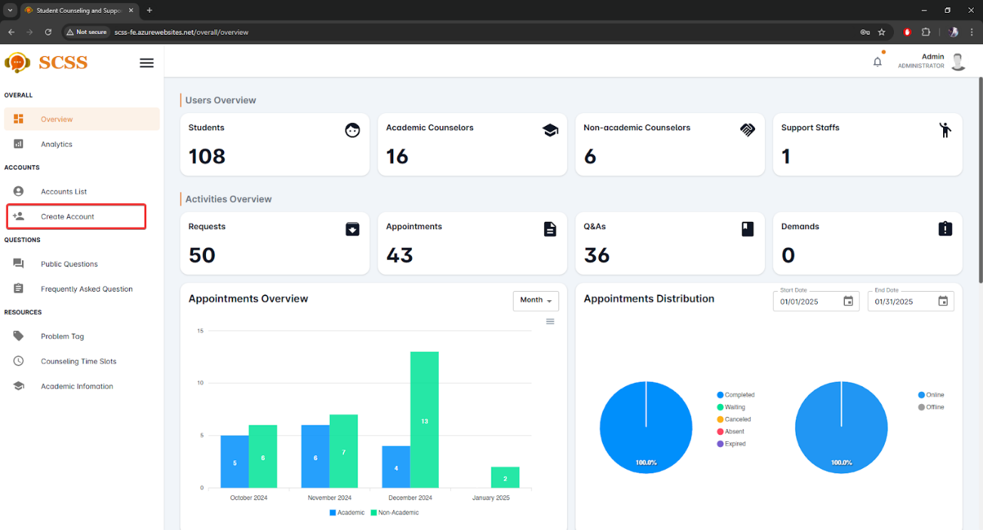

Figure - User Manual - Feature 30 – Step 3

**Step 4:** Select “Academic Counselor” or “Non-academic Counselor” tab accordingly.

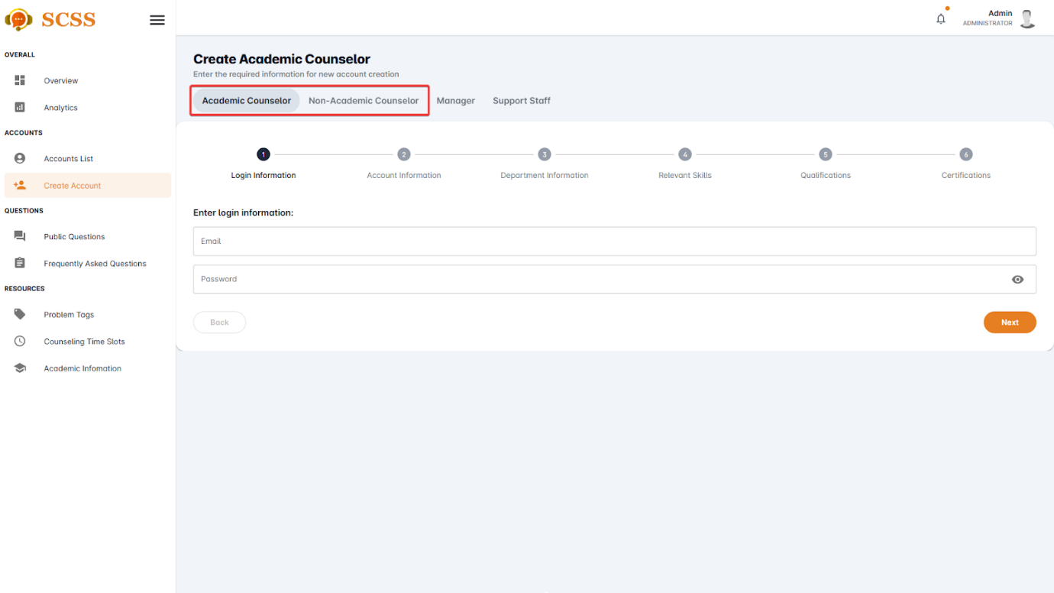

Figure - User Manual - Feature 30 – Step 4

**Step 5:** Fill out “Email”, “Password” fields and press the “Next” button at the bottom of the form when all the fields shown have been filled.

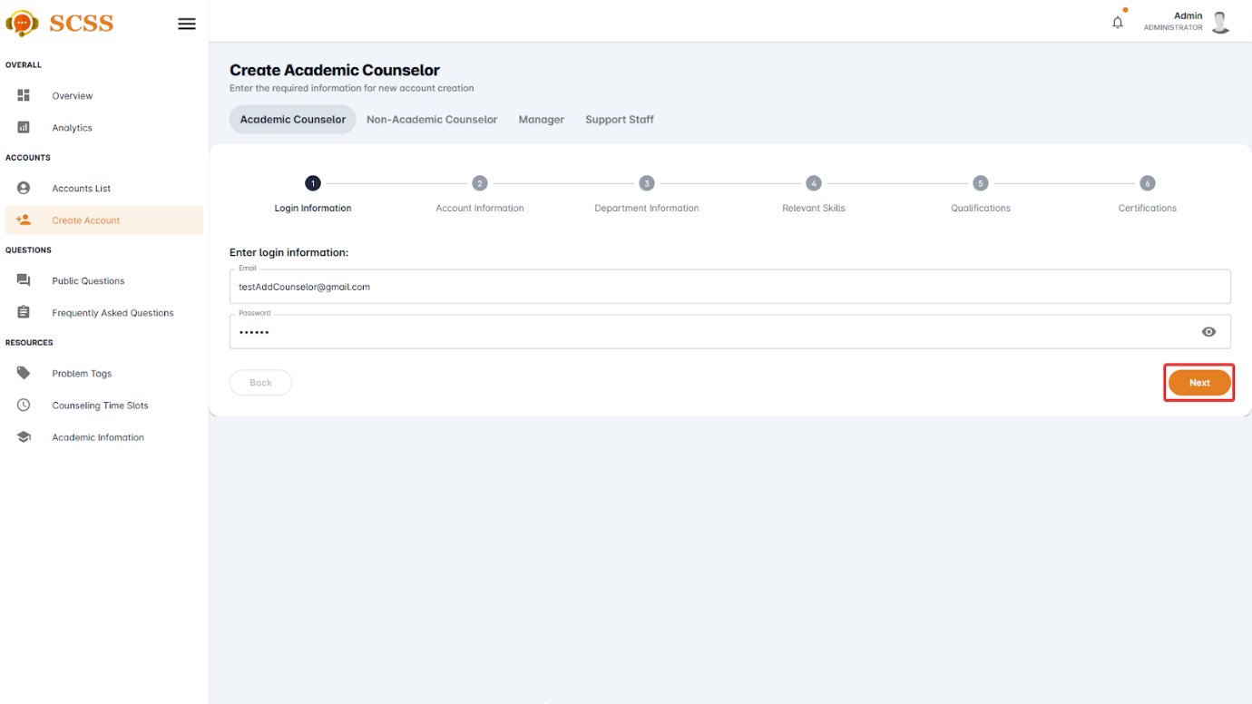

Figure - User Manual - Feature 30 – Step 5

**Step 6:** Fill out “Full name”, “Phone number”, “Email”, “Gender”, “Date of birth”, “Email”, “Password”, and “Avatar” field and press the “Next” button at the bottom of the form when all the fields shown have been filled.

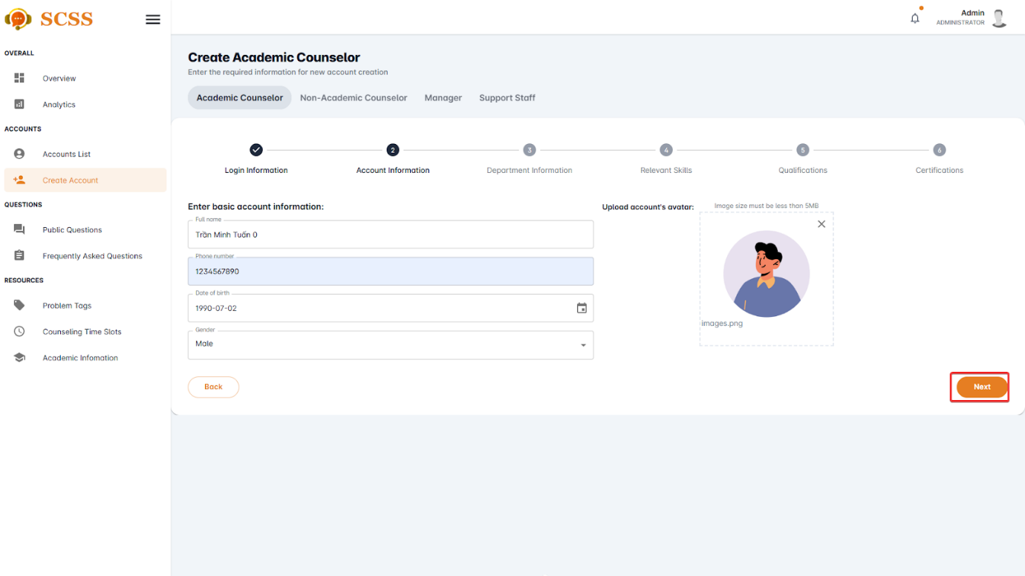

Figure - User Manual - Feature 30 – Step 6

**Step 7.1:** Fill out “Department”, and “Major” field if creating an academic counselor account and press the “Next” button at the bottom of the form when all the fields shown have been filled.

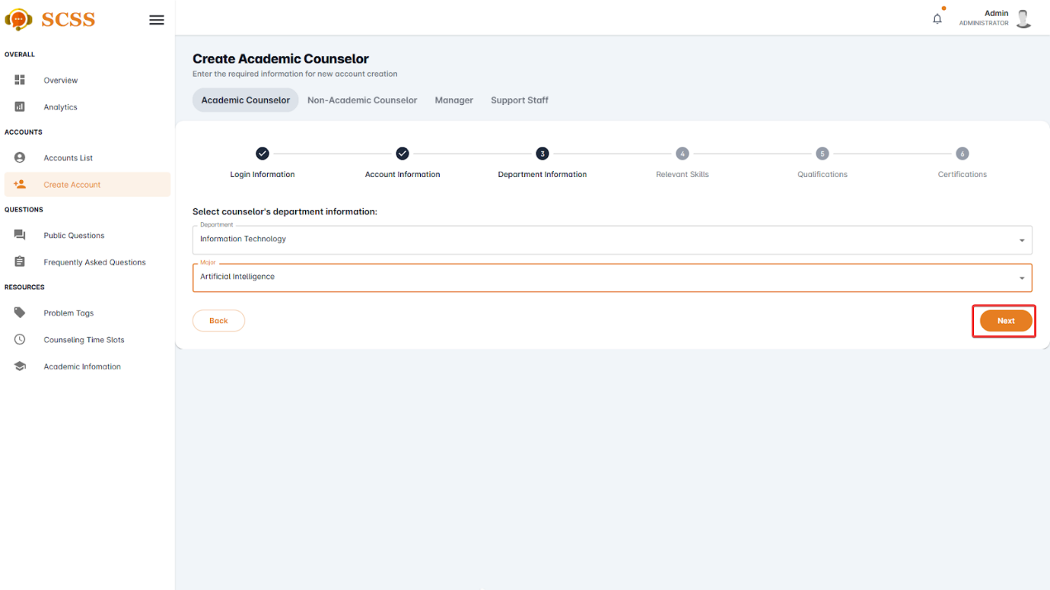

Figure - User Manual - Feature 30 – Step 7.1

**Step 7.2:** Fill out the “Expertise” field if creating a non-academic counselor account and press the “Next” button at the bottom of the form when all the fields shown have been filled.

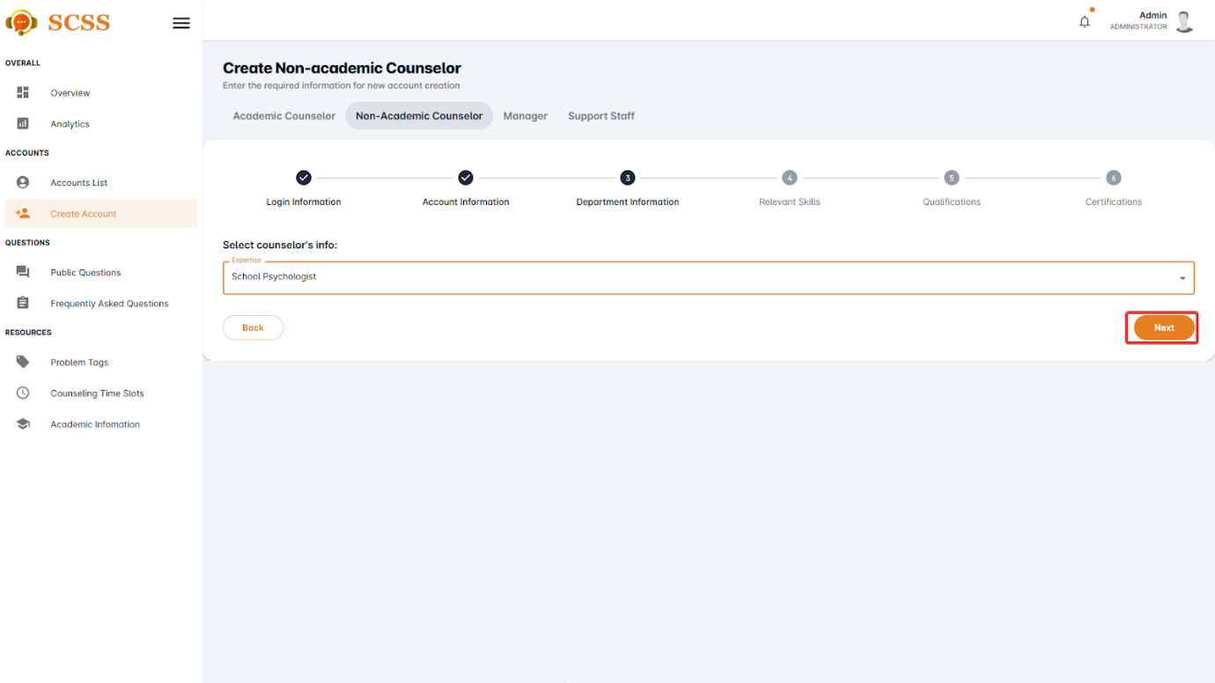

Figure - User Manual - Feature 30 – Step 7.2

**Step 8:** Fill out the “Specialized skill”, “Other skills”, “Achievements”, and “Work History” fields  and press the “Next” button at the bottom of the form when all the fields shown have been filled.

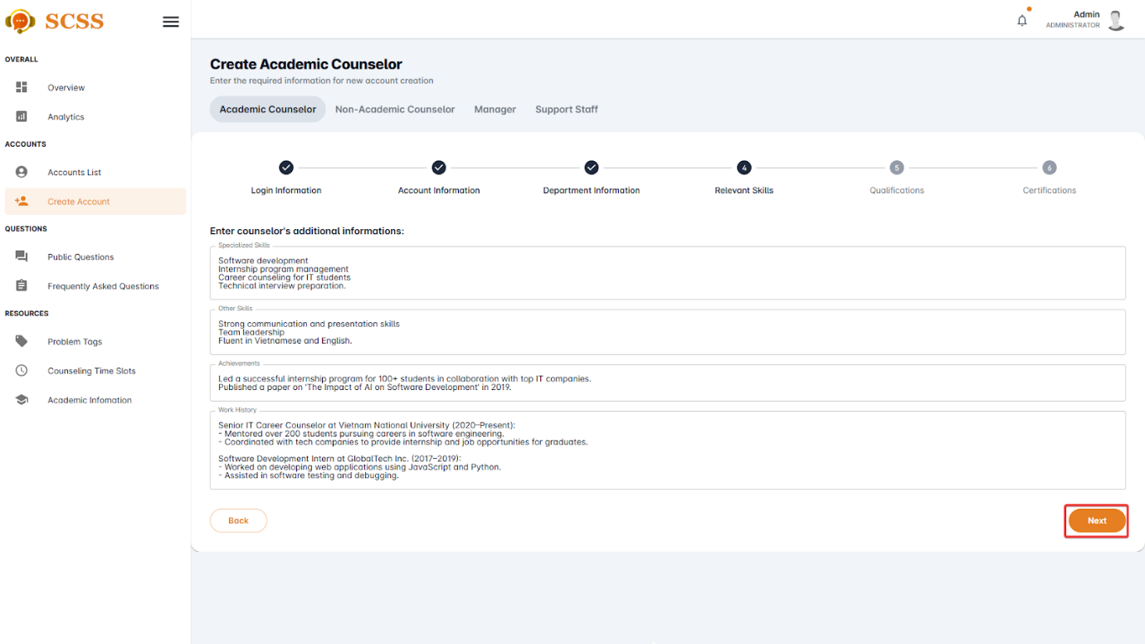

Figure - User Manual - Feature 30 – Step 8

**Step 9:** Add “qualification” by pressing the “Add qualification” button and fill out “Degree”, “Institution”, “Field of study”, “Year of graduation”, and “Qualification’s image” then press the “Add” button.

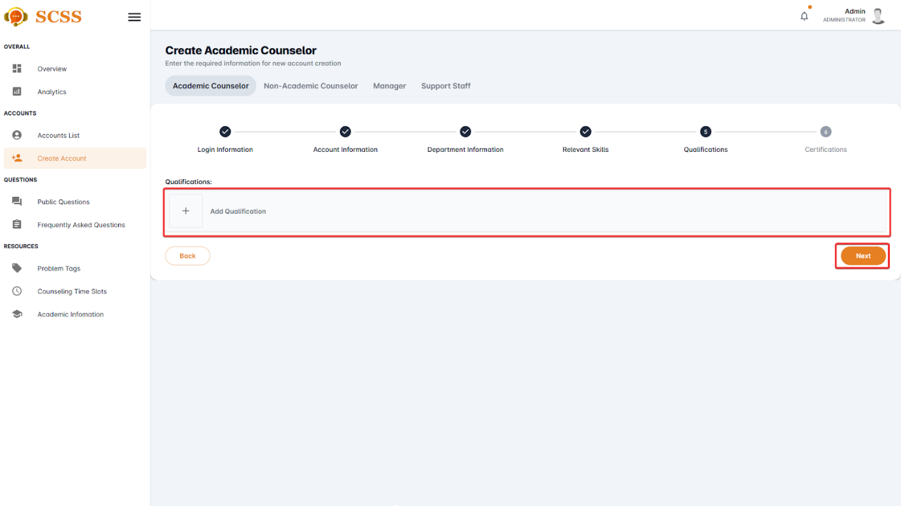

Figure - User Manual - Feature 30 – Step 9

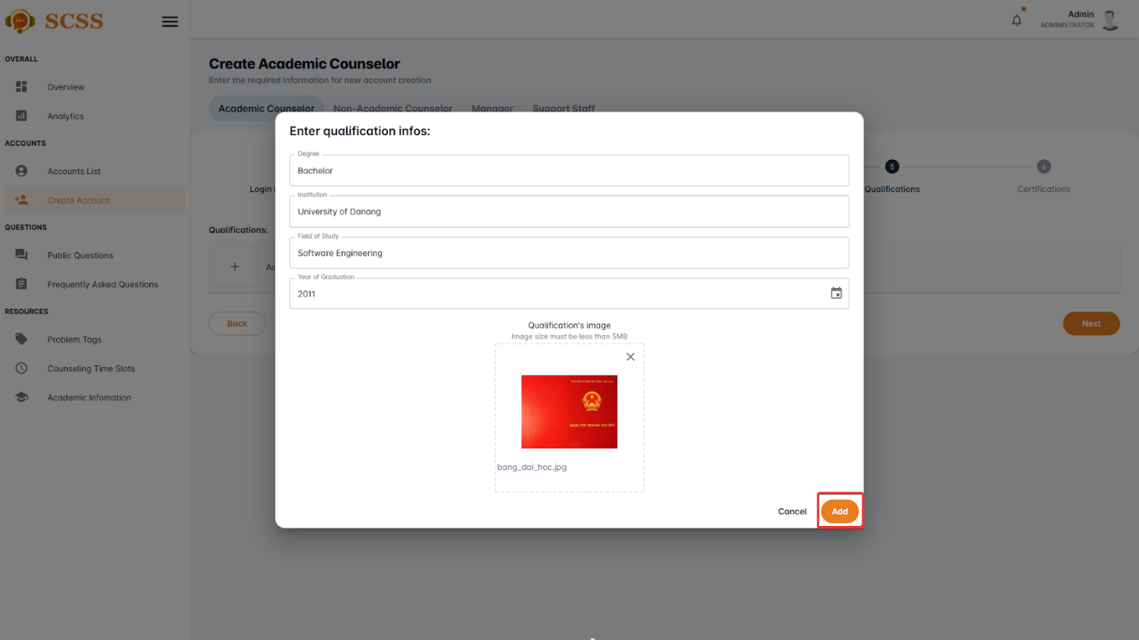

**Step 10:** Add “certification” by pressing the “Add certification” button and fill out “Certification’s name”, “Certification’s organization” and “Certification’s Image”, then press the “Add” button.

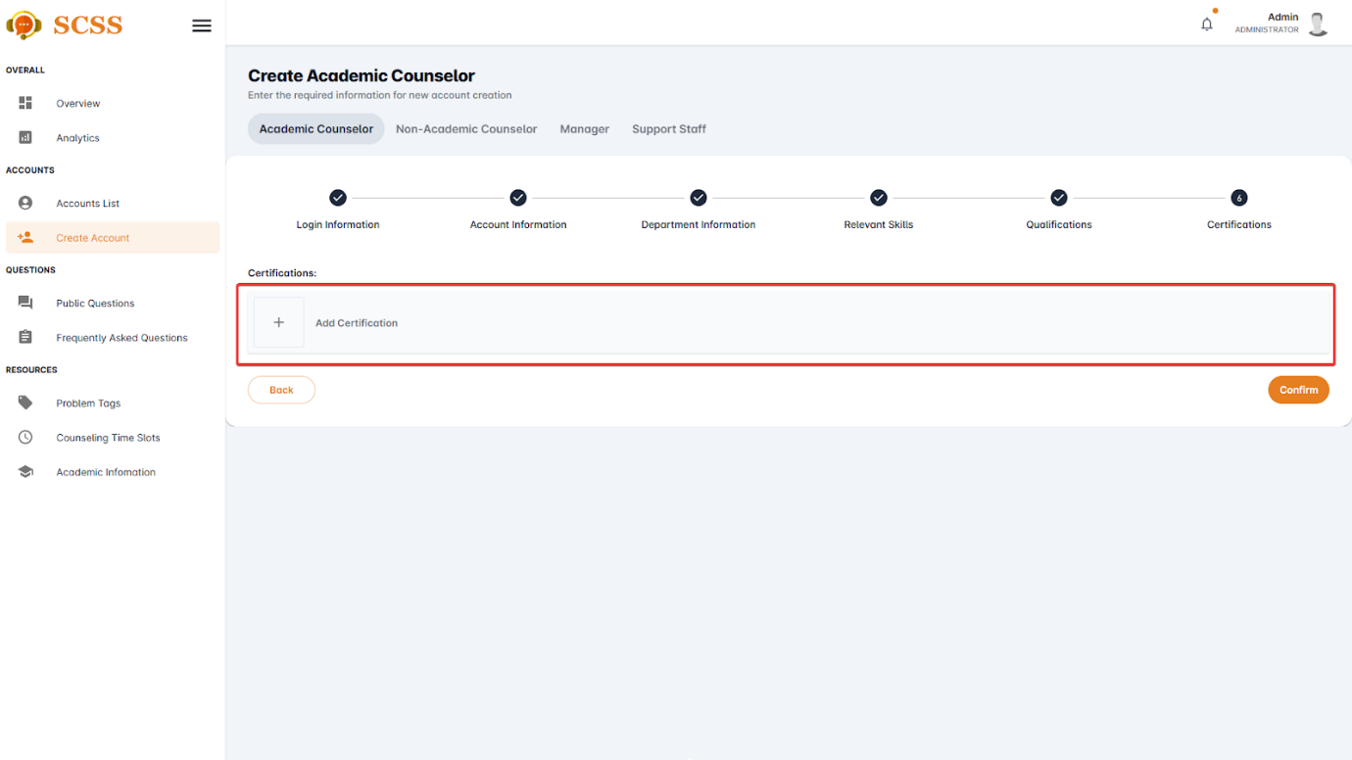

Figure - User Manual - Feature 30 – Step 10.1

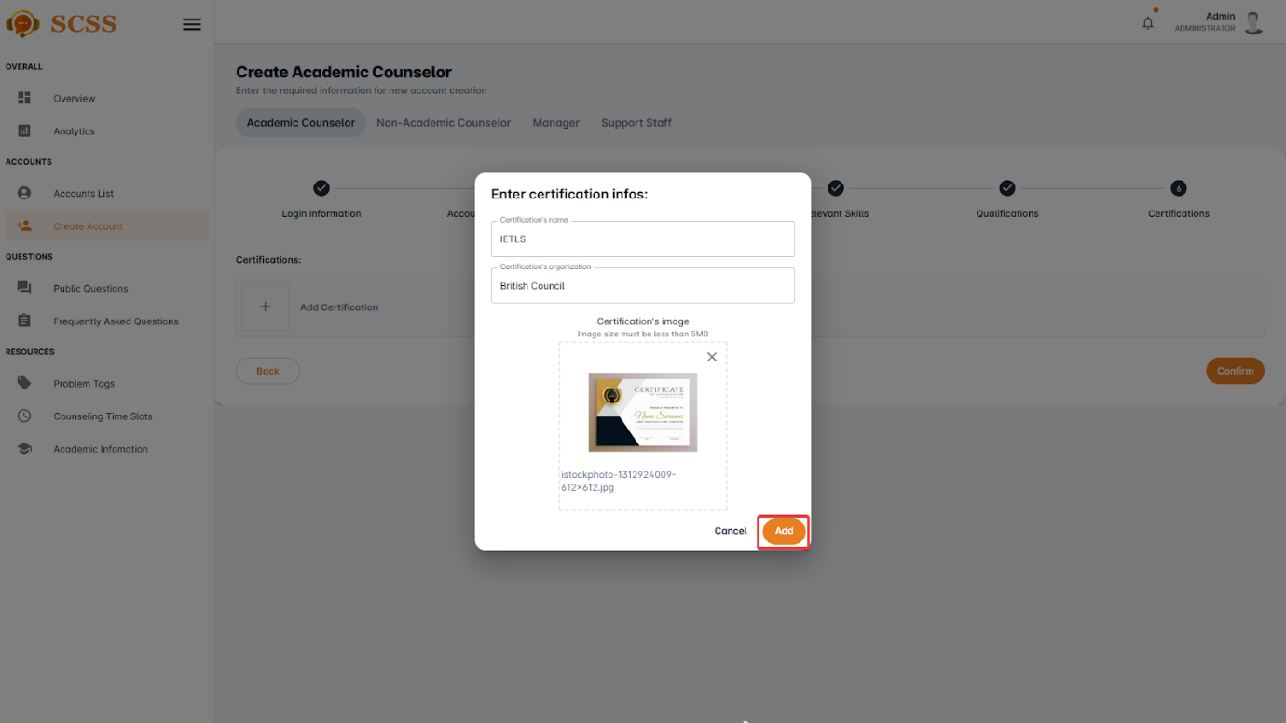

Figure - User Manual - Feature 30 – Step 10.2

**Step 11:** Press the “Confirm” button after all the required fields have been filled out.

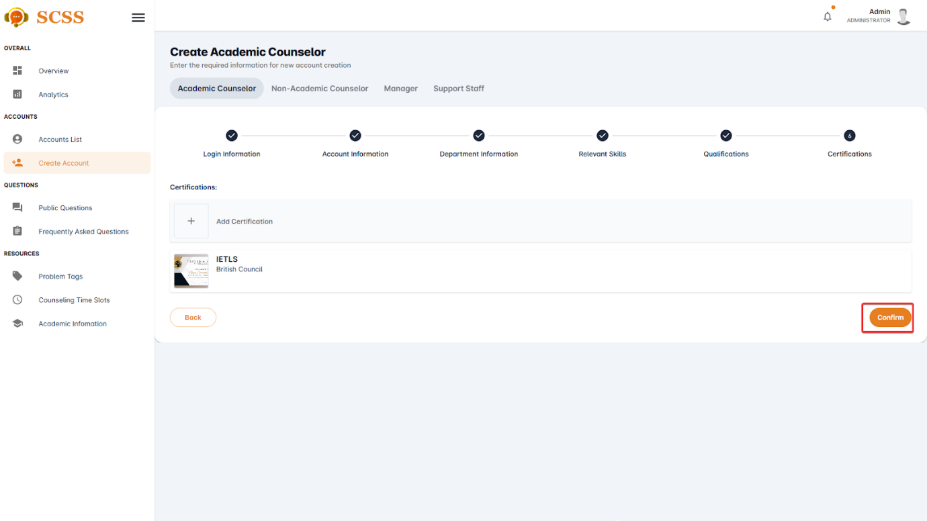

Figure - User Manual - Feature 30 – Step 11

**Step 12:** Press the “OK” button after a success dialog is shown to complete creating a counselor.

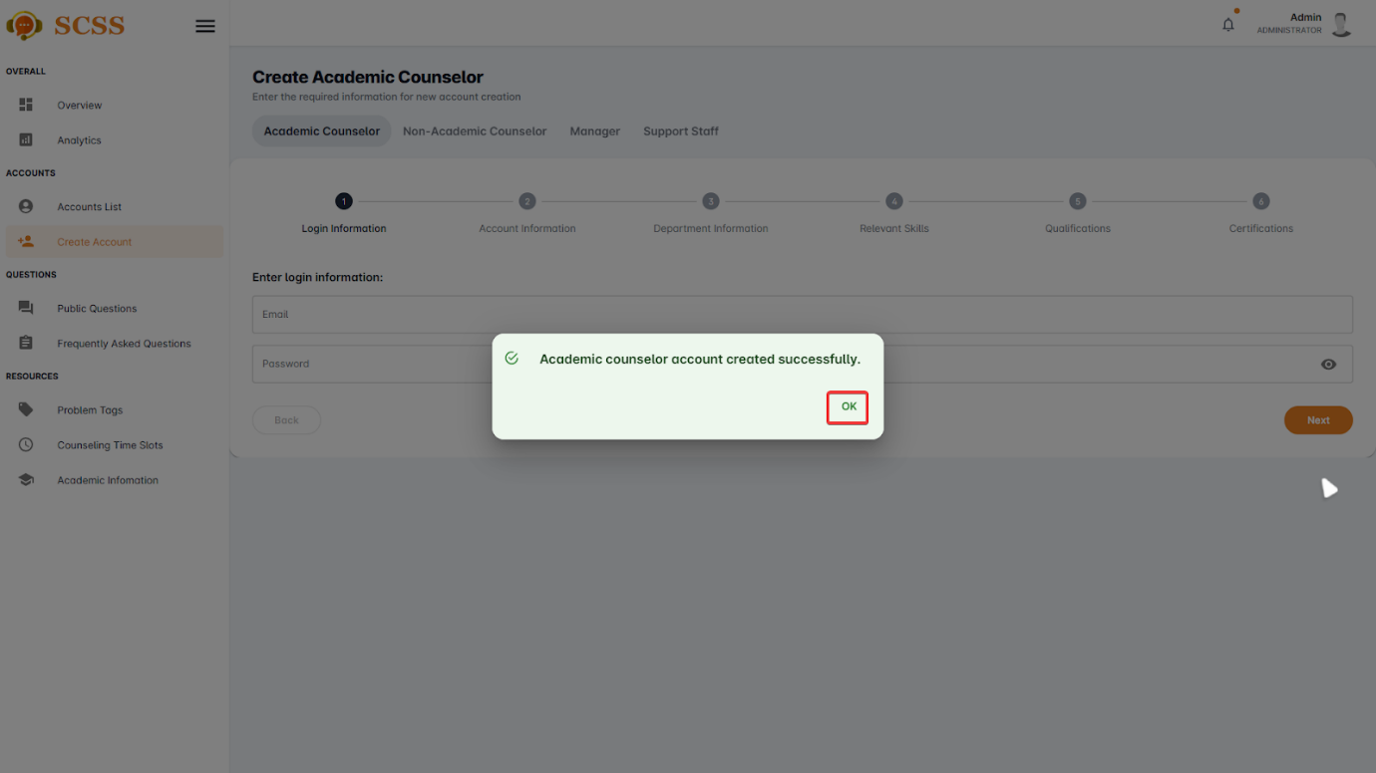

Figure - User Manual - Feature 30 – Step 12

##### 3.2.6.2. Create manager/support staff account

###### 3.2.6.2.1. Description

Use this guide so administrators can create manager or support staff accounts.

###### 3.2.6.2.2. Guide Steps

**Step 1**: Access SCSS at http://scss-fe.azurewebsites.net/. Then fill in “Email” and “Password” of the administrator account.



Figure - User Manual - Feature 31 – Step 1

**Step 2:** Click the “Sign in ” button.



Figure - User Manual - Feature 31 – Step 2

**Step 3:** From the homepage, choose “Create Account” from the left sidebar.



Figure - User Manual - Feature 31 – Step 3

**Step 4:** Select “Manager” or “Support staff” tab accordingly.

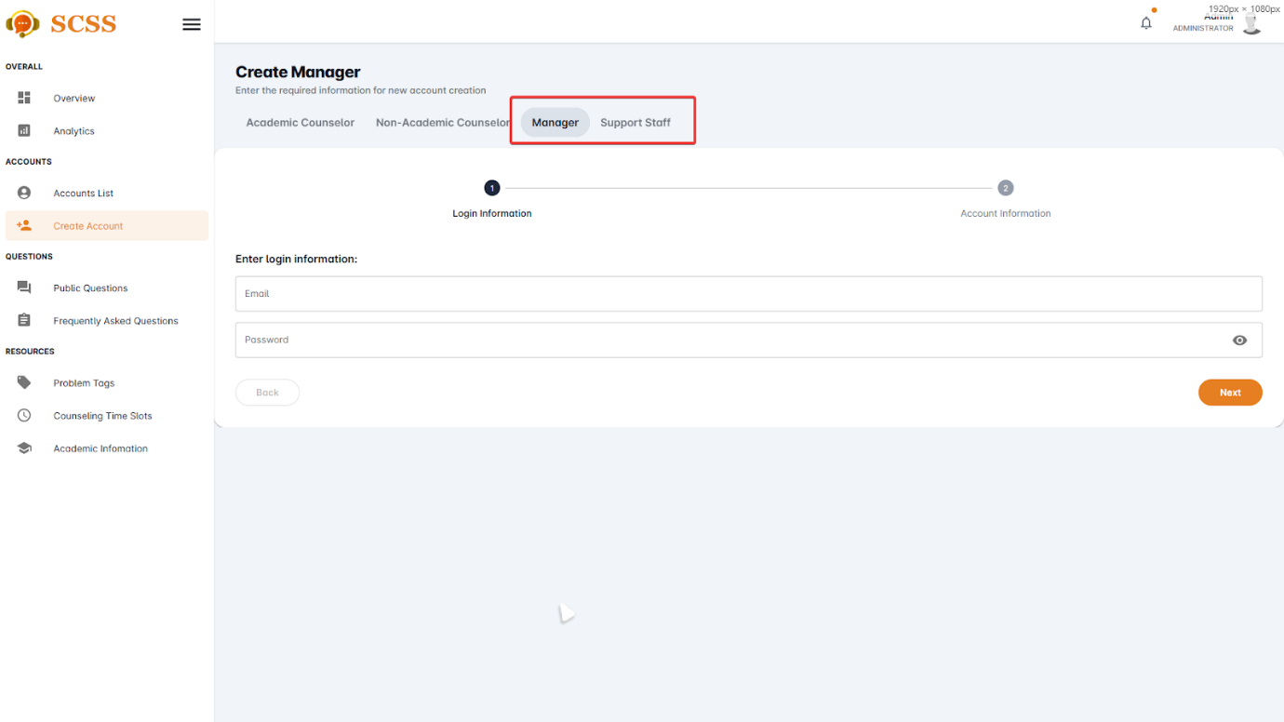

Figure - User Manual - Feature 31 – Step 4

**Step 5:** Fill out “Email”, “Password” fields and press the “Next” button at the bottom of the form when all the fields shown have been filled.

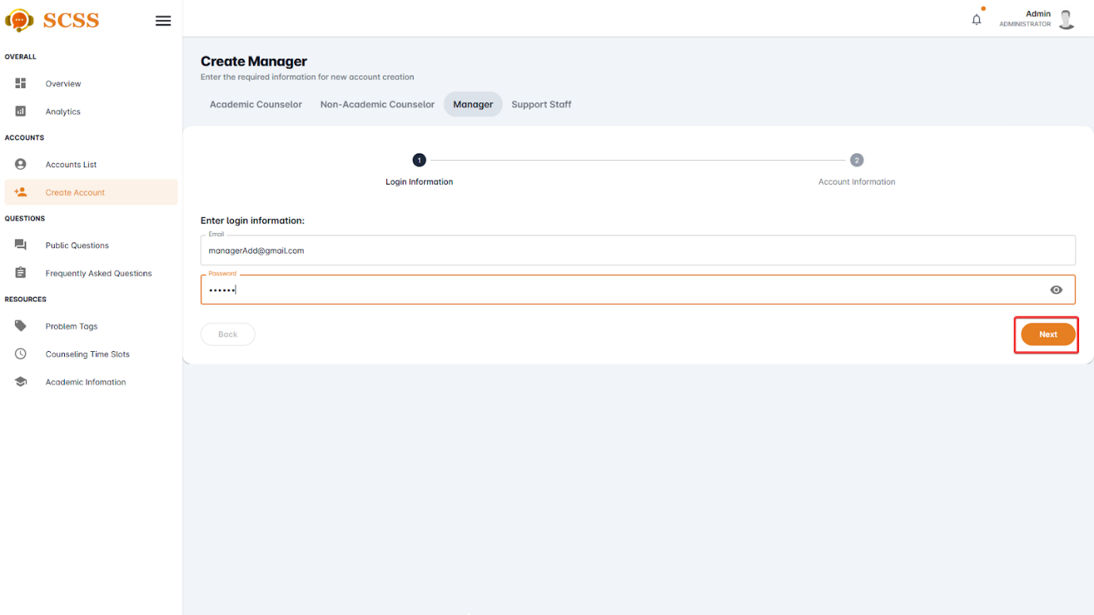

Figure - User Manual - Feature 31 – Step 5

**Step 6:** Fill out “Full name”, “Phone number”, “Email”, “Gender”, “Date of birth”, “Email”, “Password”, and “Avatar” field and press the “Next” button at the bottom of the form when all the fields shown have been filled.

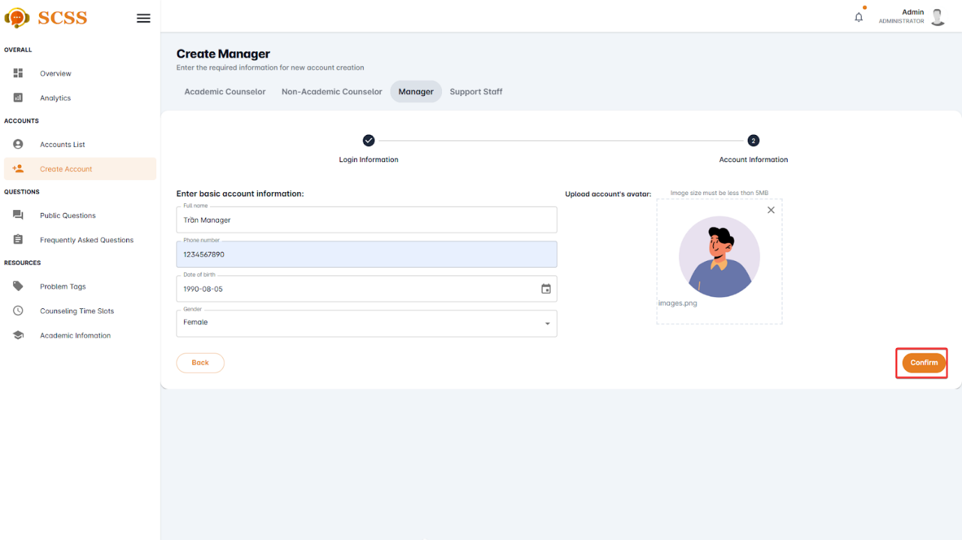

Figure - User Manual - Feature 31 – Step 6

**Step 7:** Press the “OK” button after a success dialog is shown to complete creating an account.

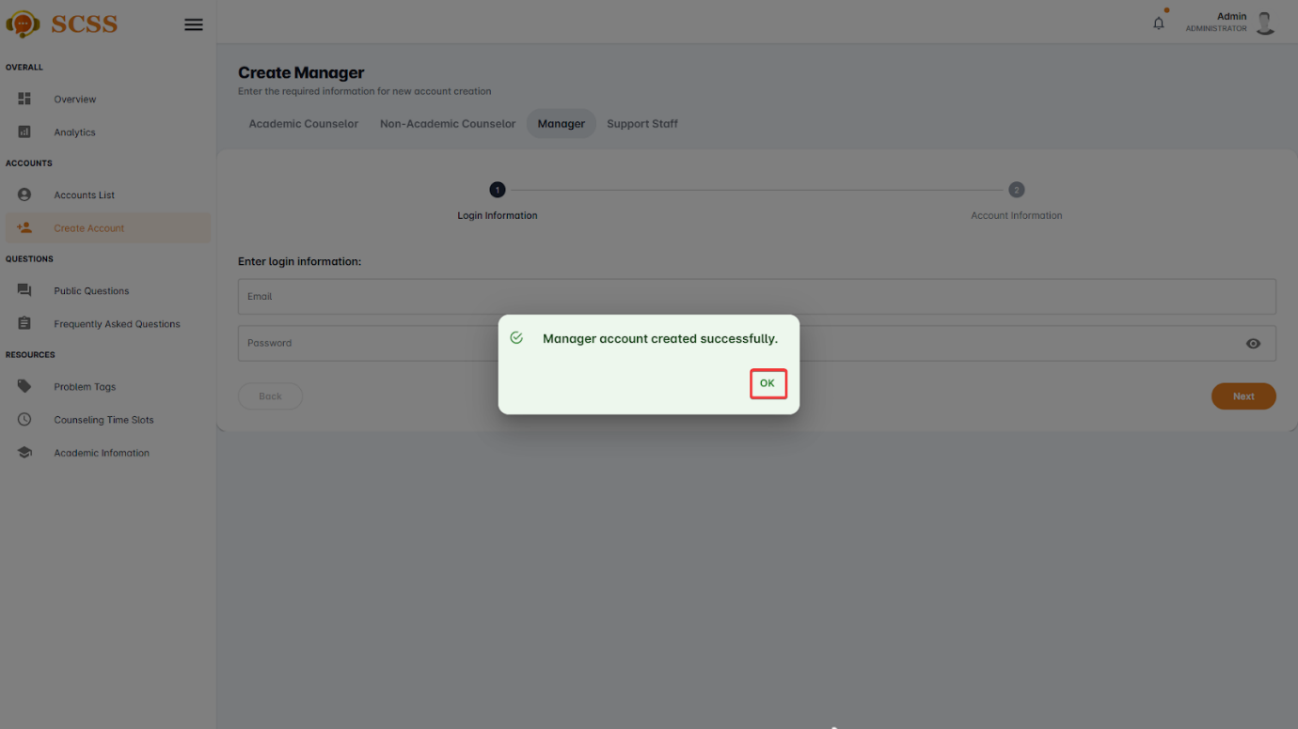

Figure - User Manual - Feature 31 – Step 7

##### 3.2.6.3. Update account

###### 3.2.6.3.1. Description

Use this guide so administrators can update accounts.

###### 3.2.6.3.2. Guide Steps

**Step 1**: Access SCSS at http://scss-fe.azurewebsites.net/. Then fill in “Email” and “Password” of the administrator account.



Figure - User Manual - Feature 32 – Step 1

**Step 2:** Click the “Sign in ” button.



Figure - User Manual - Feature 32 – Step 2

**Step 3:** From the homepage, choose “Accounts List” from the left sidebar.

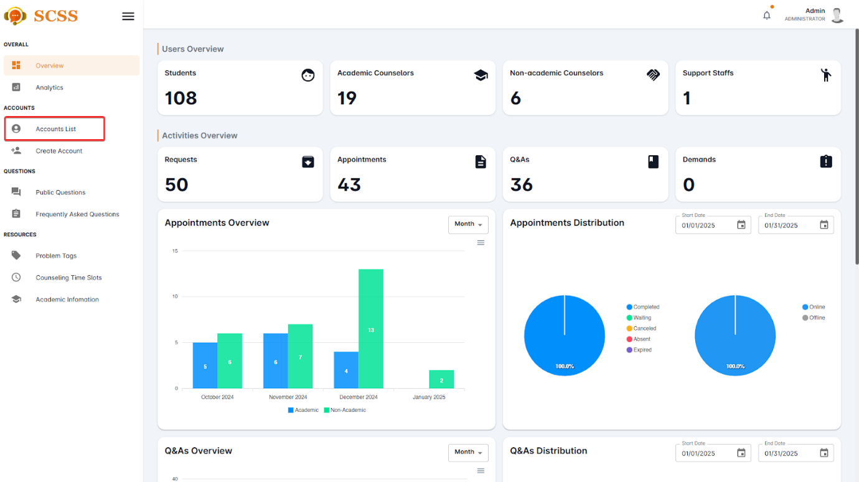

Figure - User Manual - Feature 32 – Step 3

**Step 4:** Press the underlined name of the selected account.

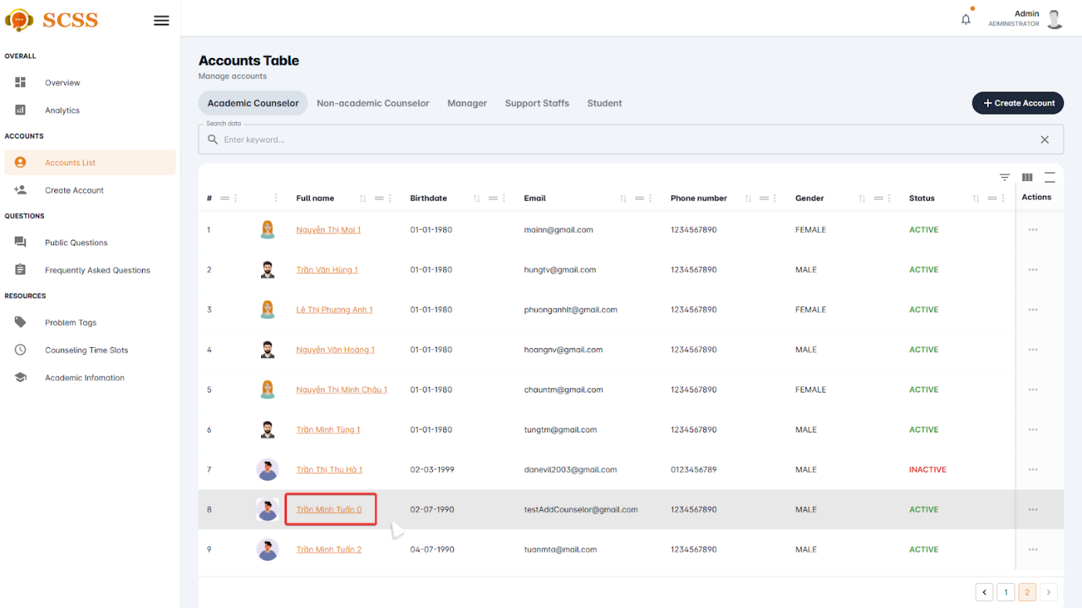

Figure - User Manual - Feature 32 – Step 4

**Step 5:** Fill out the fields that need to be updated and press the “Update” button.

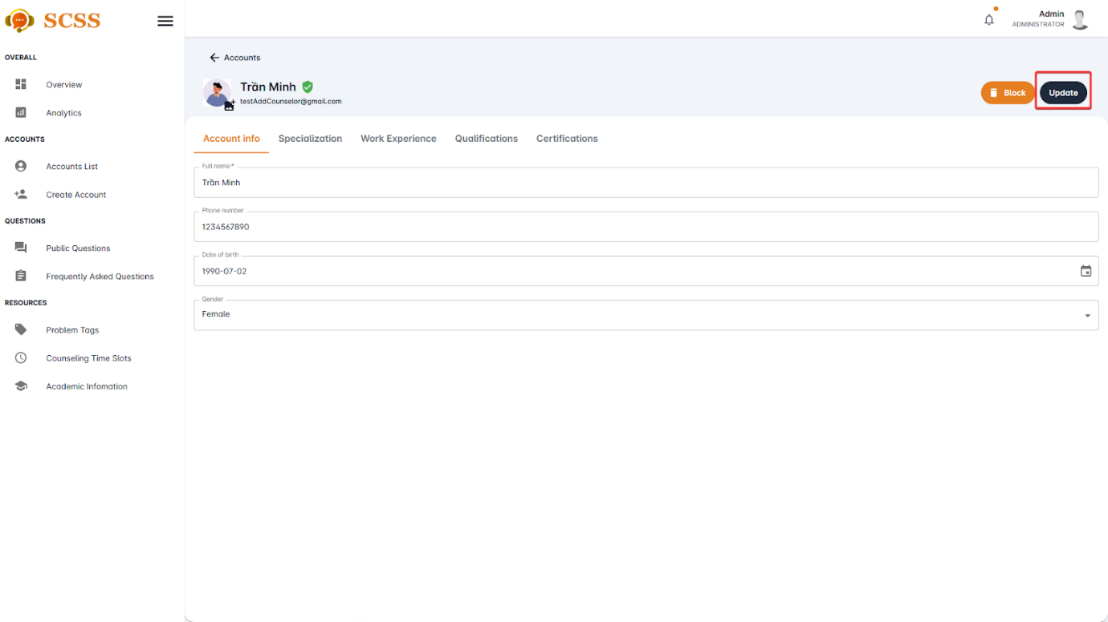

Figure - User Manual - Feature 32 – Step 5

**Step 6:** Press the “OK” button after a success dialog is shown to complete creating an account.

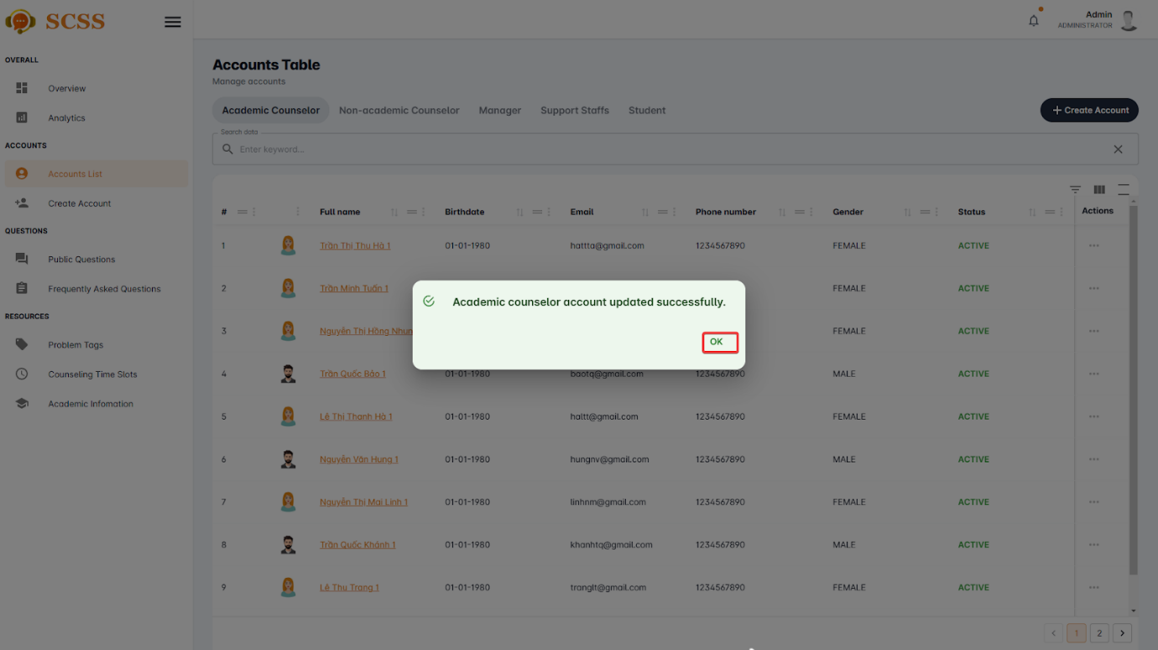

Figure - User Manual - Feature 32 – Step 6

##### 3.2.6.4. Block/Unblock accounts

###### 3.2.6.4.1. Description

Use this guide so administrators can block/unblock accounts.

###### 3.2.6.4.2. Guide Steps

**Step 1**: Access SCSS at http://scss-fe.azurewebsites.net/. Then fill in “Email” and “Password” of the administrator account.



Figure - User Manual - Feature 33 – Step 1

**Step 2:** Click the “Sign in ” button.



Figure - User Manual - Feature 33 – Step 2

**Step 3:** From the homepage, choose “Accounts List” from the left sidebar.



Figure - User Manual - Feature 33 – Step 3

**Step 4:** Press the”...” button in the row of the selected account.

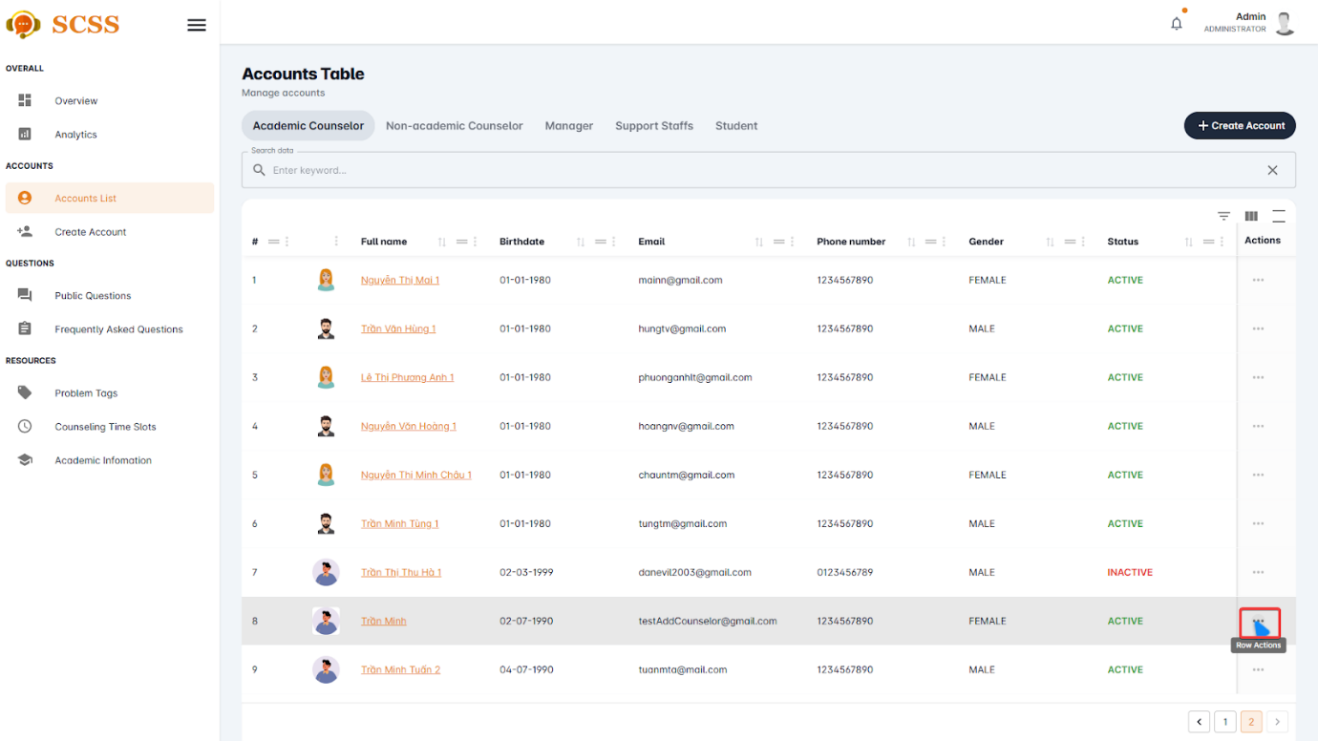

Figure - User Manual - Feature 33 – Step 4

**Step 5:** Press the “Block” or “Unblock” button.

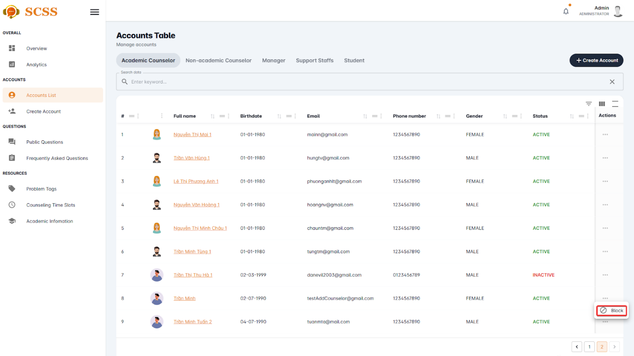

Figure - User Manual - Feature 33 – Step 5

**Step 6:** Press the “Confirm” button.

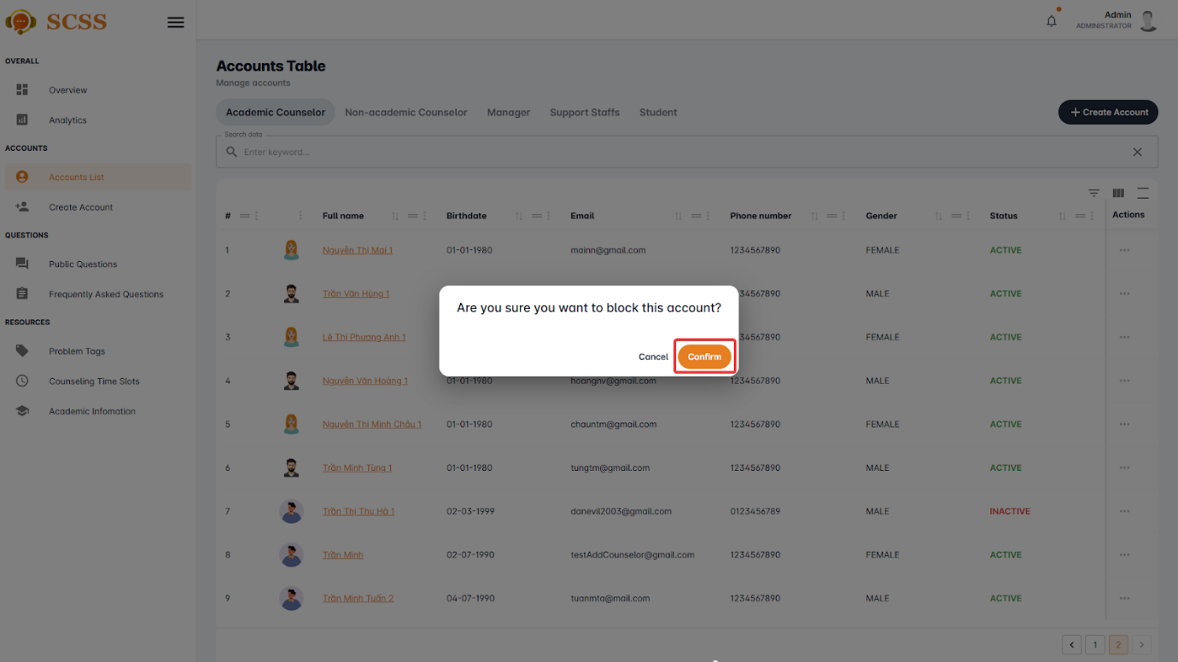

Figure - User Manual - Feature 33 – Step 6

**Step 7:** Press the “OK” button.

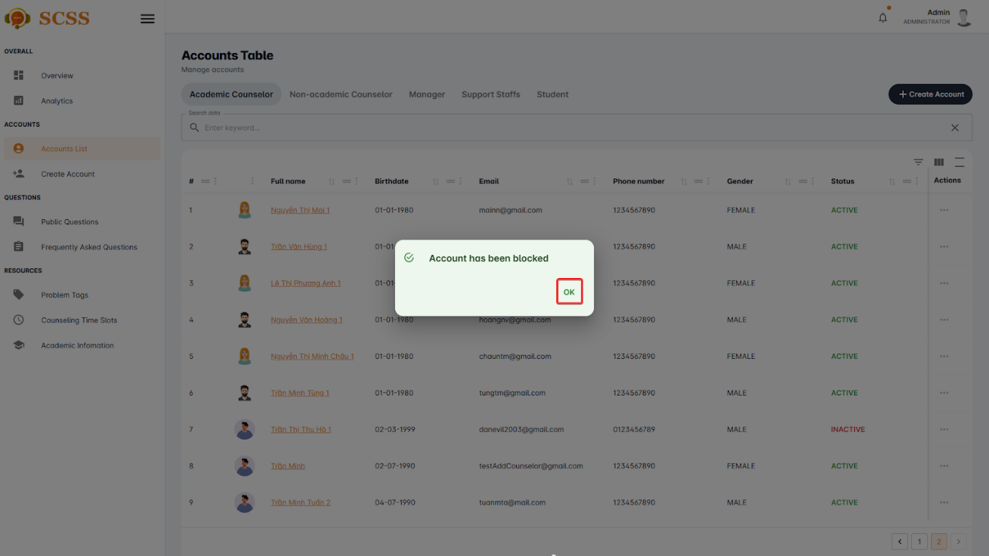

Figure - User Manual - Feature 33 – Step 7

#### 3.2.7. Resource Management

##### 3.2.7.1. Create problem tag

###### 3.2.7.1.1. Description

Use this guideline to create a problem tag using an administrator account.

###### 3.2.7.1.2. Guide Steps

**Step 1**: Access SCSS at http://scss-fe.azurewebsites.net/. Then fill in “Email” and “Password” of the administrator account.



Figure - User Manual - Feature 34 – Step 1

**Step 2:** Click the “Sign in ” button.



Figure - User Manual - Feature 34 – Step 2

**Step 3:** From the homepage, choose “Problem Tag” from the left sidebar.

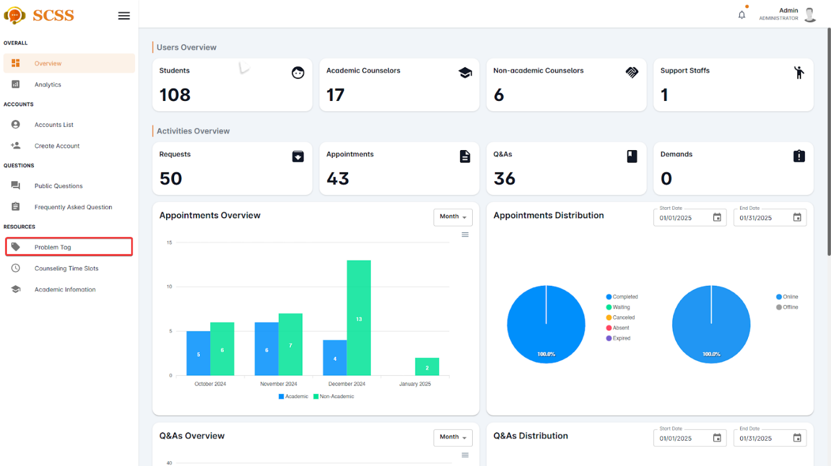

Figure - User Manual - Feature 34 – Step 3

**Step 4:** Select “Tag” tab.

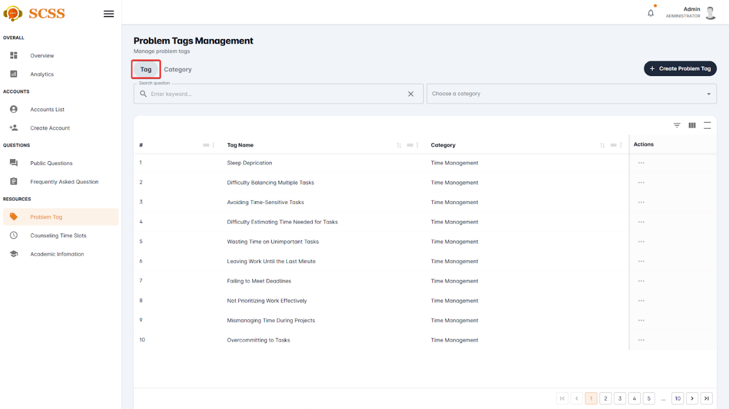

Figure - User Manual - Feature 34 – Step 4

**Step 5:** Press the “Create Problem Tag” button.

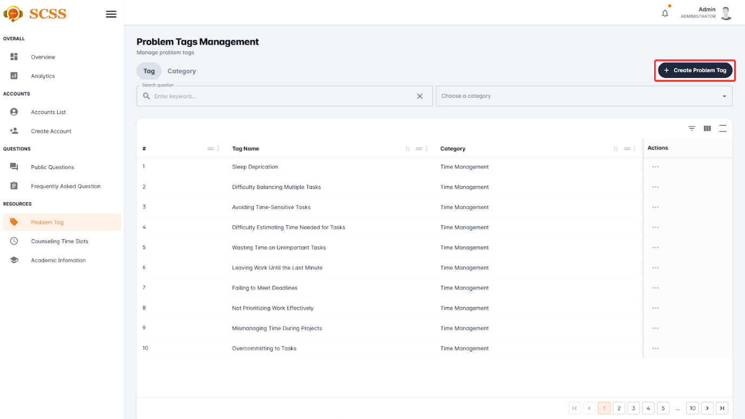

Figure - User Manual - Feature 34 – Step 5

**Step 6:** Fill out the “Problem tag name”, “Point”, and select a “Category”, then press the “Confirm” button.

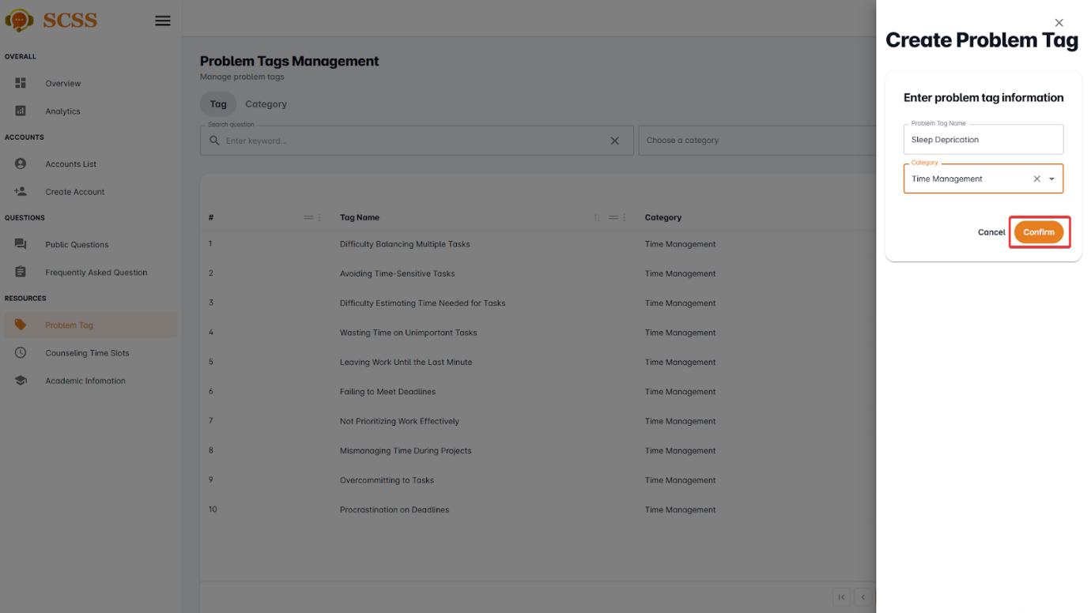

Figure - User Manual - Feature 34 – Step 6

**Step 7:** Press the “OK” button after a success dialog is shown to complete creating a problem tag.

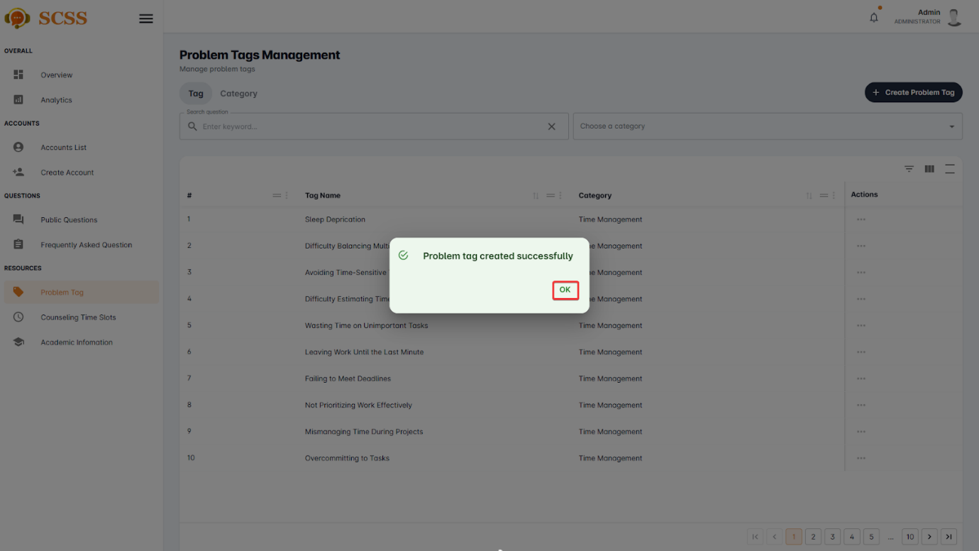

Figure - User Manual - Feature 34 – Step 7

##### 3.2.7.2. Create problem tag’s category

###### 3.2.7.2.1. Description

Use this guideline to create a problem tag’s category using an administrator account.

###### 3.2.7.2.2. Guide Steps

**Step 1**: Access SCSS at http://scss-fe.azurewebsites.net/. Then fill in “Email” and “Password” of the administrator account.



Figure - User Manual - Feature 35 – Step 1

**Step 2:** Click the “Sign in ” button.



Figure - User Manual - Feature 35 – Step 2

**Step 3:** From the homepage, choose “Problem Tag” from the left sidebar.



Figure - User Manual - Feature 35 – Step 3

**Step 4:** Select “Category” tab.

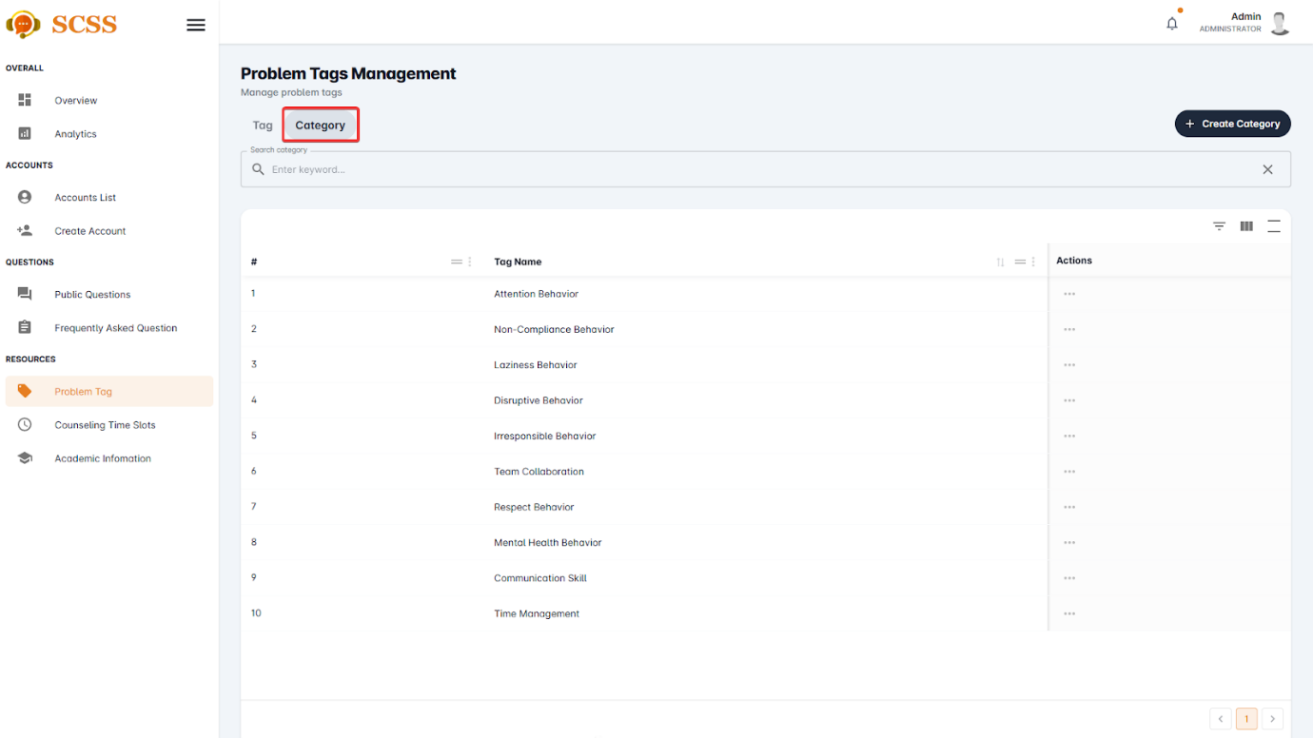

Figure - User Manual - Feature 35 – Step 4

**Step 5:** Press the “Create Category” button.

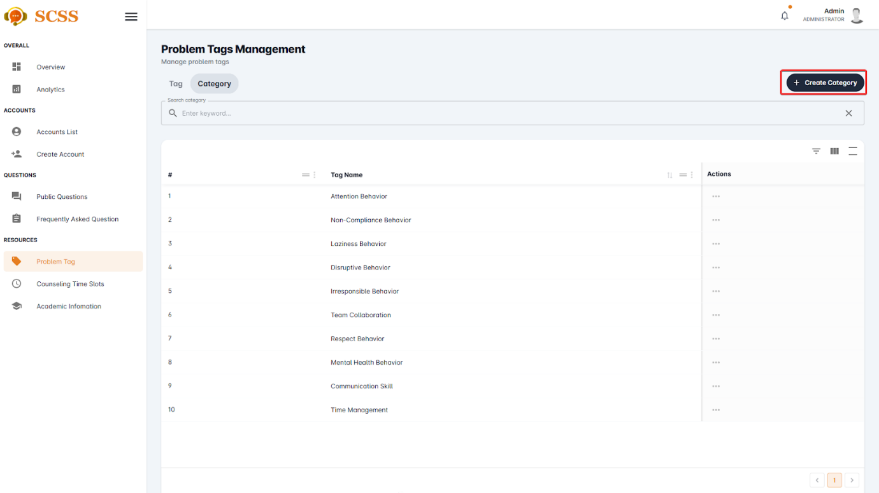

Figure - User Manual - Feature 35 – Step 5

**Step 6:** Fill out the “Category name” field, then press the “Confirm” button.

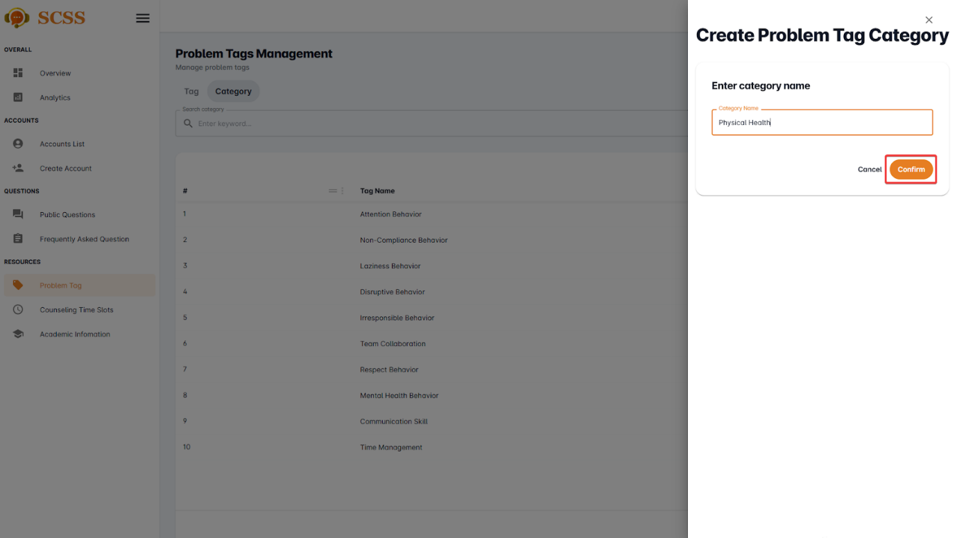

Figure - User Manual - Feature 35 – Step 6

**Step 7:** Press the “OK” button after a success dialog is shown to complete creating a problem tag’s category

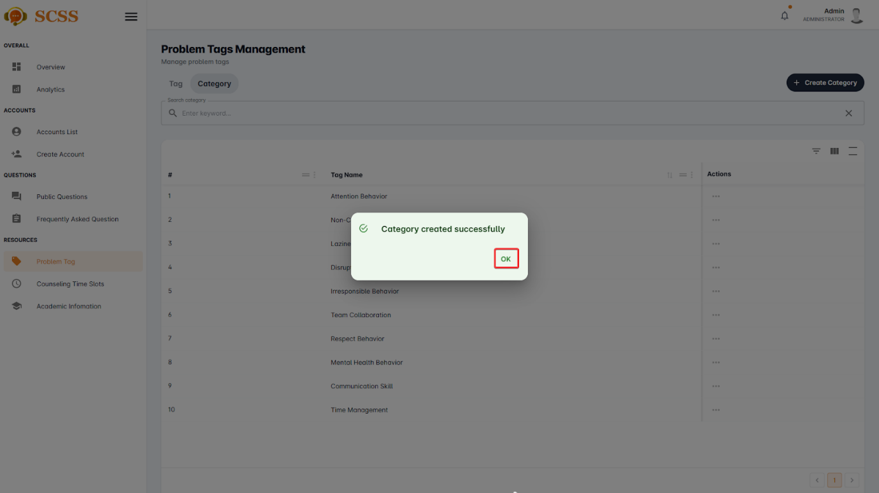

Figure - User Manual - Feature 35 – Step 7

##### 3.2.7.3. Create counseling time slot

###### 3.2.7.3.1. Description

Use this guideline to create a counseling time slot using an administrator account.

###### 3.2.7.3.2. Guide Steps

**Step 1**: Access SCSS at http://scss-fe.azurewebsites.net/. Then fill in “Email” and “Password” of the administrator account.



Figure - User Manual - Feature 36 – Step 1

**Step 2:** Click the “Sign in ” button.



Figure - User Manual - Feature 36 – Step 2

**Step 3:** From the homepage, choose “Counseling Time Slots” from the left sidebar.

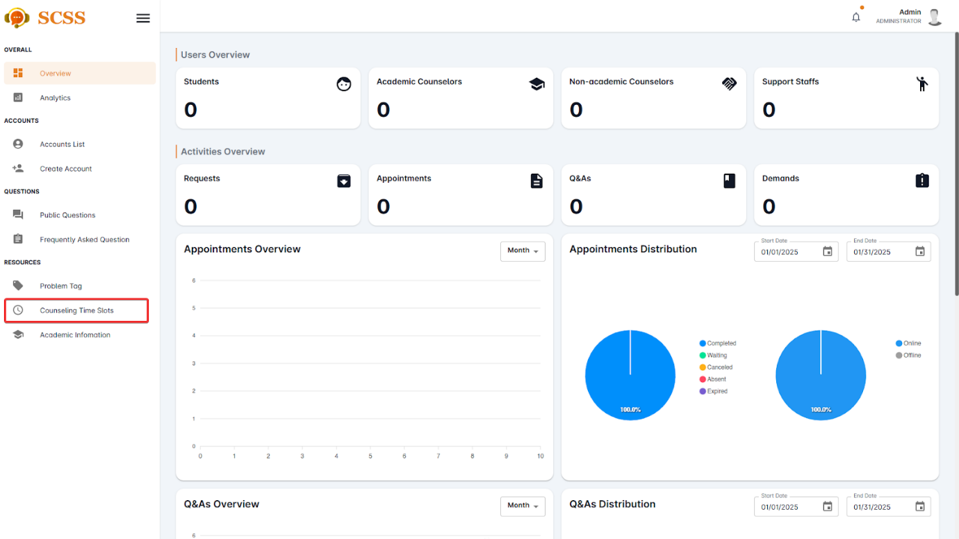

Figure - User Manual - Feature 36 – Step 3

**Step 4:** Press the “Add Time Slot” button.

.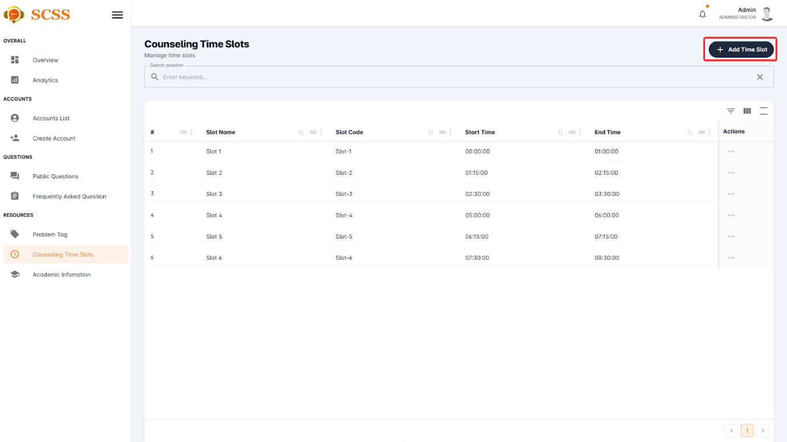

Figure - User Manual - Feature 36 – Step 4

**Step 5:** Fill out the “Slot name”, “Slot code”, “Start time”, and “End time” fields, then press the “Confirm” button.

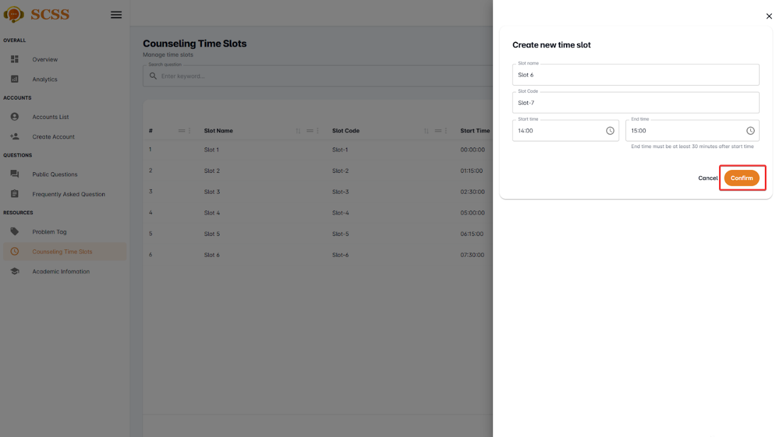

Figure - User Manual - Feature 36 – Step 5

**Step 6:** Press the “OK” button after a success dialog is shown to complete creating a counseling time slot.

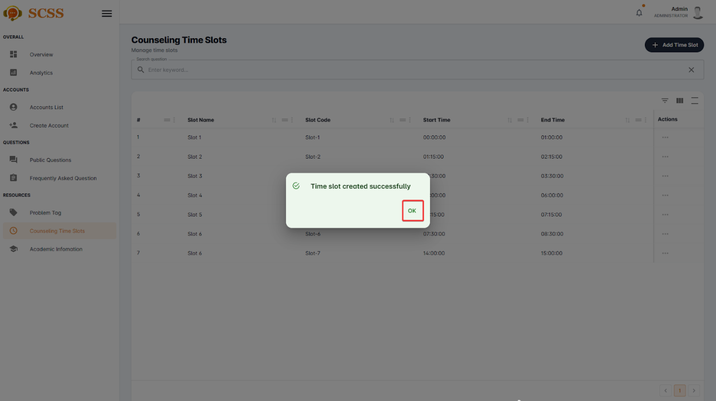

Figure - User Manual - Feature 36 – Step 7

##### 3.2.7.4. Remove problem tag’s category

###### 3.2.7.4.1. Description

Use this guideline to remove a problem tag’s category using an administrator account.

###### 3.2.7.4.2. Guide Steps

**Step 1**: Access SCSS at http://scss-fe.azurewebsites.net/. Then fill in “Email” and “Password” of the administrator account.



Figure - User Manual - Feature 37 – Step 1

**Step 2:** Click the “Sign in ” button.



Figure - User Manual - Feature 37 – Step 2

**Step 3:** From the homepage, choose “Problem Tag” from the left sidebar.



Figure - User Manual - Feature 37 – Step 3

**Step 4:** Select “Category” tab.



Figure - User Manual - Feature 37 – Step 4

**Step 5:** Press the “...” button under the actions column, in the row of the selected category.

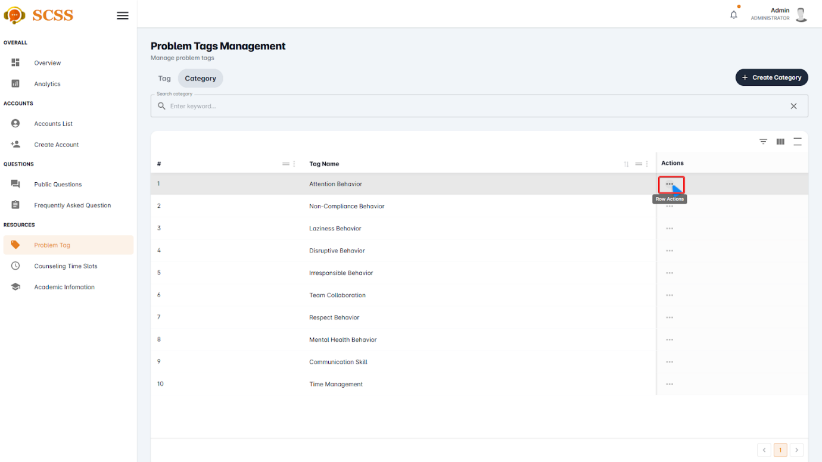

Figure - User Manual - Feature 37 – Step 5

**Step 6:** Press the “Delete” button.

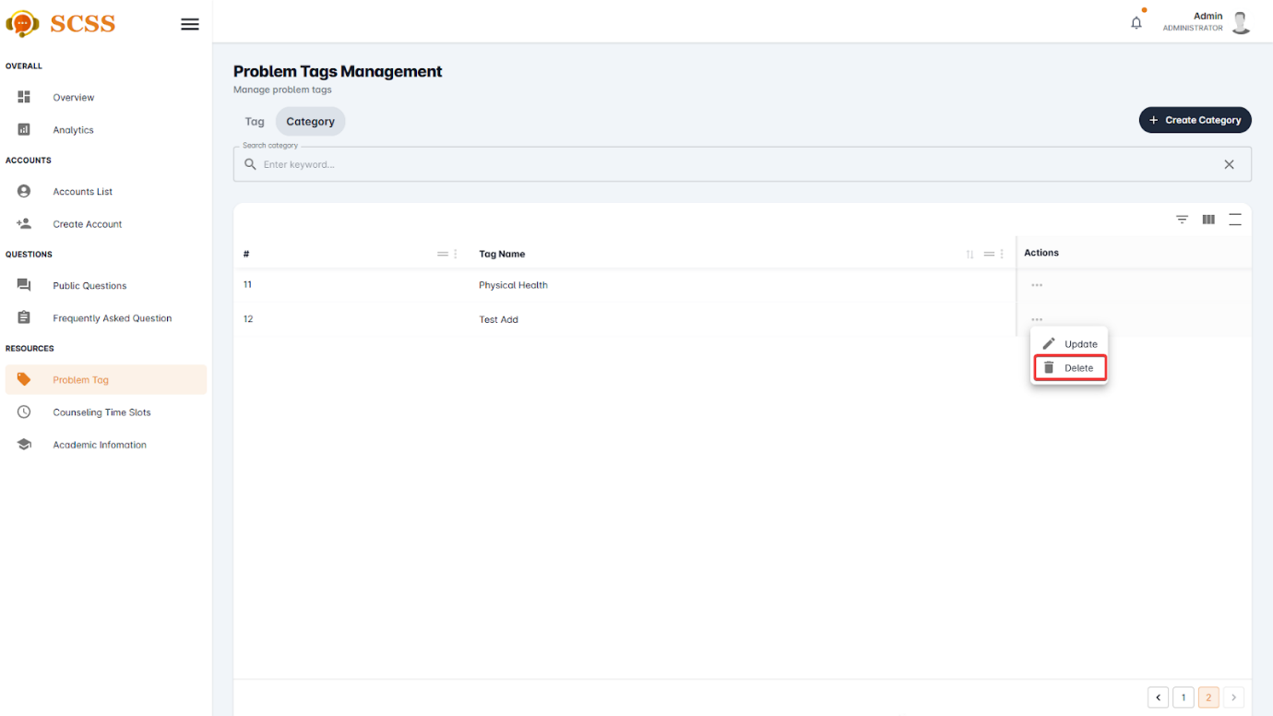

Figure - User Manual - Feature 37 – Step 6

**Step 7:** Press the “Confirm” button.

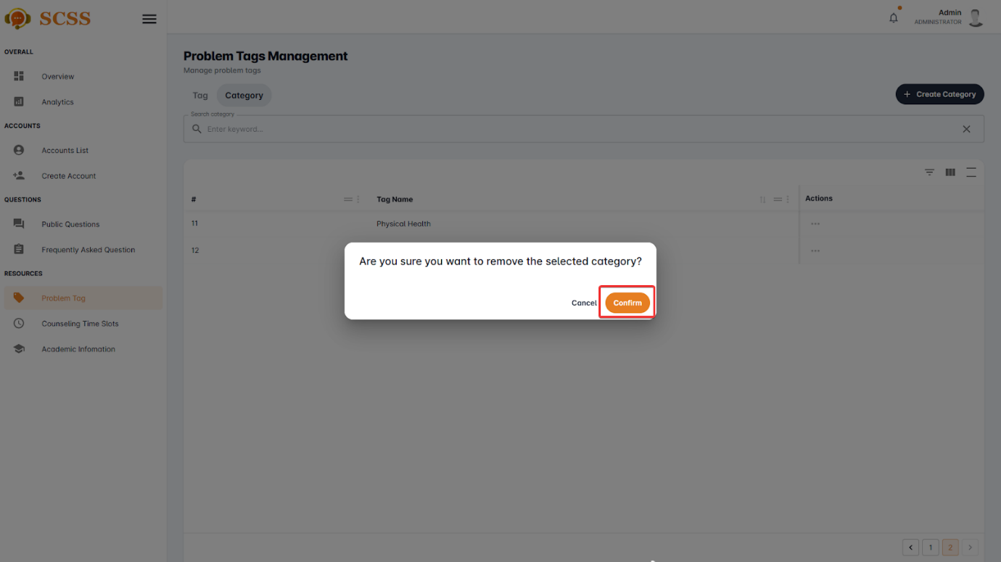

Figure - User Manual - Feature 37 – Step 7

**Step 8:** Press the “Ok” button to complete removing a category.

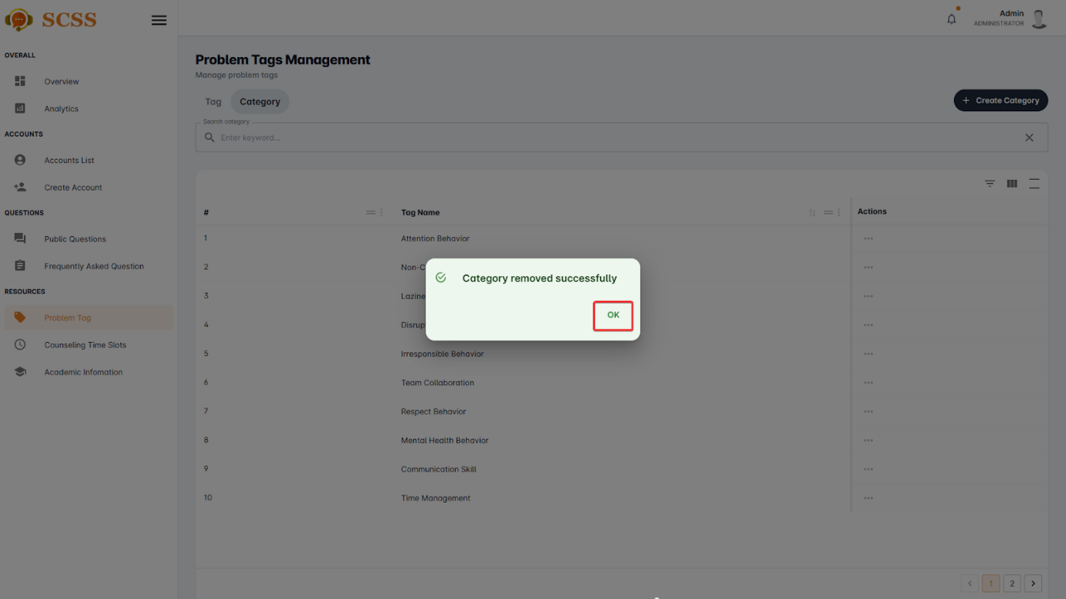

Figure - User Manual - Feature 37 – Step 8

##### 3.2.7.5. Remove problem tag

###### 3.2.7.5.1. Description

Use this guideline to remove a problem tag’s category using an administrator account.

###### 3.2.7.5.2. Guide Steps

**Step 1**: Access SCSS at http://scss-fe.azurewebsites.net/. Then fill in “Email” and “Password” of the administrator account.



Figure - User Manual - Feature 38 – Step 1

**Step 2:** Click the “Sign in ” button.



Figure - User Manual - Feature 38 – Step 2

**Step 3:** From the homepage, choose “Problem Tag” from the left sidebar.



Figure - User Manual - Feature 38 – Step 3

**Step 4:** Select “Tag” tab.



Figure - User Manual - Feature 38 – Step 4

**Step 5:** Press the “...” button under the actions column, in the row of the selected problem tag.

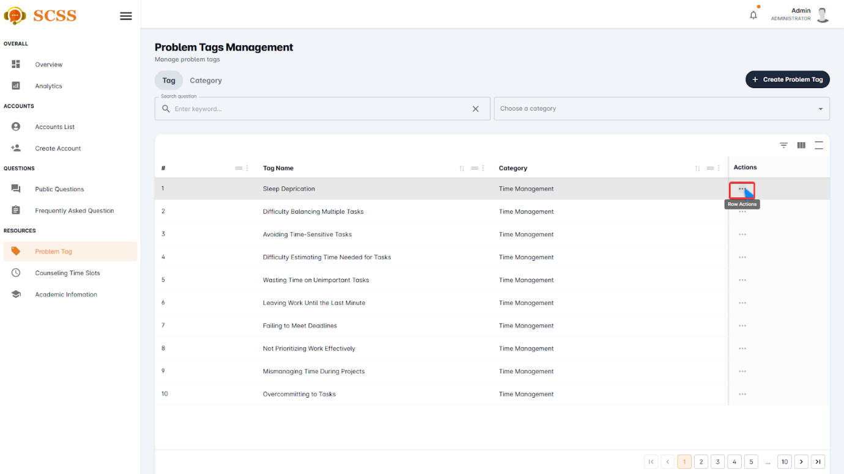

Figure - User Manual - Feature 38 – Step 5

**Step 6:** Press the “Delete” button.



Figure - User Manual - Feature 38 – Step 6

**Step 7:** Press the “Confirm” button.

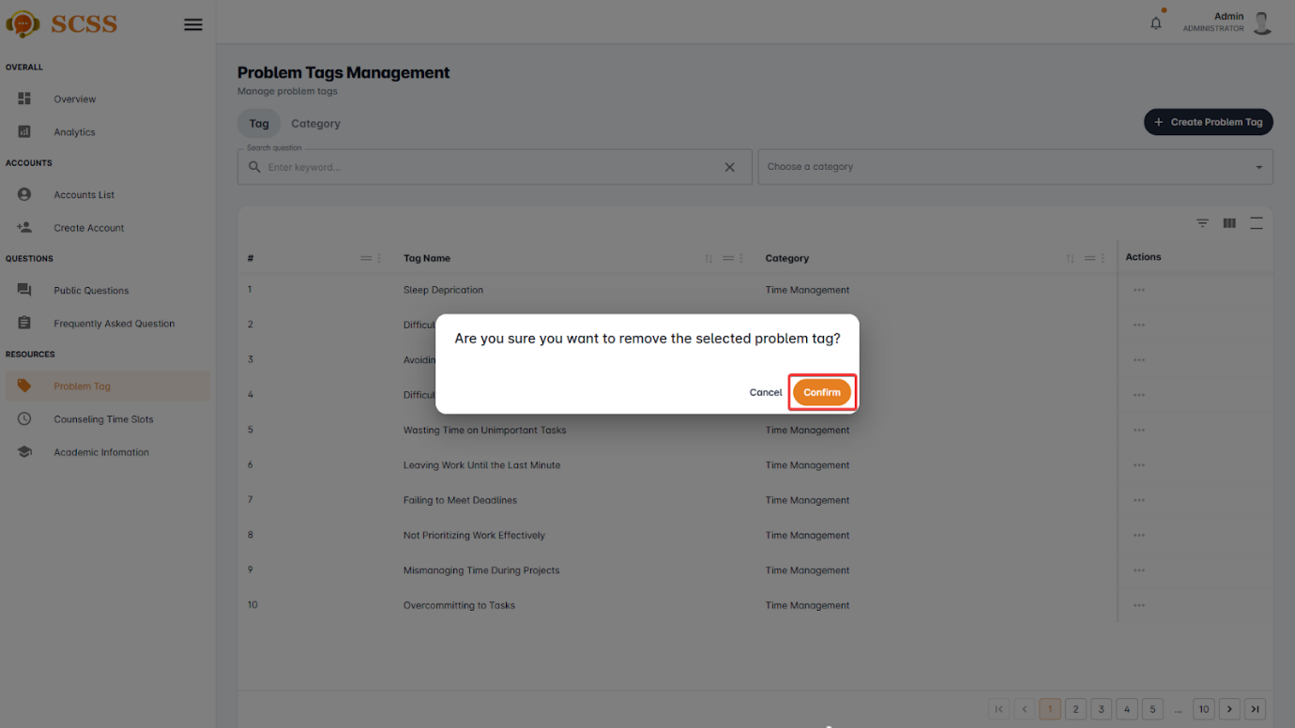

Figure - User Manual - Feature 38 – Step 7

**Step 8:** Press the “Ok” button to complete removing a problem tag.

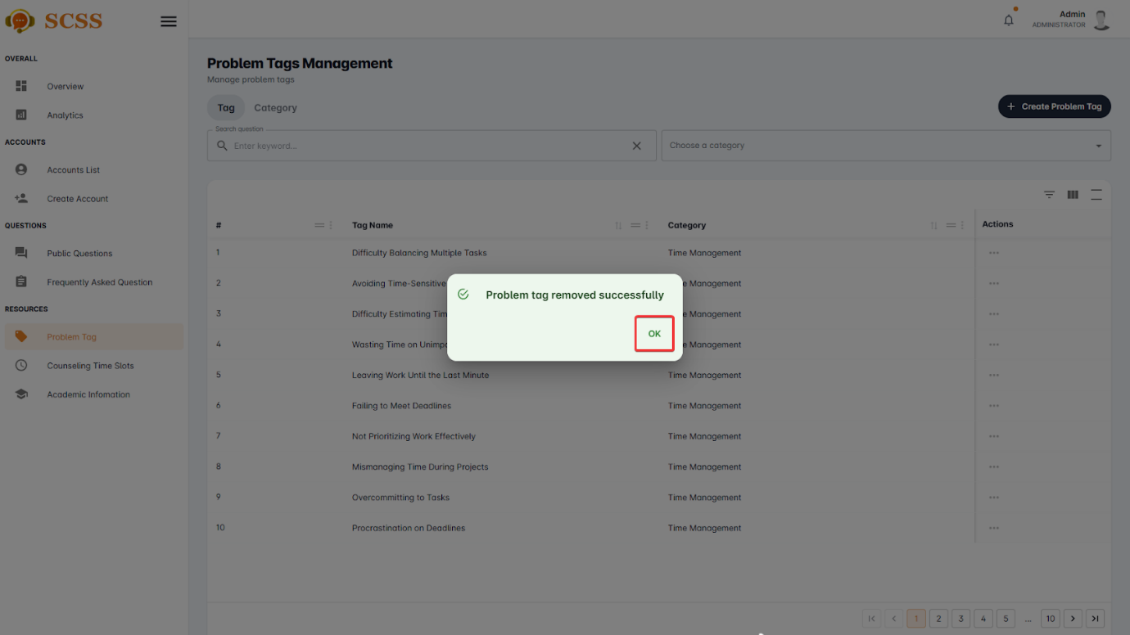

Figure - User Manual - Feature 38 – Step 8

##### 3.2.7.6. Remove counseling time slot

###### 3.2.7.6.1. Description

Use this guideline to remove a counselling time slot using an administrator account.

###### 3.2.7.6.2. Guide Steps

**Step 1**: Access SCSS at http://scss-fe.azurewebsites.net/. Then fill in “Email” and “Password” of the administrator account.



Figure - User Manual - Feature 39 – Step 1

**Step 2:** Click the “Sign in ” button.



Figure - User Manual - Feature 39 – Step 2

**Step 3:** From the homepage, choose “Counseling Time Slots” from the left sidebar.



Figure - User Manual - Feature 39 – Step 3

**Step 4:** Press the “...” button under the actions column, in the row of the selected problem tag.

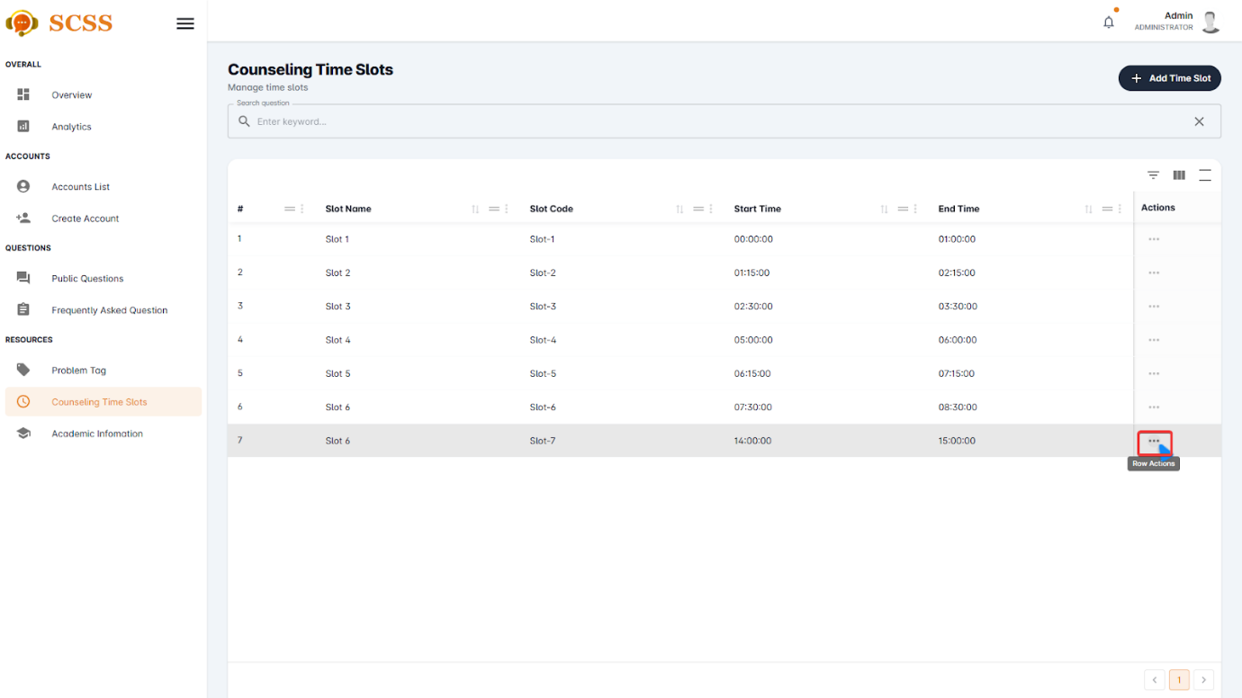

Figure - User Manual - Feature 39 – Step 4

**Step 5:** Press the “Delete” button.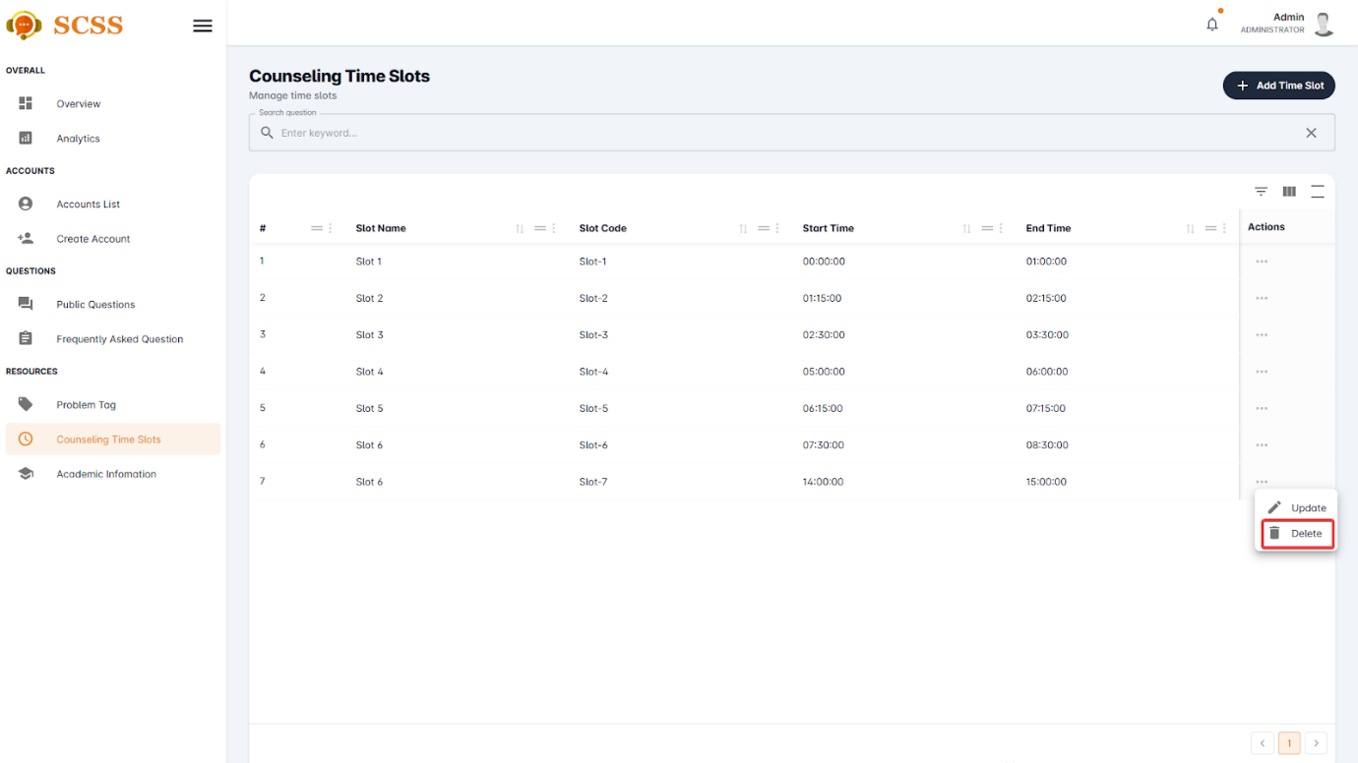

Figure - User Manual - Feature 39 – Step 5

**Step 6:** Press the “Confirm” button.

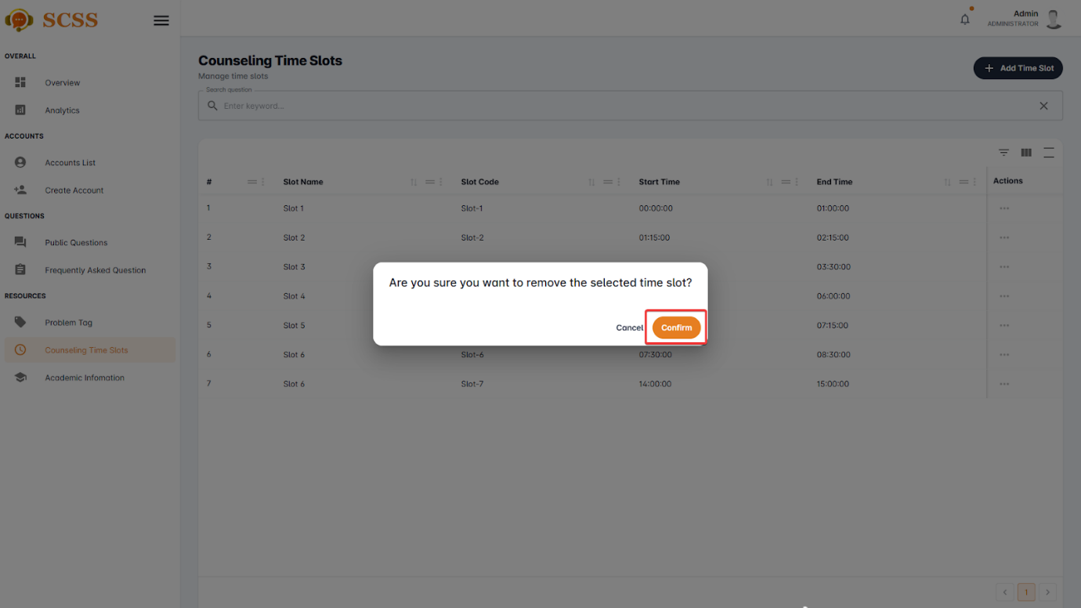

Figure - User Manual - Feature 39 – Step 6

**Step 7:** Press the “Ok” button to complete removing a time slot.

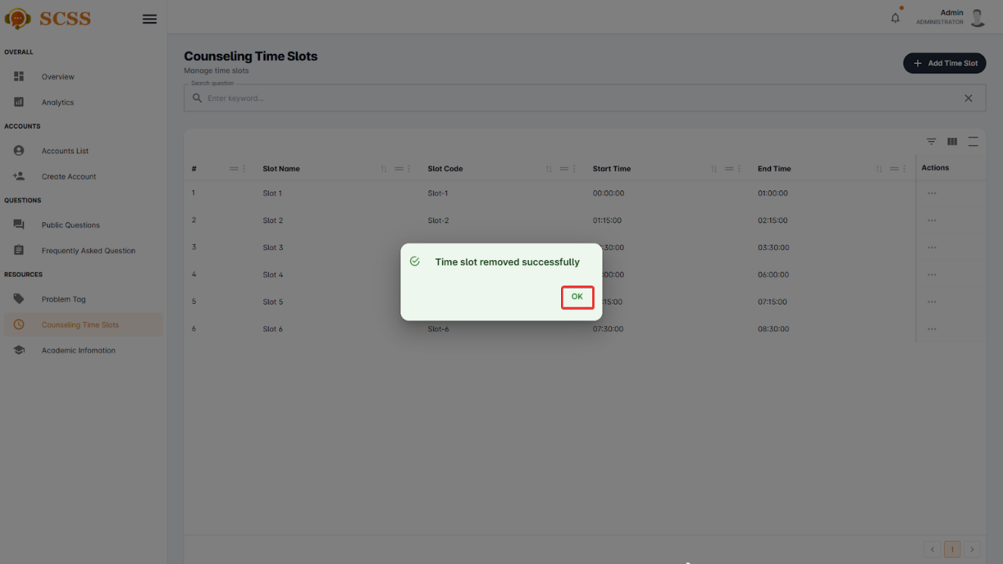

Figure - User Manual - Feature 39 – Step 7

##### 3.2.7.7. Update problem tag

###### 3.2.7.7.1. Description

Use this guideline to update a problem tag using an administrator account.

###### 3.2.7.7.2. Guide Steps

**Step 1**: Access SCSS at http://scss-fe.azurewebsites.net/. Then fill in “Email” and “Password” of the administrator account.



Figure - User Manual - Feature 40 – Step 1

**Step 2:** Click the “Sign in ” button.



Figure - User Manual - Feature 40 – Step 2

**Step 3:** From the homepage, choose “Problem Tag” from the left sidebar.



Figure - User Manual - Feature 40 – Step 3

**Step 4:** Select “Tag” tab.



Figure - User Manual - Feature 40 – Step 4

**Step 5:** Press the “...” button under the actions column, in the row of the selected problem tag.

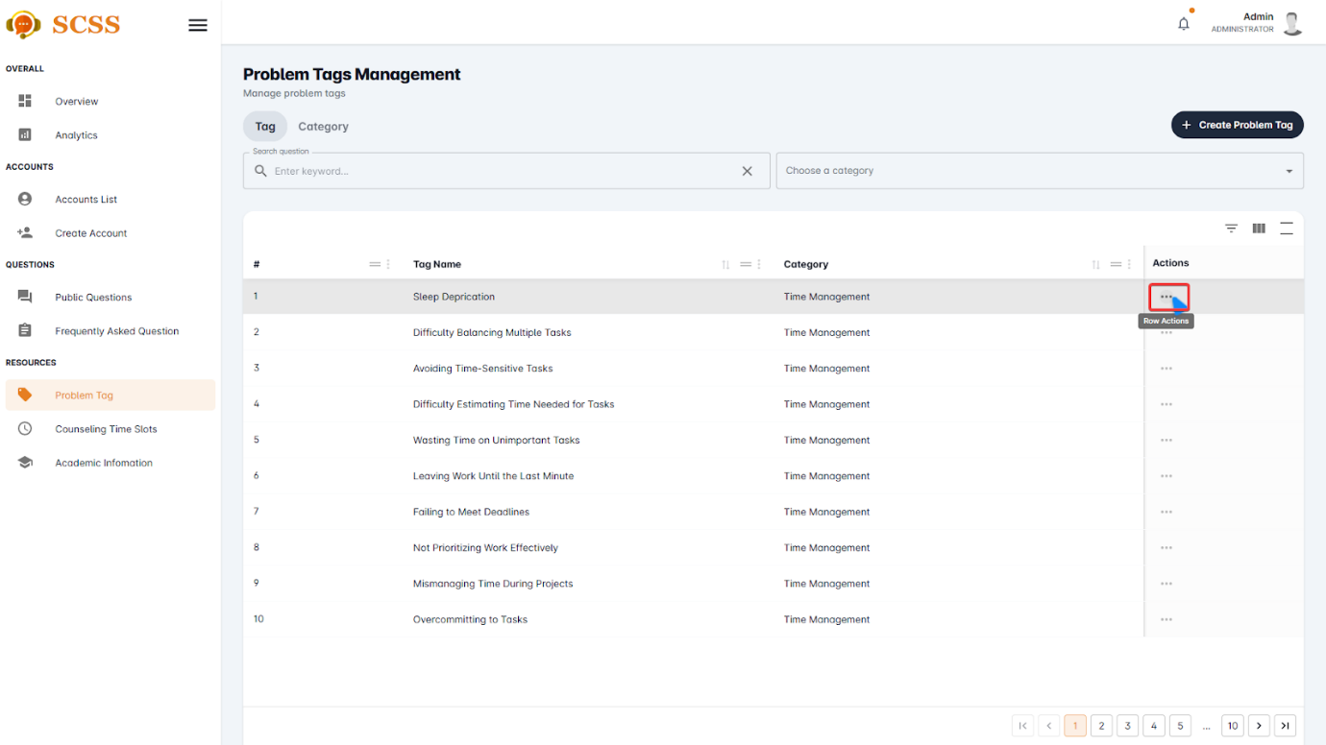

Figure - User Manual - Feature 40 – Step 5

**Step 6:** Press the “Update” button.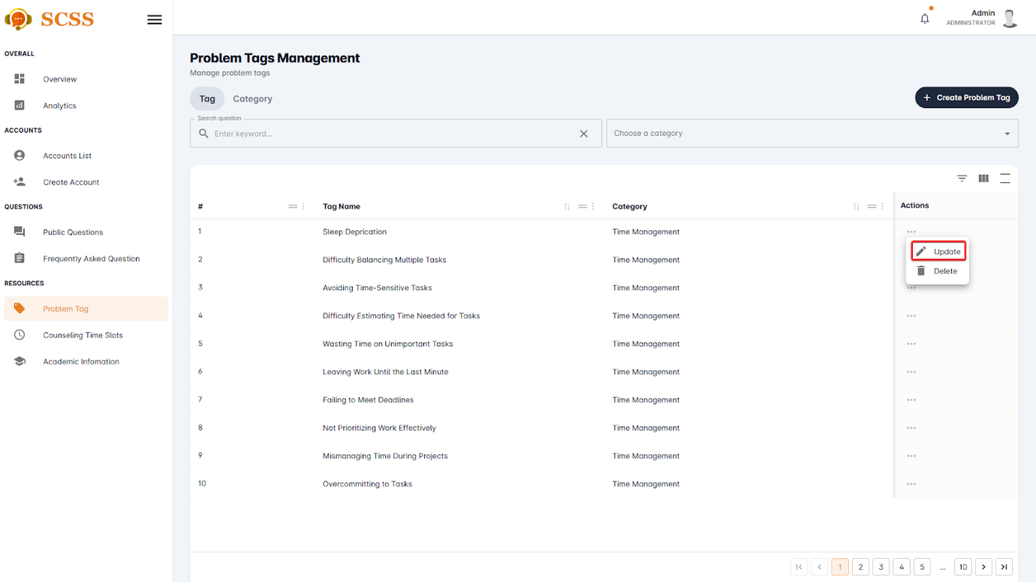

Figure - User Manual - Feature 40 – Step 6

**Step 7:** Fill out the “Problem tag name”, “Point”, and select a “Category”, then press the “Confirm” button.

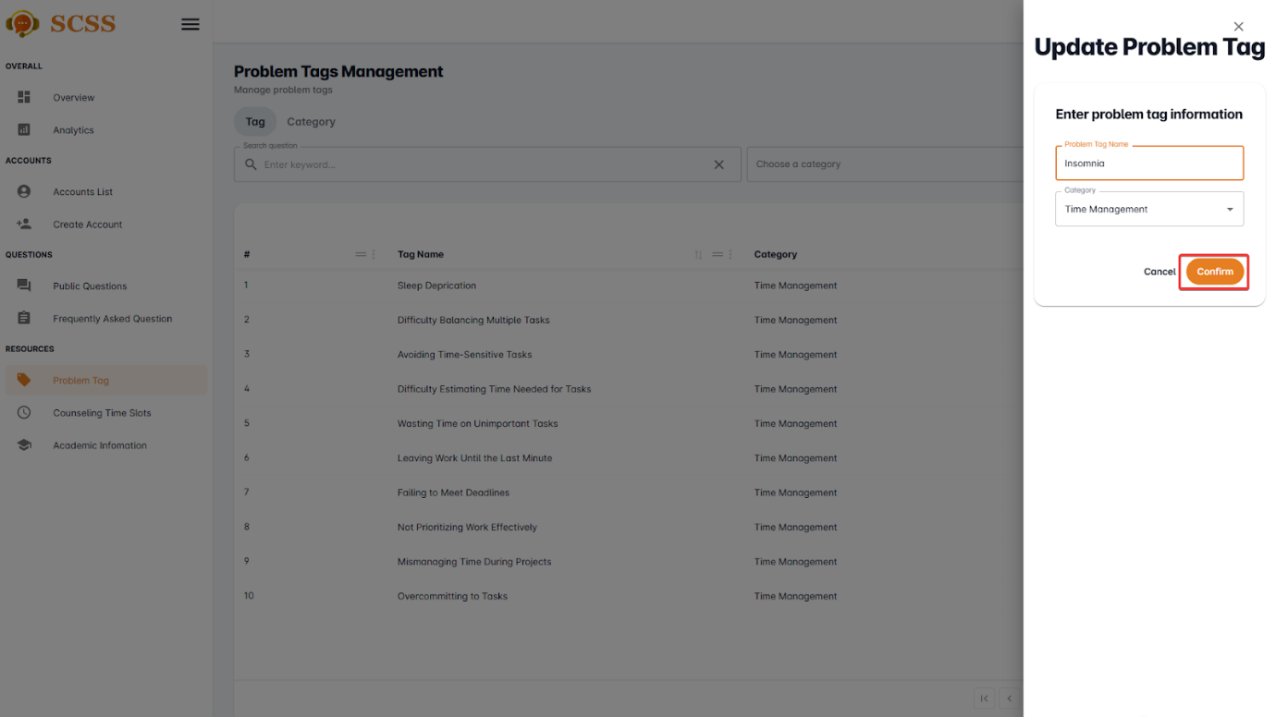

Figure - User Manual - Feature 40 – Step 7

**Step 8:** Press the “OK” button after a success dialog is shown to complete updating a problem tag.

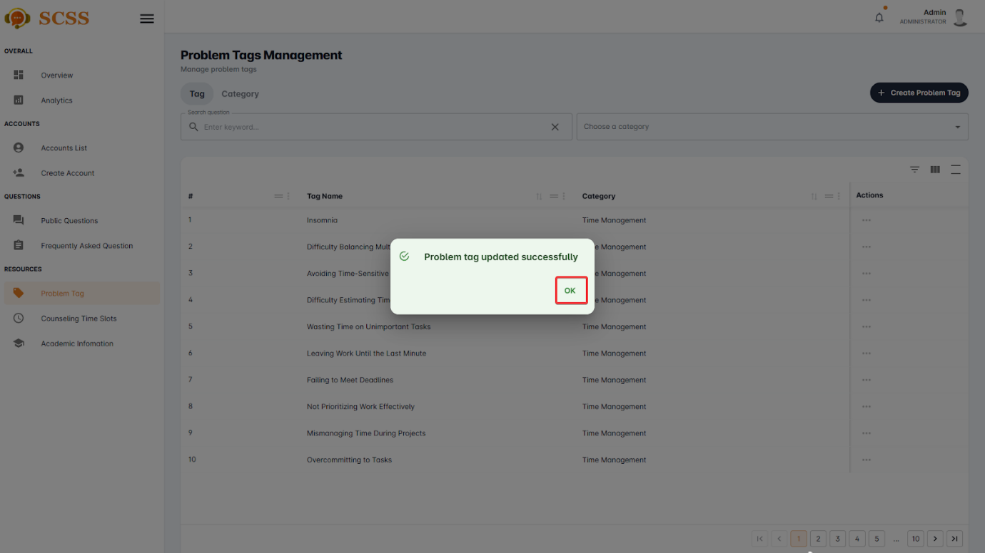

Figure - User Manual - Feature 40 – Step 8

##### 3.2.7.8. Update problem tag’s category

###### 3.2.7.8.1. Description

Use this guideline to update a problem tag’s category using an administrator account.

###### 3.2.7.8.2. Guide Steps

**Step 1**: Access SCSS at http://scss-fe.azurewebsites.net/. Then fill in “Email” and “Password” of the administrator account.



Figure - User Manual - Feature 41 – Step 1

**Step 2:** Click the “Sign in ” button.



Figure - User Manual - Feature 41 – Step 2

**Step 3:** From the homepage, choose “Problem Tag” from the left sidebar.



Figure - User Manual - Feature 41 – Step 3

**Step 4:** Select “Category” tab.



Figure - User Manual - Feature 41 – Step 4

**Step 5:** Press the “...” button under the actions column, in the row of the selected problem tag.

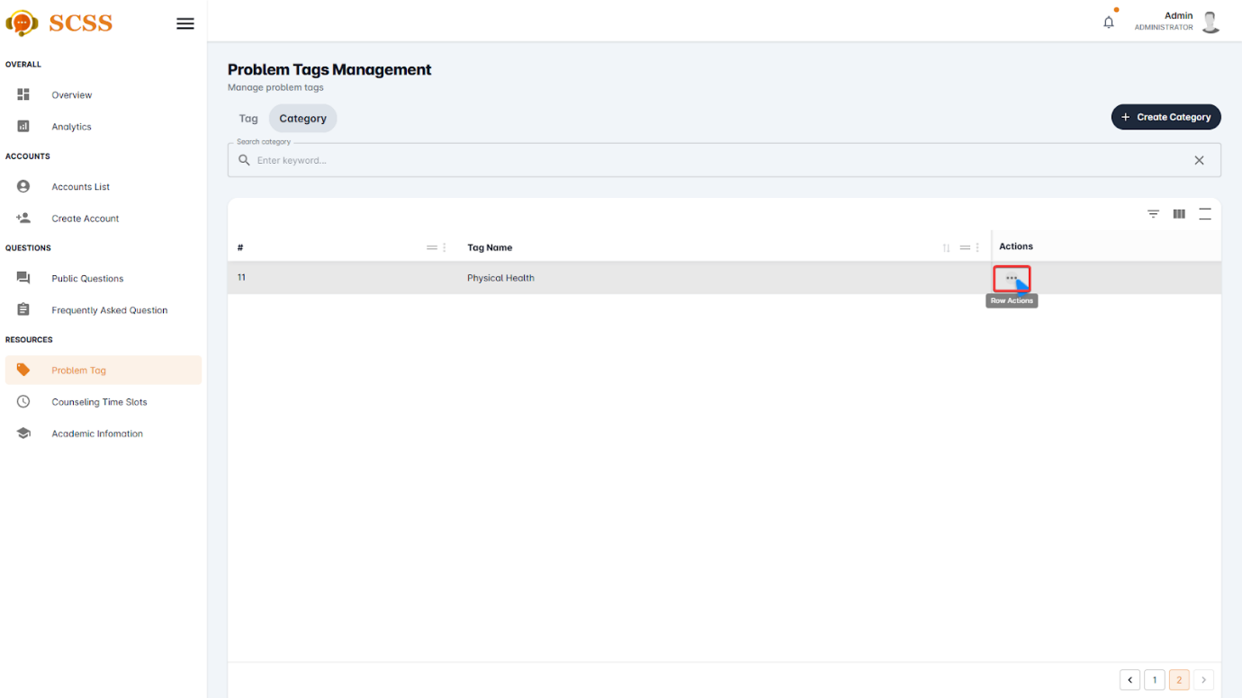

Figure - User Manual - Feature 41 – Step 5

**Step 6:** Press the “Update” button.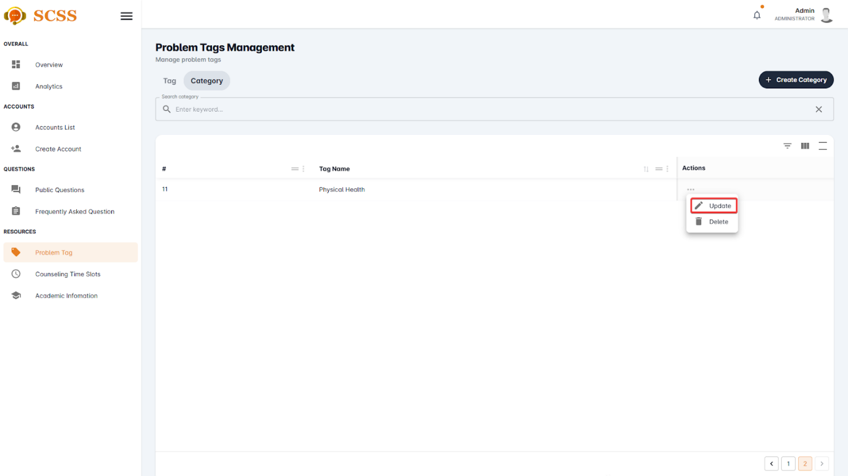

Figure - User Manual - Feature 41 – Step 6

**Step 7:** Fill out the “Category name” field, then press the “Confirm” button.

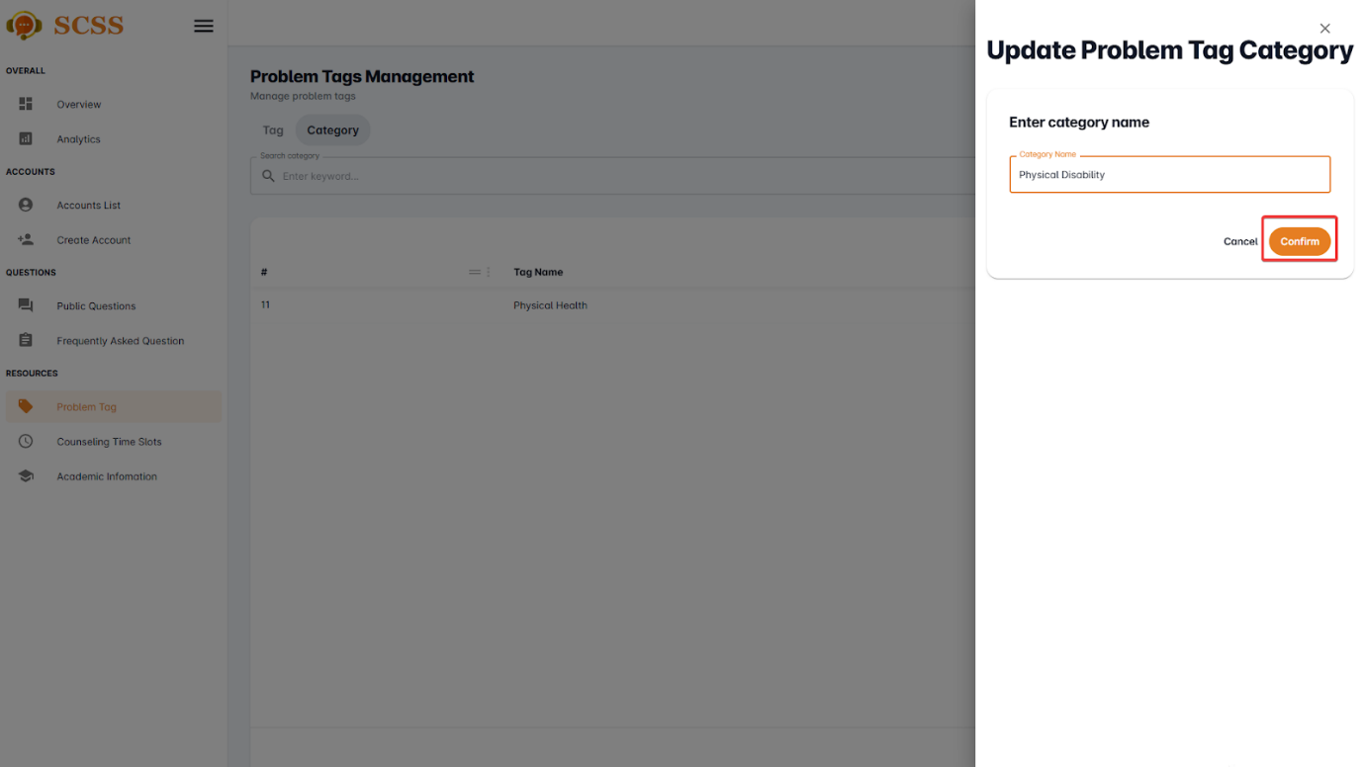

Figure - User Manual - Feature 41 – Step 7

**Step 8:** Press the “OK” button after a success dialog is shown to complete creating a problem tag’s category.

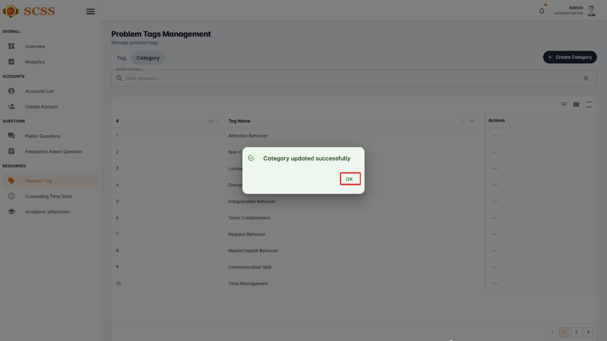

Figure - User Manual - Feature 41 – Step 8

##### 3.2.7.9. Update counseling time slot

###### 3.2.7.9.1. Description

Use this guideline to update a counseling time slot using an administrator account.

###### 3.2.7.9.2. Guide Steps

**Step 1**: Access SCSS at http://scss-fe.azurewebsites.net/. Then fill in “Email” and “Password” of the administrator account.



Figure - User Manual - Feature 42 – Step 1

**Step 2:** Click the “Sign in ” button.



Figure - User Manual - Feature 42 – Step 2

**Step 3:** From the homepage, choose “Counseling Time Slots” from the left sidebar.



Figure - User Manual - Feature 42 – Step 3

**Step 4:** Press the “...” button under the actions column, in the row of the selected counselling time slot.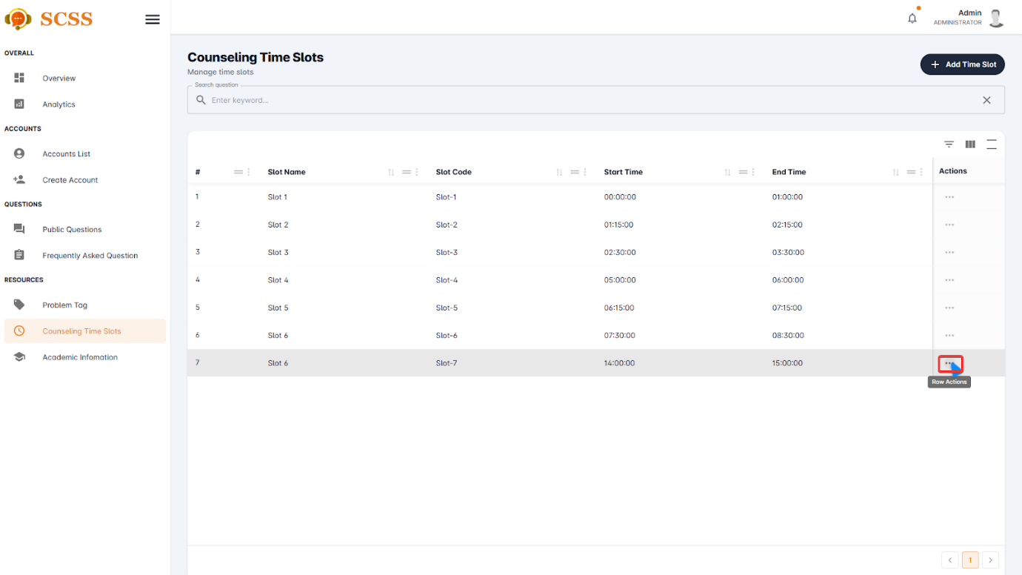

Figure - User Manual - Feature 42 – Step 4

**Step 5:** Press the “Update” button.

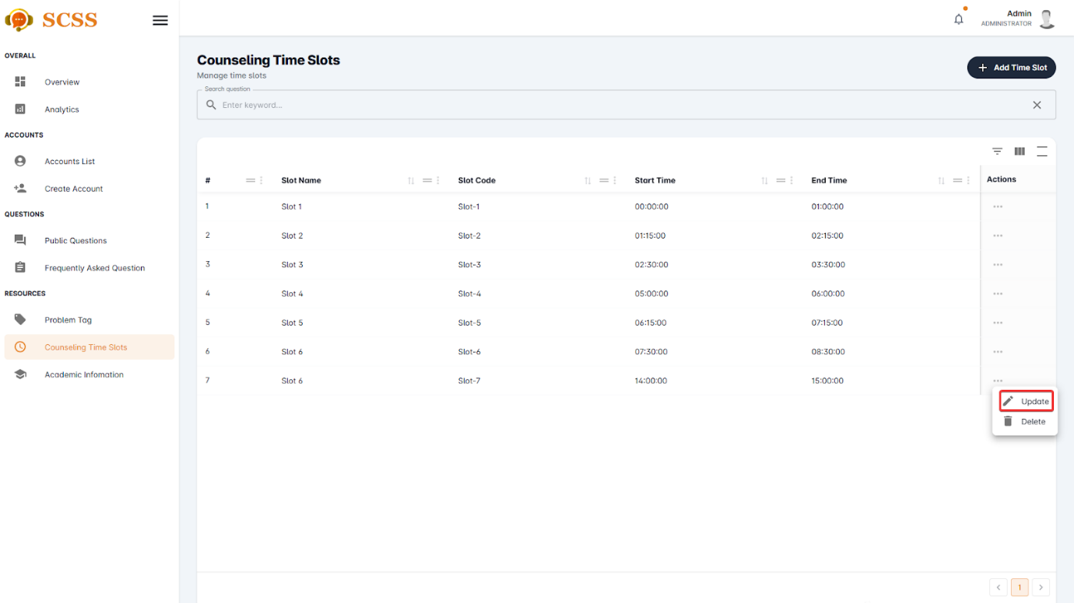

Figure - User Manual - Feature 42 – Step 5

**Step 6:** Fill out the “Slot name”, “Slot code”, “Start time”, and “End time” fields, then press the “Confirm” button.

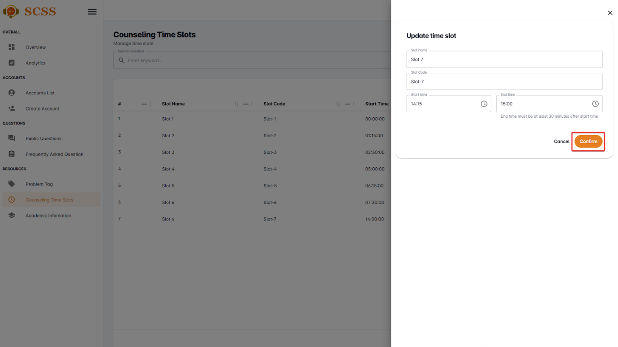

Figure - User Manual - Feature 42 – Step 6

**Step 7:** Press the “OK” button after a success dialog is shown to complete creating a counseling time slot.

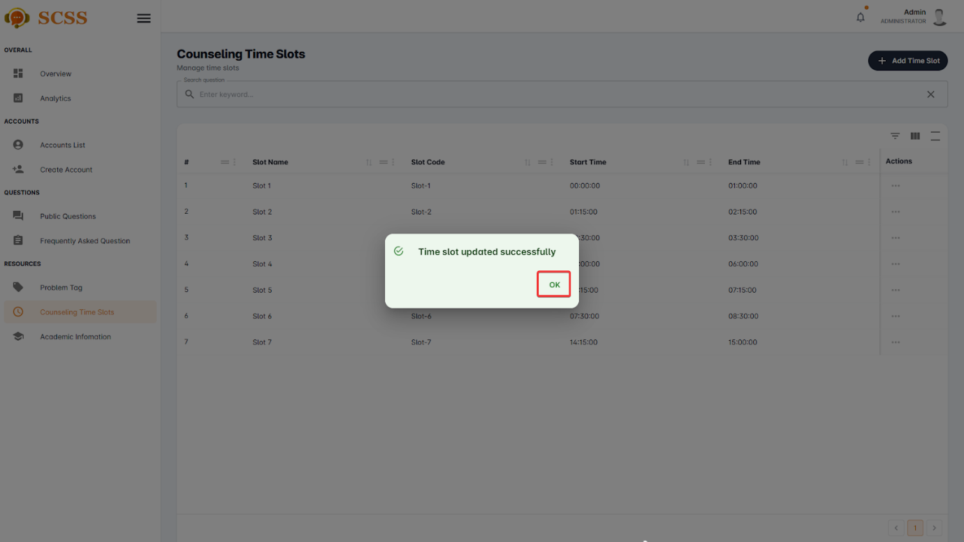

Figure - User Manual - Feature 42 – Step 7

##### 3.2.7.10. View academic information

###### 3.2.7.10.1. Description

Use this guideline to view academic information using an administrator account.

###### 3.2.7.10.2. Guide Steps

**Step 1**: Access SCSS at http://scss-fe.azurewebsites.net/. Then fill in “Email” and “Password” of the administrator account.



Figure - User Manual - Feature 43 – Step 1

**Step 2:** Click the “Sign in ” button.



Figure - User Manual - Feature 43 – Step 2

**Step 3:** From the homepage, choose “Academic Information” from the left sidebar.

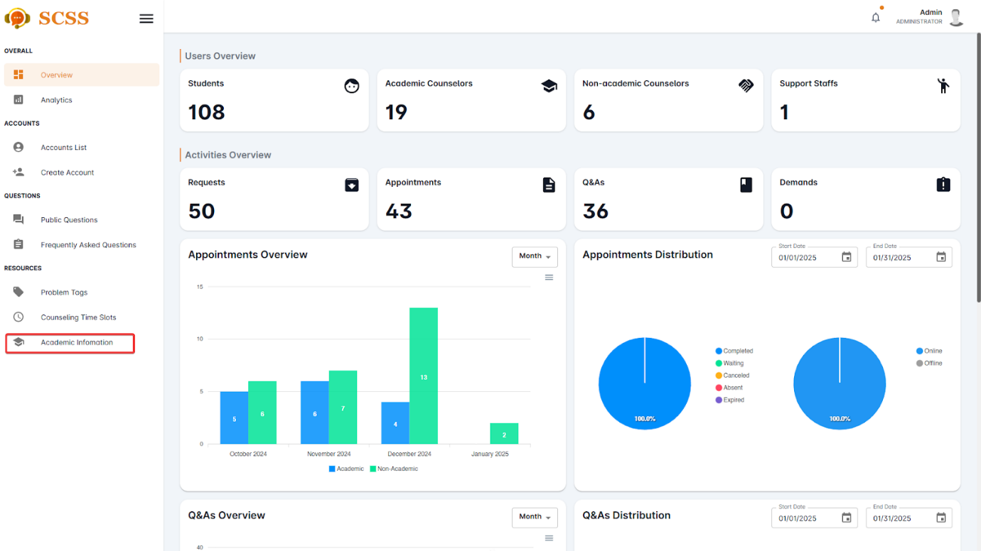

Figure - User Manual - Feature 43 – Step 3

**Step 4:** Select “Department”, “Major, “Specialization”, or “Semester” tab in accordance with the data you want to view.

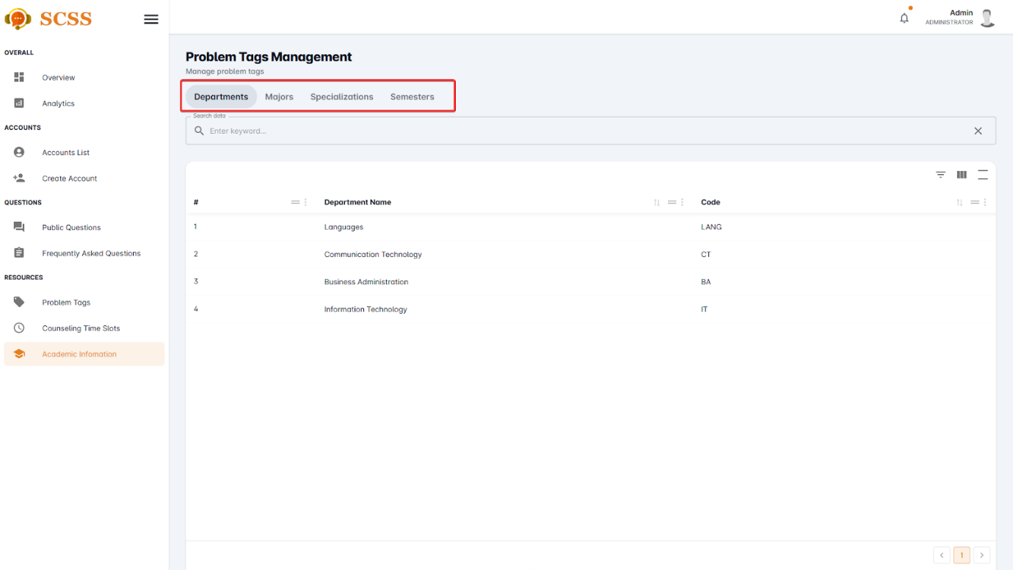

Figure - User Manual - Feature 43 – Step 4

#### 3.2.8. Question Management

##### 3.2.8.1. Update public question’s public status.

###### 3.2.8.1.1. Description

Use this guideline to update a public question’s public status using an administrator account.

###### 3.2.8.1.2. Guide Steps

**Step 1**: Access SCSS at http://scss-fe.azurewebsites.net/. Then fill in “Email” and “Password” of the administrator account.



Figure - User Manual - Feature 44 – Step 1

**Step 2:** Click the “Sign in ” button.



Figure - User Manual - Feature 44 – Step 2

**Step 3:** From the homepage, choose “Public Questions” from the left sidebar.

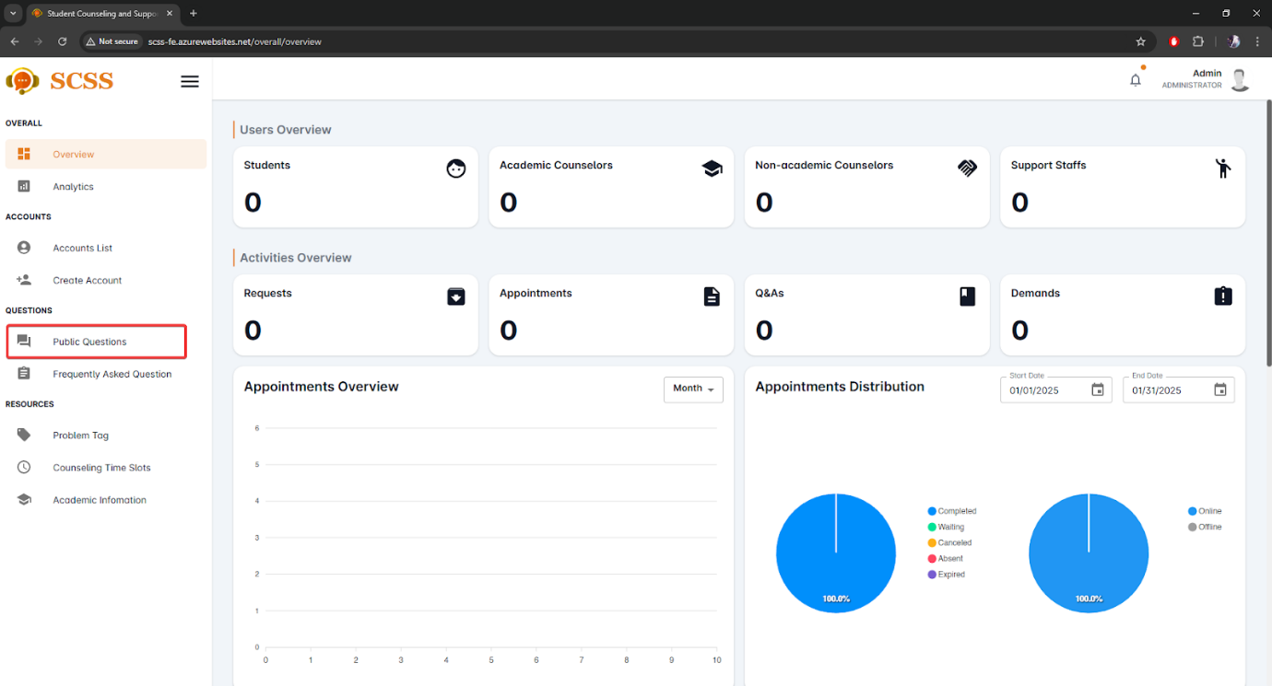

Figure - User Manual - Feature 44 – Step 3

**Step 4:** Press the “...” button under the actions column, in the row of the selected question.

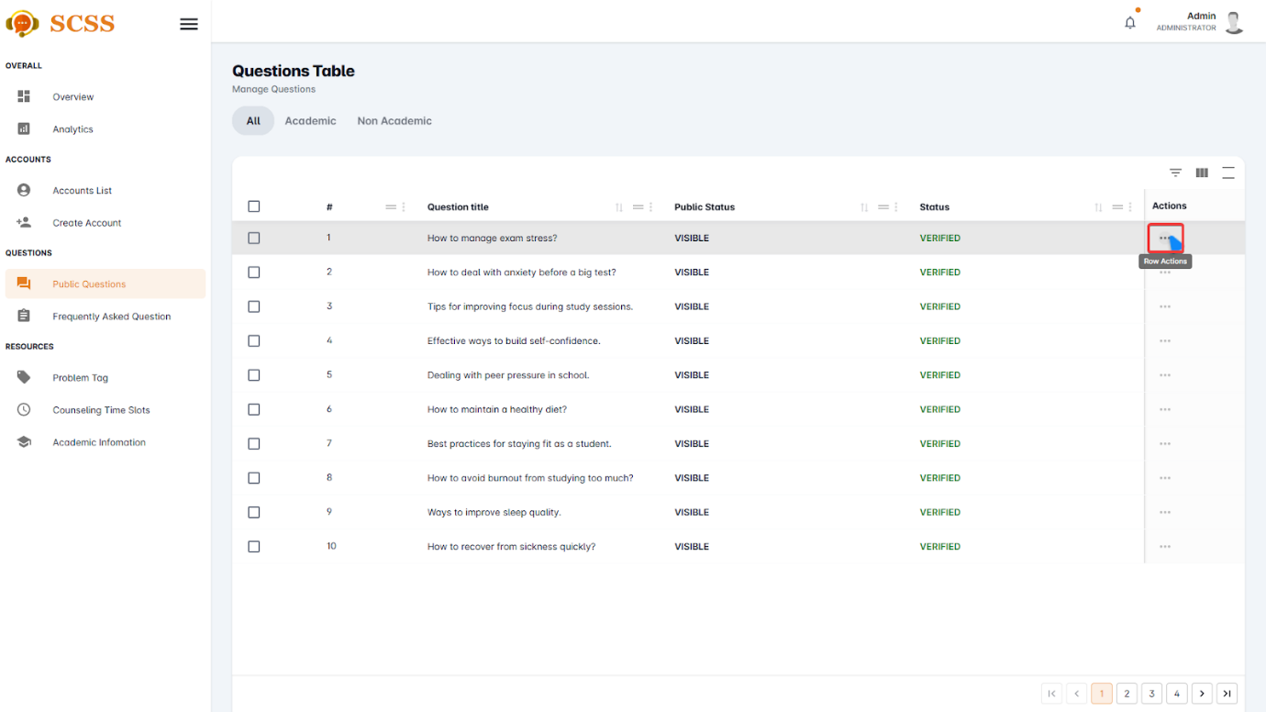

Figure - User Manual - Feature 44 – Step 4

**Step 5:** Press “Update public status” button

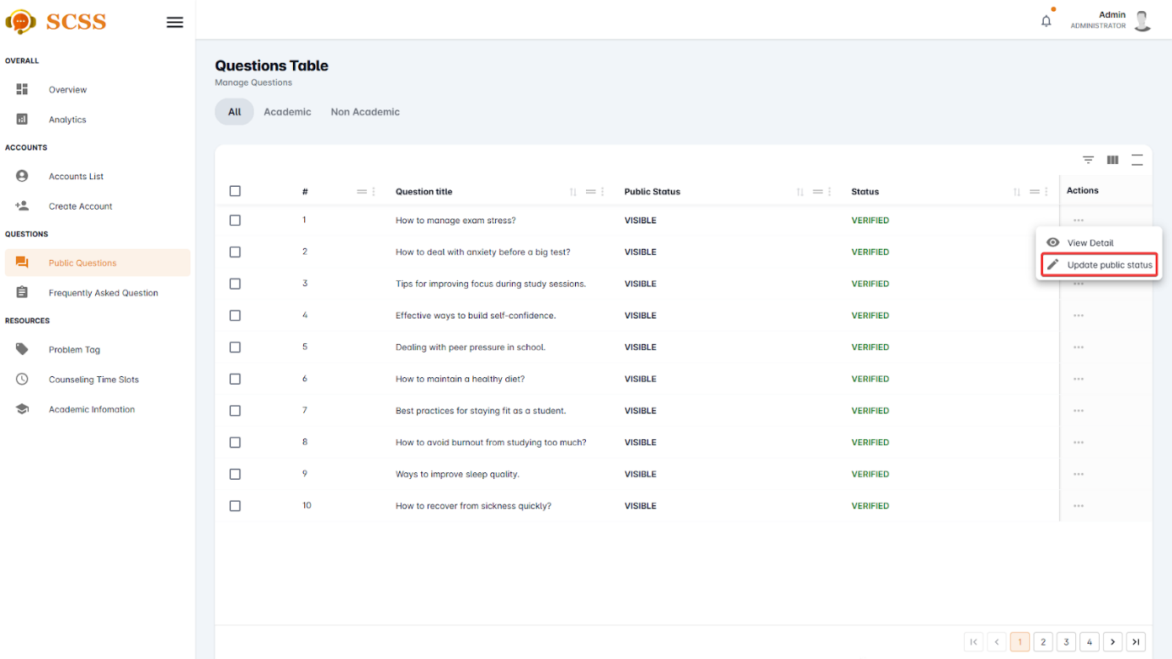

Figure - User Manual - Feature 44 – Step 5

**Step 6:** Select a new status and press “Confirm” button.

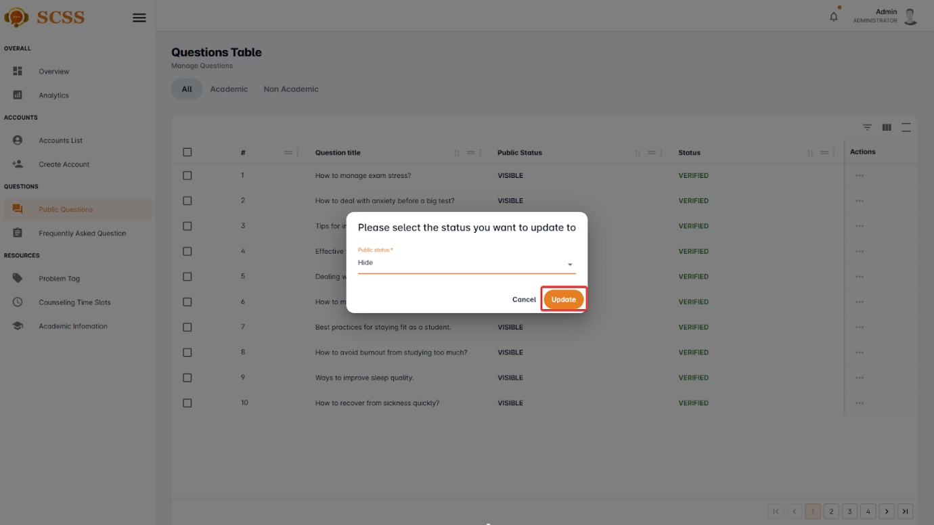

Figure - User Manual - Feature 44 – Step 6

**Step 7:** Press “Ok”.

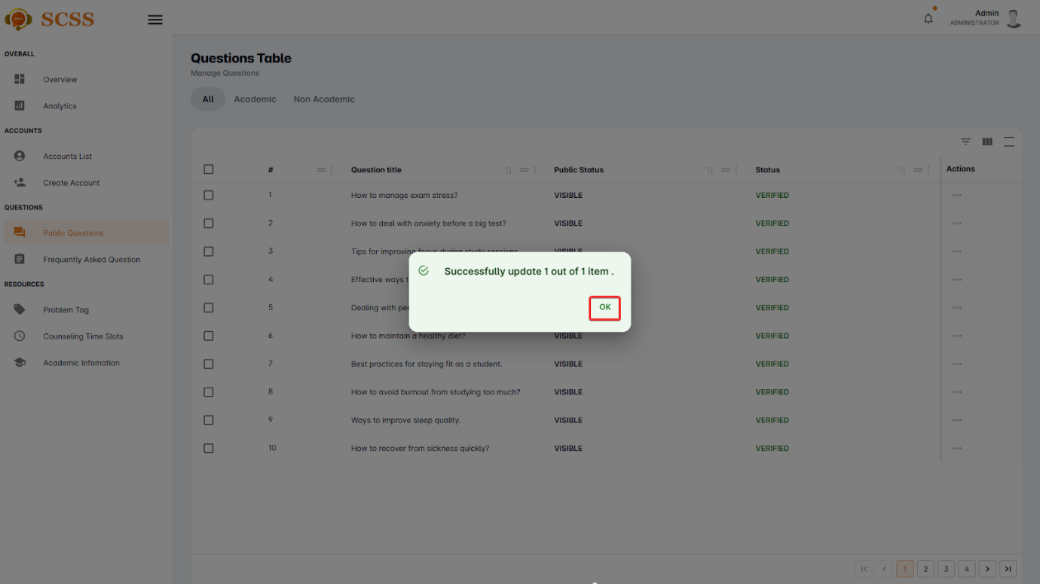

Figure - User Manual - Feature 44 – Step 7

##### 3.2.8.2. Update frequently asked question’s visibility status.

###### 3.2.8.2.1. Description

Use this guideline to update a frequently asked question’s visibility status using an administrator account.

###### 3.2.8.2.2. Guide Steps

**Step 1**: Access SCSS at http://scss-fe.azurewebsites.net/. Then fill in “Email” and “Password” of the administrator account.



Figure - User Manual - Feature 45 – Step 1

**Step 2:** Click the “Sign in ” button.



Figure - User Manual - Feature 45 – Step 2

**Step 3:** From the homepage, choose “Frequently Asked Questions” from the left sidebar.

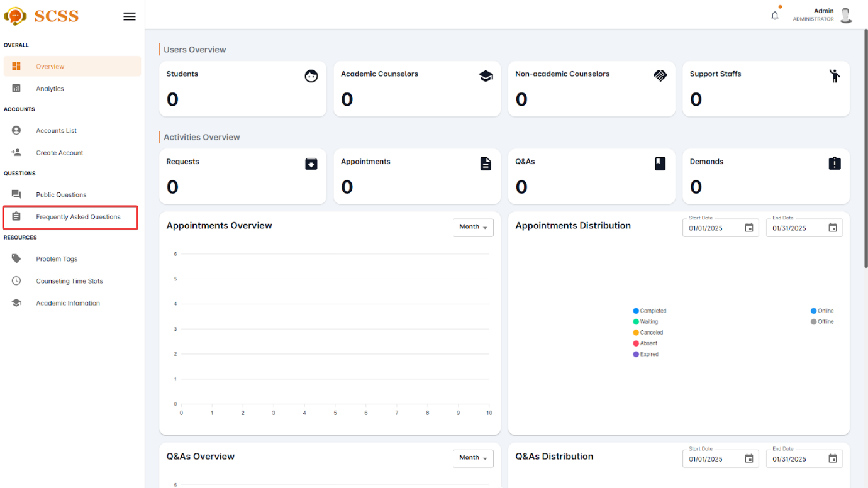

Figure - User Manual - Feature 45 – Step 3

**Step 4:** Press the “...” button under the actions column, in the row of the selected question.

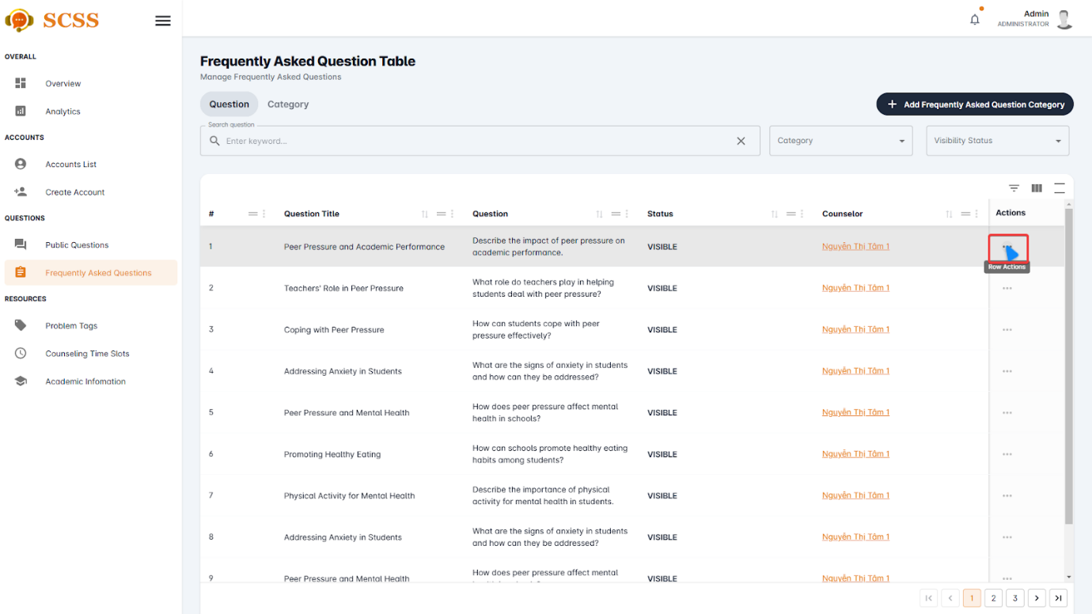

Figure - User Manual - Feature 45 – Step 4

**Step 5:** Press “Update visibility status” button

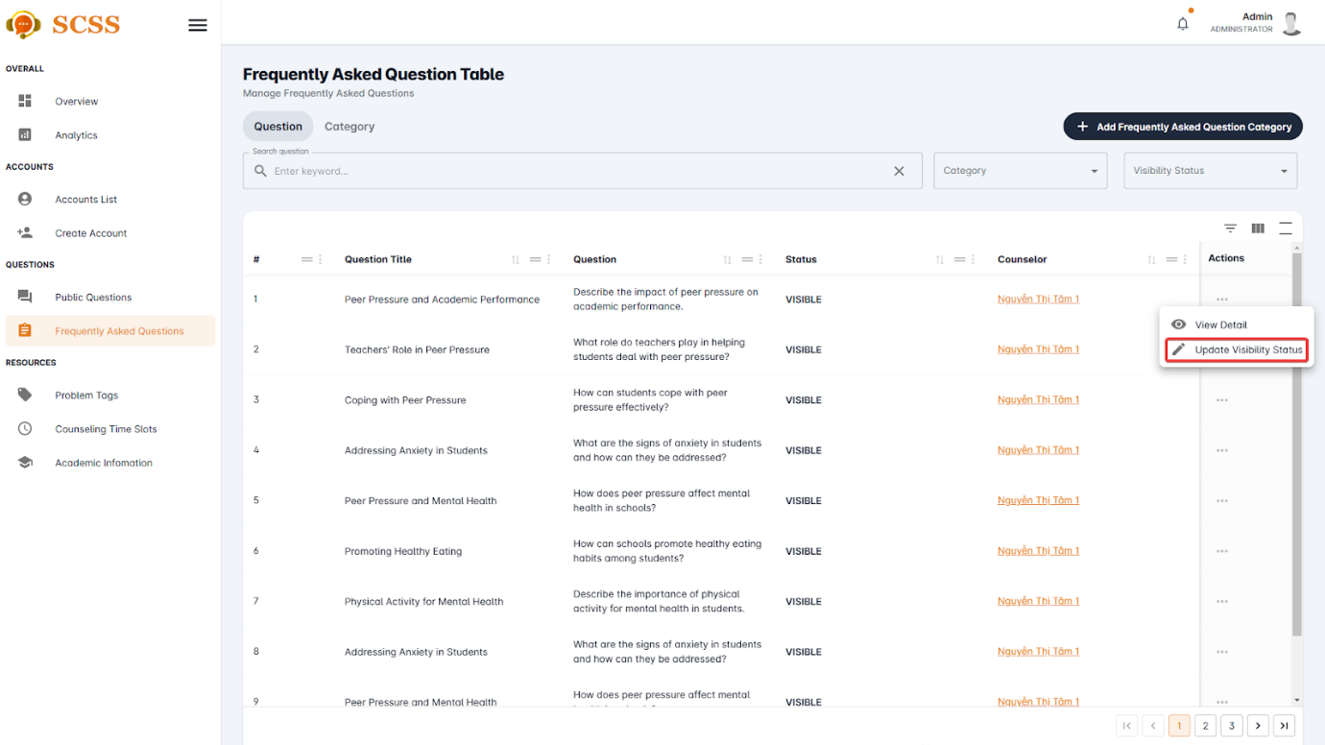

Figure - User Manual - Feature 45 – Step 5

**Step 6:** Select a new status and press “Confirm” button.

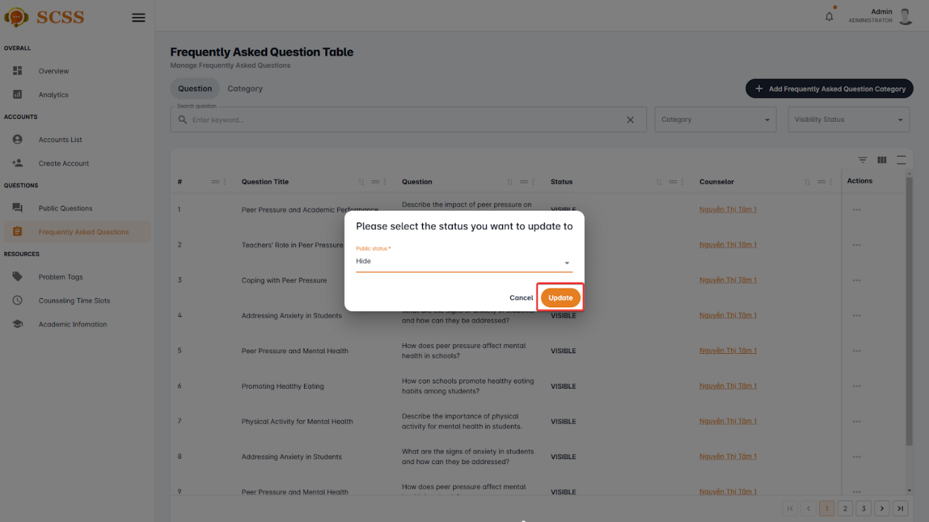

Figure - User Manual - Feature 45 – Step 6

**Step 7:** Press “Ok”.

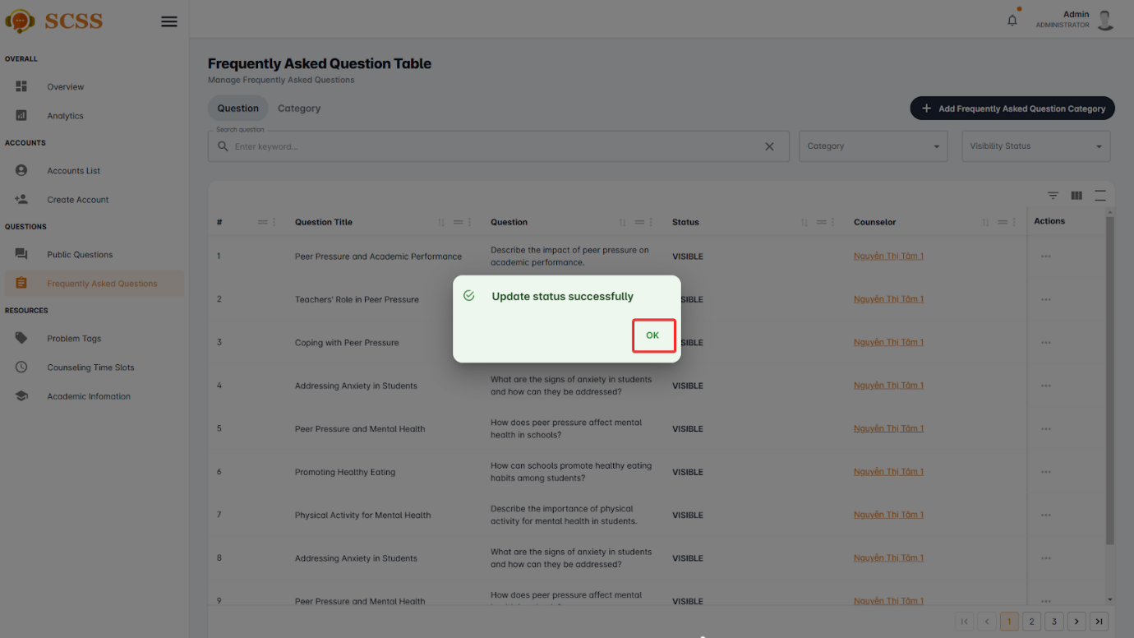

Figure - User Manual - Feature 45 – Step 7

##### 3.2.8.3. Create frequently asked question’s category.

###### 3.2.8.3.1. Description

Use this guideline to create frequently asked question’s category using an administrator account.

###### 3.2.8.3.2. Guide Steps

**Step 1**: Access SCSS at http://scss-fe.azurewebsites.net/. Then fill in “Email” and “Password” of the administrator account.



Figure - User Manual - Feature 46 – Step 1

**Step 2:** Click the “Sign in ” button.



Figure - User Manual - Feature 46 – Step 2

**Step 3:** From the homepage, choose “Frequently Asked Questions” from the left sidebar.



Figure - User Manual - Feature 46 – Step 3

**Step 4:** Press the “Add Frequently Asked Question Category” button.

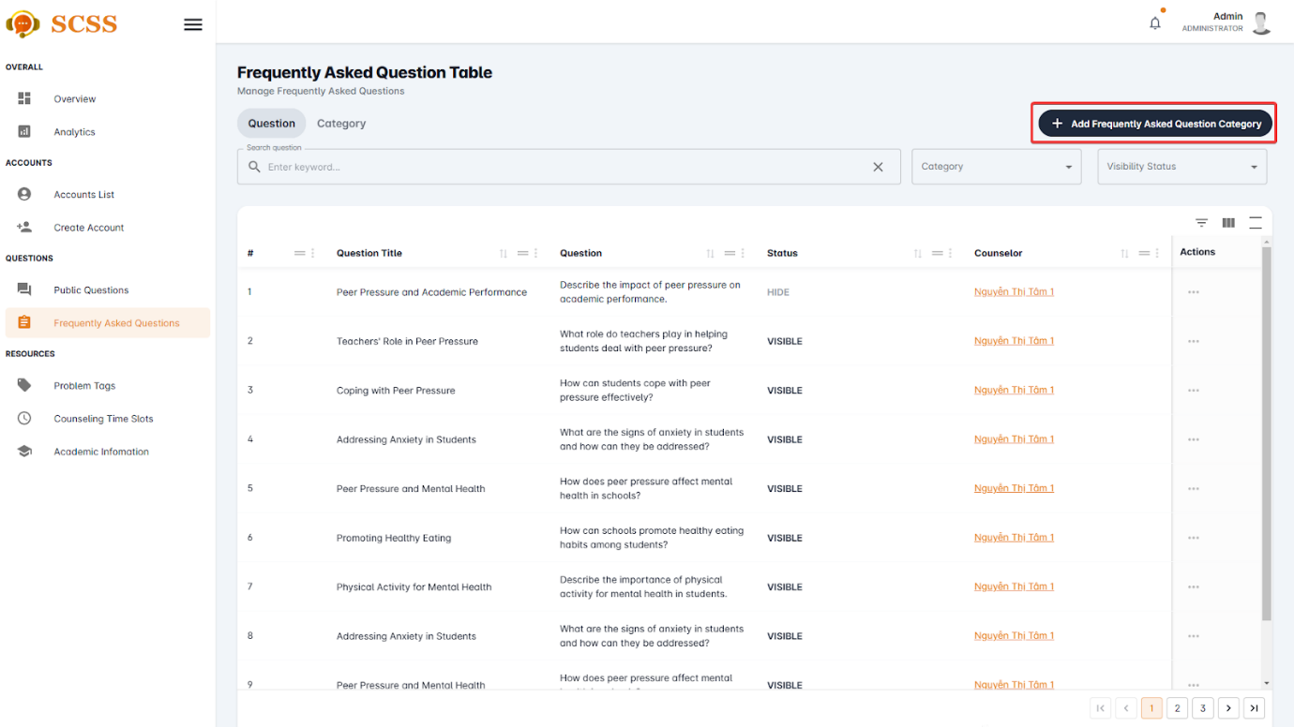

Figure - User Manual - Feature 46 – Step 4

**Step 5:** Fill in “Category’s name” and select “Type”, then press the “Confirm” button.

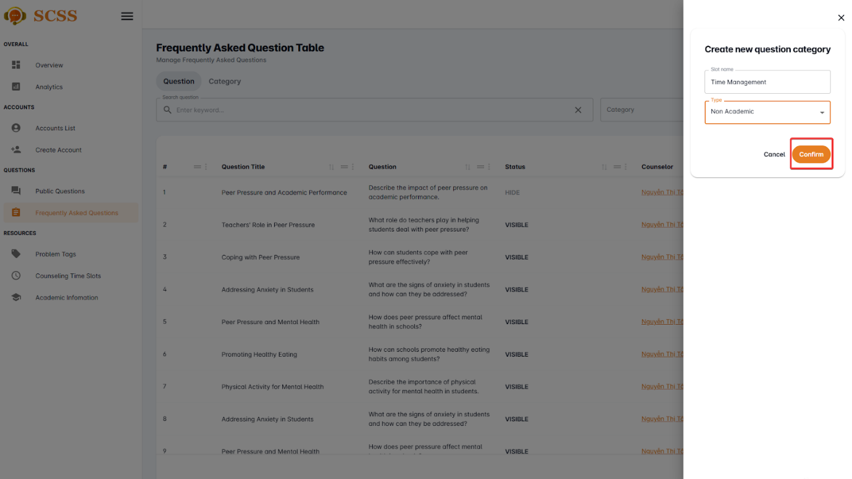

Figure - User Manual - Feature 46 – Step 5

**Step 6:** Press “Ok”.

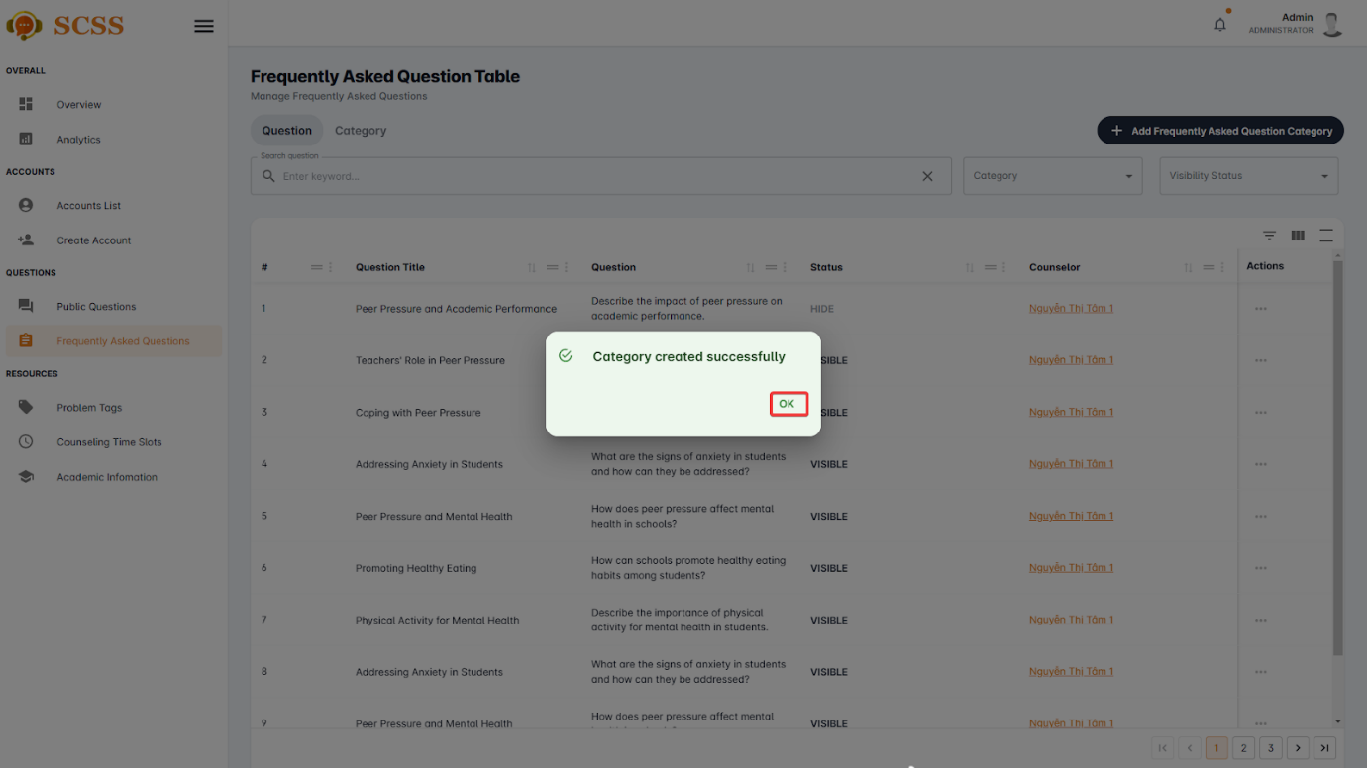

Figure - User Manual - Feature 46 – Step 6

##### 3.2.8.4. Update frequently asked question’s category.

###### 3.2.8.4.1. Description

Use this guideline to update a frequently asked question’s category using an administrator account.

###### 3.2.8.4.2. Guide Steps

**Step 1**: Access SCSS at http://scss-fe.azurewebsites.net/. Then fill in “Email” and “Password” of the administrator account.



Figure - User Manual - Feature 47 – Step 1

**Step 2:** Click the “Sign in ” button.



Figure - User Manual - Feature 47 – Step 2

**Step 3:** From the homepage, choose “Frequently Asked Questions” from the left sidebar.



Figure - User Manual - Feature 47 – Step 3

**Step 4:** Select the “Category” tab.

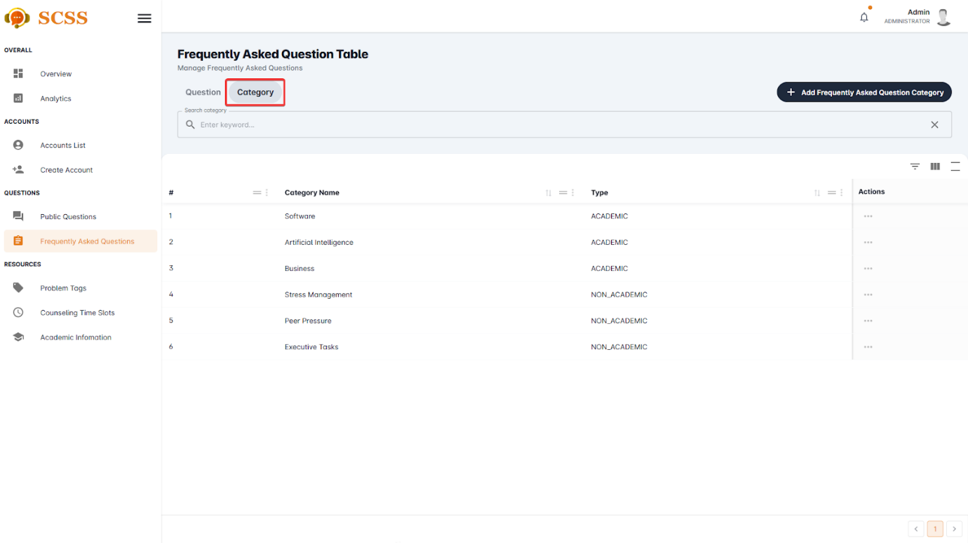

Figure - User Manual - Feature 47 – Step 4

**Step 5:** Press the “...” button, in the row of the selected category.

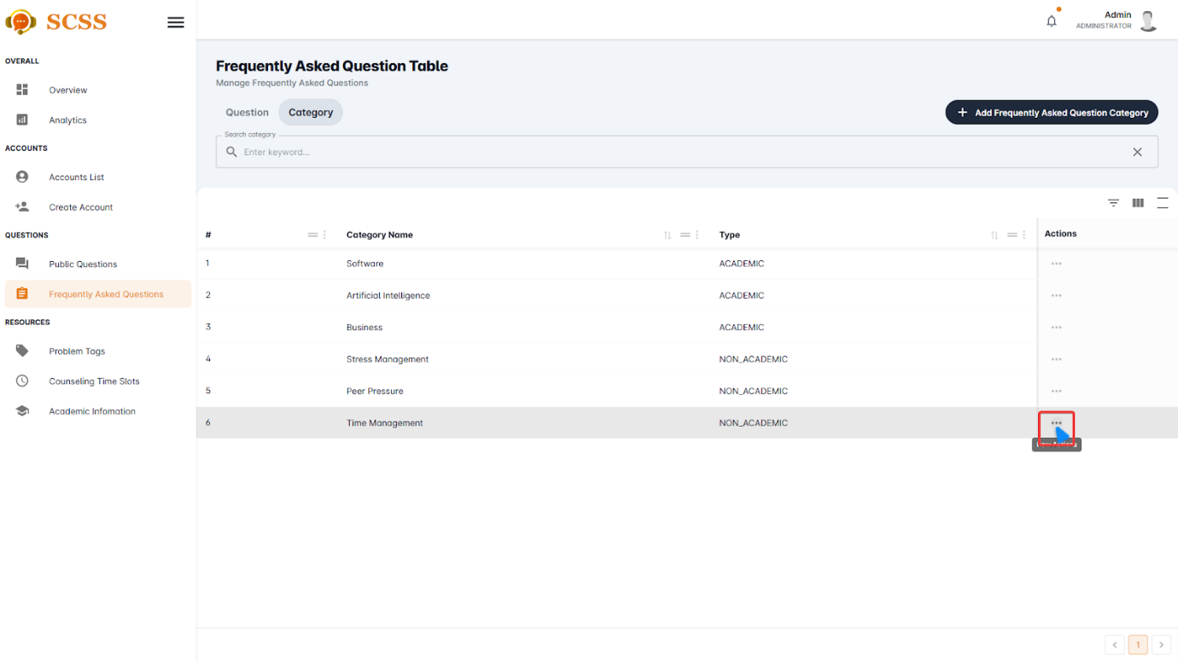

Figure - User Manual - Feature 47 – Step 5

**Step 6:** Select the “Update” button.

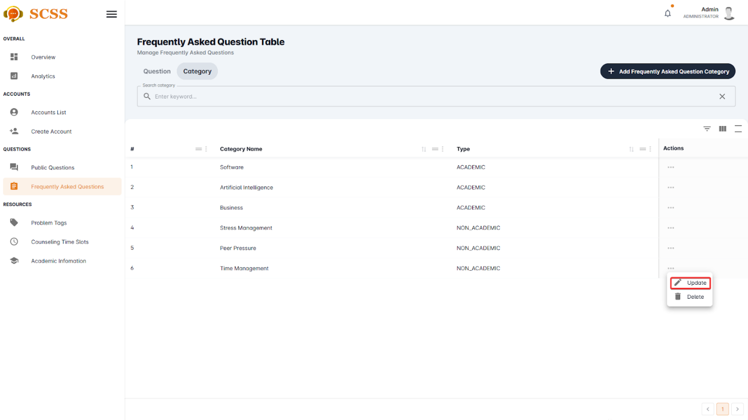

Figure - User Manual - Feature 47 – Step 6

**Step 7:** Fill in “Category’s name” and select “Type”, then press “Confirm” button.

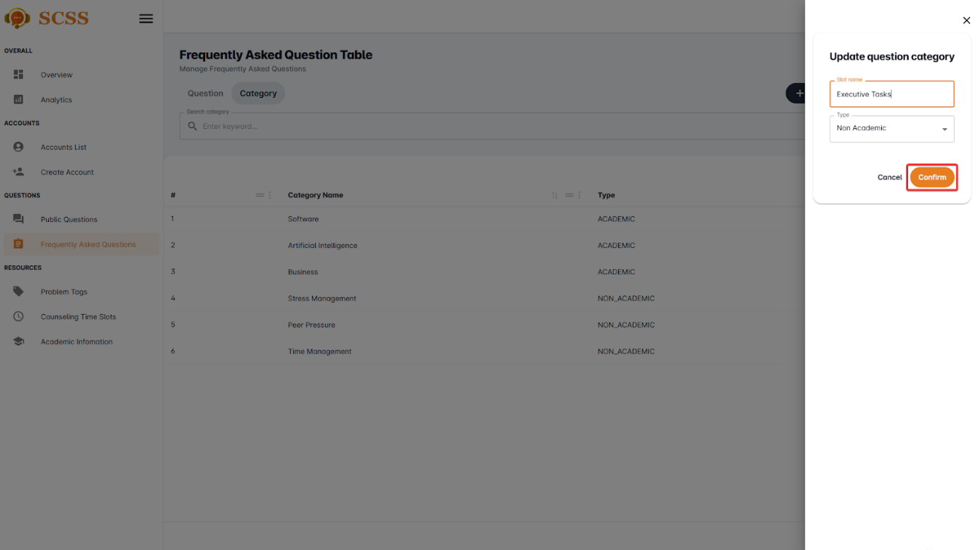

Figure - User Manual - Feature 47 – Step 7

**Step 8:** Press “Ok”.

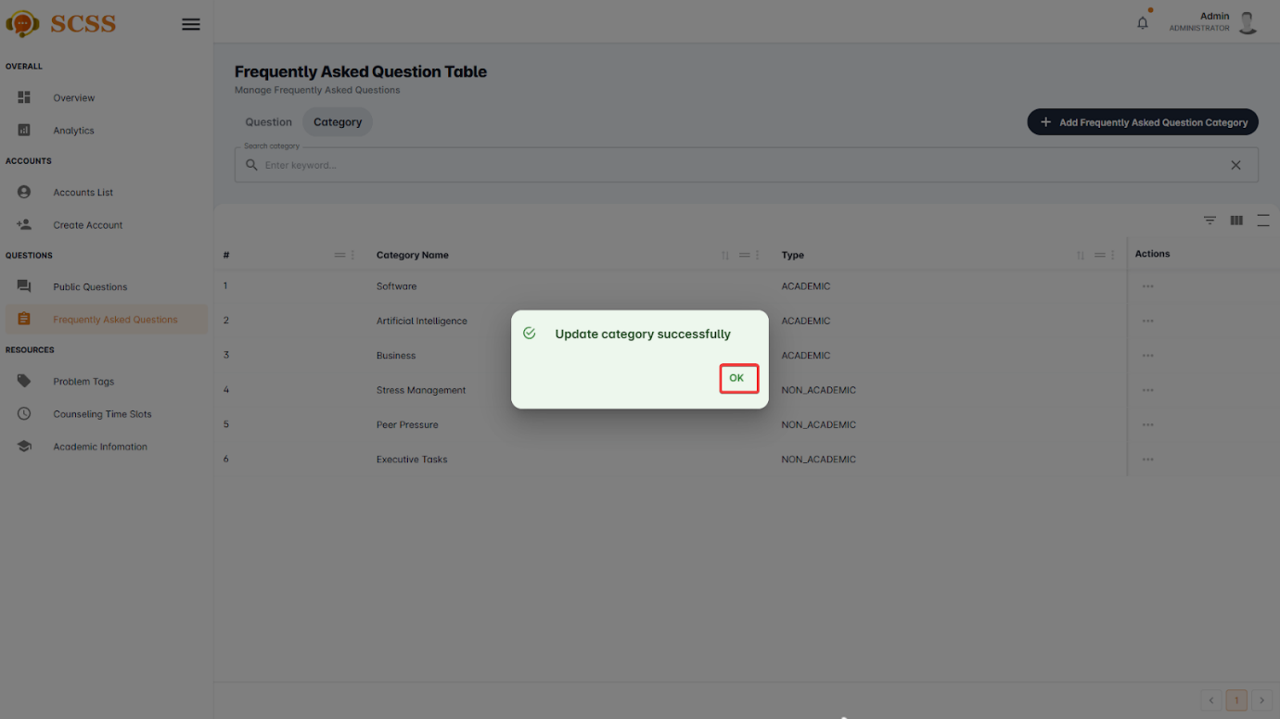

Figure - User Manual - Feature 47 – Step 8

##### 3.2.8.5. Remove frequently asked question’s category.

###### 3.2.8.5.1. Description

Use this guideline to remove a frequently asked question’s category using an administrator account.

###### 3.2.8.5.2. Guide Steps

**Step 1**: Access SCSS at http://scss-fe.azurewebsites.net/. Then fill in “Email” and “Password” of the administrator account.



Figure - User Manual - Feature 48 – Step 1

**Step 2:** Click the “Sign in ” button.



Figure - User Manual - Feature 48 – Step 2

**Step 3:** From the homepage, choose “Frequently Asked Questions” from the left sidebar.



Figure - User Manual - Feature 48 – Step 3

**Step 4:** Select the “Category” tab.



Figure - User Manual - Feature 48 – Step 4

**Step 5:** Press the “...” button, in the row of the selected category.



Figure - User Manual - Feature 48 – Step 5

**Step 6:** Select the “Delete” button.

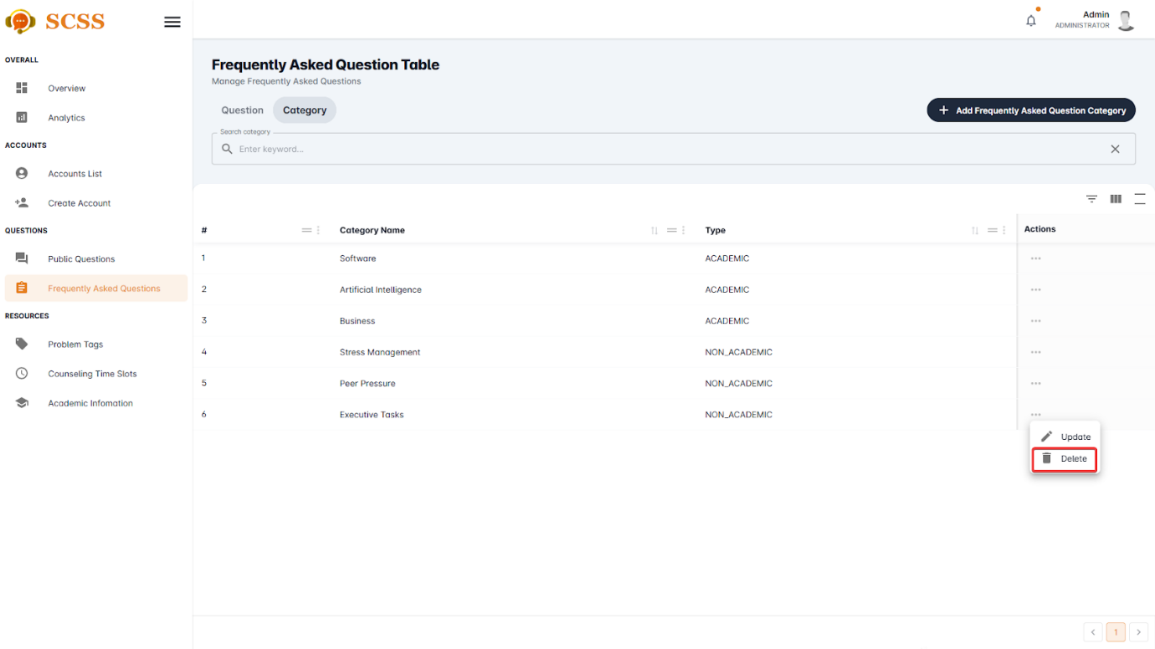

Figure - User Manual - Feature 48 – Step 6

**Step 7:** Press the “Confirm” button.

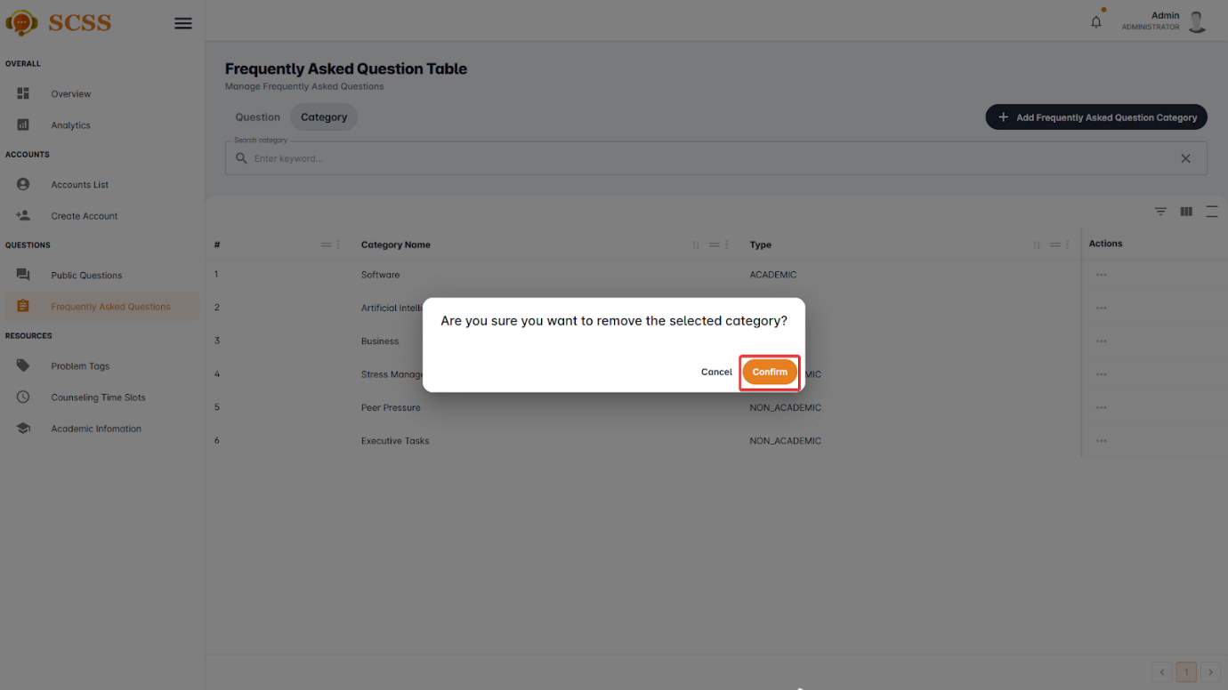

Figure - User Manual - Feature 48 – Step 7

**Step 8:** Press “Ok”.

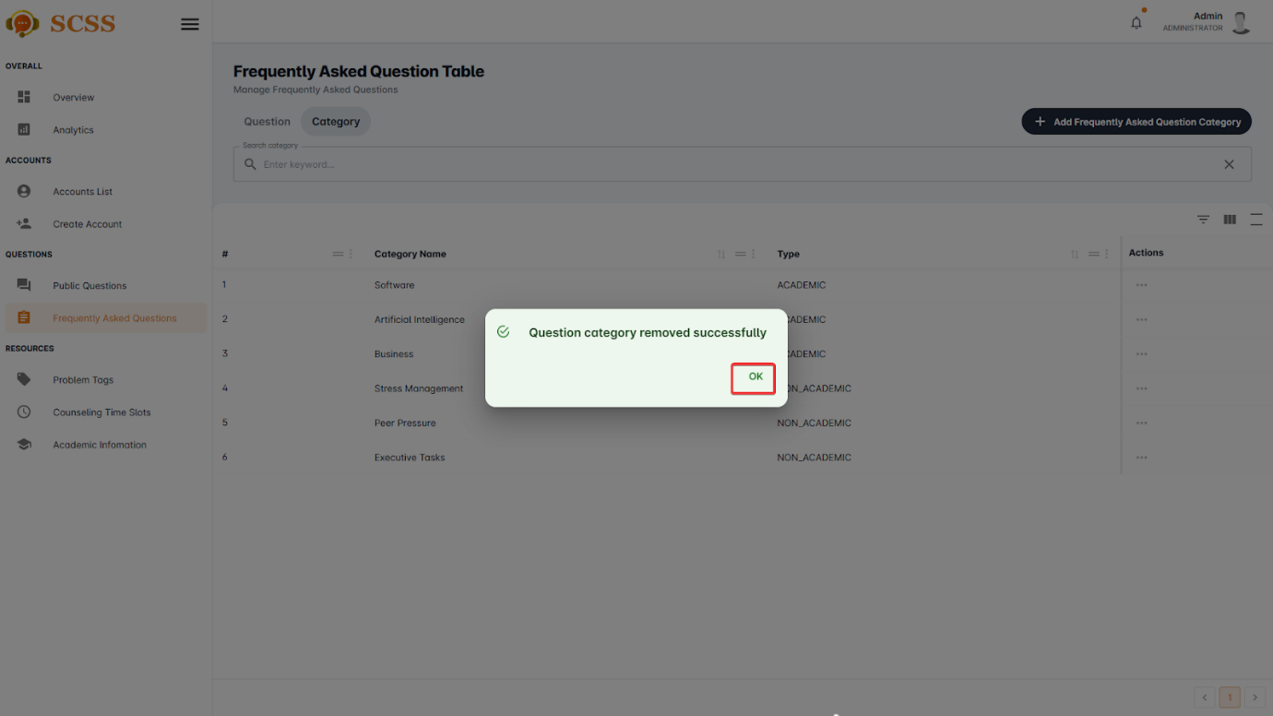

Figure - User Manual - Feature 48 – Step 8

#### 3.2.9. Analytics View

##### 3.2.9.1. View analytics

###### 3.2.9.1.1 Description

Use this guideline to view analytics.

###### 3.2.9.1.2 . Guide Steps

**Step 1**: Access SCSS at http://scss-fe.azurewebsites.net/. Then fill in “Email” and “Password” of the manager or admin account.

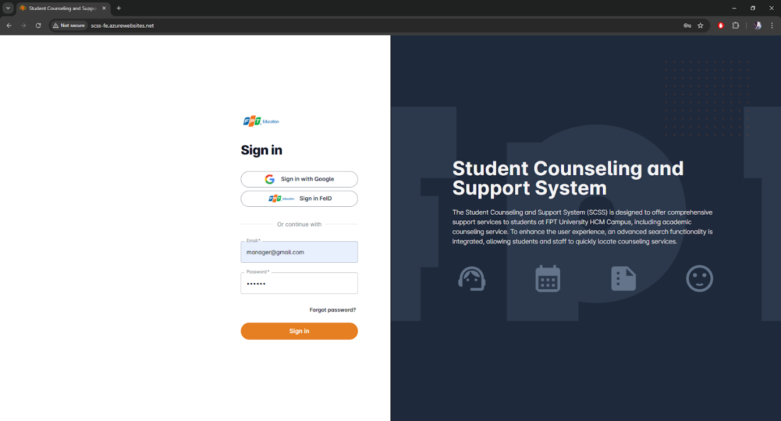

Figure - User Manual - Feature 49 – Step 1

**Step 2:** Click the “Sign in ” button.

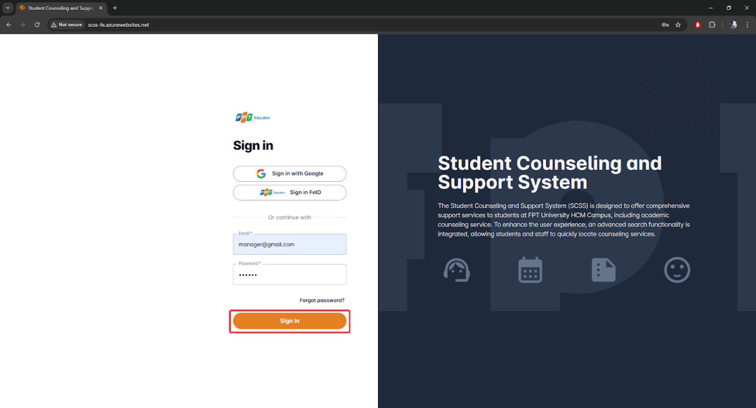

Figure - User Manual - Feature 49 – Step 2

**Step 3:** From the homepage, choose “Analytics” from the left sidebar.

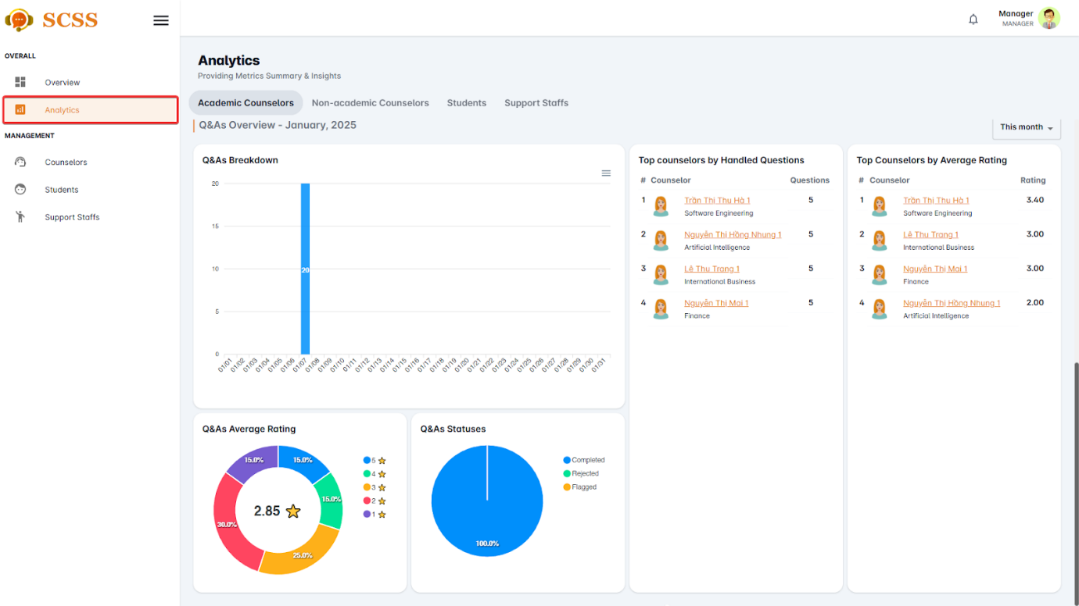

Figure - User Manual - Feature 49 – Step 3

##### 3.2.9.2. View overview

###### 3.2.9.2.1 Description

Use this guideline to view overview.

###### 3.2.9.2.2 . Guide Steps

**Step 1**: Access SCSS at http://scss-fe.azurewebsites.net/. Then fill in “Email” and “Password” of the manager or admin account.



Figure - User Manual - Feature 50 – Step 1

**Step 2:** Click the “Sign in ” button.



Figure - User Manual - Feature 50 – Step 2

**Step 3:** From the homepage, choose “Overview” from the left sidebar.

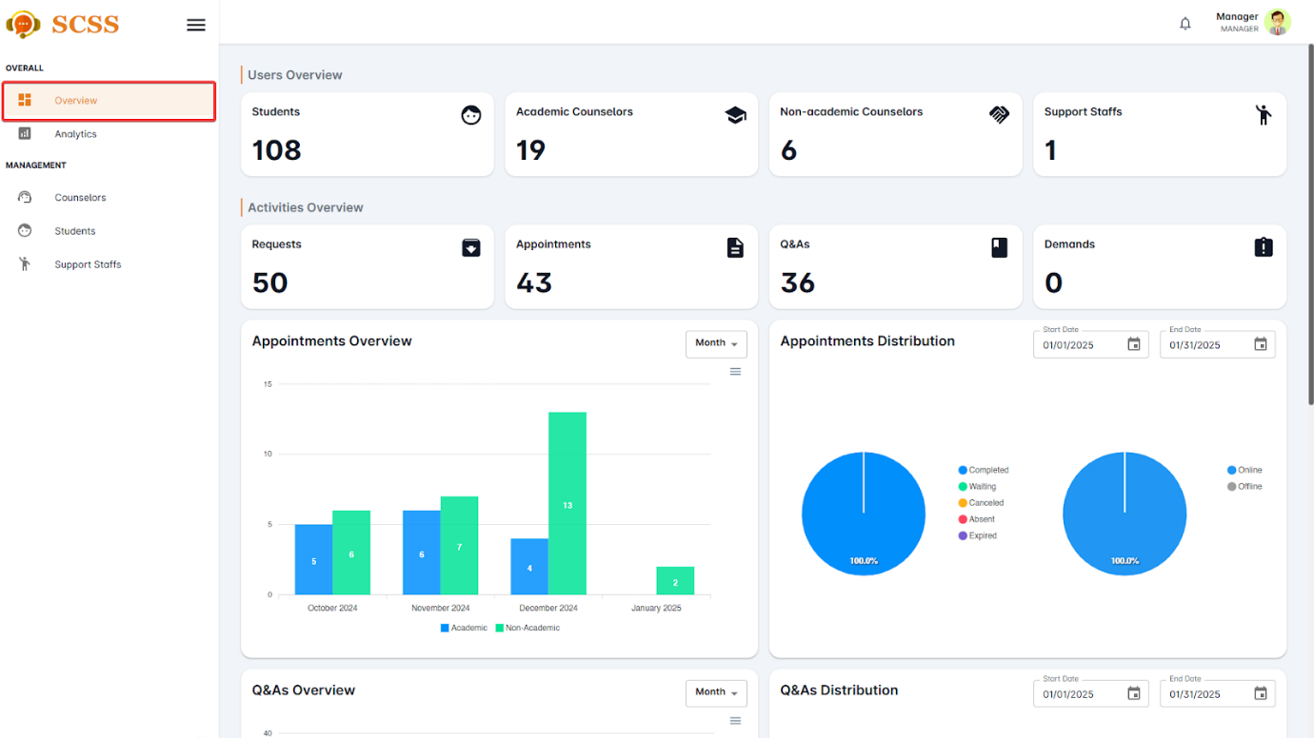

Figure - User Manual - Feature 50 – Step 3

### 3.3. Mobile Application

#### 3.3.1. Authentication

##### 3.3.1.1. Login

###### 3.3.1.1.1. Description

Use this guideline to login into SCSS with an email account. This mobile application supports login with email account that has been added as a counselor and a student.

###### 3.3.1.1.2. Guide Steps

**Step 1:** Access SCSS at mobile application**.** Then fill in “Email” and “Password”

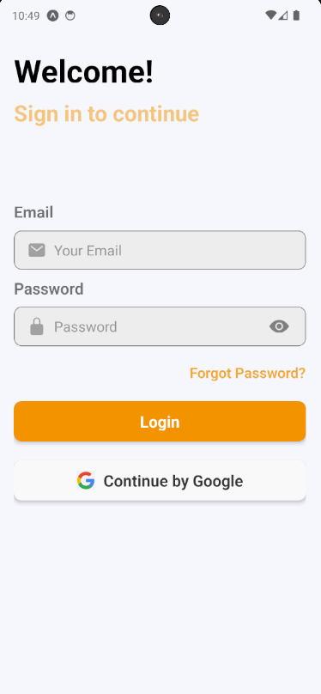

Figure - User Manual - Mobile Feature 1 – Step 1

**Step 2:** Press “Login” Button

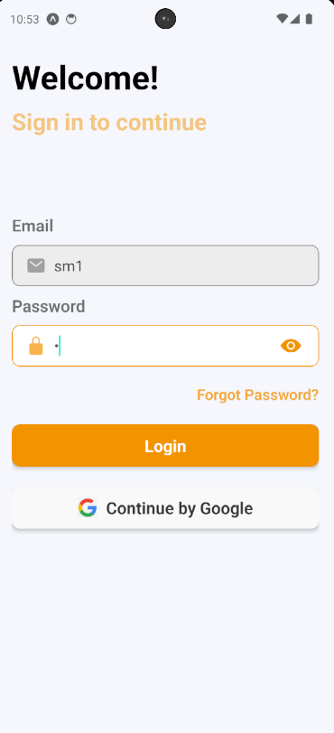

Figure - User Manual - Mobile Feature 1 – Step 2

After logging in successfully, user is directed to the Home screen with account authenticated.

##### 3.3.1.2. Reset Password

###### 3.3.1.2.1. Description

Use this guide so users can reset their email account password when they forget their password.

###### 3.3.1.2.2. Guide steps

**Step 1:** Access SCSS at mobile application**.** Then press “Forgot password?”.

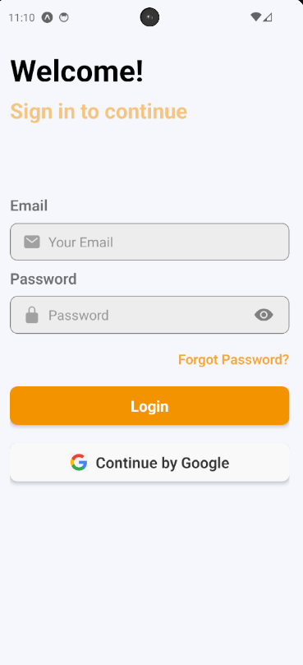

Figure - User Manual - Mobile Feature 2 – Step 1

**Step 2:** Then fill in “Email”

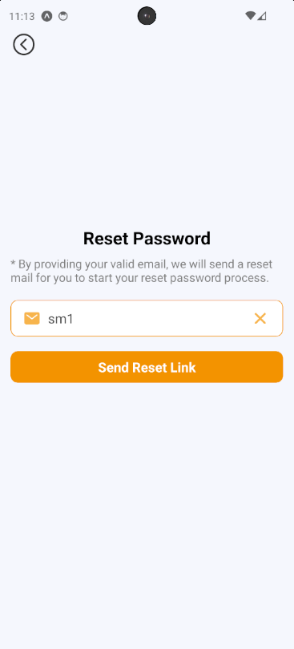

Figure - User Manual - Mobile Feature 2 – Step 2

**Step 3**: Press “Send Reset Link” button

After sending the email successfully, the user is redirected to the Verify OTP Page with the email that sent the OTP authentication code.

##### 3.3.1.3. Edit Password

###### 3.3.1.3.1. Description

Use this guide so users can update their email account password when they want to edit their password.

This web application supports updating passwords for actors: Counselor and student.

###### 3.3.1.3.2. Guide Steps

Step 1: Access SCSS at mobile application. After logging in successfully, press the avatar image on the up-right corner of the screen.

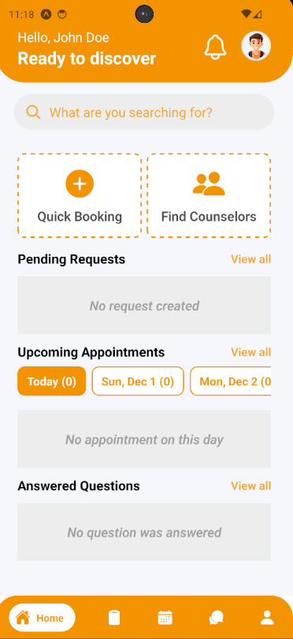

Figure - User Manual - Mobile Feature 3 – Step 1

After pressing, it will navigate the user to Profile Screen.

**Step 2:** Press Change Password to navigate to Change Password Screen

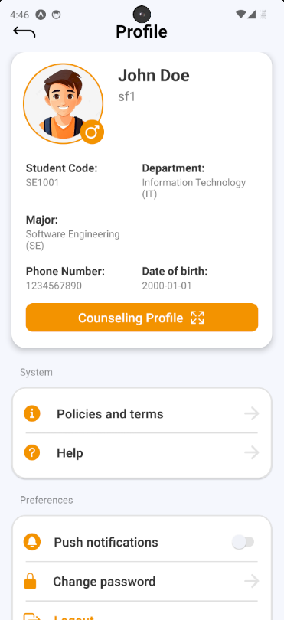

Figure - User Manual - Mobile Feature 3 – Step 2

**Step 3:** Fill in “Current password”, “New password” and “Confirm password”, then press “Save Changes” button

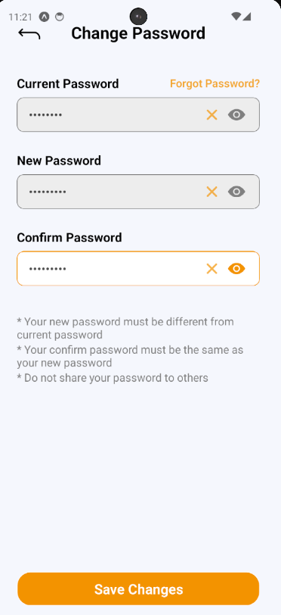

Figure - User Manual - Mobile Feature 3 – Step 3

#### 3.3.2.  Booking counseling appointment

##### 3.3.2.1. Quick booking a counselor

###### 3.3.2.1.1. Description

Use this guideline to log into the SCSS student account to book counseling appointments quickly.

###### 3.3.2.1.2. Guide Steps

**Step 1:** Access SCSS at mobile application**.** Then fill in “Email” and “Password” of the student account



Figure - User Manual - Mobile Feature 4 – Step 1

**Step 2:** Press “Login” Button



Figure - User Manual - Mobile Feature 4 – Step 2

**Step 3:** From Home Screen, choose “Quick Booking” to quickly navigate to Quick Booking Screen

.

Figure - User Manual - Mobile Feature 4 – Step 3

**Step 4:** Select and fill in all the required information to booking counseling appointment in the corresponding sequence: “Enter Reason” (mean Reason for booking appointment), “Select date”, “Select slot time”, “Select couselor's gender (optional)”

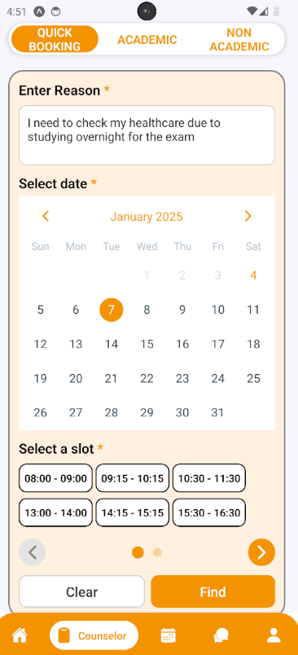

Figure - User Manual - Mobile Feature 4 – Step 4

**Step 5:** After selecting and filling all the required information, press “Find” to find a counselor.

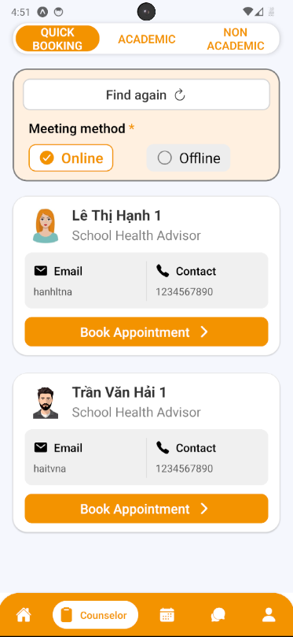

Figure - User Manual - Mobile Feature 4 – Step 5

**Step 6:** The system will match you with a counselor, and you can then select a counseling type: 'Online' or 'Offline.' After that, press the ‘Booking Appointment' button. A confirmation will appear for you to check again inputted information. Press “Yes” to proceed with booking appointment or “No” to proceed with cancel booking

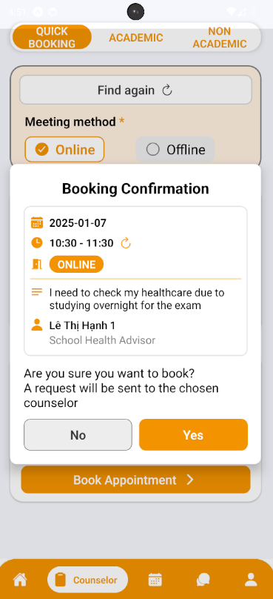

Figure - User Manual - Mobile Feature 4 – Step 6

**Step 7:** After pressing “Yes” to proceed with booking an appointment, a success message will appear and you can see your sent request by pressing “See your requests” or just stay at this screen by pressing “Return” button

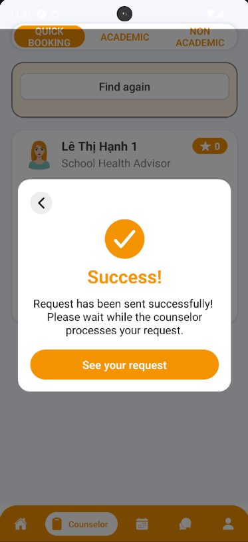

Figure - User Manual - Mobile Feature 4 – Step 7

##### 3.3.2.2. Booking a specific counselor

###### 3.3.2.2.1. Description

Use this guideline to log into the SCSS student account to book a specific counselor.

###### 3.3.2.2.2. Guide Steps

**Step 1:** Access SCSS at mobile application**.** Then fill in “Email” and “Password” of the student account



Figure - User Manual - Mobile Feature 5 – Step 1

**Step 2:** Press “Login” Button



Figure - User Manual - Mobile Feature 5 – Step 2

**Step 3:** From Home Screen, choose “Find Counselor” to quickly navigate to Academic Screen

.

Figure - User Manual - Mobile Feature 5 – Step 3

**Step 4:** From Academic Screen, you can choose filter options to narrow down counselors based on the preferences of students, including availability, academic fields/expertise, rating, counseling type, gender or search by keyword.

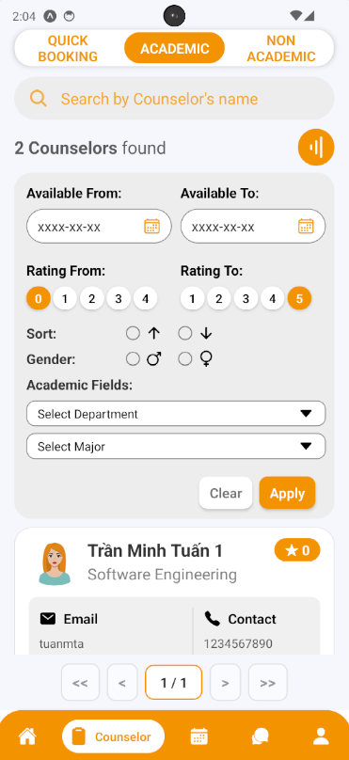

Figure - User Manual - Mobile Feature 5 – Step 4

**Step 5:** Select a counselor by pressing the button “Book Appointment”

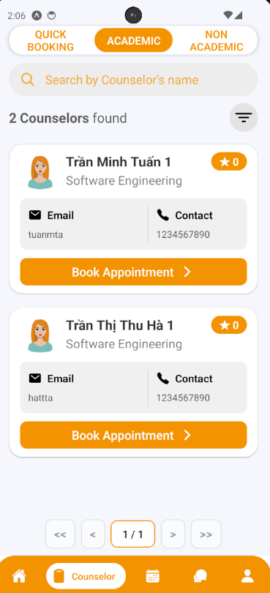

Figure - User Manual - Mobile Feature 5 – Step 5

**Step 6:**  See through the selected counselor information and fill in all the required information to book an appointment including: “Select date”, “Select slot”, “Select meeting type“, and “Reason“:

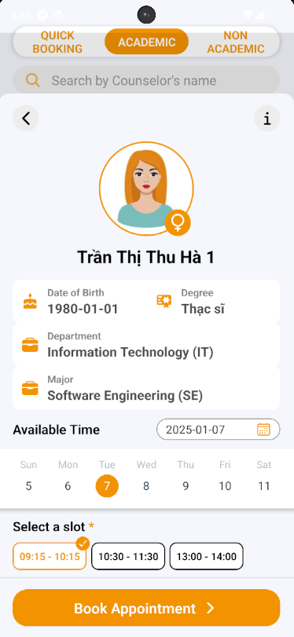

Figure - User Manual - Mobile Feature 5 – Step 6.1

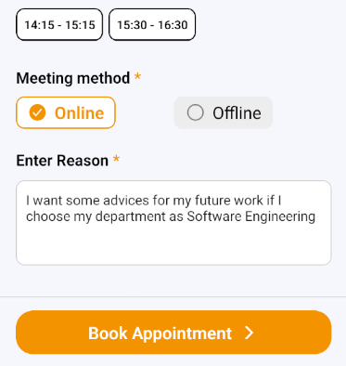

Figure - User Manual - Mobile Feature 5 – Step 6.2

**Step 7:** Press “Book Appointment”. A confirmation will appear for you to check again inputted information. Press “Yes” to proceed with booking the appointment or “No” to proceed with cancel booking

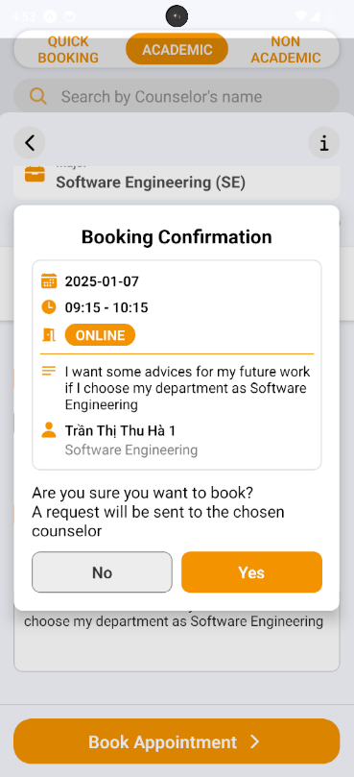

Figure - User Manual - Mobile Feature 5 – Step 7

**Step 8:** After pressing “Yes” to proceed with booking an appointment, a success message will appear and you can see your sent request by pressing “See your requests” or just stay at this screen by pressing “Return” button

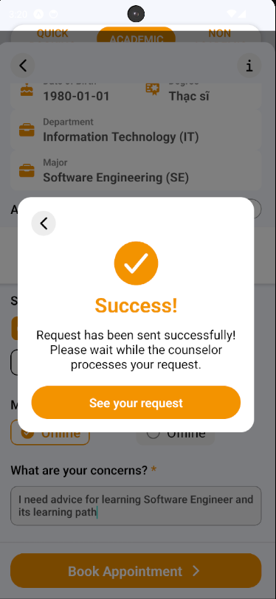

Figure - User Manual - Mobile Feature 5 – Step 8

##### 3.3.2.3. Approve Appointment Request

###### 3.3.2.3.1. Description

Use this guideline to log into the SCSS counselor account to approve student appointment request.

**Step 1:** Access SCSS at mobile application**.** Then fill in “Email” and “Password” of the counselor account



Figure - User Manual - Mobile Feature 6 – Step 1

**Step 2:** Press “Login” Button

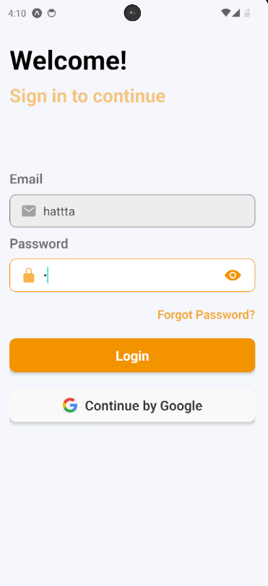

Figure - User Manual - Mobile Feature 6 – Step 2

**Step 3:** From Home Screen:

Option 1: Choose Tab number 5 (personal icon) at the bottom of the screen to navigate to Personal Screen and from that screen will navigate to Request Screen 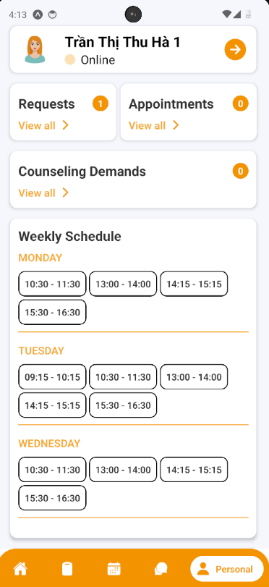

Figure - User Manual - Mobile Feature 6 – Step 3 – Option 1

Option 2: For quick navigation, press View all at Pending Request to navigate to Request Screen

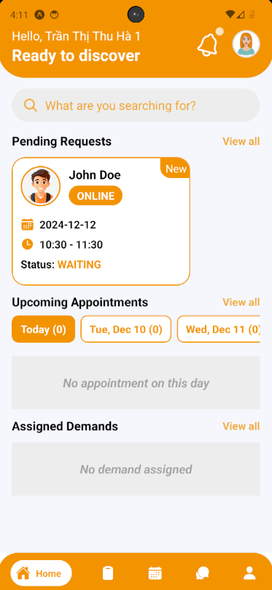

Figure - User Manual - Mobile Feature 6 – Step 3 – Option 2

**Step 4:** In Request Screen, find a request using filter section by request date, meeting method, and status

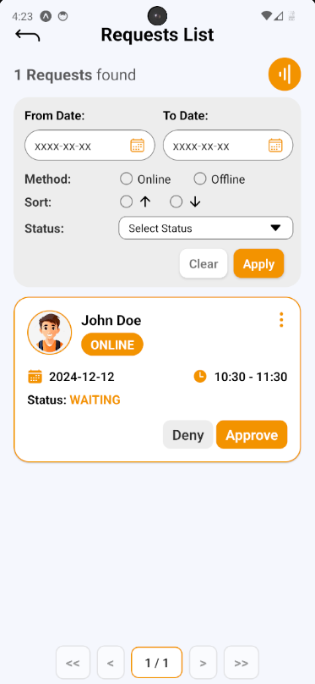

Figure - User Manual - Mobile Feature 6 – Step 4

**Step 5:** After finding and considering student request, press Approve Button on request card, a request approve confirmation will open. Based on the meeting method, this confirmation require the counselor provide Meet URL (if Online) or Address (if Offline). After fill required field, press “Yes” Button to approve request, and “No” Button to cancel confirmation

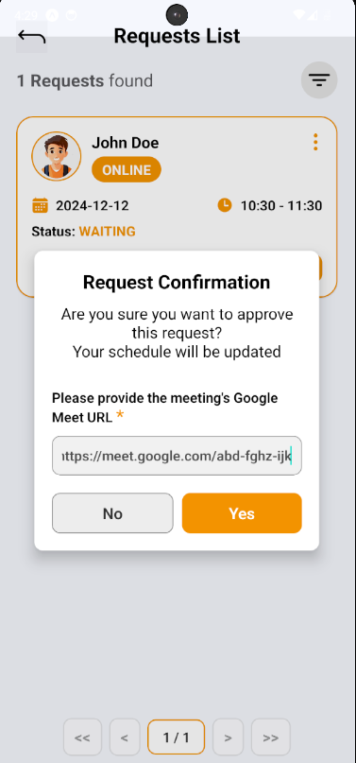

Figure - User Manual - Mobile Feature 6 – Step 5

**Step 6:** After approving student request, student request’s status is updated to “APPROVED”,  appointment and schedule of both student and counselor will update. To see appointment list, access though navigate to appointment section in Personal Screen.

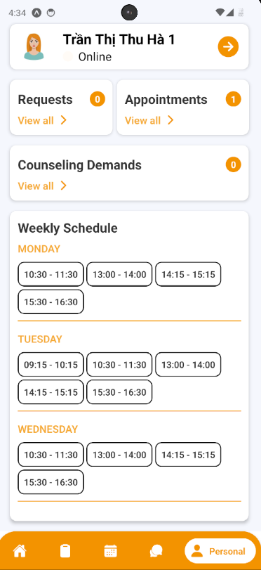

Figure - User Manual - Mobile Feature 6 – Step 6.1

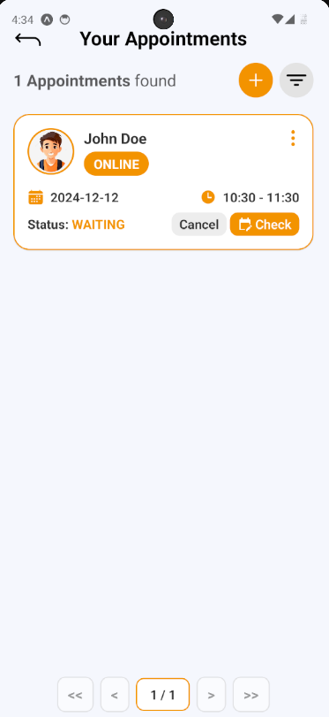

Figure - User Manual - Mobile Feature 6 – Step 6.2

**Step 7:** Choose Tab number 3 (calendar icon) at the bottom of the screen to navigate to Schedule Screen to view appointment schedule

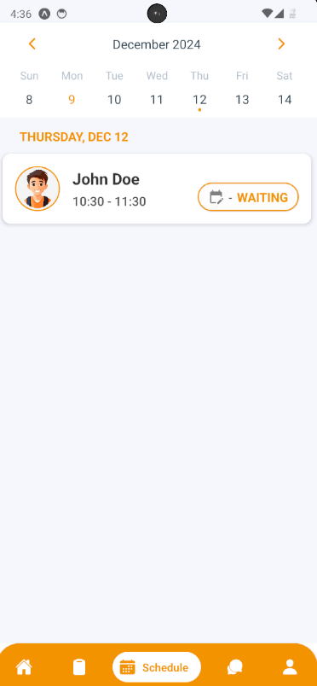

Figure - User Manual - Mobile Feature 6 – Step 7

##### 3.3.2.4. Deny Appointment Request

###### 3.3.2.4.1. Description

Use this guideline to log into the SCSS counselor account to deny student appointment request.

**Step 1:** Access SCSS at mobile application**.** Then fill in “Email” and “Password” of the counselor account



Figure - User Manual - Mobile Feature 7 – Step 1

**Step 2:** Press “Login” Button



Figure - User Manual - Mobile Feature 7 – Step 2

**Step 3:** From Home Screen:

Option 1: Choose Tab number 5 (personal icon) at the bottom of the screen to navigate to Personal Screen and from that screen will navigate to Request Screen

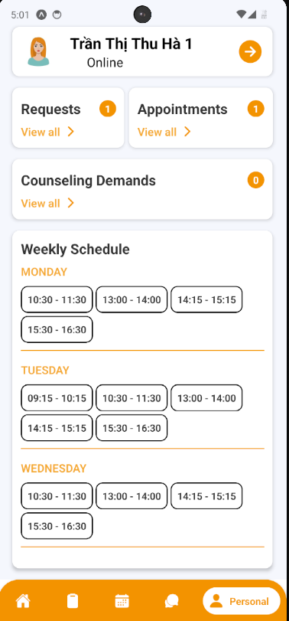

Figure - User Manual - Mobile Feature 7– Step 3 – Option 1

Option 2: For quick navigation, press View all at Pending Request to navigate to Request Screen

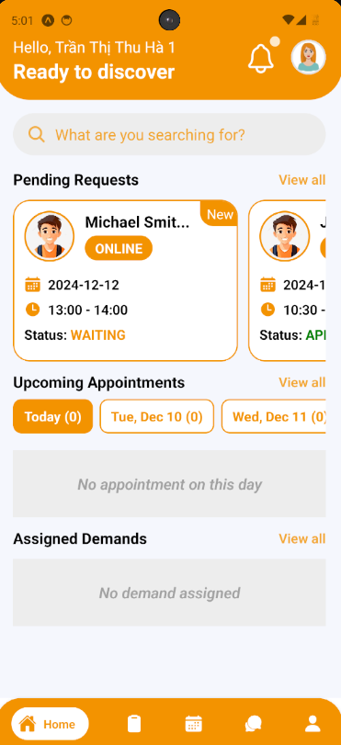

Figure - User Manual - Mobile Feature 7 – Step 3 – Option 2

**Step 4:** In Request Screen, find a request using filter section by request date, meeting method, and status

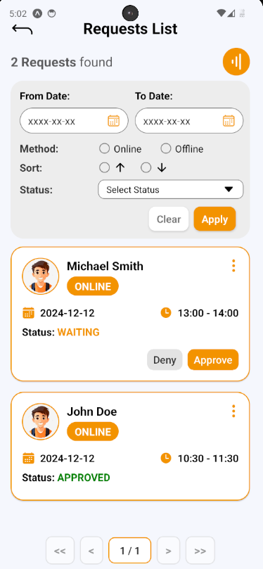

Figure - User Manual - Mobile Feature 7 – Step 4

**Step 5:** After finding and considering student request, press Deny Button on request card, a request deny confirmation will open. Press “Yes” Button to deny request, and “No” Button to cancel confirmation

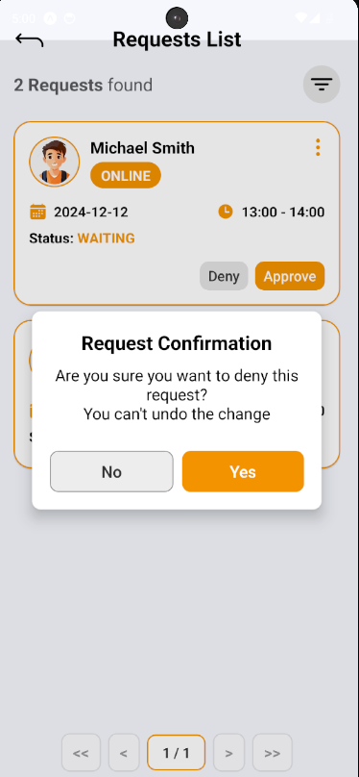

Figure - User Manual - Mobile Feature 7 – Step 5

**Step 6:** After denying student request, student request’s status is updated to “DENIED”

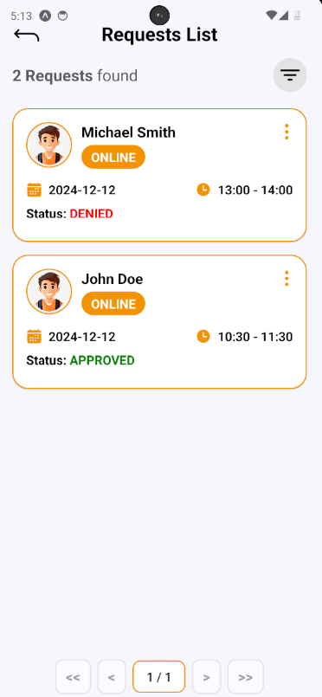

Figure - User Manual - Mobile Feature 7 – Step 6

##### 3.3.2.5. Take Attendance for Appointment

###### 3.3.2.5.1. Description

Use this guideline to log into the SCSS counselor account to take attendance for appointment

**Step 1:** Access SCSS at mobile application**.** Then fill in “Email” and “Password” of the counselor account



Figure - User Manual - Mobile Feature 8 – Step 1

**Step 2:** Press “Login” Button



Figure - User Manual - Mobile Feature 8 – Step 2

**Step 3:** From Home Screen:

Option 1: Choose Tab number 5 (personal icon) at the bottom of the screen to navigate to Personal Screen and from that screen will navigate to Appointment Screen

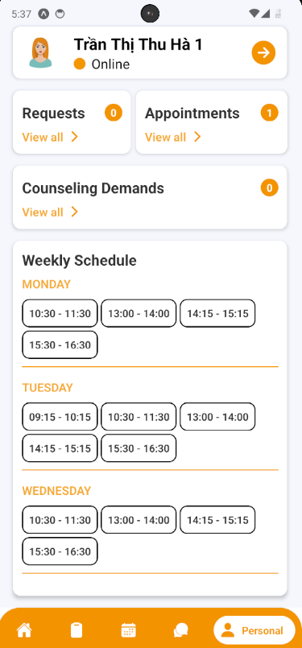

Figure - User Manual - Mobile Feature 8 – Step 3 – Option 1

Option 2: For quick navigation, press View all at Upcoming Appointments to navigate to Appointment Screen



Figure - User Manual - Mobile Feature 8 – Step 3 – Option 2

**Step 4:** In Appointment Screen, find an appointment using filter section by meeting date, and status

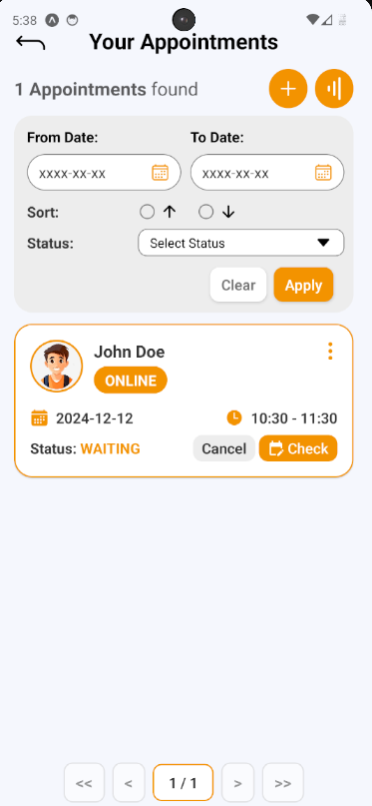

Figure - User Manual - Mobile Feature 8 – Step 4

**Step 5:** After finding appointment, press “Check” Button to open Take Attendance section on appointment card, a take attendance confirmation will open. Press “ATTEND” or “ABSENT” to change status of chosen appointment

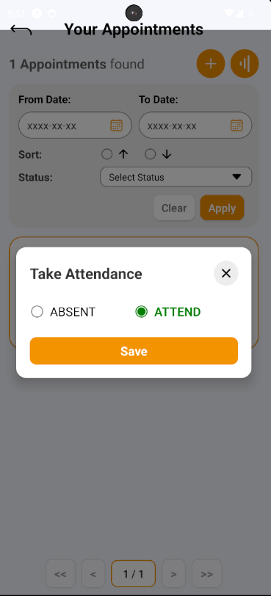

Figure - User Manual - Mobile Feature 8 – Step 5

**Step 6:** After taking attendance, the status of appointment will change to “ATTEND” or “ABSENT”

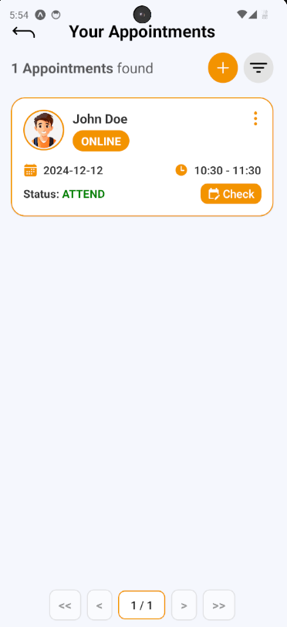

Figure - User Manual - Mobile Feature 8 – Step 6

##### 3.3.2.6. Write Feedback for Appointment

###### 3.3.2.6.1. Description

Use this guideline to log into the SCSS student account to write feedback for appointment

**Step 1:** Access SCSS at mobile application**.** Then fill in “Email” and “Password” of the student account



Figure - User Manual - Mobile Feature 9 – Step 1

**Step 2:** Press “Login” Button



Figure - User Manual - Mobile Feature 9 – Step 2

**Step 3:** From Home Screen:

Option 1: Choose Tab number 5 (personal icon) at the bottom of the screen to navigate to Personal Screen and from that screen will navigate to Appointment Screen

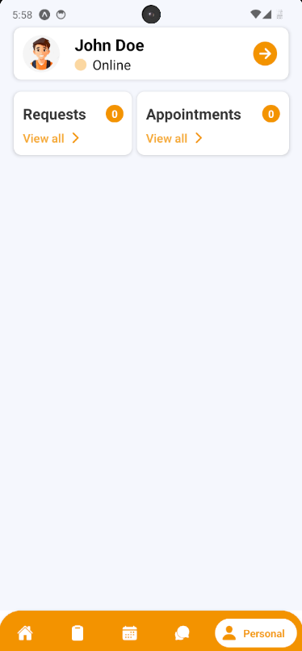

Figure - User Manual - Mobile Feature 9 – Step 3 – Option 1

Option 2: For quick navigation, press View all at Upcoming Appointments to navigate to Appointment Screen

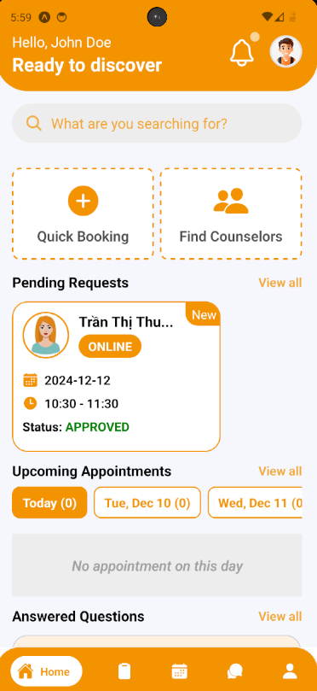

Figure - User Manual - Mobile Feature 9 – Step 3 – Option 2

**Step 4:** In Appointment Screen, find an appointment using filter section by meeting date, and status

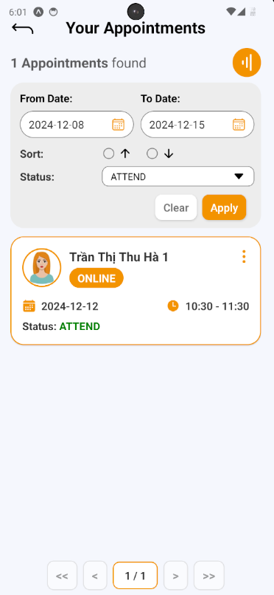

Figure - User Manual - Mobile Feature 9 – Step 4

**Step 5:** After finding a appointment (which status is “ATTEND”), press Info Button (shown as “vertical-ellipsis” icon) to show that appointment information

**Step 6:** In that appointment information, there’s a section called “Leave a review”, press it and open “Write a review” confirmation.

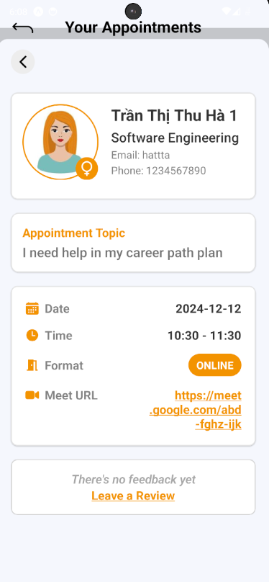

Figure - User Manual - Mobile Feature 9 – Step 6

**Step 7:** Fill in feedback content include message and rating. Then submit it by pressing “Save” Button, or cancel by pressing “Cancel” Button

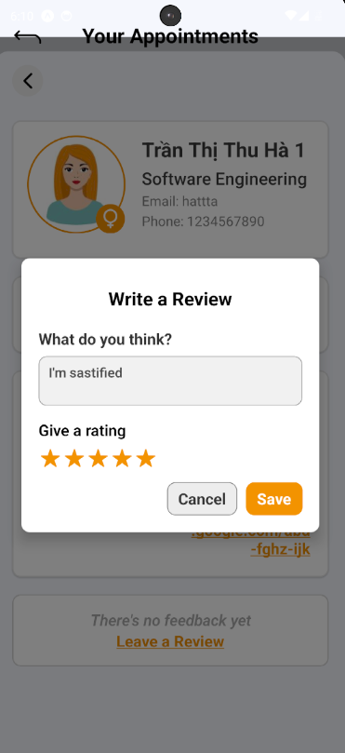

Figure - User Manual - Mobile Feature 9 – Step 7

**Step 8:** View feedback after submitting in appointment information.

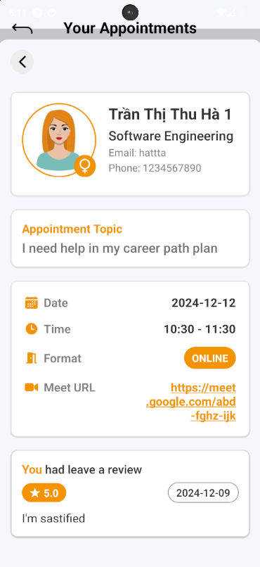

Figure - User Manual - Mobile Feature 9 – Step 8

##### 3.3.2.7. Write Report for Appointment

###### 3.3.2.7.1. Description

Use this guideline to log into the SCSS counselor account to write report for appointment

###### 3.3.2.7.2. Guide Steps

**Step 1:** Access SCSS at mobile application**.** Then fill in “Email” and “Password” of the counselor account



Figure - User Manual - Mobile Feature 10 – Step 1

**Step 2:** Press “Login” Button



Figure - User Manual - Mobile Feature 10 – Step 2

**Step 3:** From Home Screen:

Option 1: Choose Tab number 5 (personal icon) at the bottom of the screen to navigate to Personal Screen and from that screen will navigate to Appointment Screen

Figure - User Manual - Mobile Feature 10 – Step 3 – Option 1

Option 2: For quick navigation, press View all at Upcoming Appointments to navigate to Appointment Screen



Figure - User Manual - Mobile Feature 10 – Step 3 – Option 2

**Step 4:** In Appointment Screen, find an appointment using filter section by meeting date, and status

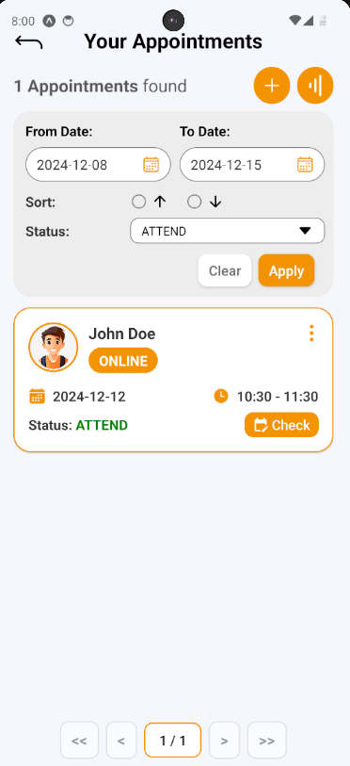

Figure - User Manual - Mobile Feature 10 – Step 4

**Step 5:** After finding a appointment (which status is “ATTEND”), press Info Button (shown as “vertical-ellipsis” icon) to show that appointment information

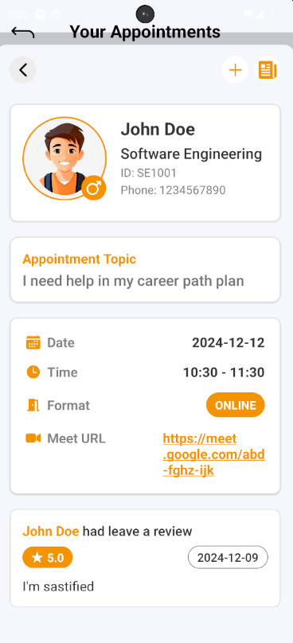

Figure - User Manual - Mobile Feature 10 – Step 5

**Step 6:** After appointment information open, press “Add” Button (shown as an icon with the “+” symbol) to open Create Report section

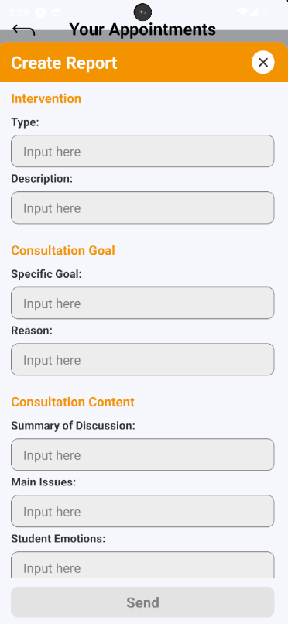

Figure - User Manual - Mobile Feature 10 – Step 6

**Step 7:** After filling all required fields, press “Send” button to create report for chosen appointment

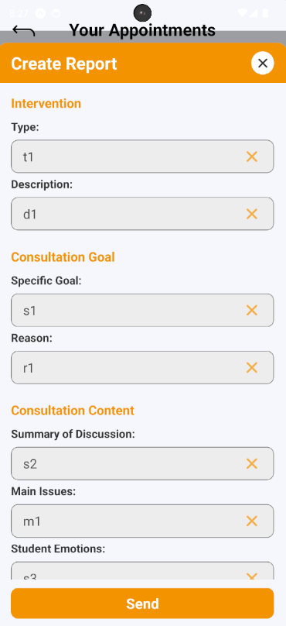

Figure - User Manual - Mobile Feature 10 – Step 7

**Step 8:** After creating report successfully, press “Report” Button (shown as “newspaper” icon) to view appointment report



Figure - User Manual - Mobile Feature 10 – Step 8.1

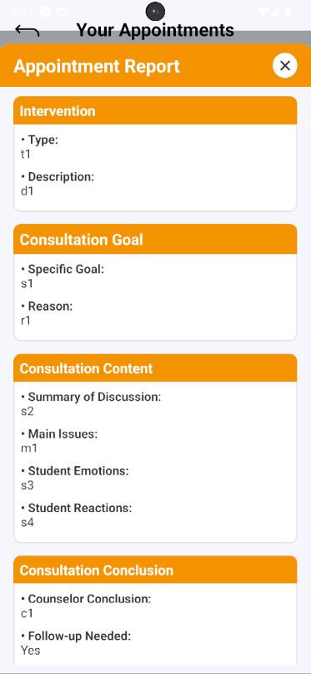

Figure - User Manual - Mobile Feature 10 – Step 8.2

##### 3.3.2.8. Cancel Appointment

###### 3.3.2.8.1. Description

Use this guideline to log into the SCSS student or counselor account to cancel an appointment

###### 3.3.2.8.2. Guide Steps

**Case 1:**

**Step 1:** Access SCSS at mobile application**.** Then fill in “Email” and “Password” of the student account



Figure - User Manual - Mobile Feature 10 – Case 1 – Step 1

**Step 2:** Press “Login” Button



Figure - User Manual - Mobile Feature 10 – Case 1 – Step 2

**Step 3:** From Home Screen:

Option 1: Choose Tab number 5 (personal icon) at the bottom of the screen to navigate to Personal Screen and from that screen will navigate to Appointment Screen

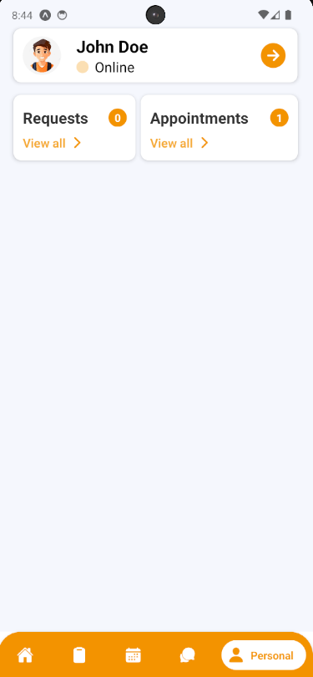

Figure - User Manual - Mobile Feature 10 – Case 1 – Step 3 – Option 1

Option 2: For quick navigation, press View all at Upcoming Appointments to navigate to Appointment Screen

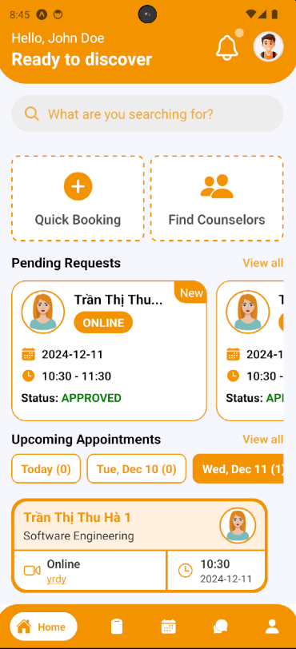

Figure - User Manual - Mobile Feature 10 – Case 1 – Step 3 – Option 2

**Step 4:** In Appointment Screen, find an appointment using filter section by request date, and status

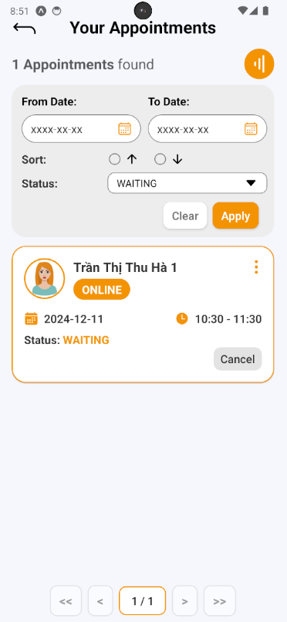

Figure - User Manual - Mobile Feature 10 – Case 1 – Step 4

**Step 5:** After finding appointment, press “Cancel” Button to open Cancel Appointment section on appointment card, a cancel appointment confirmation will open. Fill in reason then press “Yes” Button to cancel appointment, and “No” Button to cancel confirmation

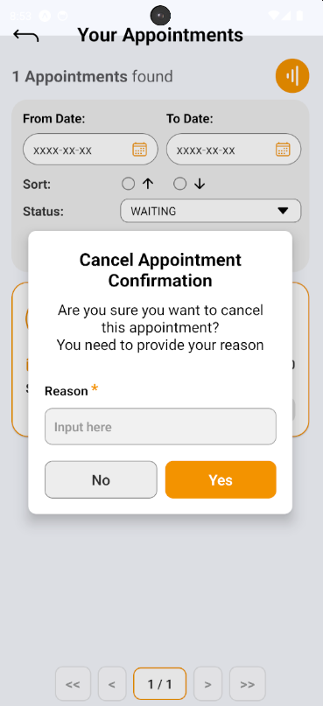

Figure - User Manual - Mobile Feature 10 – Case 1 – Step 5

**Step 6:** After cancelling appointment successfully, the appointment’s status change to “CANCELED”, then press “Info” Button (shown as “vertical-ellipsis” icon) and view canceled reason

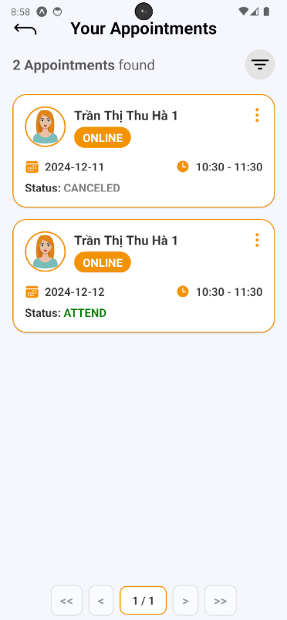

Figure - User Manual - Mobile Feature 10 – Case 1 – Step 6.1

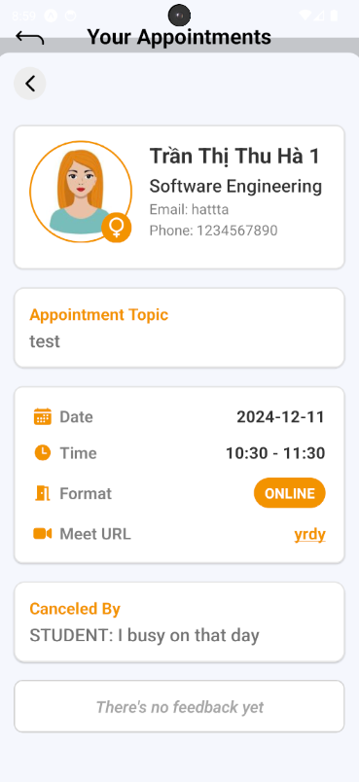

Figure - User Manual - Mobile Feature 10 – Case 1 – Step 6.2

**Case 2:**

**Step 1:** Access SCSS at mobile application**.** Then fill in “Email” and “Password” of the counselor account



Figure - User Manual - Mobile Feature 10 – Case 2 – Step 1

**Step 2:** Press “Login” Button



Figure - User Manual - Mobile Feature 10 – Case 2 – Step 2

**Step 3:** From Home Screen:

Option 1: Choose Tab number 5 (personal icon) at the bottom of the screen to navigate to Personal Screen and from that screen will navigate to Appointment Screen

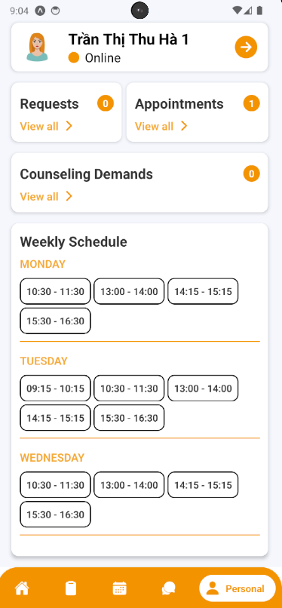

Figure - User Manual - Mobile Feature 10 – Case 2 – Step 3 – Option 1

Option 2: For quick navigation, press View all at Upcoming Appointments to navigate to Appointment Screen

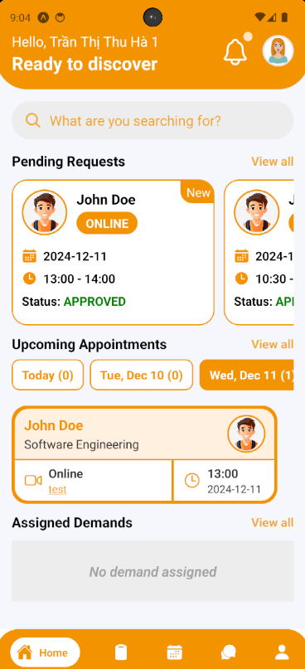

Figure - User Manual - Mobile Feature 10 – Case 2 – Step 3 – Option 2

**Step 4:** In Appointment Screen, find an appointment using filter section by request date, and status

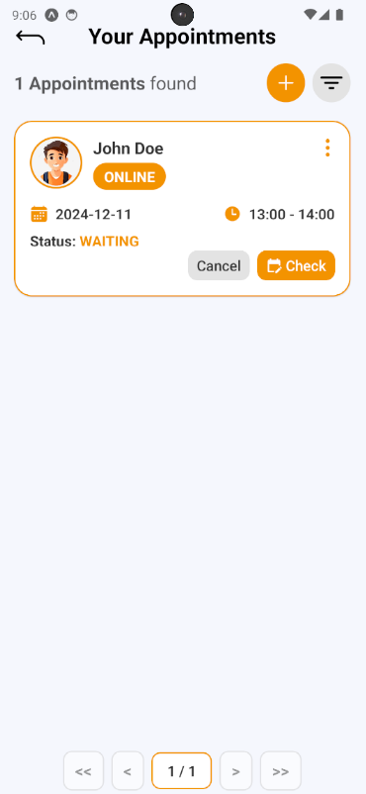

Figure - User Manual - Mobile Feature 10 – Case 2 – Step 4

**Step 5:** After finding appointment, press “Cancel” Button to open Cancel Appointment section on appointment card, a cancel appointment confirmation will open. Fill in reason then press “Yes” Button to cancel appointment, and “No” Button to cancel confirmation

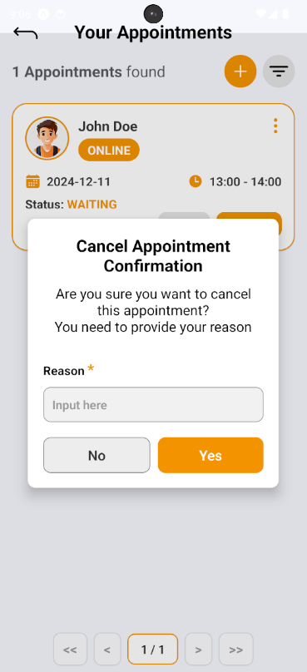

Figure - User Manual - Mobile Feature 10 – Case 2 – Step 5

**Step 6:** After cancelling appointment successfully, the appointment’s status change to “CANCELED”, then press “Info” Button (shown as “vertical-ellipsis” icon) and view canceled reason

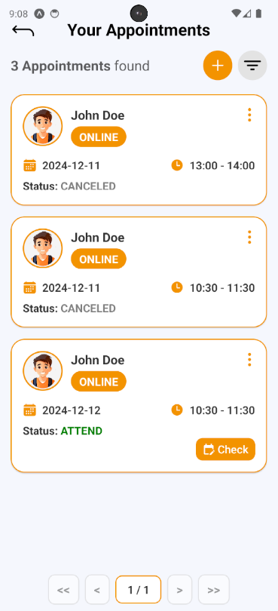

Figure - User Manual - Mobile Feature 10 – Case 2 – Step 6.1

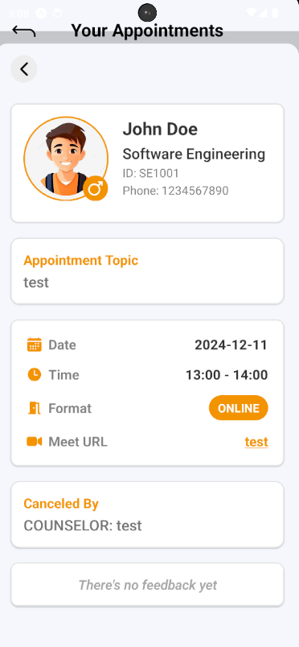

Figure - User Manual - Mobile Feature 10 – Case 2 – Step 6.2

#### 3.3.3.  Question and Answer

##### 3.3.3.1. Create a question

###### 3.3.3.1.1. Description

Use this guideline to create a question for the counselor

###### 3.3.3.1.2. Guide Steps

**Step 1:** Access SCSS at mobile application**.** Then fill in “Email” and “Password” of the student account



Figure - User Manual - Mobile Feature 11 – Step 1

**Step 2:** Press “Login” Button



Figure - User Manual - Mobile Feature 11 – Step 2

**Step 3:** From Home Screen, choose Tab number 4 (chat-bubble icon) at the bottom of the screen to navigate to My Q&A Screen

.

Figure - User Manual - Mobile Feature 11 – Step 3

**Step 4:** In My Q&A Screen, press “Add” button (shown as an icon with the “+” symbol) to open Create Question section

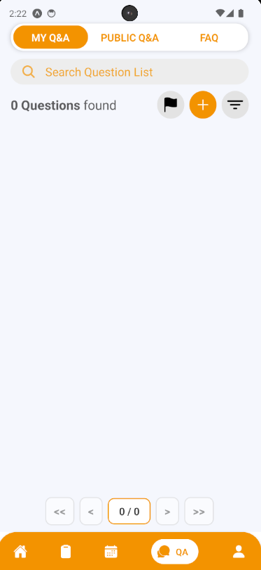

Figure - User Manual - Mobile Feature 11 – Step 4

**Step 5:** Choose the question type and fill in the question title, content if there are similar questions, it will be suggested to students before submitting in case there are duplicate question. Then after fill all required fields, press “Create Question” Button

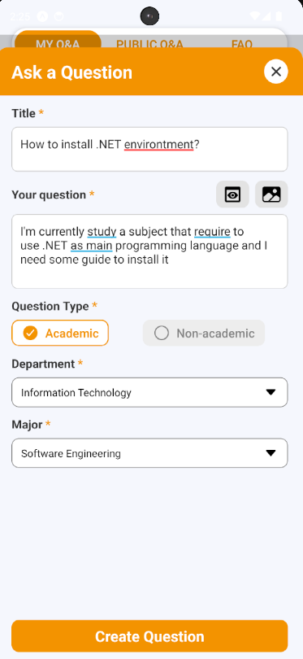

Figure - User Manual - Mobile Feature 11 – Step 5

**Step 6:** View a list of suggestion questions that similar to your question, if you don’t find satisfied answer, press “Continue to Proceed?” button

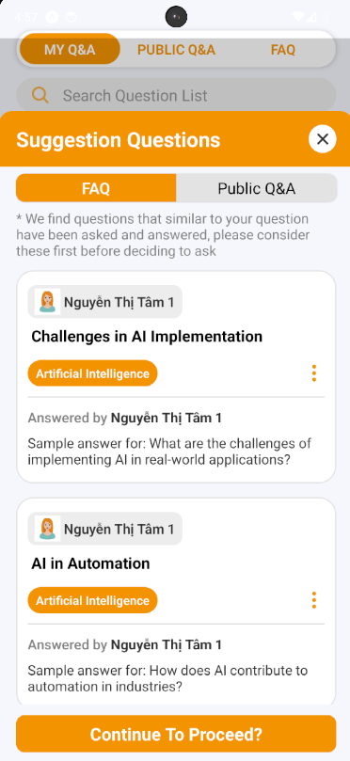

Figure - User Manual - Mobile Feature 11 – Step 6

**Step 7:** A confirmation will open, press “Yes” to create question

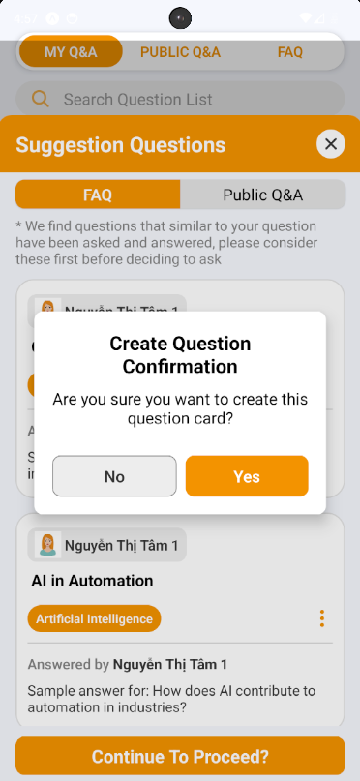

Figure - User Manual - Mobile Feature 11 – Step 7

**Step 8:** View your created question, and information of counselor that currently in charge of this question.

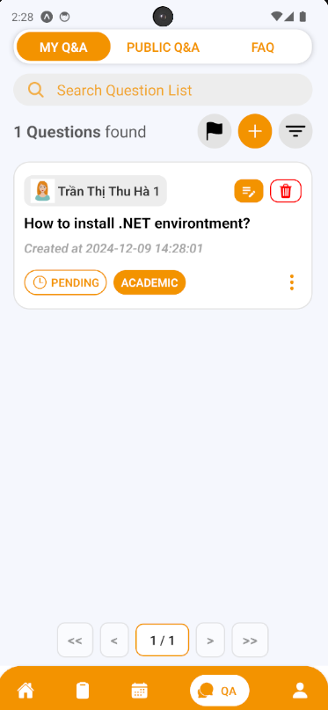

Figure - User Manual - Mobile Feature 11 – Step 8.1

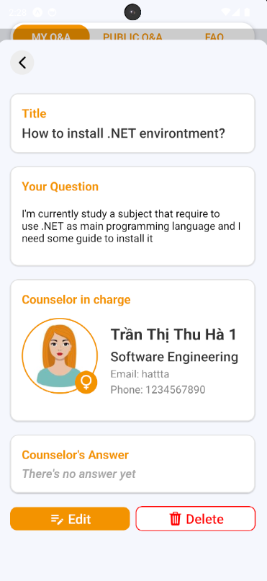

Figure - User Manual - Mobile Feature 11 – Step 8.2

##### 3.3.3.2. Edit a question

###### 3.3.3.2.1. Description

Use this guideline to edit your question’s content

###### 3.3.3.2.2. Guide Steps:

**Step 1:** Access SCSS at mobile application with student account**.** Navigate to My Q&A screen, and press “Edit” (shown as “pencil-note” icon) to open Edit Question section that lay on the question card, or inside the information of question card



Figure - User Manual - Mobile Feature 12 – Step 1.1



Figure - User Manual - Mobile Feature 12 – Step 1.1

**Step 2:** You can see current question information inside these input field and you can change it (some fields are required, so it can not empty). Then after fill all required fields, press “Edit” Button.

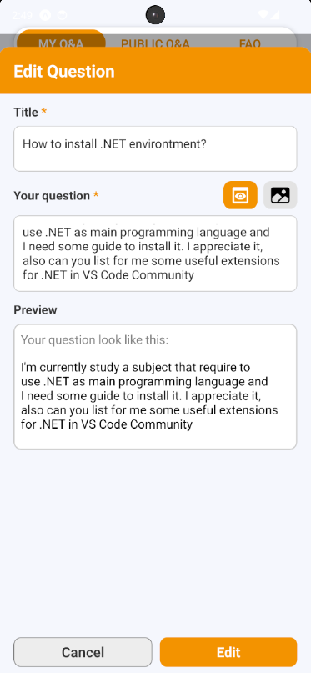

Figure - User Manual - Mobile Feature 12 – Step 2

**Step 3:** View your question after editing.

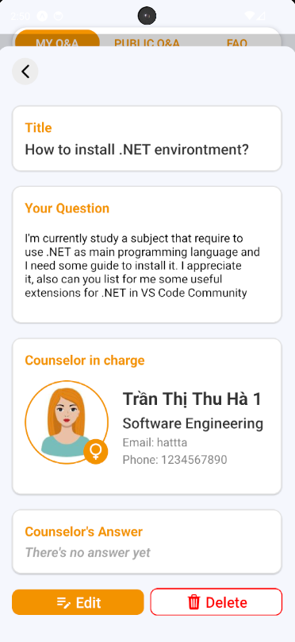

Figure - User Manual - Mobile Feature 12 – Step 3

##### 3.3.3.3. Delete a question

###### 3.3.3.3.1. Description

Use this guideline to delete your question

###### 3.3.3.3.2. Guide Steps:

**Step 1:** Access SCSS at mobile application with student account**.** Navigate to My Q&A screen, and press “Delete” (shown as an icon with the “trash” symbol) to open Delete Question section that lay on the question card, or inside the information of question card



Figure - User Manual - Mobile Feature 13 – Step 1.1



Figure - User Manual - Mobile Feature 13 – Step 1.1

**Step 2:** After pressing, Delete Question Confirmation will open. If you want to delete your question press “Yes” Button to delete it, and “No” Button if not. After deleting successfully, that question will be disappear of My Q&A screen

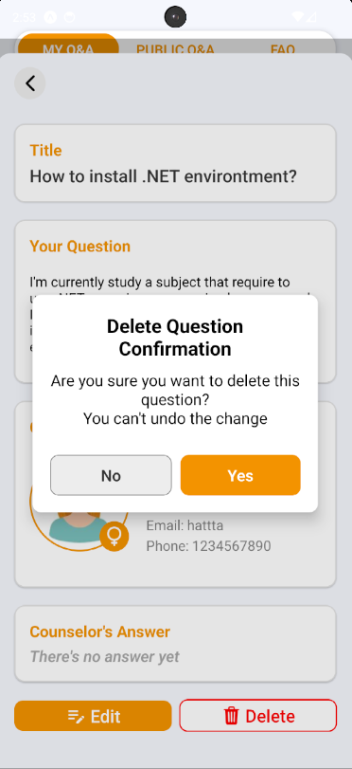

Figure - User Manual - Mobile Feature 13 – Step 2

##### 3.3.3.4. Answer a question

###### 3.3.3.4.1. Description

Use this guideline to answer a question

###### 3.3.3.4.2. Guide Steps

**Step 1:** Access SCSS at mobile application**.** Then fill in “Email” and “Password” of the counselor account



Figure - User Manual - Mobile Feature 14 – Step 1

**Step 2:** Press “Login” Button



Figure - User Manual - Mobile Feature 14 – Step 2

**Step 3:** From Home Screen, choose Tab number 4 (chat-bubble icon) at the bottom of the screen to navigate to My Q&A Screen

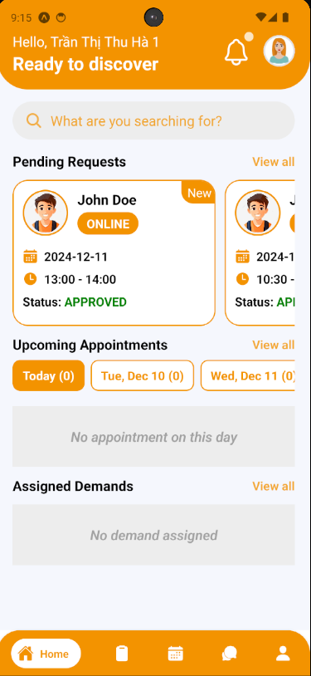

Figure - User Manual - Mobile Feature 14 – Step 3

**Step 4:** In My Q&A Screen,  find a question using filter section by student code

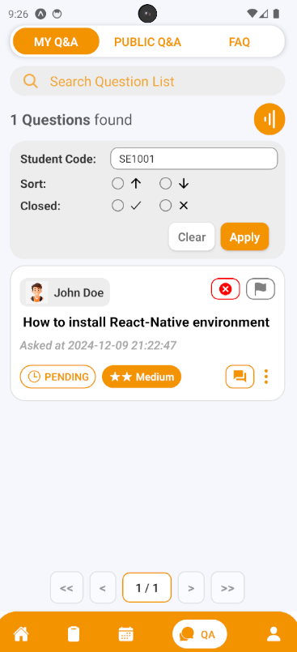

Figure - User Manual - Mobile Feature 14 – Step 4

**Step 5:** After finding question, press “Answer” Button (shown as “text-box” icon) to open Answer Question section.

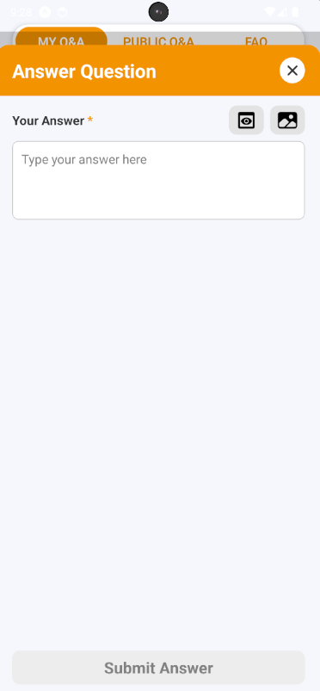

Figure - User Manual - Mobile Feature 14 – Step 5

**Step 6:** After filling answer, press “Submit Answer” Button to submit answer for the chosen question

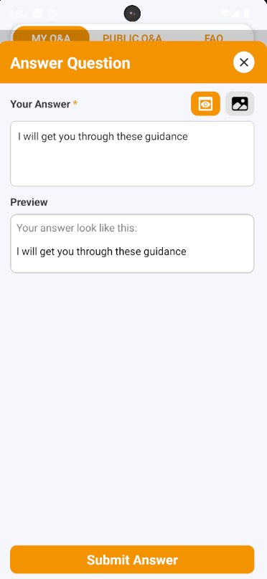

Figure - User Manual - Mobile Feature 14 – Step 6

**Step 7:** After answering question, view your answer on the question card or by pressing “Info” Button (shown as “vertical-ellipsis” icon ) to show question information

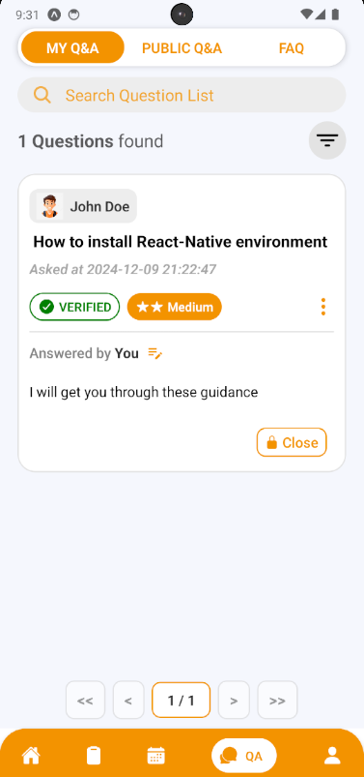

Figure - User Manual - Mobile Feature 14 – Step 7

##### 3.3.3.5. Edit Answer of a question

###### 3.3.3.5.1. Description

Use this guideline to edit answer of a question

###### 3.3.3.5.2. Guide Steps:

**Step 1:** Access SCSS at mobile application with counselor account**.** Navigate to My Q&A screen, and press “Edit” (shown as “pencil” icon) to open Edit Answer section that lay on the question card



Figure - User Manual - Mobile Feature 15 – Step 1

**Step 2:** You can see current answer information inside this input field and you can change it (this field is required, so it can not empty). Then after fill all required fields, press “Edit” Button.

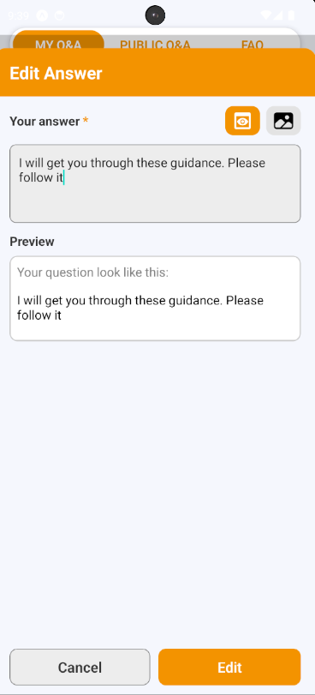

Figure - User Manual - Mobile Feature 15 – Step 2

**Step 3:** View your answer after editing.

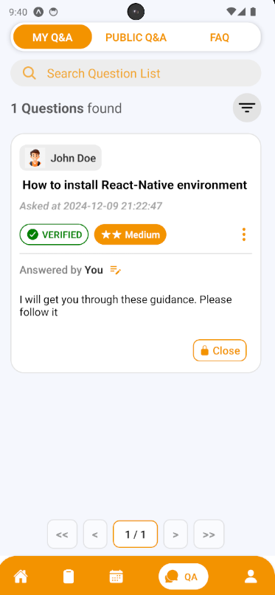

Figure - User Manual - Mobile Feature 15 – Step 3

##### 3.3.3.6. Create a chat session

###### 3.3.3.6.1. Description

Use this guideline to create a chat session for your question

###### 3.3.3.6.2. Guide Steps

**Step 1:** Access SCSS at mobile application with student account**.** Navigate to My Q&A screen, and press “Start a chat” (shown as “chat-bubble” icon) to open Create Chat Session section that lay on the question card (this button will only show when this question is verified and has already answered by counselor in charge)

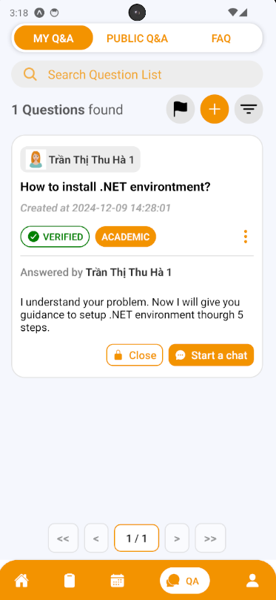

Figure - User Manual - Mobile Feature 16 – Step 1

**Step 2:** After pressing, Start a Conversation Session Confirmation will open. If you want to start a chat inside your question press “Yes” Button to create it, and “No” Button if not. After creating successfully, that chat session will show on the screen and can be open through Chat Button.

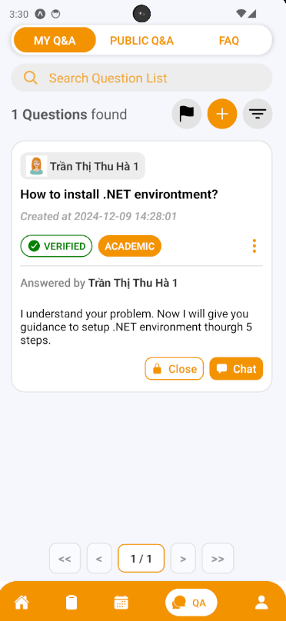

Figure - User Manual - Mobile Feature 16 – Step 2.1

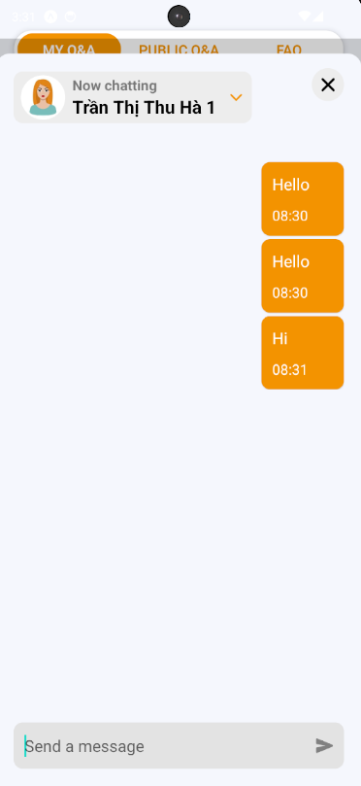

Figure - User Manual - Mobile Feature 16 – Step 2.2

##### 3.3.3.7. Accept a question’s answer

###### 3.3.3.7.1. Description

Use this guideline to close your question

###### 3.3.3.7.2. Guide Steps

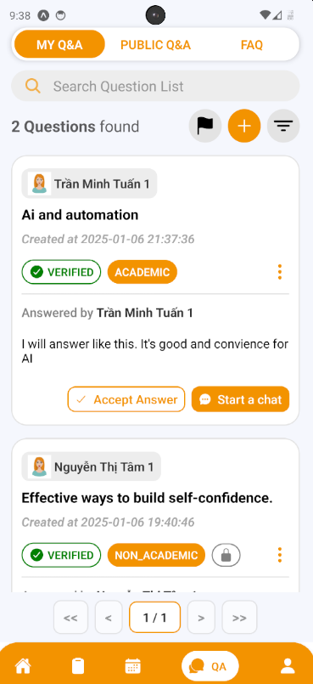**Step 1:** Access SCSS at mobile application with student account**.** Navigate to My Q&A screen, and press “Accept Answer” to open Accept Answer section that lay on the question card

Figure - User Manual - Mobile Feature 17 – Step 1

**Step 2:** After pressing, Accept Answer Confirmation will open. If you want to accept the question’s answer press “Yes” Button to accept it, and “No” Button if not.

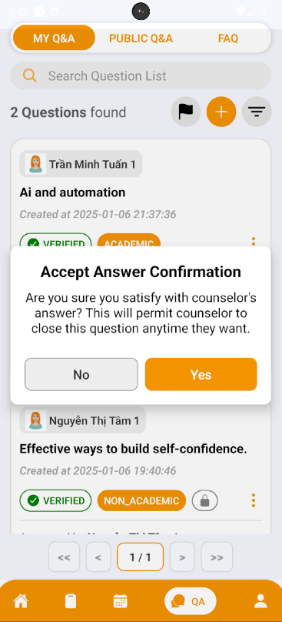

Figure - User Manual - Mobile Feature 17 – Step 2

**Step 3:**  After accepting answer, Counselor will receive accepted question’s answer from Student, then Counselor can ready to close question

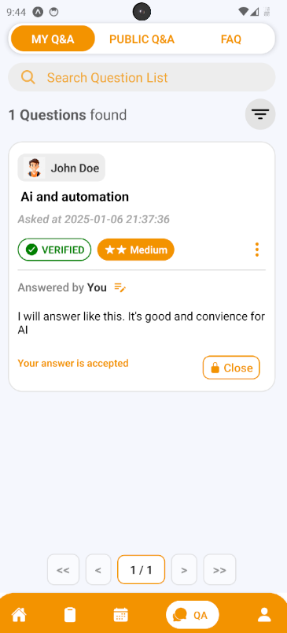

Figure - User Manual - Mobile Feature 17 – Step 3

##### 3.3.3.8. Close a question

###### 3.3.3.8.1. Description

Use this guideline to close your question

###### 3.3.3.8.2. Guide Steps

**Case 1:**

**Step 1:** Access SCSS at mobile application with student account**.** Navigate to My Q&A screen, and press “Close” (shown as “lock” icon) to open Close Question section that lay on the question card, or inside the information of question card



Figure - User Manual - Mobile Feature 18 – Case 1 - Step 1.1

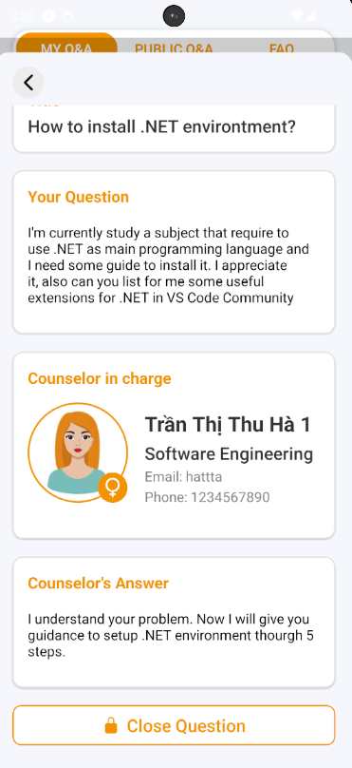

Figure - User Manual - Mobile Feature 18 – Case 1 - Step 1.2

**Step 2:** After pressing, Close Question Confirmation will open. If you want to close your question press “Yes” Button to close it, and “No” Button if not.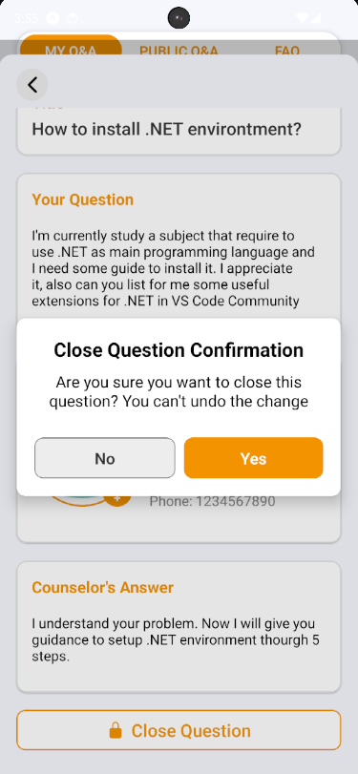

Figure - User Manual - Mobile Feature 18 – Case 1 - Step 2

**Step 3:**  After closing successfully, that question will be closed, and cannot chat anymore

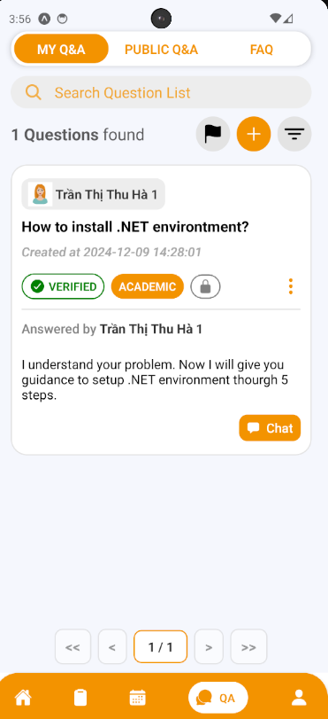

Figure - User Manual - Mobile Feature 18 – Case 1 - Step 3.1

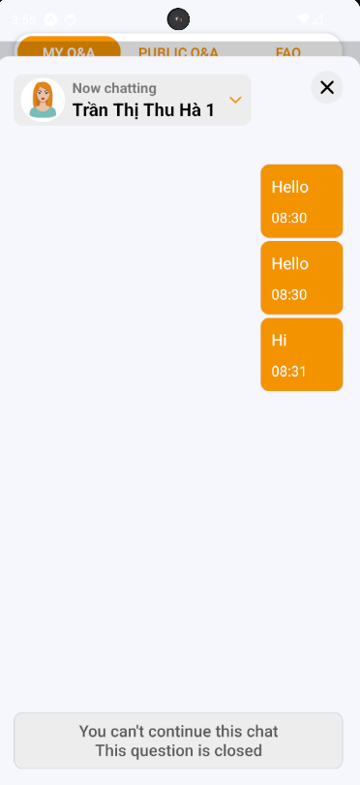

Figure - User Manual - Mobile Feature 18 – Case 1 - Step 3.1

**Case 2:**

**Step 1:** Access SCSS at mobile application with counselor account**.** Navigate to My Q&A screen, and press “Close” (shown as “lock” icon) to open Close Question section that lay on the question card, or inside the information of question card

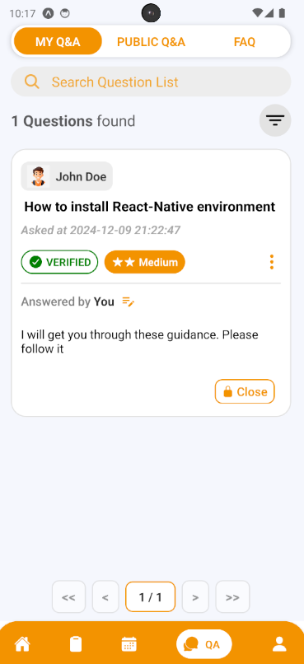

Figure - User Manual - Mobile Feature 18 – Case 2 - Step 1.1

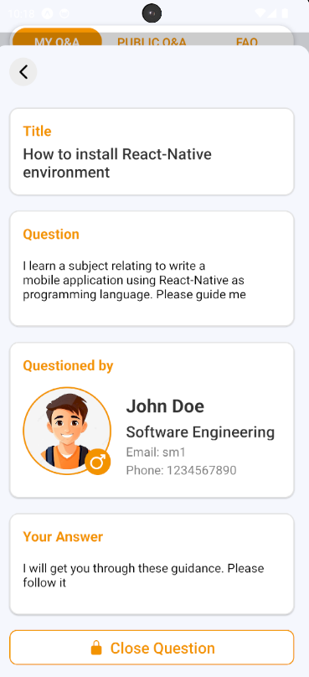

Figure - User Manual - Mobile Feature 18 – Case 2 - Step 1.1

**Step 2:** After pressing, Close Question Confirmation will open. If you want to close your question press “Yes” Button to close it, and “No” Button if not.

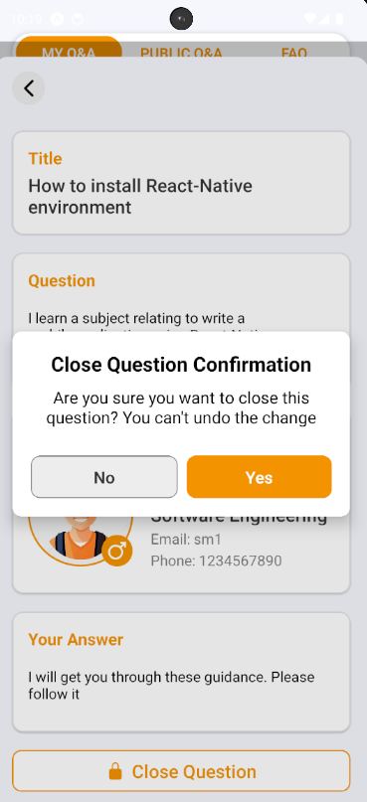

Figure - User Manual - Mobile Feature 18 – Case 2 - Step 2

**Step 3:**  After closing successfully, that question will be closed, and cannot chat anymore

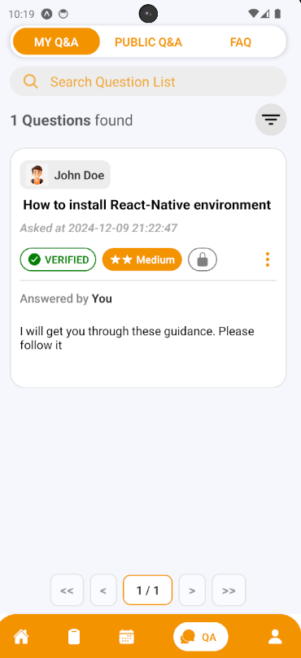

Figure - User Manual - Mobile Feature 18 – Case 2 - Step 3

##### 3.3.3.9. Create a contribution question

###### 3.3.3.9.1. Description

Use this guideline to create a contribution question

###### 3.3.3.9.2. Guide Steps

**Step 1:** Access SCSS at mobile application**.** Then fill in “Email” and “Password” of the counselor account



Figure - User Manual - Mobile Feature 19 - Step 1

**Step 2:** Press “Login” Button



Figure - User Manual - Mobile Feature 19 - Step 2

**Step 3:** From Home Screen, choose Tab number 4 (chat-bubble icon) at the bottom of the screen to navigate to My Q&A Screen

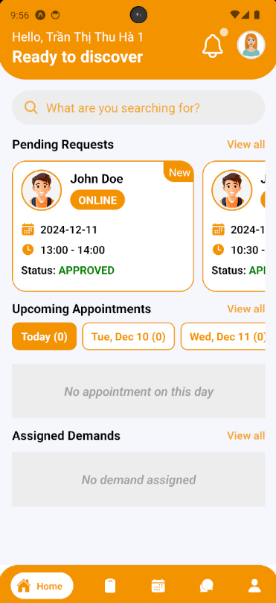**Step 4:** In My Q&A Screen, swipe to the right to navigate to FAQ Screen

Figure - User Manual - Mobile Feature 19 - Step 3

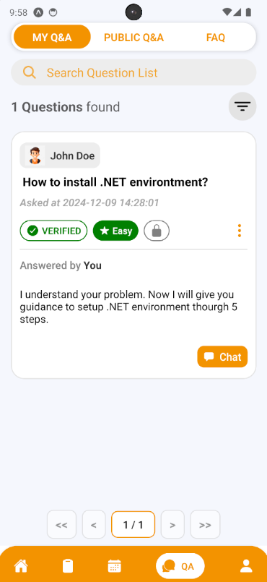

Figure - User Manual - Mobile Feature 19 - Step 4

**Step 5:** In FAQ Screen, press “Add” button (shown as an icon with the “+” symbol) to open Contribute Question section

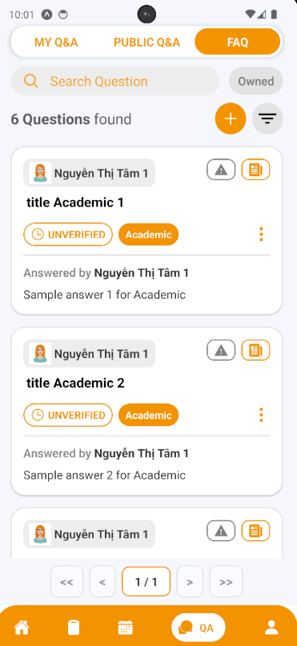

Figure - User Manual - Mobile Feature 19 - Step 5

**Step 6:** Choose the question type and fill in the question title, content, category and answer if there are similar questions, it will be suggested to students before submitting in case there are duplicate question. Then after fill all required fields, press “Create Question” Button

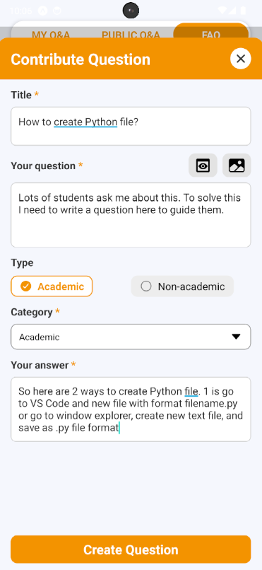

Figure - User Manual - Mobile Feature 19 - Step 6

**Step 7:** View your created question, and information of this question.

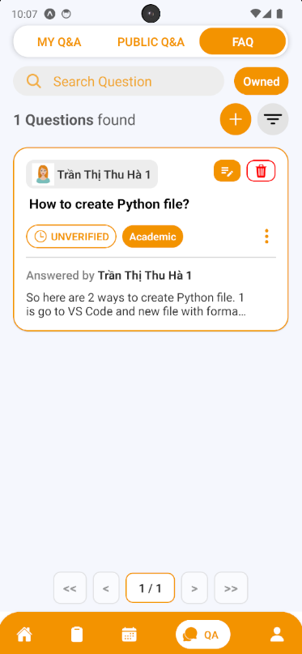

Figure - User Manual - Mobile Feature 19 - Step 7

##### 3.3.3.10. Edit a contribution question

###### 3.3.3.10.1. Description

Use this guideline to edit your contribution question

###### 3.3.3.10.2. Guide Steps:

**Step 1:** Access SCSS at mobile application with counselor account**.** Navigate to My Q&A screen, then swipe to the right to navigate to FAQ Screen and press “Edit” (shown as “pencil-note” icon) to open Edit Question section that lay on the question card, or inside the information of question card

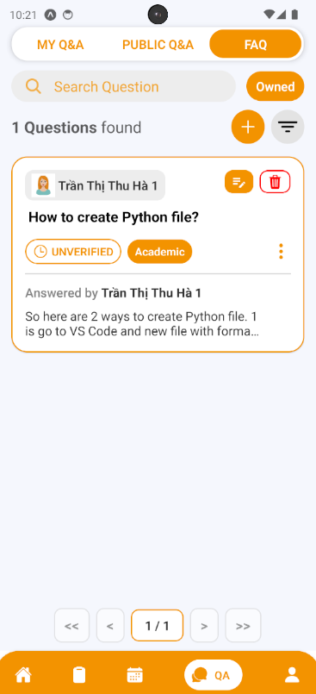

Figure - User Manual - Mobile Feature 20 - Step 1

**Step 2:** You can see current question information inside these input field and you can change it (some fields are required, so it can not empty). Then after fill all required fields, press “Edit” Button.

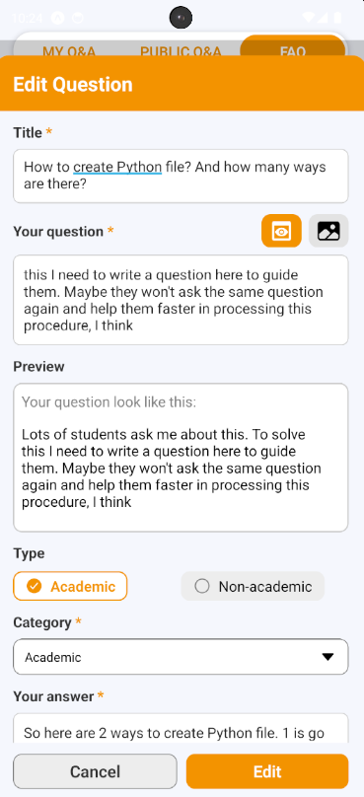

Figure - User Manual - Mobile Feature 20 - Step 2

**Step 3:** View your question after editing.

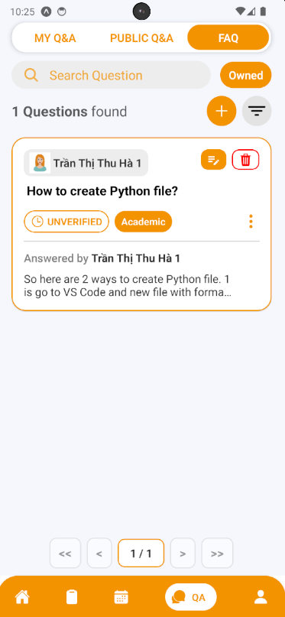

Figure - User Manual - Mobile Feature 20 - Step 3.1

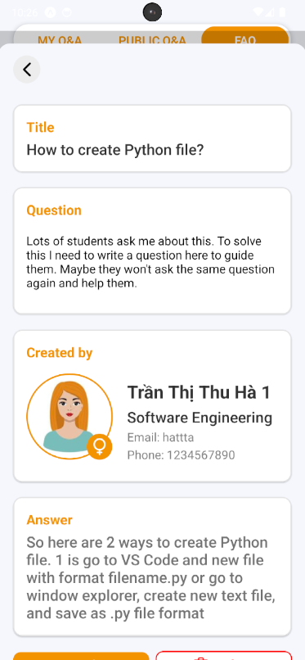

Figure - User Manual - Mobile Feature 20 - Step 3.2

##### 3.3.3.11. Delete a contribution question

###### 3.3.3.11.1. Description

Use this guideline to delete your contribution question

###### 3.3.3.11.2. Guide Steps

**Step 1:** Access SCSS at mobile application with counselor account**.** Navigate to My Q&A screen, then swipe to the right to navigate to FAQ Screen and press “Delete” (shown as an icon with the “trash” symbol) to open Delete Question section that lay on the question card, or inside the information of question card

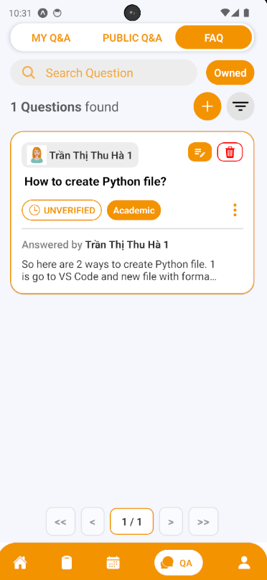

Figure - User Manual - Mobile Feature 21 - Step 1.1

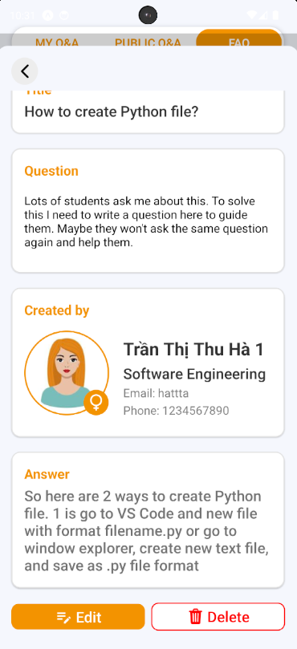

Figure - User Manual - Mobile Feature 20 - Step 1.1

**Step 2:** After pressing, Delete Question Confirmation will open. If you want to delete your question press “Yes” Button to delete it, and “No” Button if not. After deleting successfully, that question will be disappear of FAQ screen

#### 3.3.4. Counseling Demands

##### 3.3.4.1. View Demands List

###### 3.3.4.1.1. Description

Use this guideline to view demands list that assigned to specific counselor

###### 3.3.4.1.2. Guide Steps

**Step 1:** Access SCSS at mobile application**.** Then fill in “Email” and “Password” of the counselor account



Figure - User Manual - Mobile Feature 21- Step 1

**Step 2:** Press “Login” Button



Figure - User Manual - Mobile Feature 21 - Step 2

**Step 3:**

Option 1: Choose Tab number 5 (personal icon) at the bottom of the screen to navigate to Personal Screen and from that screen will navigate to Counseling Demands Screen

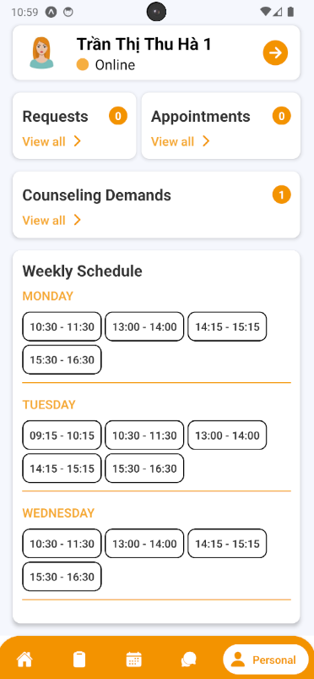

Figure - User Manual - Mobile Feature 21 - Step 3 – Option1

Option 2: For quick navigation, press View all at Assigned to navigate to Counseling Demands Screen

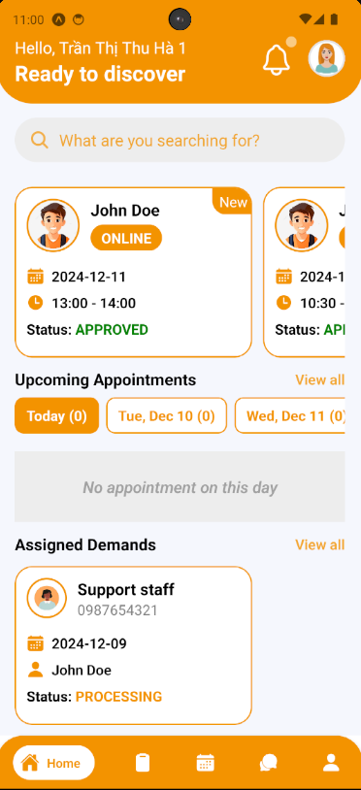

Figure - User Manual - Mobile Feature 21 - Step 3 – Option 2

**Step 4:** In Counseling Demands Screen, find a demand using filter section by status

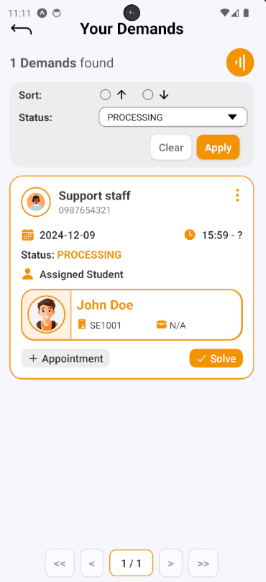

Figure - User Manual - Mobile Feature 21 - Step 4

##### 3.3.4.2. Create Appointment through Demand

###### 3.3.4.2.1. Description

Use this guideline to create appointment through demand

###### 3.3.4.2.2. Guide Steps

**Step 1:** After finding demand, press “Create Appointment” Button on demand card to open Create Appointment section.



Figure - User Manual - Mobile Feature 22 - Step 1

**Step 2:** Filling all required fields including date, time, meeting method, Meet Url/Address, Purpose and Student information (assigned through demand). After filling done, press “Create Appointment” Button to create appointment.

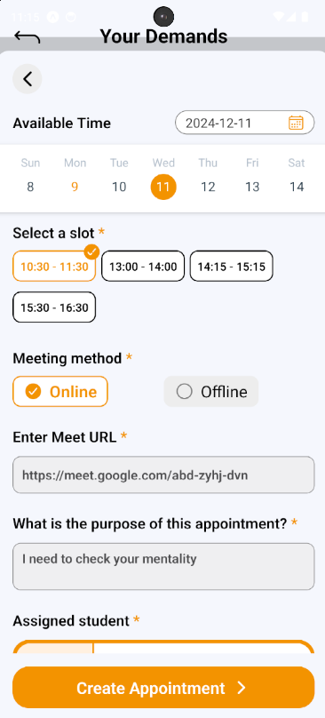

Figure - User Manual - Mobile Feature 22 - Step 2

**Step 3:** View new appointment created in Appointment Screen

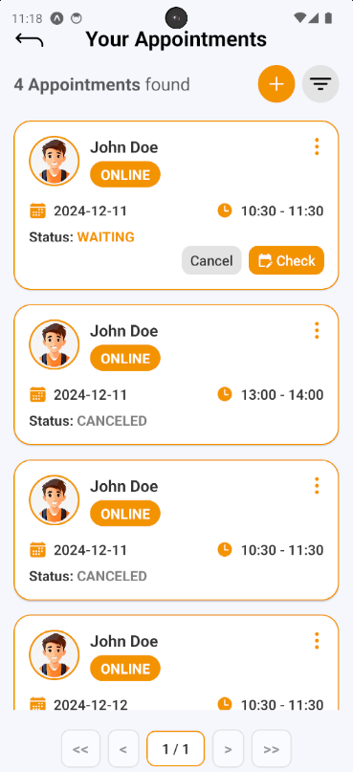

Figure - User Manual - Mobile Feature 22 - Step 3

##### 3.3.4.3. Solve Demand

###### 3.3.4.3.1. Description

Use this guideline to solve demand

###### 3.3.4.3.2. Guide Steps:

**Step 1:** After finding demand, press “Solve” Button on demand card to open Solve Demand section.

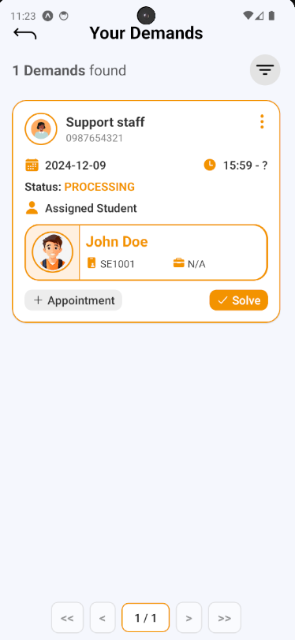

Figure - User Manual - Mobile Feature 23 - Step 1

**Step 2:** After pressing, a Solve Demand Confirmation will open, fill your note, then press “Yes” Button to solve this demand, and “No” Button to cancel solve

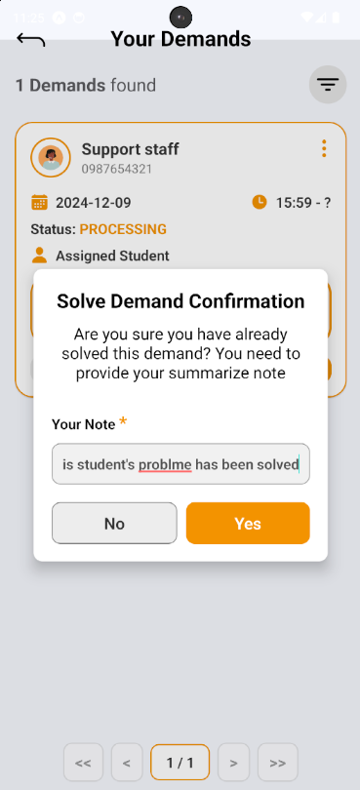

Figure - User Manual - Mobile Feature 23 - Step 2

**Step 3:** The solved demand will be marked with “DONE” status

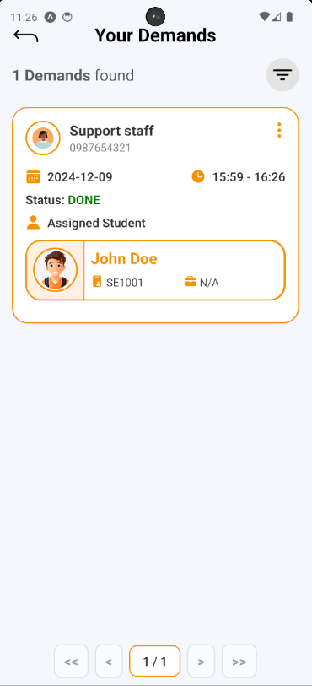

Figure - User Manual - Mobile Feature 23 - Step 3